Lab: Inheritance
Problems for exercises and homework for the "Java OOP Basics" course @ SoftUni.
You can check your solutions here: https://judge.softuni.bg/Contests/478/Inheritance-Lab .

Part I: Upload Solutions
In that exercise Judge uses Reflection to check your solutions.
If you are using packages for every problem you should:
- Go to project folder
- Go to src folder
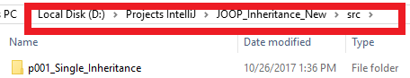
- Send the whole package to zip and upload.

If you are creating project for every problem, you should:
- Go to project folder
- Go to src folder:
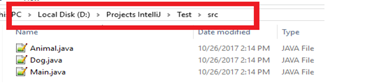
- Send everything to zip and upload.

Part II: Inheritance

Single Inheritance
Create two classes named Animal and Dog.
Animal with a single public method eat() that prints: "eating…"
Dog with a single public method bark() that prints: "barking…"
Dog should inherit from Animal.
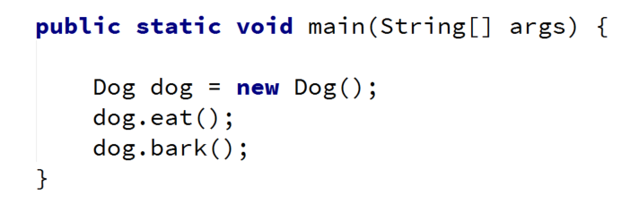
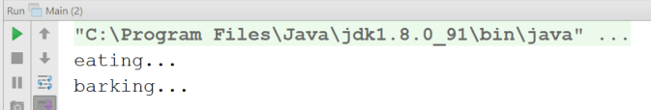

Hints
Use the extends keyword to build a hierarchy

Multiple Inheritance
Create three classes named Animal, Dog and Puppy.
Animal with a single public method eat() that prints: "eating…"
Dog with a single public method bark() that prints: "barking…"
Puppy with a single public method weep() that prints: "weeping…"
Dog should inherit from Animal. Puppy should inherit from Dog.
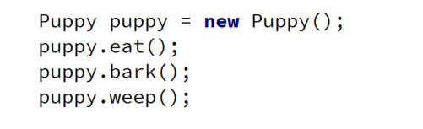
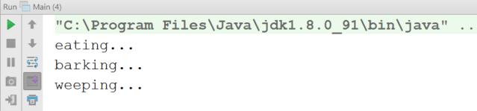

Hierarchical Inheritance
Create three classes named Animal, Dog and Cat.
Animal with a single public method eat() that prints: "eating…"
Dog with a single public method bark() that prints: "barking…"
Cat with a single public method meow() that prints: "meowing…"
Dog and Cat should inherit from Animal.
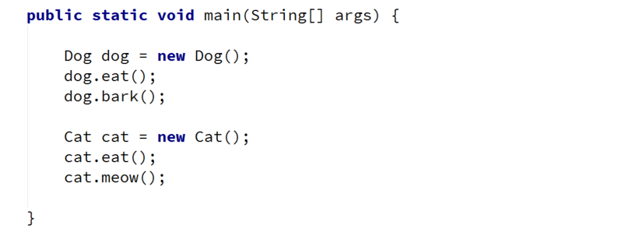
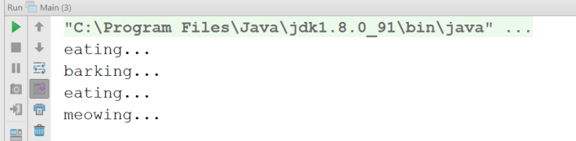

Part III: Reusing Classes

Fragile Base Class
Create three classes named Animal, Predator and Food.
Predator should inherit from Animal.
Animal:
- Protected field: foodEaten: ArrayList<Food>
- Public final method: eat(Food): void
- Public method: eatAll(Food[]): void
Predator:
- Private field: health: int
- Public method: feed(Food): void
Food:
- Just an empty class
Note: First, make eatAll() to use eat() to do its job. Do not make the eat() method final. override eat() in Predator. Now if you change the implementation of eatAll() (to no longer use eat(), you can use Collections.addAll()) you should observe a bug introduced in you program.

Random Array List
Create a RandomArrayList class that has all the functionality of an ArrayList.
Add additional function that returns and removes a random element from the list.
- Public method: getRandomElement(): Object

Hints

Stack of Strings
Create a class Stack which can store only strings and has the following functionality:
- Private field: data: ArrayList<String>
- Public method: push(String item): void
- Public method: pop(): String
- Public method: peek(): String
- Public method: isEmpty(): boolean
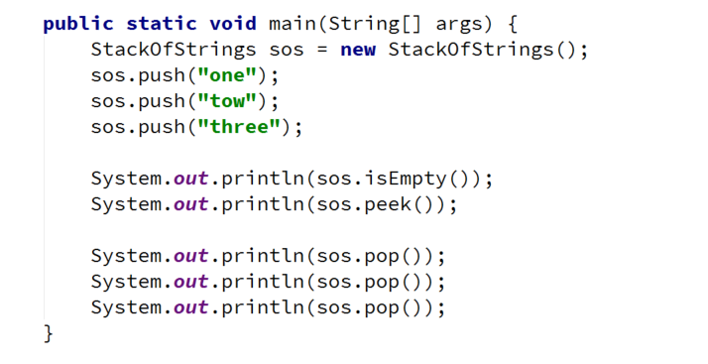

Hints
Use composition/delegation in order to have a field in which to store the stack's data

