03. Water Adventure
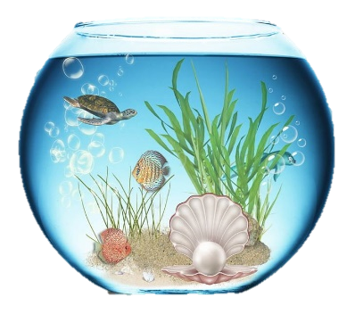
You are told that there is an aquarium near your home, which is an attraction that should not be missed, so you decide to visit it. To remember the adventure, you decide to make a report for the aquarium.

Preparation
Download the skeleton provided in Judge. Do not change the packages.
Pay attention to the name of the package, all the classes, their fields, and methods the same way they are presented in the following document. The fields you create must be the private access modifier. It is also important to keep the project structure as described above.

Problem description
Your task is to create a repository (aquarium) that stores departments by creating the classes, described below.

Fish
First, write a Java class, called Fish with fields:
- name: String
- color: String
- fins: int
The constructor of the Fish class should receive a name, color, and fins.
The class should also have the following methods:
- Getter getName()
- Getter getColor()
- Getter getFins()
- Override toString() method in the format:
"Fish: {name}
Color: {color}
Number of fins: {fins}"

Aquarium
The next step is to write an Aquarium class that has a collection of an object of type Fish with the corresponding unique name of a fish. The name of the collection should have the name fishInPool. All the entities of the fishInPool collection have the same fields. The Pool has also some additional fields:
- name: String
- capacity: int
- size: int - the volume of the pool
The constructor of the Aquarium class should receive the name, capacity, and size, also you should initialize the collection of fish with a new instance.
Implement the following features:
- Getter getName().
- Getter getCapacity().
- Getter getSize().
- Getter getFishInPool() - returns the number of fish in the current pool.
- Method add(Fish fish) - add the entity if there isn't a fish with the same name and if there is enough space for it.
- Method remove(String name) - removes a fish from the pool with the given name, if such exists, and returns a boolean if the deletion is successful.
- Method findFish(String name) - returns a fish with the given name, it doesn't exist return null.
- Method report() - returns information about the aquarium and the fish inside it in the following format:
"Aquarium: {name} ^ Size: {size}
{Fish1}
{Fish2}
…"

Constraints
- The name of each fish in the pool will always be unique.
- Each fish will have a different number of fins.
- The fins of a fish and the size of the aquarium will always be positive numbers.
- You will always be given fish added before receiving the method for its manipulation.

Examples
Sample code usage
package aquarium;
public class Main {
public static void main(String[] args) {
// Initialize Aquarium
Aquarium aquarium = new Aquarium("Ocean", 5, 15);
// Initialize Fish
Fish fish = new Fish("Goldy", "gold", 4);
// Print Fish
System.out.println(fish.toString());
//Fish: Goldy
//Color: gold
//Number of fins: 4
// Add Fish
aquarium.add(fish);

// Find Fish
aquarium.findFish("Goldy");

// Get Fish in Pool
aquarium.getFishInPool();
// Remove Fish
System.out.println(aquarium.remove("Goldy")); // true
Fish secondFish = new Fish("Dory", "blue", 2);
Fish thirdFish = new Fish("Nemo", "orange", 5);
// Add fish
aquarium.add(secondFish);
aquarium.add(thirdFish);
// Print Aquarium report
System.out.println(aquarium.report());
//Aquarium Info:
//Aquarium: Ocean ^ Size: 15
//Fish: Dory
//Color: blue
//Number of fins: 2
//Fish: Nemo
//Color: orange
//Number of fins: 5
}
}

Submission
Submit a single .zip file, containing the aquarium package, with the classes inside (Fish, Aquarium, and the Main class), there is no specific content required inside the Main class e. g. you can do any kind of local testing of your program there. However, there should be a main(String[] args) method inside.

