03. Parrots

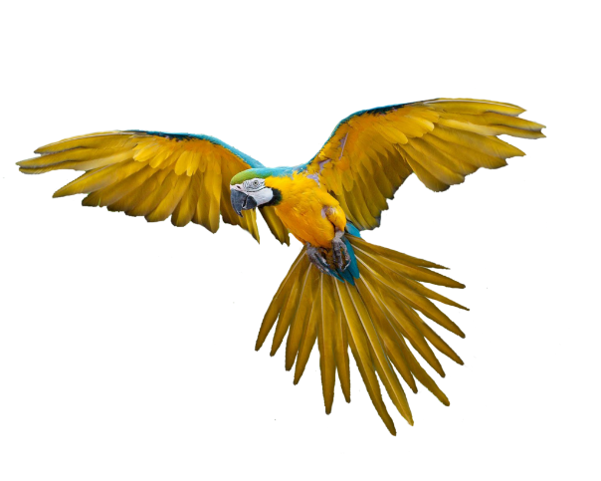

Preparation
Download the skeleton provided in Judge. Do not change the packages.
Pay attention to name the package (parrots), all the classes, their fields and methods the same way they are presented in the following document. It is also important to keep the project structure as described.

Problem description
Your task is to create a repository which stores departments by creating the classes described below.

Parrot
First, write a Java class Parrot with the following fields:
- name: String
- species: String
- available: boolean - true by default
The class constructor should receive (name, species).
The class should also have the following methods:
- getName()
- getSpecies()
- isAvailable()
- setAvailable()
- Override the toString() method in the format:
"Parrot ({species}): {name}"

Cage
Next, write a Java class Cage that has data (a collection which stores the entity Parrot). All entities inside the repository have the same fields. Also, the Cage class should have those fields:
- name: String
- capacity: int
- data: List<Parrot> that holds added parrots
The class constructor should receive (name, capacity), also it should initialize the data with a new instance of the collection.
Implement the following features:
- getName()
- getCapacity()
- add(Parrot parrot) method - adds an entity to the data if there is room for it
- remove(String name) method - removes a parrot by given name, if such exists, and returns boolean
- sellParrot(String name) method - sell (set its available property to false without removing it from the collection) the first parrot with the given name, also return the parrot
- sellParrotBySpecies(String species) method - sells and returns all parrots from that species as a List
- count() - returns the number of parrots
- report() - returns a String in the following format, including only not sold parrots:
  - "Parrots available at {cageName}:
{Parrot ₁}
{Parrot ₂}
(…)"

Constraints
- The names of the parrots will be always unique.
- You will always have a parrot added before receiving methods manipulating the Cage’s parrots.

Examples
This is an example how the Cage class is intended to be used.
Sample code usage
//Initialize the repository (Cage)
Cage cage = new Cage("Wildness", 20);
//Initialize entity
Parrot parrot = new Parrot("Fluffy", "Loriinae");
//Print Parrot
System.out.println(parrot); // Parrot (Loriinae): Fluffy

//Add Parrot
cage.add(parrot);
System.out.println(cage.count()); //1
//Remove Parrot
cage.remove("Parrot Name"); //false

Parrot secondParrot = new Parrot("Bunny", "Cacatuidae");
Parrot thirdParrot = new Parrot("Jumpy", "Strigopoidea");
Parrot fourthParrot = new Parrot("Puffy", "Strigopoidea");
Parrot fifthParrot = new Parrot("Marlin", "Arinae");

//Add Parrots
cage.add(secondParrot);
cage.add(thirdParrot);
cage.add(fourthParrot);
cage.add(fifthParrot);

//Sell Parrot by name
System.out.println(cage.sellParrot("Bunny")); //Parrot (Cacatuidae): Bunny
//Sell Parrot by species
List<Parrot> soldSpecies = cage.sellParrotBySpecies("Strigopoidea");
soldSpecies.forEach(f-> {
System.out.println(f.getName());
});
//Jumpy
//Puffy

System.out.println(cage.report());
//Parrots available at Wildness:
//Parrot (Loriinae): Fluffy
//Parrot (Arinae): Marlin

Submission
Submit single .zip file, containing parrots package, with the classes inside (Parrot, Cage and the Main class), there is no specific content required inside the Main class e. g. you can do any kind of local testing of youр program there. However, there should be main(String[] args) method inside.

