Lab: Iterators and Comparators
Problems for exercises and homework for the "Java OOP Advanced" course @ SoftUni.
You can check your solutions here: https://judge.softuni.bg/Contests/523/Iterators-and-Comparators-Lab

Book
Create a class Book from UML diagram below:
Book
- | title: String
- | year: int
- | authors: List<String>
- | setTitle(String)
- | setYear(String)
- | setAuthors(String…)
+ | getTitle(): String
+ | getYear(): int
+ | getAuthors(): List<String>
You can use only one constructor. Authors can be anonymous, one or many.

Examples
Main.java
public static void main(String[] args) {
Book bookOne = new Book("Animal Farm", 2003, "George Orwell");
Book bookThree = new Book("The Documents in the Case", 2002);
Book bookTwo = new Book("The Documents in the Case", 1930, "Dorothy Sayers", "Robert Eustace");
List<Book> books = new ArrayList<>();
books.add(bookOne);
books.add(bookTwo);
books.add(bookThree);
}

Solution
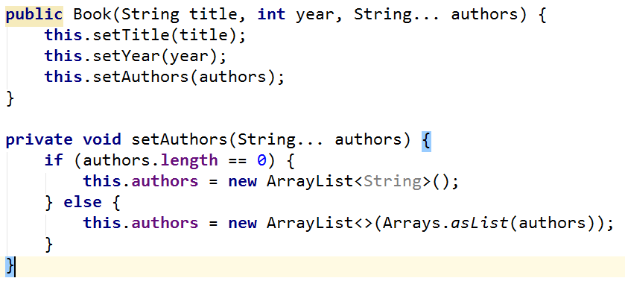

Library
Create a class Library from UML diagram below:
<<Iterable<Book>>>
Library
- | books: Book[]
+ | iterator(): Iterator<Book>
Create a nested class LibIterator from UML diagram below:
<<Iterator<Book>>>
LibIterator
- | counter: int
+ | hasNext(): boolean
+ | next(): Book

Examples
Main.java
public static void main(String[] args) {
Book bookOne = new Book("Animal Farm", 2003, "George Orwell");
Book bookThree = new Book("The Documents in the Case", 2002);
Book bookTwo = new Book("The Documents in the Case", 1930, "Dorothy Sayers", "Robert Eustace");
Library library = new Library<>(bookOne, bookTwo, bookThree);
for (Book book : library) {
System.out.println(book.getTitle());
}
}

Solution
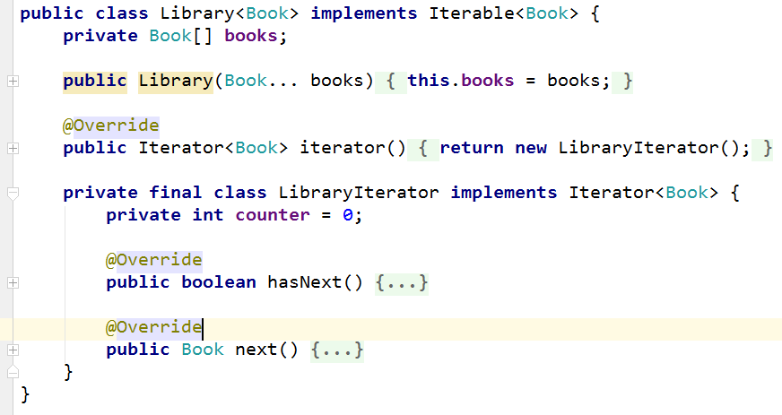

Comparable Book
Expand Book by implementing Comparable<Book>
Book have to be compared by name. When name is equal, compare them by year.
Expand Book from UML diagram below:
<<Comparable<Book>>>
Book
- | title: String
- | year: int
- | authors: List<String>
- | setTitle(String)
- | setYear(String)
- | setAuthors(String…)
+ | getTitle(): String
+ | getYear(): int
+ | getAuthors(): List<String>
+ | compareTo(Book): int
You can use only one constructor. Authors can be anonymous, one or many.

Examples
Main.java
public static void main(String[] args) {
Book bookOne = new Book("Animal Farm", 2003, "George Orwell");
Book bookThree = new Book("The Documents in the Case", 2002);
Book bookTwo = new Book("The Documents in the Case", 1930, "Dorothy Sayers", "Robert Eustace");
if (bookOne.compareTo(bookTwo) > 0) {
System.out.println(String.format("%s is before %s", bookOne, bookTwo));
} else if (bookOne.compareTo(bookTwo) < 0) {
System.out.println(String.format("%s is before %s", bookTwo, bookOne));
} else {
System.out.println("Book are equal");
}
}

Book Comparator
Create a class BookComparator from UML diagram below:
<<Comparator<Book>>>
BookComparator
+ | compare(Book, Book): int
BookComparator have to compare two books by:
- Book title
- Year of publishing a book

Examples
Main.java
public static void main(String[] args) {
Book bookOne = new Book("Animal Farm", 2003, "George Orwell");
Book bookThree = new Book("The Documents in the Case", 2002);
Book bookTwo = new Book("The Documents in the Case", 1930, "Dorothy Sayers", "Robert Eustace");
List<Book> books = new ArrayList<>();
books.add(bookOne);
books.add(bookTwo);
books.add(bookThree);
books.sort(new BookComparator());
for (Book book : books) {
System.out.println(book.getTitle() + book.getYear());
}
}

