Lab: Graphs Bellman Ford, Longest Path in DAG
This document defines the lab for the "Algorithms – Advanced (Java)" course @ Software University. Please submit your solutions (source code) to all below-described problems in Judge.

Bellman-Ford Shortes paths
You will be given a graph from the console, your task is to find the shortest path and print it as a sequence from S source vertex to D destination vertex, and then on the second line, the weight of that path, or if there is no such, in case of negative cycle print a message "Negative Cycle Detected".

Input
- The input comes from the console. First is an integer, the number of nodes, then the number of edges, after that, each edge on a new line in the following format "{source} {destination} {weight}". Then you will read two integers on a separate line, the source, and destination nodes.

Output
- Print on a single line the path found separated by spaces and on the second line the weight of that path, or if there is no path, message "Negative Cycle Detected".

Example
Input | Output
6  8  1 2 8  1 3 10  2 4 1  3 6 2  4 3 -4  4 6 -1  6 5 -2  5 3 1  1  6 | 1 2 4 3 6  7
4  4  1 2 1  2 3 -1  3 4 -1  4 1 -1  1  4 | Negative Cycle Detected

Initialize Distances
We need an array to hold the minimum distance to each node. Initially, the distance to the source node is 0, and the distance to all other nodes is set to infinity (or, in our case, the maximal value for the int type):
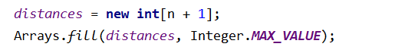
We also need to keep track of the nodes we've visited and, to reconstruct the path later, the previous node. The source node has no previous, the value for it will be -1.

Run Bellman-Ford
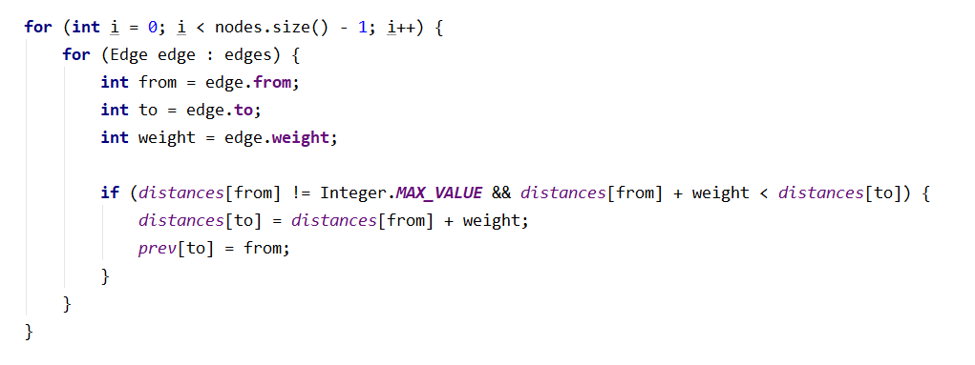

Add Handling for Negative Cycles
Simply rerun one more time the algorithm for all edges.
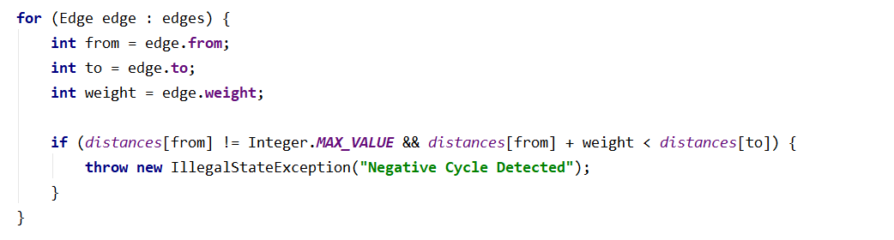

Reconstruct Shortest Path
You are familiar with this part it is indeed pretty easy.

Longest Path
You will be given a graph from the console, your task is to find the longest path to the D destination vertex and then print the weight of that path.

Input
- The input comes from the console. First is an integer the number of nodes, then the number of edges, after that, each edge on a new line in the following format "{source} {destination} {weight}". Then you will read two integers on a separate line, the source, and destination nodes.

Output
- Print on a single line the weight of that path.

Example
Input | Output
6  11  1 2 5  1 3 3  2 4 6  2 3 2  3 5 4  3 6 2  3 4 7  4 6 1  4 5 3  5 6 4  6 2 1  1  6 | 21
4  4  1 2 5  1 3 3  3 4 6  4 2 4  1  2 | 13

