Exercise: Graphs Bellman Ford, Longest Path in DAG, Dijkstra and MST
This document defines the lab for the "Algorithms – Advanced (Java)" course @ Software University. Please submit your solutions (source code) to all below-described problems in Judge.

Cable Network
A cable networking company plans to extend its existing cable network by connecting as many customers as possible within a fixed budget limit. The company has calculated the cost of building some prospective connections. You are given the existing cable network (a set of customers and connections between them) along with the estimated connection costs between some pairs of customers and prospective customers. A customer can only be connected to the network via a direct connection with an already connected customer. Example:
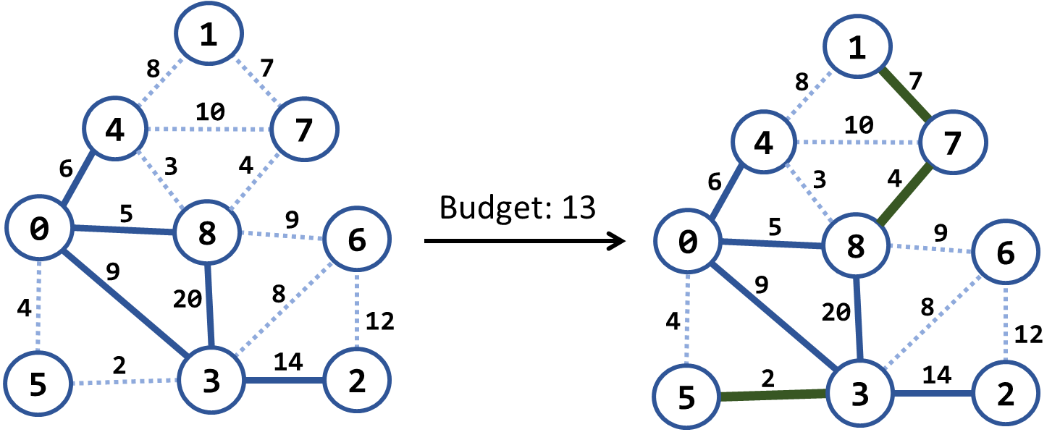
In the above example, we have an existing cable network (the solid blue lines), the estimated costs for connecting some of the customers (dotted blue lines), and a budget limit of 20. Within this budget, the company can connect 3 new customers by the following new connections (solid green lines): {3 → 5}, {8 → 7} and {7 → 1}. The total cost for those new connections will be 2 + 4 + 7 = 13, which fits in the budget limit of 20. No more customers can be connected within this budget limit. Note that each edge, at the time of its addition to the network, connects a new customer with an existing one.

Examples
Input | Picture (Before) | Output | Picture (After)
Budget: 20  Nodes: 9  Edges: 15  1 4 8  4 0 6 connected  1 7 7  4 7 10  4 8 3  7 8 4  0 8 5 connected  8 6 9  8 3 20 connected  0 5 4  0 3 9 connected  6 3 8  6 2 12  5 3 2  3 2 14 connected | 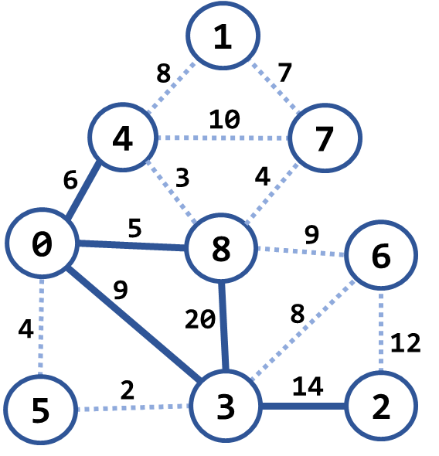 | Budget used: 13 | 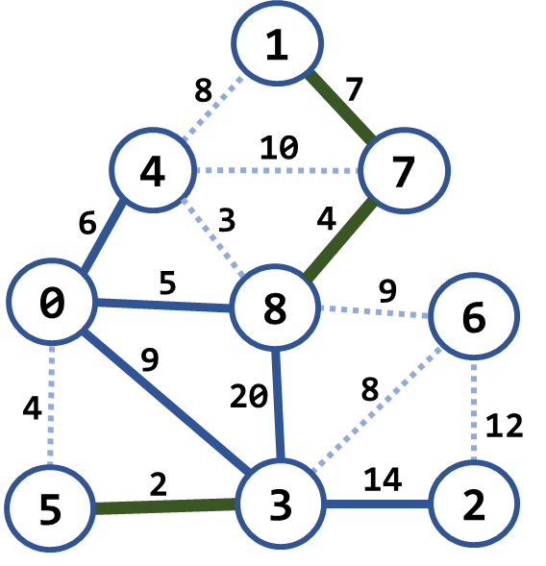
Budget: 7  Nodes: 4  Edges: 5  0 1 9  0 3 4 connected  3 1 6  3 2 11 connected  1 2 5 | 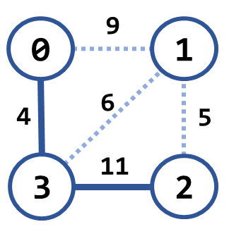 | Budget used: 5 | 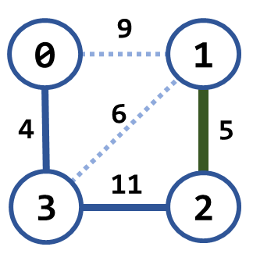
Budget: 20  Nodes: 8  Edges: 16  0 1 4  0 2 5  0 3 1 connected  1 2 8  1 3 2  2 3 3  2 4 16  2 5 9  3 4 7  3 5 14  4 5 12  4 6 22  4 7 9  5 6 6  5 7 18  6 7 15 | 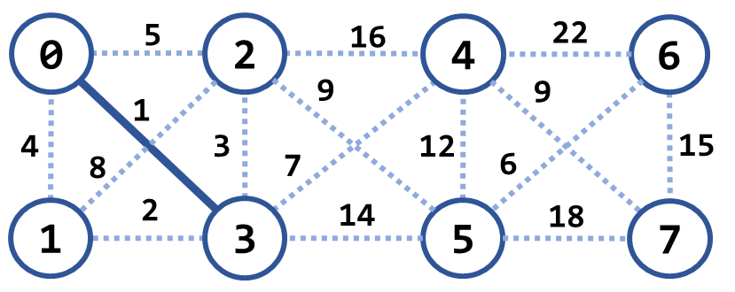 | Budget used: 12 | 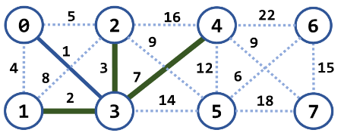

Hints
Modify Prims's algorithm. Until the budget is spent, connect the smallest possible edge from the connected node to the non-connected node.

Modified Kruskal Algorithm
Implement Kruskal's algorithm by keeping the disjoint sets in a forest where each node holds a parent + children. Thus, when two sets need to be merged, the result can be easily optimized to have two levels only: root and leaves. When two trees are merged, all nodes from the second (its root + root's children) should be attached to the first tree's root node:
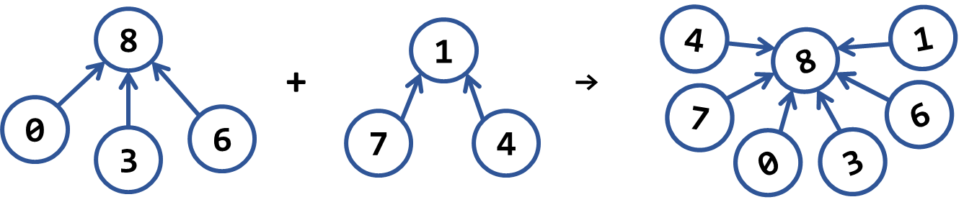

Examples
Input | Picture (Graph) | Output | Picture (MST)
Nodes: 4  Edges: 5  0 1 9  0 3 4  3 1 6  3 2 11  1 2 5 | 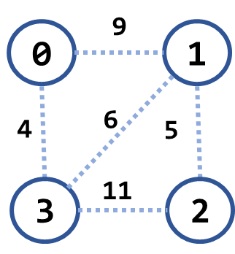 | Minimum spanning forest weight: 15  (0 3) -> 4  (1 2) -> 5  (1 3) -> 6 | 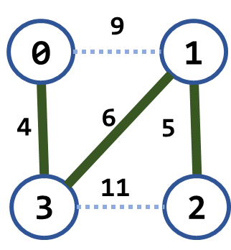
Nodes: 9  Edges: 15  1 4 8  4 0 6  1 7 7  4 7 10  4 8 3  7 8 4  0 8 5  8 6 9  8 3 20  0 5 4  0 3 9  6 3 8  6 2 12  5 3 2  3 2 14 | 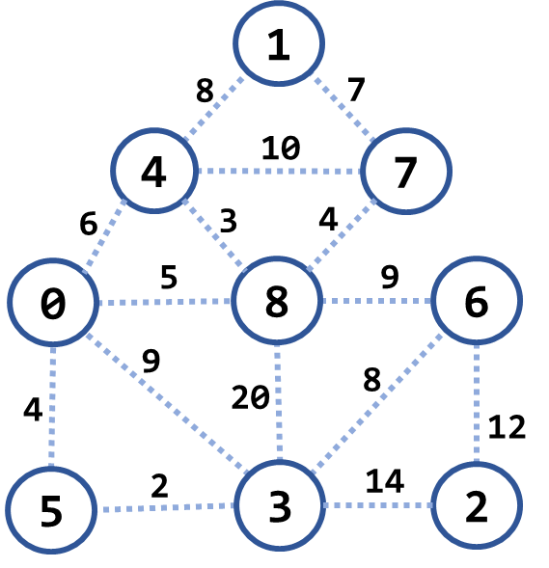 | Minimum spanning forest weight: 45  (3 5) -> 2  (4 8) -> 3  (0 5) -> 4  (8 7) -> 4  (0 8) -> 5  (1 7) -> 7  (3 6) -> 8  (6 2) -> 12 | 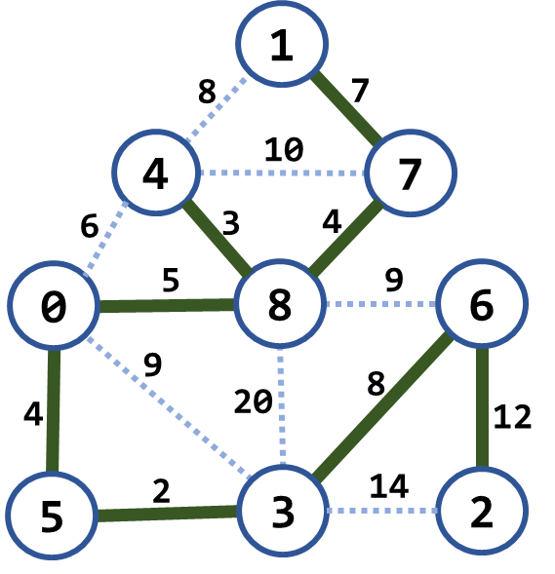
Nodes: 8  Edges: 16  0 1 4  0 2 5  0 3 1  1 2 8  1 3 2  2 3 3  2 4 16  2 5 9  3 4 7  3 5 14  4 5 12  4 6 22  4 7 9  5 6 6  5 7 18  6 7 15 | 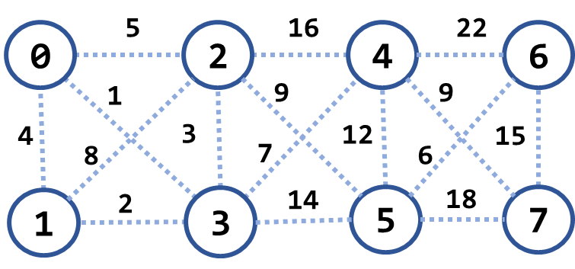 | Minimum spanning forest weight: 37  (0 3) -> 1  (1 3) -> 2  (2 3) -> 3  (5 6) -> 6  (3 4) -> 7  (2 5) -> 9  (4 7) -> 9 | 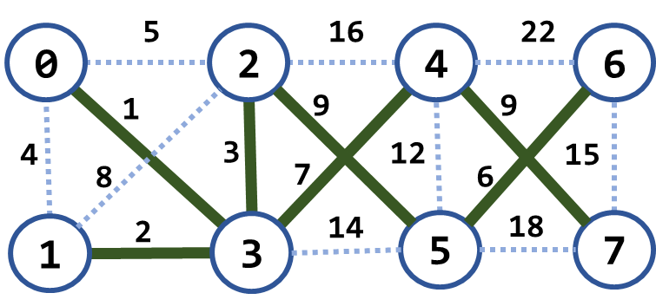

Most Reliable Path
We have a set of towns, and some of them are connected by direct paths. Each path has a coefficient of reliability (in percentage): the chance to pass without incidents. Your goal is to compute the most reliable path between two given nodes. Assume all percentages will be integer numbers and round the result to the second digit after the decimal separator. For example, let's consider the graph below:
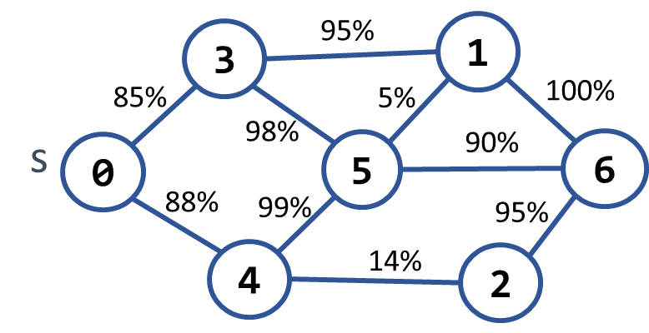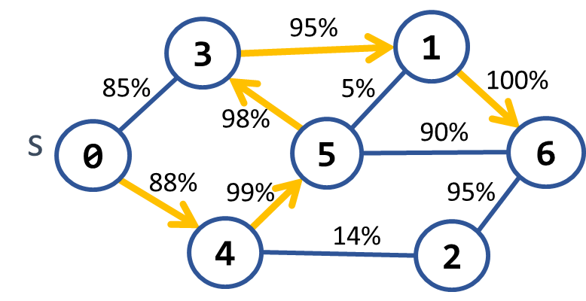
The most reliable path between 0 and 6 is shown on the right: 0 → 4 → 5 → 3 → 1 → 6. Its cost = 88% * 99% * 98% * 95% * 100% = 81.11%. The table below shows the optimal reliability coefficients for all paths starting from node 0:
v | 0 | 1 | 2 | 3 | 4 | 5 | 6
reliability[s → d] | 100% | 81.11% | 77.05% | 85.38% | 88% | 87.12% | 81.11%

Examples
Input | Output | Picture
Nodes: 7  Path: 0 – 6  Edges: 10  0 3 85  0 4 88  3 1 95  3 5 98  4 5 99  4 2 14  5 1 5  5 6 90  1 6 100  2 6 95 | Most reliable path reliability: 81.11%  0 -> 4 -> 5 -> 3 -> 1 -> 6
Nodes: 4  Path 0 – 1  Edges: 4  0 1 94  0 2 97  2 3 99  1 3 98 | Most reliable path reliability: 94.11%  0 -> 2 -> 3 -> 1 | 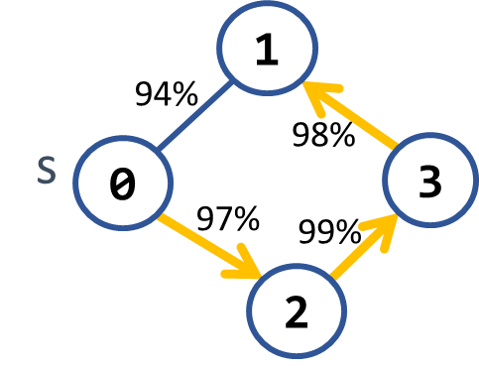

Hints
Modify Dijkstra's algorithm.

Cheap Town Tour
You now live in a new country, and you want to start a tour and visit every town in the country, and since you are new in the country, your finances are minimalized, so you want your trip to be as cheap as possible. You will be given the amount of the cities on the first line, then the amount of the roads (n), and on the next n lines, you will receive which tows the road connects and the cost to use it.
Assume you can start from any town, and your target is to visit every one of them at the minimum cost.

Input
- On the first line, you will be given the number of the towns
- On the second line, you will be given the amount of streets (n)
- On the next n lines you will be given a connection in the format: "{first} -> {second} -> {cost}"

Output
- Print the total cost of the road you have chosen in the format: "Total cost: {totalCost}"

Examples
Input | Output | Comment
4  5  0 - 1 - 10  0 - 2 - 6  0 - 3 - 5  1 - 3 - 15  2 - 3 - 4 | Total cost: 19  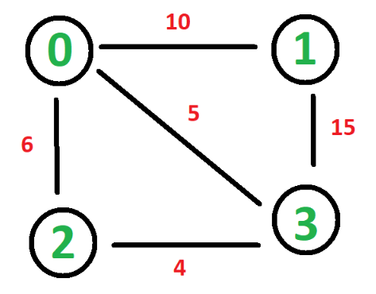 | The cheapest way to visit all the towns is using the roads with cost:  4 + 5 + 10 = 19

Undefined
You will be given a graph from the console. Your task is to find the shortest path and print it as a sequence from S source vertex to D destination vertex and then on the second line, the weight of that path, be careful there might be negative cycles if there are printed "Undefined".

Input
- The input comes from the console. First is an integer, the number of nodes, then the number of edges. After that each edge on a new line in the following format "{source} {destination} {weight}". Then you will read two integers on a separate line, the source, and destination nodes.

Output
- Print on a single line the path found separated by spaces and on the second line the weight of that path, or if there is no path, message "Negative Cycle Detected".

Example
Input | Output
5  8  1 2 -1  1 3 4  2 3 3  2 4 2  2 5 2  4 2 1  4 3 5  5 4 -3  1  4 | 1 2 5 4  -2
5  8  1 2 -1  1 3 4  2 3 3  2 4 2  2 5 2  4 2 -1  4 3 5  5 4 -3  1  4 | Undefined

Big Trip
You will be given a trip description from the console. Your task is to find the longest trip possible and print how much time it will cost. After that, print the path itself on a single line separated by spaces.

Input
- The input comes from the console. First is an integer, the number of nodes, then the number of edges. After that each edge on a new line in the following format "{source} {destination} {weight}". Then you will read two integers on a separate line, the source, and destination nodes.

Output
- Print on the first line the weight of that path.
- On the second line the path.

Example
Input | Output
6  10  1 2 3  1 5 5  2 4 4  2 3 7  2 6 2  3 4 -1  3 6 2  5 3 6  5 2 2  4 6 -2  1  3 | 14  1 5 2 3
6  10  1 2 3  1 5 5  2 4 4  2 3 -7  2 6 2  3 4 -1  3 6 2  5 3 6  5 2 2  4 6 -2  1  3 | 11  1 5 3

