Lab: Graphs Strongly Connected Components, Max Flow
This document defines the lab for the "Algorithms – Advanced (Java)" course @ Software University. Please submit your solutions (source code) to all below-described problems in Judge.

Strongly Connected Components (SCC) – Kosaraju- Sharir Algorithm
A strongly connected component is any subgraph in a graph that fulfills the prerequisite that for any two vertices u and v in the subgraph, there exists a path from u to v.
For example, you want to check if all towns on a map are reachable using the current road network. The towns are represented as vertexes, and the roads are represented as edges. To find the groups in which all towns can reach one another, we need an algorithm for finding Strongly Connected Components (SCC).
We can use the Kosaraju-Sharir algorithm.

Example
Graph | Output
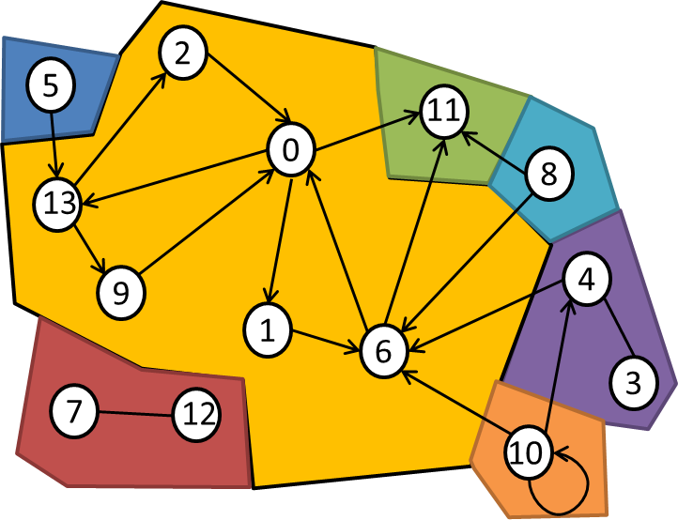 | Strongly Connected Components:  {5}  {8}  {10}  {11}  {3, 4}  {7, 12}  {0, 1, 2, 6, 9, 13}

Run the Unit Tests
Run the unit tests in the StronglyConnectedComponents.Tests project. Since we haven't written the algorithm yet, so they should all fail.

Start with a Hardcoded Example
In the StronglyConnectedComponentsTest class, you're provided with a test case – a graph with 14 nodes represented as an adjacency list. Your task is to complete the findStronglyConnectedComponents() method in the StronglyConnectedComponents class, which receives the graph and returns the strongly connected components as a List<List<Integer>>, where each inner list represents a strongly connected component (scc).
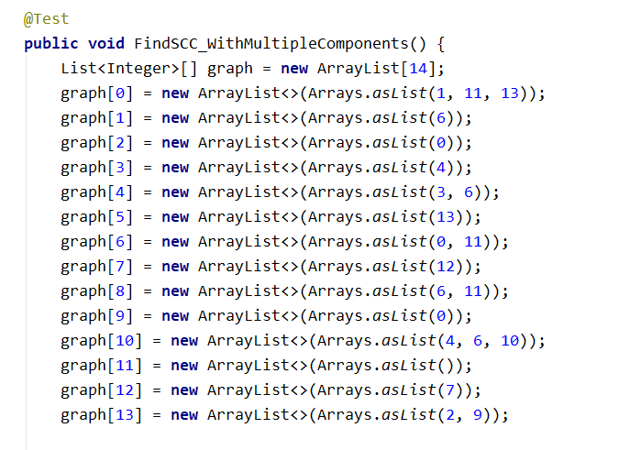
This is how this graph looks like:
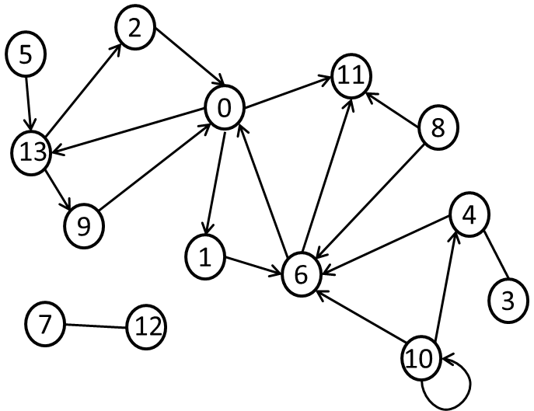

Initialize Variables
We should store the passed in a graph and initialize the collection that will keep the results.
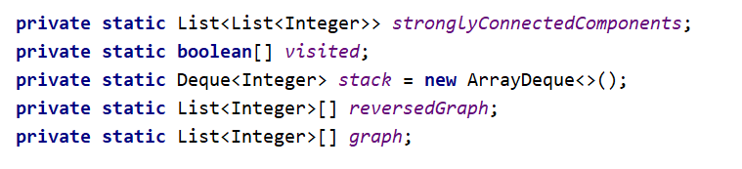

DFS
The Kosaraju-Sharir algorithm works by first finding all components of the graph. This can be done by using DFS, each time a DFS finishes, all visited elements represent a connected component. For every component, we also want the order in which we visited the vertexes, we can store this information by using a Stack, every time the DFS returns from a vertex (all its children have been visited), we add the vertex to the Stack. Since the first vertex that will be added to the Stack is the deepest one, when we're finished on top of the Stack will be the vertex we started from.
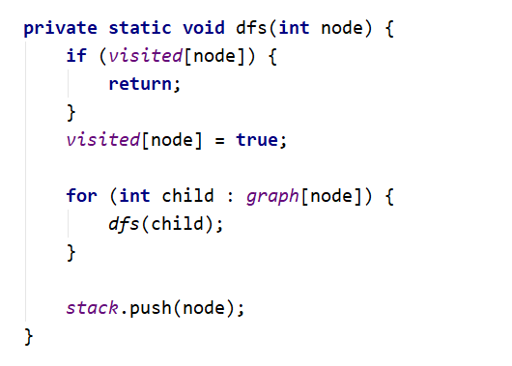

Build Reverse Graph
After knowing all connected components we have all connected components, we need to build the reverse graph. Building it is not hard we loop through the adjacency list, and for each connection u -> v, we instead add a connection v -> u in the reversed graph:
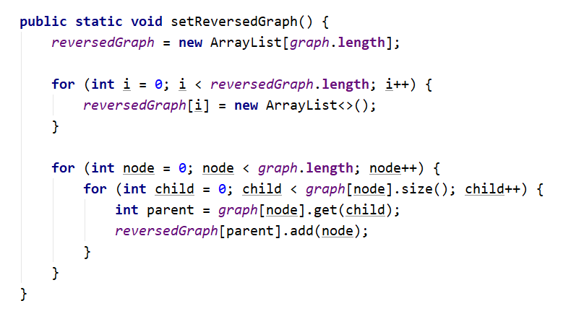

Reverse DFS
After we have the reversed graph, we can find the strongly connected components.
The conjecture is the following, if a vertex is part of an SCC (strongly connected component), then there is a path from that vertex to any other in the SCC and from any other in the SCC to that vertex, if that is true then reversing the edges should not change this (if there is a path from u -> v and from v -> u, then reversing the edges would mean there is a path from v -> u and u -> v).
Starting from the top of the Stack, we pop an element and start a DFS in the reversed graph.
Every time the ReverseDFS function finishes, all nodes we visited represent a strongly connected component.
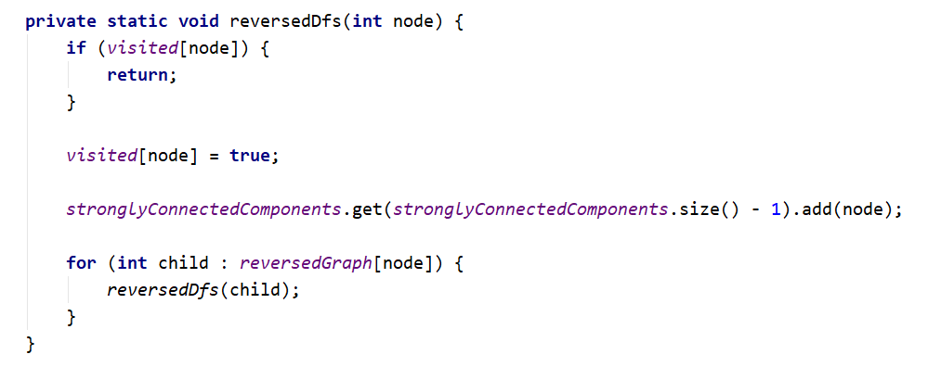
And this is the result visually:

Run the Unit Tests Again
This time all tests should pass.
You've successfully implemented the Kosaraju-Sharir algorithm!

Articulation Points
Sometimes we need to find articulation points (cut vertices) in a certain network – points that will split the graph into separated components when removed.
In situations such as networks for ISPs (Internet Service Providers), electricity, or water, it is very important to have redundancy in the networks. If between every vertex u and vertex v in a network, there existed at least 2 different paths (paths that have no vertexes in common aside from the beginning and the end vertex), such a network would be called biconnected. However, if there existed some point x (different from u and v) which is always a part of any path between u and v, such a point would be an articulation point.
Let's implement the Hopcroft-Tarjan algorithm for finding the articulation points in the following graph:
Graph | Output
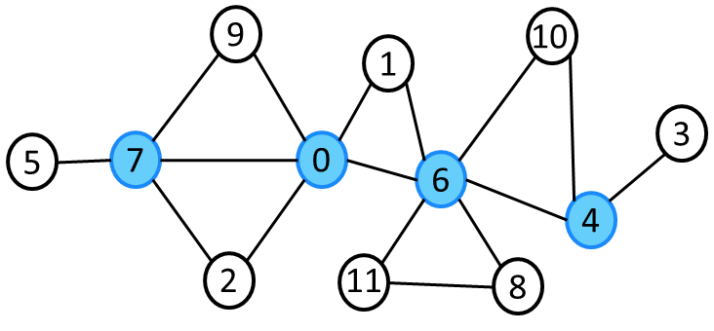 | Articulation points: 4, 6, 7, 0

Run the Unit Tests to Make Sure They Initially Fail
The algorithm is still not implemented, so all unit tests should fail.

Initialize Variables
First, we'll initialize the collections we need, we'll need something to store the graph we'll work with, and we can also initialize a collection to keep the articulation points. We'll also need collections to hold the depths, low points, and the parents of the vertices and a collection to keep visited vertices:
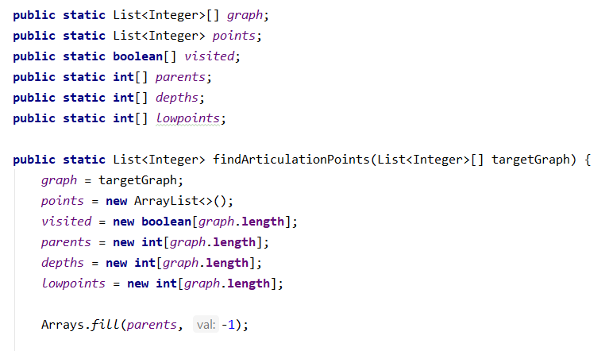

Create the Main Recursive Function
Our algorithm works based on DFS. We need to create the recursive function, as parameters, we'll pass the index of the starting node and the starting depth.
At the beginning of the function, we'll mark the current node as visited and initialize its depth and low point to the depth parameter.
Locally in the stack frame, we'll also keep track of the number of children of the vertex, and to simplify our checks, we'll also use a variable to keep track of the current point, an articulation point.
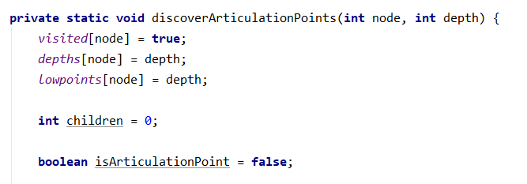

Implement the Main Loop
As we mentioned, the algorithm is based on DFS, so we'll implement the main loop in a DFS where we traverse all children of a vertex. If a child isn't already visited, we mark its parent as the current vertex and recursively call the function for the child with an increased depth.
After returning from the recursion, we increment the child count and compare the low point of the child compared to the depth of the current vertex. If the child's low point is equal to or bigger than the current depth, we know it hasn't found a different path to a previous node, so the current vertex must be an articulation point. After the check, we set the low point for the current vertex to be the smaller between itself and the child's low point.
In case the child was visited but is not our direct parent (so we avoid the situation where we go to a child and check back to where we came from), we set the low point of the current vertex to be the smaller of itself and the depth of the visited child.
After we have visited all children of a vertex, we can conclude whether it's an articulation point or not. If the current vertex is the starting vertex and it has at least 2 children (each in a different component), it's an articulation point, alternatively, if it's not the starting node and the isArticulation Boolean is true, it's also an articulation point.
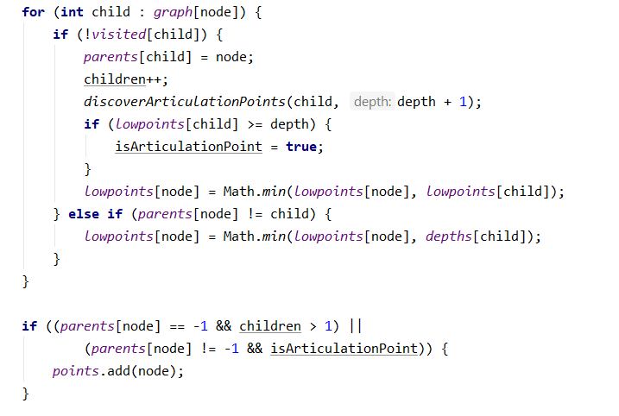

Run the Unit Tests Again
The unit test should now pass if you've completed all tasks correctly.
Congratulations! You have completed the Hopcroft-Tarjan algorithm for finding articulation points!

Max Flow algorithm - Edmonds-Karp
Max flow algorithms are important because many problems can be modified and then represented as a max flow problem. In this problem, we'll try to implement one such Max flow algorithm – the Edmonds-Karp algorithm.
Example
Find the maximum flow possible in the network starting from node 0 and ending in node 5
Graph | Output
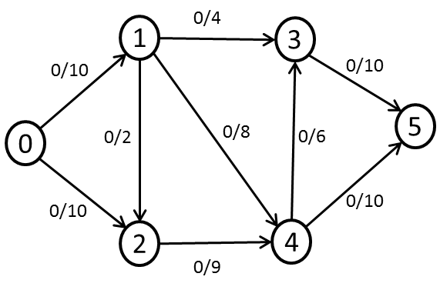 | Max flow = 19

Provided Assets
The graph is given as an adjacency matrix where the rows and the columns are the vertexes, and the cells represent the capacity of the edge. For example, cell [2, 4] with a value of 50 would mean that there is an edge from node 2 to node 4 with a capacity of 50, if a cell's value is 0 then there is no edge between the nodes.

Run the Unit Tests to Make Sure They Initially Fail
Run the Unit Tests to Make Sure They Initially Fail
The algorithm is still not implemented, so all unit tests should fail.

Initialize Variables
Max flow algorithms rely on finding a path from the start vertex (source) to the end vertex (sink). Such a path is called an augmenting path, after finding such a path, we usually have to trace it back to the start, so we need to keep a collection to see where we came from. We'll create an array for keeping track of the parents of vertexes, to know if we have set a parent for a vertex or not we'll initialize the parent's array with starting value -1:
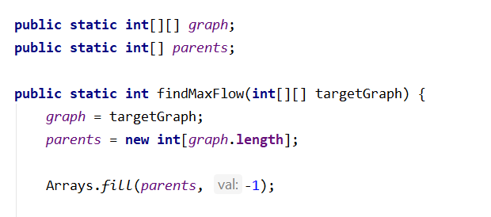

Find Augmenting Paths
The key point in Max flow algorithms is finding an augmenting path, the Edmonds-Karp algorithm is an implementation of the Ford-Fulkerson algorithm where we find the augmenting path using BFS:
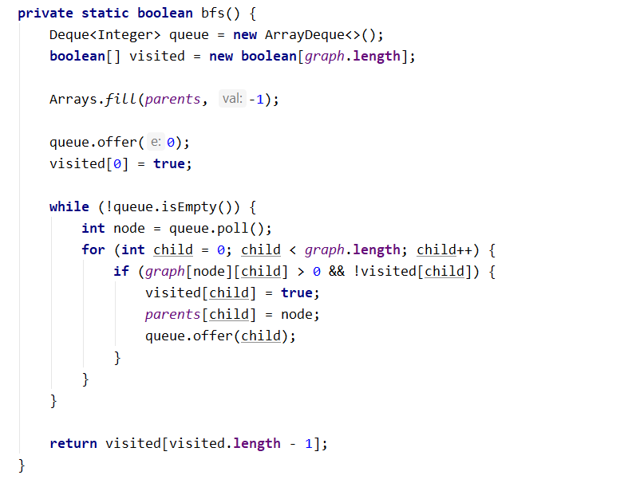

Reconstruct Path
While the BFS algorithm keeps finding augmenting paths, we'll traverse the path starting from the end/sink back while keeping track of the smallest edge capacity we've passed. We keep track of the smallest capacity in our path because the most amount of flow we can pass through the path is at most the amount we can pass through the smallest edge.
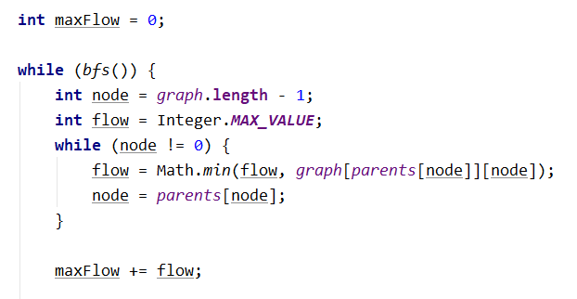

Modify the Graph
After finding the most flow we can have through the augmenting path, we add it to the max flow, and then we modify the graph to mark that we have filled the found augmenting path. We subtract from each edge in the augmenting path's capacity the amount of flow we've run through the path and increase the capacity of the reverse edges with the same amount:
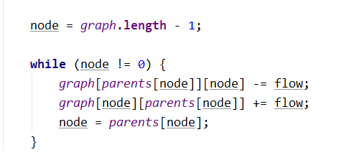
With this, we should be done the only thing left is to return the max flow.

Run the Unit Tests Again
If you've completed all tasks correctly, the unit test should now pass.
Congratulations! You've implemented the Edmonds-Karp algorithm!

