Exercise: Graphs Bellman-Ford, Longest Path in DAG, Dijkstra, and MST
This document defines the lab for the "Algorithms – Advanced (C#)" course @ Software University.
Please submit your solutions (source code) to all below-described problems in Judge.

Most Reliable Path
We have a set of towns, and some of them are connected by direct paths. Each path has a coefficient of reliability (in percentage): the chance to pass without incidents.
Your goal is to compute the most reliable path between two given nodes. Assume all percentages will be integer numbers and round the result to the second digit after the decimal separator. For example, let's consider the graph below:
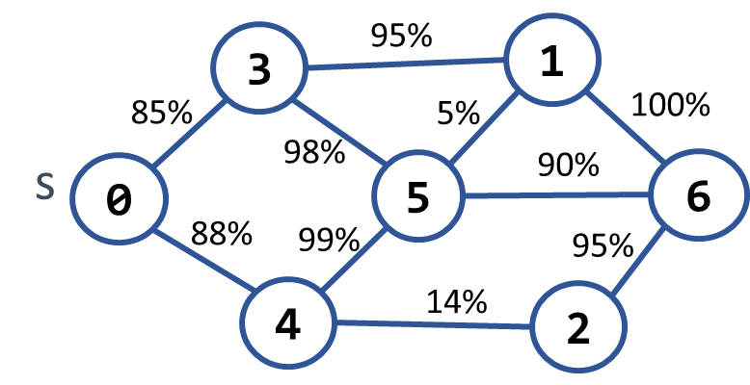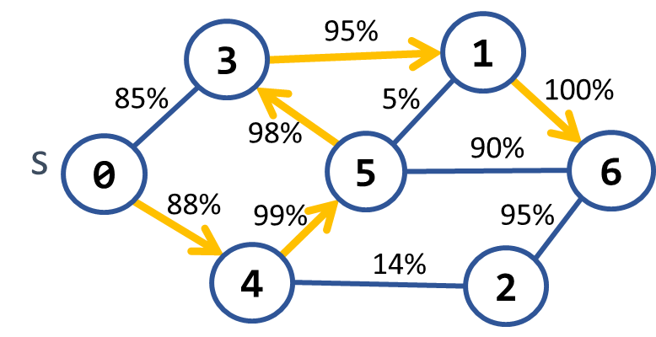
The most reliable path between 0 and 6 is shown on the right: 0 → 4 → 5 → 3 → 1 → 6. Its cost = 88% * 99% * 98% * 95% * 100% = 81.11%. The table below shows the optimal reliability coefficients for all paths starting from node 0:

v | 0 | 1 | 2 | 3 | 4 | 5 | 6
reliability[s → d] | 100% | 81.11% | 77.05% | 85.38% | 88% | 87.12% | 81.11%

Input
- On the first line, you will receive an integer – n – number of nodes.
- On the second line, you will receive an integer – e – number of edges.
- On the next e lines, you will receive edges in the following format: "{first} {second} {weight}".
- On the next line, you will receive an integer – source – starting of the path.
- On the last line, you will receive an integer – destination – end of the path.

Output
- First print " Most reliable path reliability: {reliability}%" on the console.
  - reliability should be formatted to the 2nd digit after the decimal point.
- Print the most reliable path in the following format: "{sourceNode} -> {node1} -> … -> {destination"}".

Examples
Input | Output | Picture
7  10  0 3 85  0 4 88  3 1 95  3 5 98  4 5 99  4 2 14  5 1 5  5 6 90  1 6 100  2 6 95  0  6 | Most reliable path reliability: 81.11%  0 -> 4 -> 5 -> 3 -> 1 -> 6
4  4  0 1 94  0 2 97  2 3 99  1 3 98  0  1 | Most reliable path reliability: 94.11%  0 -> 2 -> 3 -> 1 | 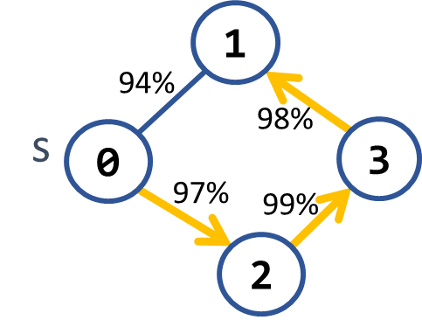

Hints
Modify Dijkstra's algorithm.

Cheap Town Tour
You now live in a new country, and you want to start a tour and visit every town in the country, and since you are new in the country, your finances are minimalized, so you want your trip to be as cheap as possible.
You will be given the amount of the cities on the first line, then the amount of the roads (n), and on the next n lines, you will receive which tows the road connects and the cost to use it.
Assume you can start from any town, and your target is to visit every one of them at the minimum cost.

Input
- On the first line, you will be given the number of the towns.
- On the second line, you will be given the number of streets (n).
- On the next n lines, you will be given a connection in the format: "{first} -> {second} -> {cost}"

Output
- Print the total cost of the road you have chosen in the format: "Total cost: {totalCost}"

Examples
Input | Output | Comment
4  5  0 - 1 - 10  0 - 2 - 6  0 - 3 - 5  1 - 3 - 15  2 - 3 - 4 | Total cost: 19 | 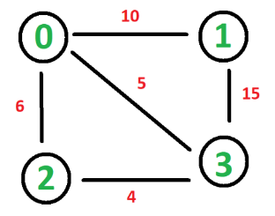  The cheapest way to visit all the towns is using the roads with a cost:  4 + 5 + 10 = 19

Undefined
Your task is to find the shortest path in a graph from S vertex to D vertex. However, edges might have negative weights, so you should be cautious of negative cycles.

Input
- On the first line, you will receive an integer – n – number of nodes.
- On the second line, you will receive an integer – e – number of edges.
- On the next e lines, you will receive edges in the following format: "{source} {destination} {weight}".
- On the next line, you will receive an integer – source – the start of the path.
- On the last line, you will receive an integer – destination – end of the path.

Output
- If there is a negative cycle, you should print "Undefined".
- Otherwise, first, print on a single line the path, and after that, print the path weight.

Example
Input | Output
5  8  1 2 -1  1 3 4  2 3 3  2 4 2  2 5 2  4 2 1  4 3 5  5 4 -3  1  4 | 1 2 5 4  -2
5  8  1 2 -1  1 3 4  2 3 3  2 4 2  2 5 2  4 2 -1  4 3 5  5 4 -3  1  4 | Undefined

Big Trip
Your task is to find how much time it will cost for the longest trip possible from the source vertex to the destination vertex.

Input
- On the first line, you will receive an integer – n – number of nodes.
- On the second line, you will receive an integer – e – number of edges.
- On the next e lines, you will receive edges in the following format: "{source} {destination} {time}".
- On the next line, you will receive an integer – source – the start of the path.
- On the last line, you will receive an integer – destination – end of the path.

Output
- First, print on a single line the path, and after that, print the path weight.

Example
Input | Output
6  10  1 2 3  1 5 5  2 4 4  2 3 7  2 6 2  3 4 -1  3 6 2  5 3 6  5 2 2  4 6 -2  1  3 | 14  1 5 2 3
6  10  1 2 3  1 5 5  2 4 4  2 3 -7  2 6 2  3 4 -1  3 6 2  5 3 6  5 2 2  4 6 -2  1  3 | 11  1 5 3

Cable Network
A cable networking company plans to extend its existing cable network by connecting as many customers as possible within a fixed budget limit. The company has calculated the cost of building some prospective connections.
You are given the existing cable network (a set of customers and connections between them) along with the estimated connection costs between some pairs of customers and prospective customers. A customer can only be connected to the network via a direct connection with an already connected customer.
Example:
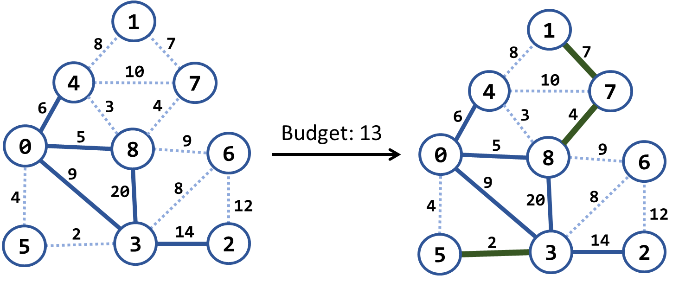
In the above example, we have an existing cable network (the solid blue lines), the estimated costs for connecting some customers (dotted blue lines), and a budget limit of 20.
Within this budget, the company can connect 3 new customers by the following new connections (solid green lines): {3 → 5}, {8 → 7} and {7 → 1}. The total cost for those new connections will be 2 + 4 + 7 = 13, which fits within the budget limit of 20. No more customers can be connected within this budget limit.
NOTE that each edge, at the time of its addition to the network, connects a new customer with an existing one.

Input
- On the first line, you will receive an integer – budget.
- On the second line, you will receive an integer – n – number of nodes.
- On the third line, you will receive an integer – e – number of edges.
- On the next e lines, you will receive edges in the following format: "{start} {end} {weight} {connected}".

Output
- Print "Budget used: {usedBudget}" on the console.

Examples
Input | Picture (Before) | Output | Picture (After)
20  9  15  1 4 8  4 0 6 connected  1 7 7  4 7 10  4 8 3  7 8 4  0 8 5 connected  8 6 9  8 3 20 connected  0 5 4  0 3 9 connected  6 3 8  6 2 12  5 3 2  3 2 14 connected | 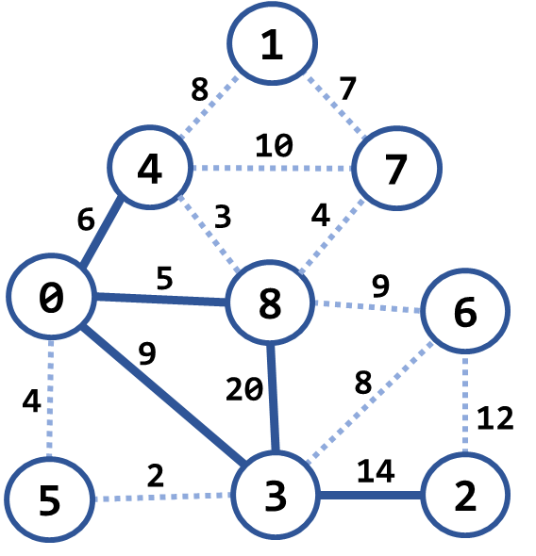 | Budget used: 13 | 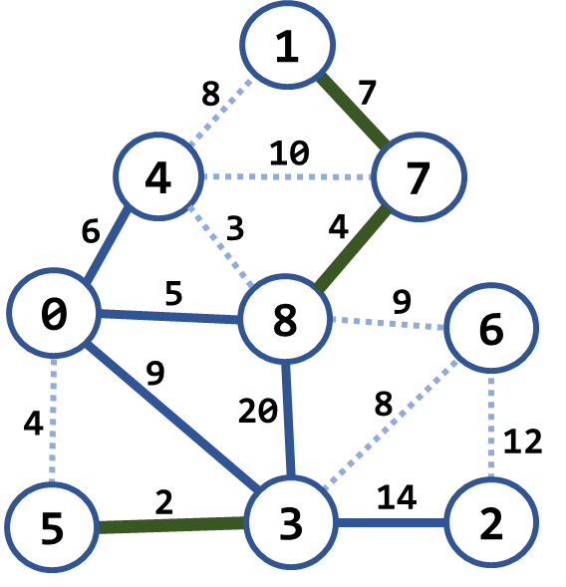
7  4  5  0 1 9  0 3 4 connected  3 1 6  3 2 11 connected  1 2 5 | 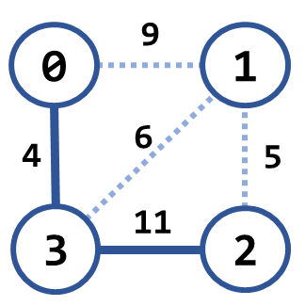 | Budget used: 5 | 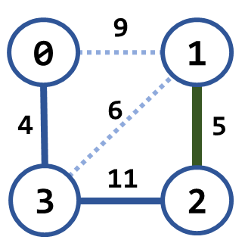
20  8  16  0 1 4  0 2 5  0 3 1 connected  1 2 8  1 3 2  2 3 3  2 4 16  2 5 9  3 4 7  3 5 14  4 5 12  4 6 22  4 7 9  5 6 6  5 7 18  6 7 15 | 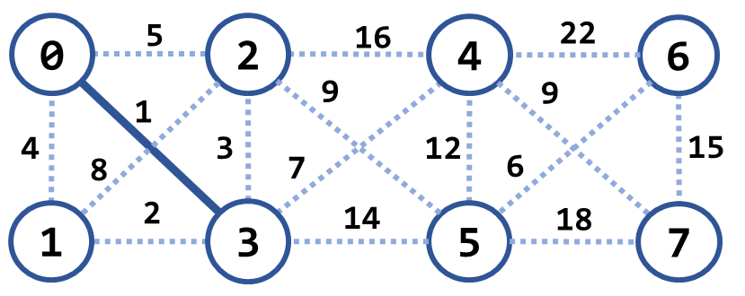 | Budget used: 12 | 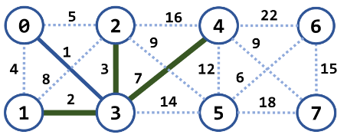

Hints
Modify Prims's algorithm. Until the budget is spent, connect the smallest possible edge from the connected node to the non-connected node.

