Lab: Nested Loops
Problems for in-class and homework exercises for the course "Programming Basics" @ SoftUni.
Test your solutions in the Judge system: https://judge.softuni.org/Contests/3497/Nested-Loops-Lab-PS

Clock
Write a function that prints the hours of the day from 0:0 to 23:59, each on a separate line. The hours must be printed in the format "{hours}:{minutes}".

Sample Input and Output
Input | Output
(no input) | 0:0  0:1  0:2  0:3  0:4  0:5  0:6  0:7  0:8  0:9  0:10  ...  23:50  23:51  23:52  23:53  23:54  23:55  23:56  23:57  23:58  23:59

Hints and Guidelines
- Create 2 nested for loops to iterate through every minute and hour of the day:
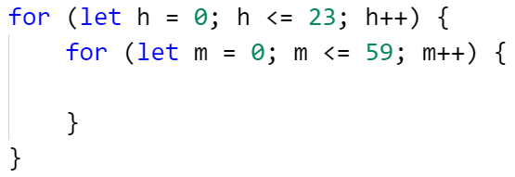
- Print the result:
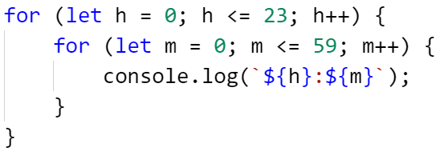

Testing in the Judge System
Test the solution to this problem here: https://judge.softuni.org/Contests/Compete/Index/3497#0

Multiplication Table
Print on the console the multiplication table for the numbers 1 to 10 in the format
"{first multiplier} * {second multiplier} = {result}".

Sample Input and Output
Input | Output
(no input) | 1 * 1 = 1  1 * 2 = 2  1 * 3 = 3  1 * 4 = 4  1 * 5 = 5  1 * 6 = 6  1 * 7 = 7  1 * 8 = 8  1 * 9 = 9  1 * 10 = 10  ...  10 * 1 = 10  10 * 2 = 20  10 * 3 = 30  10 * 4 = 40  10 * 5 = 50  10 * 6 = 60  10 * 7 = 70  10 * 8 = 80  10 * 9 = 90  10 * 10 = 100

Hints and Guidelines
- Create 2 nested for loops to iterate over each possible value of the two multipliers from 1 to 10:
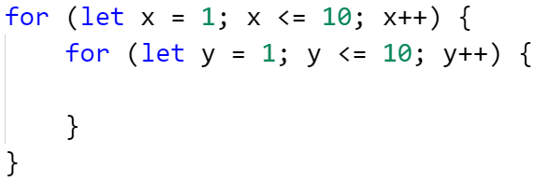
- Find the product of the two multipliers and print the result:
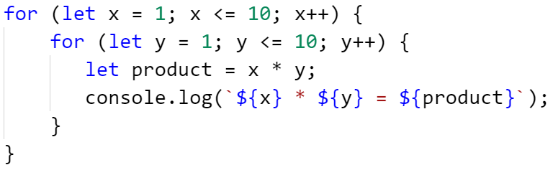

Testing in the Judge System
Test the solution to this problem here: https://judge.softuni.org/Contests/Compete/Index/3497#1

Combinations
Write a function solve(n) that calculates how many solutions in natural numbers (including zero) have the equation:
x1 + x2 + x3 = n
The number n is an integer and is entered from the console.

Sample Input and Output
Input | Output | Comments | Input | Output | Input | Output
solve(25) | 351 | We generate all combinations of 3 numbers, the first being:  0+0+0=0, but since it is not equal to 25, we continue:  0+0+1=1 – also not 25, etc.  We come to the first valid combination:  0 + 0 + 25 = 25, we increase the number of valid combinations by 1, the second valid combination is:  0 + 1 + 24 = 25  The third:  0 + 2 + 23 = 25, etc.  After generating all possible combinations, the number of valid ones is 351. | solve(20) | 231 | solve(5) | 21

Hints and Guidelines:

- Create 3 nested for loops to iterate every possible value of one of the 3 numbers in the equation:
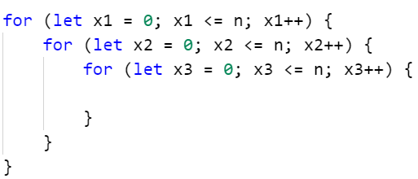

- Check the innermost nested loop for the values of x1, x2, and x3 in each iteration. For the equation to be valid, its sum must be equal to n. Create a validCombinationsCount variable to store the number of valid combinations and add to it each time you generate one:
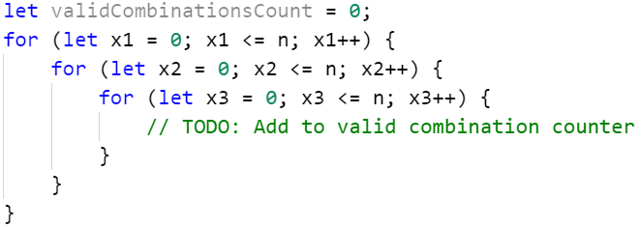

- Finally, print the number of valid combinations (validCombinationsCount).

Testing in the Judge System
Test the solution to this problem here: https://judge.softuni.org/Contests/Compete/Index/3497#2

Sum of Two Numbers
Write a function solve(beginning, ending, magicNumber) that checks all possible combinations of a pair of numbers in the interval of two given numbers.
The output prints which in order is the first combination whose sum of the numbers equals a given magic number.
If there is no combination matching the condition, a message is printed that none was found.

Input Data
The function accepts 3 arguments:
- The first - beginning of the interval - an integer in the range [1...999]
- The second - end of the interval - an integer in the range [greater than the first one...1000]
- The third - a magic number - an integer in the range [1...10000]

Output Data
One line is printed on the console:
- At the first combination found whose sum of numbers equals the magic number:
  - "Combination N:{sequence number} ({first number} + {second number} = {magic number})"
- If no combination matching the condition is found:
  - "{number of all combinations} combinations - neither equals {magic number}"

Sample Input and Output
Input | Output | Comments | Input | Output
solve(1,10,  5) | Combination N:4 (1 + 4 = 5) | All combinations of two numbers between 1 and 10 are:  1 1, 1 2, 1 3, 1 4, 1 5, ... 2 1, 2 2, ... 4 9, 4 10, 5 1 ... 10 9, 10 10  The first combination whose sum of numbers is equal to the magic number 5 is the fourth (1 and 4) | solve(88,  888,  1000) | Combination N:20025 (112 + 888 = 1000)
Input | Output | Comments | Input | Output
solve(23,  24,  20) | 4 combinations - neither equals 20 | All combinations of two numbers between 23 and 24 are: 23 23, 23 24, 24 23, 24 24 (total 4)  There are no pairs of numbers whose sum is equal to the magic 20 | solve(88,  888,  2000) | 641601 combinations - neither equals 2000

Testing in the Judge System
Test the solution to this problem here: https://judge.softuni.org/Contests/Compete/Index/3497#3

Traveling
Annie loves to travel and wants to visit several different destinations this year. When she chooses a destination, she will decide how much money she will need to get there and start saving. When she has saved enough, she will be able to travel.
The function receives an array, each time reading the first destination and the minimum budget that will be needed for the trip.
Then you will read a few sums that Annie saves by working and when she manages to save enough for the trip, she will leave, and it should be printed on the console:
"Going to {destination}!"
When she has visited all the destinations she wants, instead of a destination she will enter "End" and the program will end.

Sample Input and Output
Input | Output | Input | Output
solve(["Greece",  1000,  200,  200,  300,  100,  150,  240,  "Spain",  1200,  300,  500,  193,  423,  "End"]) | Going to Greece!  Going to Spain! | solve(["France",  2000,  300,  300,  200,  400,  190,  258,  360,  "Portugal",  1450,  400,  400,  200,  300,  300,  "Egypt",  1900,  1000,  280,  300,  500,  "End"]) | Going to France!  Going to Portugal!  Going to Egypt!

Testing in the Judge System
Test the solution to this problem here: https://judge.softuni.org/Contests/Compete/Index/3497#4

Building
Write a function that outputs on the console the room numbers in a building (in descending order) when the following conditions are met:
- On each even floor, there are only offices
- On each odd floor, there are only apartments
- Each apartment is marked as follows: A{floor number}{apartment number}, apartment numbers start from 0
- Each office is marked as follows: O{floor number}{office number}, office numbers also start from 0
- There are always apartments on the top floor, and they are bigger than the others, that is why they have 'L' instead of 'A' in front of their number. If there is only one floor, there are only big apartments!
The function solve(floors, rooms) accepts – the number of floors and the number of rooms per floor.

Sample Input and Output
Input | Output | Comments
solve(6, 4) | L60 L61 L62 L63  A50 A51 A52 A53  O40 O41 O42 O43  A30 A31 A32 A33  O20 O21 O22 O23  A10 A11 A12 A13 | We have a total of 6 floors, with 4 rooms per floor. The odd floors have only apartments, and even floors have only offices.
Input | Output | Input | Output
solve(9, 5) | L90 L91 L92 L93 L94  O80 O81 O82 O83 O84  A70 A71 A72 A73 A74  O60 O61 O62 O63 O64  A50 A51 A52 A53 A54  O40 O41 O42 O43 O44  A30 A31 A32 A33 A34  O20 O21 O22 O23 O24  A10 A11 A12 A13 A14 | solve(4, 4) | L40 L41 L42 L43  A30 A31 A32 A33  O20 O21 O22 O23  A10 A11 A12 A13

Testing in the Judge System
Test the solution to this problem here: https://judge.softuni.org/Contests/Compete/Index/3497#5

