Exercises: Table Relations
This document defines the exercise assignments for the MySQL course @ SoftUni
Submit the source code of your solutions in Judge

One-To-One Relationship

Create two tables as follows. Use appropriate data types.
people
person_id | first_name | salary | passport_id
1 | Roberto | 43300.00 | 102
2 | Tom | 56100.00 | 103
3 | Yana | 60200.00 | 101
passports
passport_id | passport_number
101 | N34FG21B
102 | K65LO4R7
103 | ZE657QP2

Insert the data from the example above.
- Alter table people and make person_id a primary key.
- Create a foreign key between people and passports by using the passport_id column.
- Think about which passport field should be UNIQUE.
- Format salary to second digit after decimal point.
Submit your queries by using "MySQL run queries & check DB" strategy.

One-To-Many Relationship
models
model_id | name | manufacturer_id
101 | X1 | 1
102 | i6 | 1
103 | Model S | 2
104 | Model X | 2
105 | Model 3 | 2
106 | Nova | 3
Create two tables as follows. Use appropriate data types.
manufacturers
manufacturer_id | name | established_on
1 | BMW | 01/03/1916
2 | Tesla | 01/01/2003

Insert the data from the example above.
- Add primary and foreign keys.
Submit your queries by using "MySQL run queries & check DB" strategy.

Many-To-Many Relationship
Create three tables as follows. Use appropriate data types.
students
student_id | name
1 | Mila
2 | Toni
3 | Ron
exams
exam_id | name
101 | Spring MVC
102 | Neo4j
103 | Oracle 11g

students_exams
student_id | exam_id
1 | 101
1 | 102
2 | 101
3 | 103
2 | 102
2 | 103

Insert the data from the example above.
- Add primary and foreign keys.
- Have in mind that the table student_exams should have a
composite primary key.
Submit your queries by using "MySQL run queries & check DB" strategy.

Self-Referencing
Create a single table as follows. Use appropriate data types.
teachers
teacher_id | name | manager_id
101 | John
102 | Maya | 106
103 | Silvia | 106
104 | Ted | 105
105 | Mark | 101
106 | Greta | 101
Insert the data from the example above.
- Add primary and foreign keys.
- The foreign key should be between manager_id and teacher_id.
Submit your queries by using " MySQL run queries & check DB" strategy.

Online Store Database
Create a new database and design the following structure:
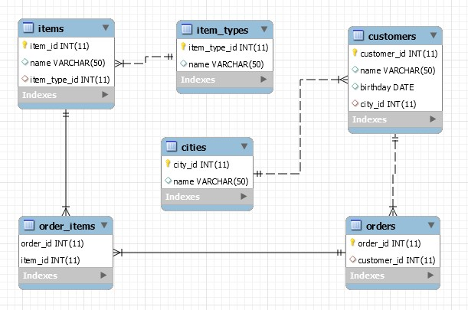
Submit your queries by using "MySQL run queries & check DB" strategy.

University Database
Create a new database and design the following structure: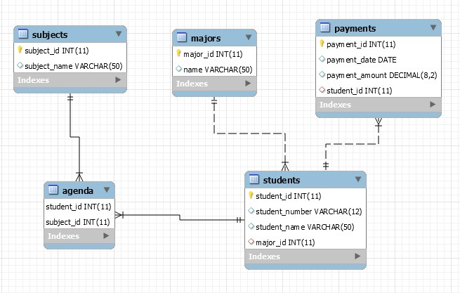

Submit your queries by using "MySQL run queries & check DB" strategy.

SoftUni Design
Create an E/R Diagram of the SoftUni Database. There are some special relations you should check out: employees are self-referenced (manager_id) and departments have One-to-One with the employees (manager_id) while the employees have One-to-Many (department_id). You might find it interesting how it looks on а diagram.

Geography Design
Create an E/R Diagram of the Geography Database.

Peaks in Rila
Display all peaks for "Rila" mountain_range. Include:
- mountain_range
- peak_name
- peak_elevation
Peaks should be sorted by peak_elevation descending.

Example
mountain_range | peak_name | peak_elevation
Rila | Musala | 2925
… | … | …
Submit your queries by using "MySQL prepare DB & run queries" strategy.

