MySQL Exam
Royal United Kingsman – Bank
Royal United Kingsman Bank or most widely known as R.U.K. Bank is a new bank founded by Darkman Nakov. You have been employed by the bank to design a database prototype, which will lay the foundation for the main database. You will need to prove your skills in database definition, data manipulation and extraction and database programmability.

Section 0: Database Overview
You have been given an Entity / Relationship Diagram of the Database:
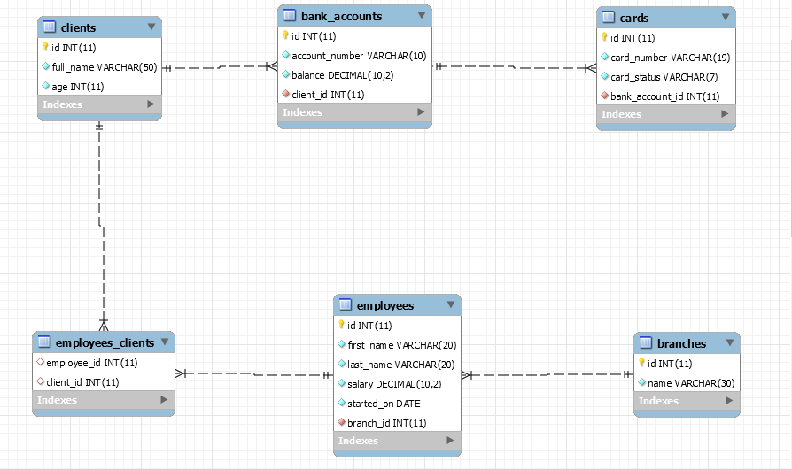
The Bank's Database needs to hold information about branches, employees, clients, bank accounts, cards.
Your task is to create a database called ruk_database. Then you will have to create several tables.
- branches – contains information about the branches.
- employees – contains information about the employees.
  - Each employee has a branch.
- clients – contains information about the clients.
- employees_clients – a many to many mapping table between the employees and the clients.
- bank_accounts – contains information about the bank accounts.
  - Each bank_account has a client.
- cards – contains information about the cards.
  - Each card has a client.
  - Each card has a bank_account.

Section 1: Data Definition Language (DDL) – 40 pts
Make sure you implement the whole database correctly on your local machine, so that you could work with it.
The instructions you'll be given will be the minimal needed for you to implement the database.

Table Design
You have been tasked to create the tables in the database by the following models:
branches
Column Name | Data Type | Constraints
id | Integer, from 1 to 2,147,483,647. | Primary Key  AUTO_INCREMENT
name | A string containing a maximum of 30 characters. Unicode is NOT needed. | NULL is NOT permitted.  UNIQUE values.
employees
Column Name | Data Type | Constraints
id | Integer, from 1 to 2,147,483,647. | Primary Key  AUTO_INCREMENT
first_name | A string containing a maximum of 20 characters. Unicode is NOT needed. | NULL is NOT permitted.
last_name | A string containing a maximum of 20 characters. Unicode is NOT needed. | NULL is NOT permitted.
salary | DECIMAL, up to 10 digits, 2 of which after the decimal point. | NULL is NOT permitted.
started_on | A DATE field. Format - (YYYY-MM-DD). | NULL is NOT permitted.
branch_id | Integer, from 1 to 2,147,483,647. | Relationship with table branches.  NULL is NOT permitted.
clients
Column Name | Data Type | Constraints
id | Integer, from 1 to 2,147,483,647. | Primary Key  AUTO_INCREMENT
full_name | A string containing a maximum of 50 characters. Unicode is NOT needed. | NULL is NOT permitted.
age | Integer, from 1 to 2,147,483,647. | NULL is NOT permitted.
employees_clients
Column Name | Data Type | Constraints
employee_id | Integer, from 1 to 2,147,483,647. | Relationship with table employees.
client_id | Integer, from 1 to 2,147,483,647. | Relationship with table clients.
bank_accounts
Column Name | Data Type | Constraints
id | Integer, from 1 to 2,147,483,647. | Primary Key  AUTO_INCREMENT
account_number | A string containing a maximum of 10 characters. Unicode is NOT needed. | NULL is NOT permitted.
balance | DECIMAL, up to 10 digits, 2 of which after the decimal point. | NULL is NOT permitted.
client_id | Integer, from 1 to 2,147,483,647. | Relationship with table clients.  NULL is NOT permitted.  UNIQUE values.
cards
Column Name | Data Type | Constraints
id | Integer, from 1 to 2,147,483,647. | Primary Key  AUTO_INCREMENT
card_number | A string containing a maximum of 19 characters. Unicode is NOT needed. | NULL is NOT permitted.
card_status | A string containing a maximum of 7 characters. Unicode is NOT needed. | NULL is NOT permitted.
bank_account_id | Integer, from 1 to 2,147,483,647. | Relationship with table bank_accounts.  NULL is NOT permitted.

Submit your solutions in Judge on the first task. Submit all SQL table creation statements.
You will also be given a data.sql file. It will contain a dataset with random data which you will need to store in your local database. This data will be given to you so you will not have to think of data and lose essential time in the process. The data is in the form of INSERT statement queries.

Section 2: Data Manipulation Language (DML) – 30 pts
Here we need to do several manipulations in the database, like changing data, adding data etc.

Insert
You will have to insert records of data into the cards table, based on the clients table.
For clients with id between 191 and 200 (inclusive), insert data in the cards table with the following values:
- card_number – set it to full name of the client, but reversed!
- card_status – set it to "Active".
- bank_account_id –set it to client's id value.

Update
Update all clients which have the same id as the employee they are appointed to. Set their employee_id with the employee with the lowest count of clients.
If there are 2 such employees with equal count of clients, take the one with the lowest id.

Delete
R.U.K. Bank is a sophisticated network. As such, it cannot allow procrastination and lazy behavior.
Delete all employees which do not have any clients.

Section 3: Querying – 50 pts
And now we need to do some data extraction. Note that the example results from this section use a fresh database. It is highly recommended that you clear the database that has been manipulated by the previous problems from the DML section and insert again the dataset you’ve been given, to ensure maximum consistency with the examples given in this section.

Clients
Extract from the database, all of the clients.
Order the results ascending by client id.

Required Columns
- id (clients)
- full_name

Example
id | full_name
1 | Hunter Wesgate
... | ...

Newbies
One of your bosses has requested a functionality which checks the newly employed – highly paid people.
Extract from the database, all of the employees, which have salary greater than or equal to 100000 and have started later than or equal to the 1st of January - 2018.
The salary should have a "$" as a prefix.
Order the results descending by salary, then by id.

Required Columns
- id (employees)
- full_name (first_name + " " + last_name)
- salary
- started_on

Example
id | full_name | salary | started_on
41 | Lisbeth Skett | $981421.79 | 2018-04-16
... | ... | ...

Cards against Humanity
Extract from the database, all of the cards, and the clients that own them, so that they end up in the following format:
{card_number} : {full_name}
Order the results descending by card id.

Required Columns
- id (cards)
- card_token

Example
id | card_token
500 | SM80 M775 4918 653X : Erin Cullingworth
... | ...

Top 5 Employees
Extract from the database, the top 5 employees, in terms of clients assigned to them.
Order the results descending by count of clients, and ascending by employee id.

Required Columns
- name (employees)
- started_on
- count_of_clients

Example
name | started_on | count_of_clients
Trula Glasscott | 2017-08-23 | 14
... | ... | ...

Branch cards
Extract from the database, all branches with the count of their issued cards. Order the results by the count of cards, then by branch name.

Required Columns
- name (branch)
- count_of_cards

Example
name | count_of_cards
Becker Branch | 93
Mifflin Branch | 82
Mendota Branch | 67
Moulton Branch | 58

Section 4: Programmability – 30 pts
The time has come for you to prove that you can be a little more dynamic on the database. So, you will have to write several procedures.

Extract client cards count
Create a user defined function with the name udf_client_cards_count(name VARCHAR(30)) that receives a client's full name and returns the number of cards he has.

Required Columns
- full_name (clients)
- cards (count of cards)

Example
Query
SELECT c.full_name, udf_client_cards_count('Baxy David') as `cards` FROM clients c
WHERE c.full_name = 'Baxy David';
full_name | cards
Baxy David | 6

Extract Client Info
Create a stored procedure udp_clientinfo which accepts the following parameters:
- full_name
And extracts data about the client with the given full name.
Aside from the full_name, the procedure should extract the client's age, bank account number and balance.
The account’s salary should have "$" prefix.

Result
full_name | age | account_number | balance
Hunter Wesgate | 33 | 69666616-8 | $803355.32

