MySQL Exam
Online store – electronic devices
A client who owns a big online store for electronic devices needs your help to manage the database of the shop.
Help him by implementing the database structure, optimizing his system and making analysis for the future management strategy of the shop.

Section 0: Database Overview
You have been given an Entity / Relationship Diagram of the Database:
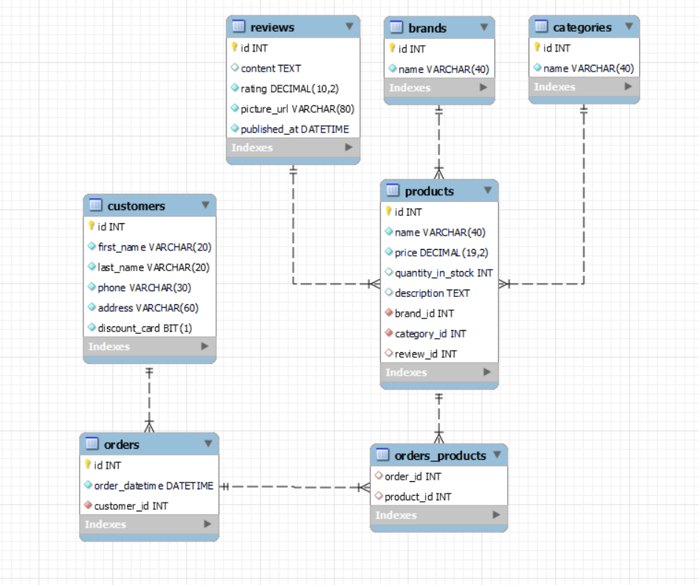
The online_stores’s Database needs to hold information about products, customers, orders, categories, brands, and reviews.
Your task is to create a database called online_store. Then you will have to create several tables.
- brands – contains information about the brands.
- categories – contains information about the categories.
- reviews – contains information about the reviews.
- products – contains information about the products.
  - Each product has a brand, review and category.
- customers – contains information about the customers.
- orders – contains information about the orders.
  - Each order has a customer.
- orders_products – a many to many mapping table between the orders and the products.

Section 1: Data Definition Language (DDL) – 40 pts
Make sure you implement the whole database correctly on your local machine so that you can work with it.
The instructions you'll be given will be the minimum needed for you to implement the database.

Table Design
You have been tasked to create the tables in the database by the following models:

brands
Column Name | Data Type | Constraints
id | Integer, from 1 to 2,147,483,647. | Primary Key  AUTO_INCREMENT
name | A string containing a maximum of 40 characters. Unicode is NOT needed. | NULL is NOT permitted.  UNIQUE values.

categories
Column Name | Data Type | Constraints
id | Integer, from 1 to 2,147,483,647. | Primary Key  AUTO_INCREMENT
name | A string containing a maximum of 40 characters. Unicode is NOT needed. | NULL is NOT permitted.  UNIQUE values.

reviews
Column Name | Data Type | Constraints
id | Integer, from 1 to 2,147,483,647. | Primary Key  AUTO_INCREMENT
content | A very long string field
rating | DECIMAL, up to 10 digits, 2 of which are after the decimal point. | NULL is NOT permitted.
picture_url | A string containing a maximum of 80 characters. Unicode is NOT needed. | NULL is NOT permitted.
published_at | The publishing datetime of the review. | NULL is NOT permitted.

products
Column Name | Data Type | Constraints
id | Integer, from 1 to 2,147,483,647. | Primary Key  AUTO_INCREMENT
name | A string containing a maximum of 40 characters. Unicode is NOT needed. | NULL is NOT permitted.
price | DECIMAL, up to 19 digits, 2 of which are after the decimal point. | NULL is NOT permitted.
quantity_in_stock | Integer, from 1 to 2,147,483,647.
description | A very long string field
brand_id | Integer, from 1 to 2,147,483,647. | Relationship with table brands.  NULL is NOT permitted.
category_id | Integer, from 1 to 2,147,483,647. | Relationship with table categories.  NULL is NOT permitted.
review_id | Integer, from 1 to 2,147,483,647. | Relationship with table reviews.

customers
Column Name | Data Type | Constraints
id | Integer, from 1 to 2,147,483,647. | Primary Key  AUTO_INCREMENT
first_name | A string containing a maximum of 20 characters. Unicode is NOT needed. | NULL is NOT permitted.
last_name | A string containing a maximum of 20 characters. Unicode is NOT needed. | NULL is NOT permitted.
phone | A string containing a maximum of 30 characters. Unicode is NOT needed | NULL is NOT permitted.  UNIQUE values.
address | A string containing a maximum of 60 characters. Unicode is NOT needed. | NULL is NOT permitted.
discount_card | Can be true or false | NULL is NOT permitted.  Default is FALSE

orders
Column Name | Data Type | Constraints
id | Integer, from 1 to 2,147,483,647. | Primary Key  AUTO_INCREMENT
order_datetime | The publishing datetime of the order. | NULL is NOT permitted.
customer_id | Integer, from 1 to 2,147,483,647. | Relationship with table customers.  NULL is NOT permitted.

orders_products
Column Name | Data Type | Constraints
order_id | Integer, from 1 to 2,147,483,647. | Relationship with table orders.
product_id | Integer, from 1 to 2,147,483,647. | Relationship with table products.

Submit your solutions in Judge on the first task. Submit all SQL table creation statements.
You will also be given a data.sql file. It will contain a dataset with random data which you will need to store in your local database. This data will be given to you so you will not have to think of data and lose essential time in the process. The data is in the form of INSERT statement queries.

Section 2: Data Manipulation Language (DML) – 30 pts
Here we need to do several manipulations in the database, like changing data, adding data, etc.

Insert
You will have to insert records of data into the reviews table, based on the products table.
For products with an id equal or greater than 5, insert data in the reviews table with the following values:
• content – set it to the first 15 characters from the description of the product.
• picture_url – set it to the product's name but reversed.
• published_at – set it to 10-10-2010.
• rating – set it to the price of the product divided by 8.

Update
Reduce all product quantity by 5 for products with quantity equal to or greater than 60 and less than 70 (inclusive).

Delete
Delete all customers, who didn't order anything.

Section 3: Querying – 50 pts
And now we need to do some data extraction. Note that the example results from this section use a fresh database. It is highly recommended that you clear the database that has been manipulated by the previous problems from the DML section and insert again the dataset you’ve been given, to ensure maximum consistency with the examples given in this section.

Categories
Extract from the online_store system database, info about the name of categories.
Order the results by category_name in descending order;

Required Columns
- id (categories)
- name

Example
id | name
5 | Small domestic appliances
... | ...

Quantity
Write a query that returns: product_id, brand_id, name and quantity from table products. Filter products whose price is higher than 1000 and their quantity is lower than 30.
Order the results ascending by quantity_in_stock, then by id.

Required Columns
- id (product)
- brand_id
- name (product)
- quantity_in_stock

Example
id | brand_id | name | quantity_in_stock
19 | 6 | GeneralElectric superCool | 4
36 | 3 | Overhold | 13
2 | 11 | DSLR camera NIKON D5600 | 21
27 | 3 | Eagle Vision GS340 | 24

Review
Write a query that returns: id, content, rating, picture_url and published_at for all reviews whose content starts with 'My' and the characters of the content are more than 61 symbols.
Order by rating in descending order.

Required Columns
- id (reviews)
- content
- rating
- picture_url
- published_at

Example
id | content | rating | picture_url | published_at
13 | My kids love this product! I am amazed how well it works actually. | 4.80 | kjF54Foiu982 | 2020-10-12 23:12:00
12 | My experience with those type of products is really bad, but i am very impressed with this | 4.70 | ds245asdfa84e88 | 2019-12-11 13:14:00
2 | My neighbor Karly has one of these. She works as a gambler and she says it looks tall. | 4.60 | ukQQ_TEYAfBGkw%3A1635 | 2019-10-02 14:32:00
… | … | … | … | …

First customers
There are many customers in our shop system, but we need to find only those who are clients from the beginning of the online store creation.
Extract from the database, the full name of the customer, the address, and the date of order. The year must be lower or equal to 2018.
Order the results descending by full_name.

Required Columns
- full_name (first_name + " " + last_name)
- address
- order_datetime

Examples
full_name | address | order_date
Shirley Clayfield | 51 East Drive | 2018-02-04 20:34:33
Selene Mateo | 9 Elka Point | 2018-04-13 07:44:15
… | … | …
Cherilyn Bradane | 323 Steensland Parkway | 2018-12-03 05:19:24

Best categories
Extract from the database, the top 5 categories.
Order the results descending by items count, then by total_quantity in ascending.

Required Columns
- items_count (number of items in the category)
- name
- total_quantity (sum of all items in this category)

Example
items_count | name | total_quantity
12 | Small domestic appliances | 639
10 | Phones and tablets | 775
9 | Photo and Video | 259
9 | Laptops | 437
9 | Home appliances | 542

Section 4: Programmability – 30 pts
The time has come for you to prove that you can be a little more dynamic on the database. So, you will have to write several procedures.

Extract client card count
Create a user defined function with the name udf_customer_products_count(name VARCHAR(30)) that receives a customer's first name and returns the total number of products he ordered;

Required Columns
- first_name (customers)
- last_name (customers)
- total_products (udf_customer_products_count)

Example
Query
SELECT c.first_name,c.last_name, udf_customer_products_count('Shirley') as `total_products` FROM customers c
WHERE c.first_name = 'Shirley';
first_name | last_name | total_products
Shirley | Clayfield | 5

Reduce price
Create a stored procedure udp_reduce_price which accepts the following parameters:
- category_name (VARCHAR(50))
Extracts data about the products from the given category and reduces the prices by 30% of all products that have reviews with rating less than 4 and are from the given category.

Result
Query
CALL udp_reduce_price ('Phones and tablets');
This execution will update 6 products – Galaxy M52 5G, Galaxy Z Fold3 5G, XS 420 …

Result
Galaxy M52 5G - 789.00 -> 552.30
Galaxy Z Fold3 5G – 599.00 -> 419.30
XS 420 – 754.00 -> 527.80
… … …

