MySQL Exam
SoftUni Internet Movie Database – SU-IMDb
The biggest international movie festival is about to begin. They hired a team of programmers to help manage their database. Now you are the leader of the team and you need to manage the system so they can keep track of all movies and actors and finally on the ceremony to give the annual awards to the winners.

Section 0: Database Overview
You have been given an Entity / Relationship Diagram of the Database:
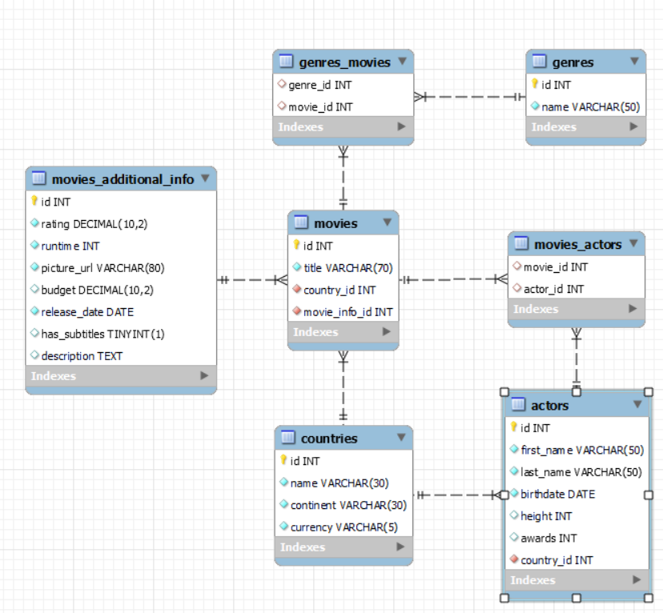

The softuni_imdb’s Database needs to hold information about movies, countries, actors, genres and movies additional info.
Your task is to create a database called softuni_imdb. Then you will have to create several tables.
- countries – contains information about the countries.
- movies – contains information about the movies.
  - Each movie has actors, country and genres.
- actors – contains information about the actors.
  - Each actor has a country.
- genres – contains information about the genres.
- movies additional info – contains information about the customers.
- movies_actors – a many to many mapping table between the movies and the actors.
- genres_movies – a many to many mapping table between the genres and the movies.

Section 1: Data Definition Language (DDL) – 40 pts
Make sure you implement the whole database correctly on your local machine so that you can work with it.
The instructions you'll be given will be the minimum needed for you to implement the database.

Table Design
You have been tasked to create the tables in the database by the following models:

countries
Column Name | Data Type | Constraints
id | Integer, from 1 to 2,147,483,647. | Primary Key  AUTO_INCREMENT
name | A string containing a maximum of 30 characters. Unicode is NOT needed. | NULL is NOT permitted.  UNIQUE values.
continent | A string containing a maximum of 30 characters. Unicode is NOT needed. | NULL is NOT permitted.
currency | A string containing a maximum of 5 characters. Unicode is NOT needed. | NULL is NOT permitted.

genres
Column Name | Data Type | Constraints
id | Integer, from 1 to 2,147,483,647. | Primary Key  AUTO_INCREMENT
name | A string containing a maximum of 50 characters. Unicode is NOT needed. | NULL is NOT permitted.  UNIQUE values.

actors
Column Name | Data Type | Constraints
id | Integer, from 1 to 2,147,483,647. | Primary Key  AUTO_INCREMENT
first_name | A string containing a maximum of 50 characters. Unicode is NOT needed. | NULL is NOT permitted.
last_name | A string containing a maximum of 50 characters. Unicode is NOT needed. | NULL is NOT permitted.
birthdate | The birthdate date of the person. | NULL is NOT permitted.
height | Integer, from 1 to 2,147,483,647.
awards | Integer, from 1 to 2,147,483,647.
country_id | Integer, from 1 to 2,147,483,647. | Relationship with table countries.  NULL is NOT permitted.

movies_additional_info
Column Name | Data Type | Constraints
id | Integer, from 1 to 2,147,483,647. | Primary Key  AUTO_INCREMENT
rating | DECIMAL, up to 10 digits, 2 of which are after the decimal point. | NULL is NOT permitted.
runtime | Integer, from 1 to 2,147,483,647. | NULL is NOT permitted.
picture_url | A string containing a maximum of 80 characters. Unicode is NOT needed. | NULL is NOT permitted.
budget | DECIMAL, up to 10 digits, 2 of which are after the decimal point.
release_date | The release date of the movie. | NULL is NOT permitted.
has_subtitles | Can be true or false
description | A very long string field

movies
Column Name | Data Type | Constraints
id | Integer, from 1 to 2,147,483,647. | Primary Key  AUTO_INCREMENT
title | A string containing a maximum of 70 characters. Unicode is NOT needed. | NULL is NOT permitted.  UNIQUE values.
country_id | Integer, from 1 to 2,147,483,647. | Relationship with table countries.  NULL is NOT permitted.
movie_info_id | Integer, from 1 to 2,147,483,647. | Relationship with table movies_additional_info.  NULL is NOT permitted.  UNIQUE values.

movies_actors
Column Name | Data Type | Constraints
movie_id | Integer, from 1 to 2,147,483,647. | Relationship with table movies.
actor_id | Integer, from 1 to 2,147,483,647. | Relationship with table actors.

genres_movies
Column Name | Data Type | Constraints
genre_id | Integer, from 1 to 2,147,483,647. | Relationship with table genres.
movie_id | Integer, from 1 to 2,147,483,647. | Relationship with table movies.
Submit your solutions in Judge on the first task. Submit all SQL table creation statements.
You will also be given a data.sql file. It will contain a dataset with random data which you will need to store in your local database. This data will be given to you so you will not have to think of data and lose essential time in the process. The data is in the form of INSERT statement queries.

Section 2: Data Manipulation Language (DML) – 30 pts
Here we need to do several manipulations in the database, like changing data, adding data, etc.
Select and join only tables and columns that are needed in the exercises. Any additional or less information will be considered wrong.

Insert
You will have to insert records of data into the actors table.
The new data will be based on actors with id equal or less than 10. Insert data in the actors table with the following values:
• first_name – set it to the first name of the actor but reversed.
• last_name – set it to the last name of the actor but reversed.
• birthdate – set it to the birthdate of the actor but 2 days earlier.
• height – set it to the height of the actor plus 10.
• awards – set them to the country_id.
• country_id – set it to the id of Armenia.

Update
Reduce all movies runtime by 10 minutes for movies with movies_additional_info id equal to or greater than 15 and less than 25 (inclusive).

Delete
Delete all countries that don’t have movies.

Section 3: Querying – 50 pts
And now we need to do some data extraction. Note that the example results from this section use a fresh database. It is highly recommended that you clear the database that has been manipulated by the previous problems from the DML section and insert again the dataset you’ve been given, to ensure maximum consistency with the examples given in this section.

Countries
Extract from the softuni_imdb system database, info about the name of countries.
Order the results by currency in descending order and then by id.

Required Columns
- id (countries)
- name
- continent
- currency

Example
id | name | continent | currency
42 | South Africa | Africa | ZAR
53 | Uzbekistan | Asia | UZS
50 | Uruguay | South America | UYU
... | ...

Old movies
Write a query that returns: title, runtime, budget and release_date from table movies_additional_info. Filter movies which have been released from 1996 to 1999 year (inclusive).
Order the results ascending by runtime then by id and show only the first 20 results.

Required Columns
- id
- title
- runtime
- budget
- release_date

Example
id | title | runtime | budget | release_date
251 | Maniac | 60 | 110495.27 | 1999-10-28
298 | Ronin | 60 | 447741.91 | 1997-07-25
103 | Opfergang | 62 | 481899.08 | 1999-09-02
… | … | … | … | …

Movie casting
Some actors are free and can apply the casting for a new movie. You must search for them and prepare their documents.
Write a query that returns: the full name, email, age and height of all actors that are not participating in a movie.
To find their email you must take their last name reversed followed by the number of characters of their last name and then the casting email "@cast.com"
Order by height in ascending order.

Required Columns
- full_name (first_name + " " + last_name)
- email (last_name reversed + number of characters from the last_name + @cast.com)
- age (2022 – the year of the birth)
- height

Example
full_name | email | age | height
Hube Miranda | adnariM7@cast.com | 35 | 155
Charlotte Eyres | seryE5@cast.com | 55 | 156
… | … | … | …
Connie Mackneis | sienkcaM8@cast.com | 27 | 184

International Festival
The international movie festival is about to begin. We need to find the countries that are nominated to host the event.
Extract from the database, the name of the country and the number of movies created in this country. The number of movies must be higher or equal to 7.
Order the results descending by name.

Required Columns
- name (country)
- movies_count (number of movies created in the country)

Examples
name | movies_count
Sweden | 13
Serbia | 8
Philippines | 9
… | …
Argentina | 7

Rating system
From the database extract the title, rating, subtitles, and the budget of movies. If the rating is equal or less than 4 the user must see "poor", above 4 and less or equal to 7 "good" and above that it should display "excellent". If the movie has subtitles the user should see "english", otherwise "-".
Order the results descending by budget.

Required Columns
- title
- rating (less or equal to 4 – "poor", above 4 and less or equal to 7 – "good", above 7 – "excellent")
- subtitles (if it has subtitles it– "english", otherwise – "-")
- budget

Example
title | rating | subtitles | budget
Metsän tarina | good | english | 499981.78
Family Secrets (Familjehemligheter) | poor | - | 497338.13
Place in the Sun, A (En plats i solen) | excellent | english | 496586.35
. . . | . . . | . . . | . . .
Saban, Son of Saban | good | - | 21027.33

Section 4: Programmability – 30 pts
The time has come for you to prove that you can be a little more dynamic on the database. So, you will have to write several procedures.

History movies
Create a user defined function with the name udf_actor_history_movies_count(full_name VARCHAR(50)) that receives an actor’s full name and returns the total number of history movies in which the actor has a role.

Required Columns
- history_movies(udf_customer_products_count)

Example
Query
SELECT udf_actor_history_movies_count('Stephan Lundberg') AS 'history_movies';
history_movies
2

Query
SELECT udf_actor_history_movies_count('Jared Di Batista') AS 'history_movies';
history_movies
1

Movie awards
A movie has won an award. Your task is to find all actors and give them the award.
Create a stored procedure udp_award_movie which accepts the following parameters:
- movie_title(VARCHAR(50))
Extract data about the movie with the given title and find all actors that play in it and increase their awards with 1.

Result
Query
CALL udp_award_movie('Tea For Two');
This execution will update 3 actors – Vanna Bilborough, Armando Cabrera, Ingrid Ackenhead

Result
full_name | awards  before | -> | awards  after
Vanna Bilborough | 20 | -> | 21
Armando Cabrera | 18 | -> | 19
Ingrid Ackenhead | 24 | -> | 25

