MySQL Exam
Restaurant
A very classy 3-floor restaurant has opened in the city. The owner wants to have restaurant management software that will help him and the managers run the restaurant end to end.
Help them by implementing the database structure, optimizing his system and making analysis for the future management strategy of the restaurant.

Section 0: Database Overview
You have been given an Entity / Relationship Diagram of the Database:
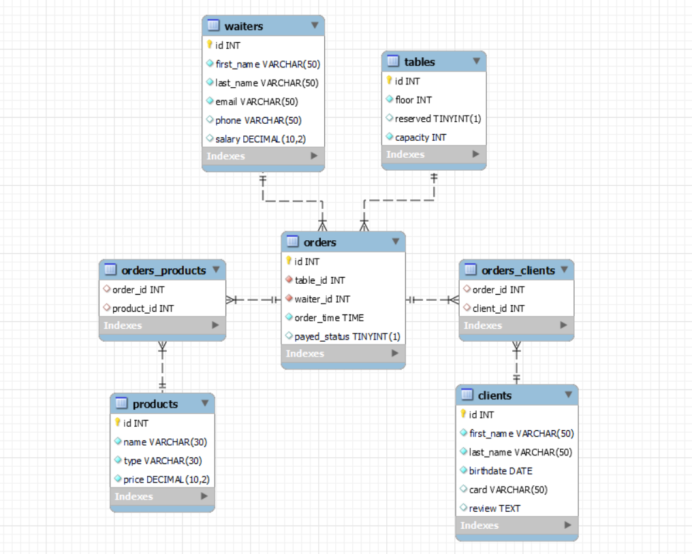
The restaurant_db Database needs to hold information about orders, products, clients, waiters and tables.
Your task is to create a database called restaurant_db. Then you will have to create several tables.
- products – contains information about the products.
- clients – contains information about the clients.
- tables – contains information about the tables.
- waiters – contains information about the waiters.
- orders – contains information about the orders.
  - Each order has a table, waiter and clients.
- orders_products – a many to many mapping table between the orders and the products.
- orders_clients – a many to many mapping table between the orders and the clients.

Section 1: Data Definition Language (DDL) – 40 pts
Make sure you implement the whole database correctly on your local machine so that you can work with it.
The instructions you'll be given will be the minimum needed for you to implement the database.

Table Design
You have been tasked to create the tables in the database by the following models:

products
Column Name | Data Type | Constraints
id | Integer, from 1 to 2,147,483,647. | Primary Key  AUTO_INCREMENT
name | A string containing a maximum of 30 characters. Unicode is NOT needed. | NULL is NOT permitted.  UNIQUE values.
type | A string containing a maximum of 30 characters. Unicode is NOT needed. | NULL is NOT permitted.
price | DECIMAL, up to 10 digits, 2 of which are after the decimal point. | NULL is NOT permitted.

clients
Column Name | Data Type | Constraints
id | Integer, from 1 to 2,147,483,647. | Primary Key  AUTO_INCREMENT
first_name | A string containing a maximum of 50 characters. Unicode is NOT needed. | NULL is NOT permitted.
last_name | A string containing a maximum of 50 characters. Unicode is NOT needed. | NULL is NOT permitted.
birthdate | The birth date of the client. | NULL is NOT permitted.
card | A string containing a maximum of 50 characters. Unicode is NOT needed.
review | A very long string field

tables
Column Name | Data Type | Constraints
id | Integer, from 1 to 2,147,483,647. | Primary Key  AUTO_INCREMENT
floor | Integer, from 1 to 2,147,483,647. | NULL is NOT permitted.
reserved | Can be true or false
capacity | Integer, from 1 to 2,147,483,647. | NULL is NOT permitted.

waiters
Column Name | Data Type | Constraints
id | Integer, from 1 to 2,147,483,647. | Primary Key  AUTO_INCREMENT
first_name | A string containing a maximum of 50 characters. Unicode is NOT needed. | NULL is NOT permitted.
last_name | A string containing a maximum of 50 characters. Unicode is NOT needed. | NULL is NOT permitted.
email | A string containing a maximum of 50 characters. Unicode is NOT needed. | NULL is NOT permitted.
phone | A string containing a maximum of 50 characters. Unicode is NOT needed.
salary | DECIMAL, up to 10 digits, 2 of which are after the decimal point.

orders
Column Name | Data Type | Constraints
id | Integer, from 1 to 2,147,483,647. | Primary Key  AUTO_INCREMENT
table_id | Integer, from 1 to 2,147,483,647. | NULL is NOT permitted.
waiter_id | Integer, from 1 to 2,147,483,647. | NULL is NOT permitted.
order_time | Time that the order has been created. | NULL is NOT permitted.
payed_status | Can be true or false.

orders_clients
Column Name | Data Type | Constraints
order_id | Integer, from 1 to 2,147,483,647. | Relationship with table orders.
client_id | Integer, from 1 to 2,147,483,647. | Relationship with table clients.

orders_products
Column Name | Data Type | Constraints
order_id | Integer, from 1 to 2,147,483,647. | Relationship with table orders.
product_id | Integer, from 1 to 2,147,483,647. | Relationship with table products.
Submit your solutions in Judge on the first task. Submit all SQL table creation statements.
You will also be given a data.sql file. It will contain a dataset with random data which you will need to store in your local database. This data will be given to you so you will not have to think of data and lose essential time in the process. The data is in the form of INSERT statement queries.

Section 2: Data Manipulation Language (DML) – 30 pts
Here we need to do several manipulations in the database, like changing data, adding data, etc.
Select and join only tables and columns that are needed in the exercises. Any additional or less information will be considered wrong.

Insert
You will have to insert records of data into the products table, based on the waiters table.
For waiters with id greater than 6, insert data in the products table with the following values:
• name – set it to the last name of the waiter followed by white space and then "specialty".
- (last_name + " " + "specialty")
• type – set it to the "Cocktail".
• price – set it to 1% of the waiter's salary and round the DECIMAL always to the next largest number.
(HINT: FLOOR will round the decimal to the previous whole number, but we need the opposite of FLOOR)

Update
Somebody made a mistake with the orders and you should correct it. Find the orders with id from 12(inclusive) to 23(inclusive) and lower their tables id with 1.
- e.g. table_id 40 -> table_id 39

Delete
Delete all waiters, who don't have any orders.

Section 3: Querying – 50 pts
And now we need to do some data extraction. Note that the example results from this section use a fresh database. It is highly recommended that you clear the database that has been manipulated by the previous problems from the DML section and insert again the dataset you’ve been given, to ensure maximum consistency with the examples given in this section.

Clients
Extract from the restaurant_db system database, info about the clients.
Order the results by birthdate in descending order and id in descending;

Required Columns
- id (clients)
- first_name
- last_name
- birthdate
- card
- review

Example
id | first_name | last_name | birthdate | card | review
88 | Eal | Scorey | 2000-10-29 | maestro | I tried to shatter it but got potato all over it.
57 | Jedidiah | Thunnercliffe | 1999-09-26 | NULL | I saw one of these in Bhutan and I bought one.
93 | Debi | De Souza | 1999-04-29 | visa | NULL
31 | Joye | Beveridge | 1999-04-29 | maestro | I tried to pepper it but got prune all over it.
... | ... | ... | ... | ... | ...

Birthdate
Write a query that returns: first_name, last_name, birthdate and review from clients. Filter clients which don't have card and their birthdate is between 1978 and 1993 inclusive.
Show only the first 5 results and order them descending by last_name, then by id ascending.

Required Columns
- first_name
- last_name
- birthdate
- review

Example
first_name | last_name | birthdate | review
Trudie | Swayte | 1979-10-14 | heard about this on melodic death metal radio, decided to give it a try.
Chantal | Sor | 1978-12-04 | My neighbor Krista has one of these. She works as a salesman and she says it looks soapy.
Alphard | Skelly | 1978-05-15 | My neighbor Lori has one of these. She works as a taxidermist and she says it looks whopping.
Marya | Niessen | 1989-06-09 | The box this comes in is 5 light-year by 6 foot and weights 17 megaton!!!
George | Dymocke | 1988-04-03 | i use it barely when i'm in my store.

Accounts
The waiters need to have access to the new software, so they need personal accounts. Your task is to generate their usernames and passwords.
Write a query that returns: the username and password for all waiters who are not fired (a fired waiter is a waiter without salary). The username is generated by their last name immediately followed by their first name followed by the number of characters from first name and at the end "Restaurant". The password is their email starting from the 2nd character to the 13th character and then reversed.
Order by password in descending order.

Required Columns
- username (last_name + first_name + characters count from first_name + "Restaurant")
- password (starting from the 2nd character to the 13th character of their email and then reversed)

Example
username | password
BroadisDrusy5Restaurant | wen@3sidaorb
GeeringBrandon7Restaurant | ssi@9gnireeg
LevinChristy7Restaurant | namys@2nivel
… | …
FulgerRaffarty8Restaurant | csid@6regluf

Top from menu
There are many items on our menu list, but the owner wants to know which one is the best sellable item from the restaurant.
Extract from the database the id (product), the name and the count of products from all orders with this name where the count is greater or equal to 5.
Order the results descending by count and then by name in ascending.

Required Columns
- id (product)
- name (product)
- count (the count of products with the same name)

Examples
id | name | count
143 | Beef Minced Meat with Bulgur | 9
100 | Hot chocolate | 9
136 | Chicken Crispy Fillets 300 g. | 8
… | … | …
86 | Розе от Совиньон Блан Резерва | 5

Availability
There are a lot of people waiting to have dinner in the restaurant. You can help the waiters by checking the available tables in restaurant_db.
Write a query that returns the table_id, capacity, count_clients and availability of all tables from the 1st floor. Count_clients is the number of people from all orders that are sitting on that table. Availability is based on how many people are sitting and the capacity of the table. If the capacity is greater than count_clients then it should be "Free seats", if the capacity is equal to the count_clients it should be "Full", and if the capacity is lower than the count_clients it should be "Extra seats".
Order the results descending by table_id.

Required Columns
- table_id
- capacity
- count_clients (is the number of people from all orders that are sitting on that table)
- availability (based on how many people are sitting and the capacity of the table)

Example
table_id | capacity | count_clients | availability
29 | 5 | 5 | Full
18 | 6 | 6 | Full
13 | 9 | 6 | Free seats
… | … | … | …
2 | 10 | 19 | Extra seats

Section 4: Programmability – 30 pts
The time has come for you to prove that you can be a little more dynamic on the database. So, you will have to write several procedures.

Extract bill
Create a user defined function with the name udf_client_bill(full_name VARCHAR(50)) that receives a customer's full name and returns the total price of products he ordered;

Required Columns
- first_name (client)
- last_name (client)
- bill (udf_client_bill) (should be DECIMAL(19,2))

Example
Query
SELECT c.first_name,c.last_name, udf_client_bill('Silvio Blyth') as 'bill' FROM clients c
WHERE c.first_name = 'Silvio' AND c.last_name= 'Blyth';
first_name | last_name | bill
Silvio | Blyth | 96.90

Happy hour
Create a stored procedure udp_happy_hour which accepts the following parameters:
- type (VARCHAR(50))
Extracts data about the products from the given type and reduces the prices by 20% of all products which have prices higher or equal to 10.00 and are from the given type.

Result
Query
CALL udp_happy_hour ('Cognac');
This execution will update 1 product – Martell VS Single Distillery F

Result
Brandy Ararat 5YO Armenia|6.00 -> 6.00
Brandy Sarajishvili VS, Georgi|8.00 -> 8.00
Martell VS Single Distillery F|10.00 -> 8.00

