Truffle Hunter
In the summer Peter loves to hunt truffles. He has a well-trained dog, but his problem is how to deal with the wild boars, which eat his trifles.
Create a program that helps Peter to pick up truffles. There are three kinds of truffles in the forest:
- Black truffle - 'B'
- Summer truffle - 'S'
- White truffle - 'W'
In the first line, the size of the forest is given, which will be a matrix with a square shape. Then for each row, you will receive the truffles. All of the empty positions will be marked with a '-' (dash).
Then you will start receiving commands. Here are the possible ones you can receive:
- "Collect {row} {col}" - Peter goes to the given place in the forest and collects the truffle if it exists. When he collects a truffle, the cells should be changed to a dash ('-').
- "Wild_Boar {row} {col} {direction}" - a wild boar appears in the given coordinates (they will be always valid) in the forest and it goes all the way in that direction. Which means the wild boar, goes from the given cell to the last cell in the given direction. It eats the given cell, skips the next, and eats the next one if there is a truffle there, and so on until it reaches the last cell in the given direction. Mark the eaten cells with a dash ('-'). There are four possible directions:
  - "up", "down", "left", and "right"
- "Stop the hunt" – the program stops and the result is printed.
Here is an example (up and right) of the wild boar eating pattern:
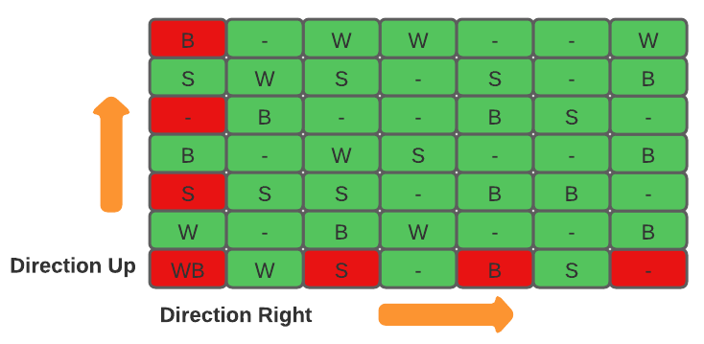
In the end, print the truffles that Peter has successfully found and the count of truffles that the wild boar ate in the following format:
"Peter manages to harvest {count black truffles} black, {count summer truffles} summer, and {count white truffles} white truffles."
"The wild boar has eaten {count of truffles} truffles."
Then print the last state of the forest.

Input
- On the first line, you will receive the size of the forest (matrix) in a square shape.
- On the next lines, for each row, you will receive the truffles in the described format.
- Next, until you receive "Stop the hunt", you will be receiving commands in the described format.

Output
As an output print three lines:
- All types of truffles that Peter has collected are in the format described above.
- Truffles eaten by the wild boar in the format described above.
- The final state of the forest - each cell separated by a single space.

Constraints
- The size of the square matrix will be between [3…10].
- The coordinate of the wild boar will be always valid.
- The input will always be valid and you don't need to check it explicitly.

Examples
Input | Output
5  B W S - -  S S B W W  S S - W B  B B S - W  S S - - -  Collect 0 2  Collect 3 0  Collect 4 2  Collect 3 4  Collect 2 3  Wild_Boar 2 2 up  Wild_Boar 1 1 right  Stop the hunt | Peter manages to harvest 1 black, 1 summer, and 2 white truffles.  The wild boar has eaten 2 truffles.  B W - - -  S - B - W  S S - - B  - B S - -  S S - - -

Comment
The first command is "Collect", so we go to the given coordinates and collect 'S' (summer truffle).
The next command is "Collect", so we go to the given coordinates and collect 'B' (black truffle).
The next command is "Collect", so we go to the given coordinates but there is no truffle there, so we continue to the next command.
The next command is "Collect", so we go to the given coordinates and collect 'W' (white truffle).
The next command is "Collect", so we go to the given coordinates and collect 'W' (white truffle).
The next command is "Wild_Boar", so to the wild boar start from the given index in a direction up. There were not any truffles in the coordinates, so the wild boar left without eating anything.
The next command is "Wild_Boar", so to the wild boar start from the given index in a direction right. He managed to eat two truffles, which are 'S' (summer truffle) and 'W' (white truffle).
The last command is "Stop the hunt", the program stops and the corresponding message is printed, with the last state of the forest.

Input | Output
4  B - S W  S - B W  S S - B  B W S -  Collect 0 0  Collect 1 2  Collect 3 2  Collect 3 1  Stop the hunt | Peter manages to harvest 2 black, 1 summer, and 1 white truffles.  The wild boar has eaten 0 truffles.  - - S W  S - - W  S S - B  B - - -

