Lab: First Steps in Coding
Problems for lab exercise for the "Programming Basics" course @ SoftUni Global
Submit your solutions to the SoftUni Judge system: https://judge.softuni.org/Contests/Compete/Index/4564

Console Program "Hello SoftUni"
Write a C# program, which prints the text "Hello SoftUni".

Hints and Guidelines
- Start Visual Studio
- Create a new project
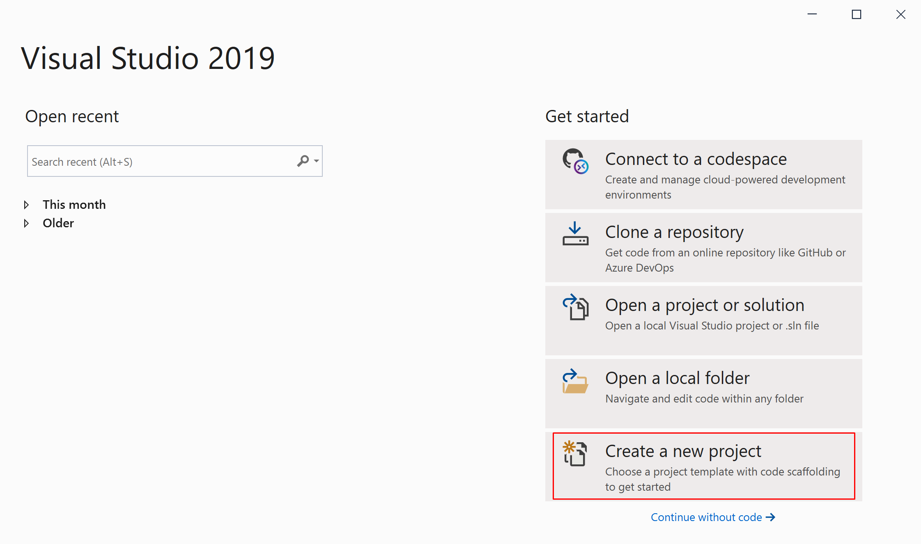
- Select: Console App (.NET Core) 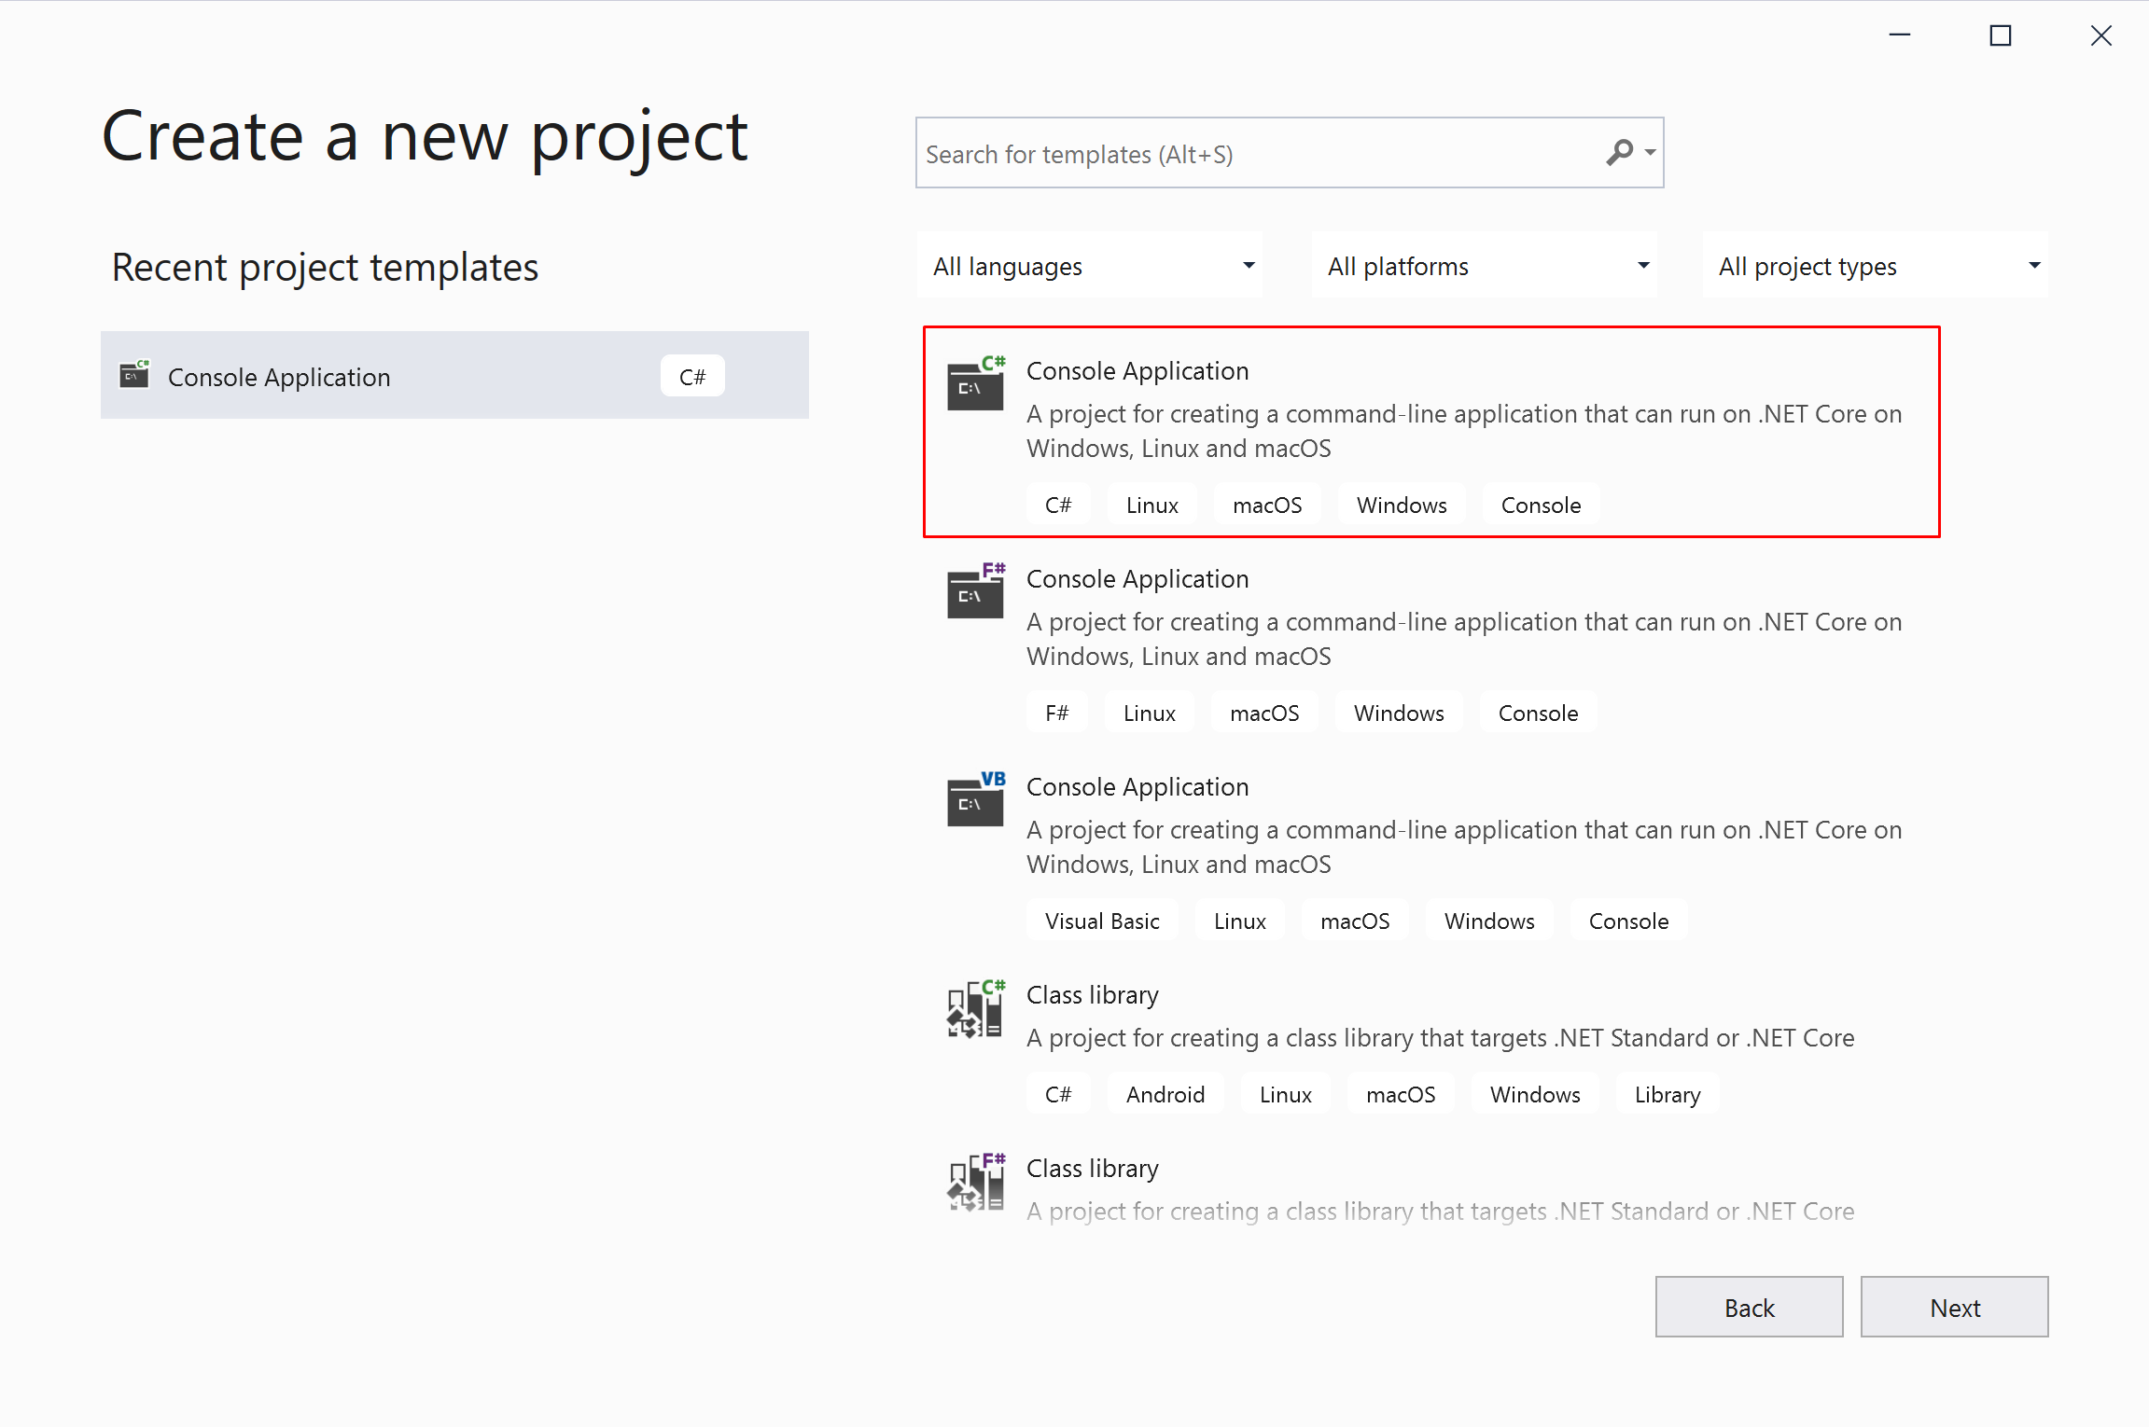
- Enter an appropriate project name and select a directory in which to be created:
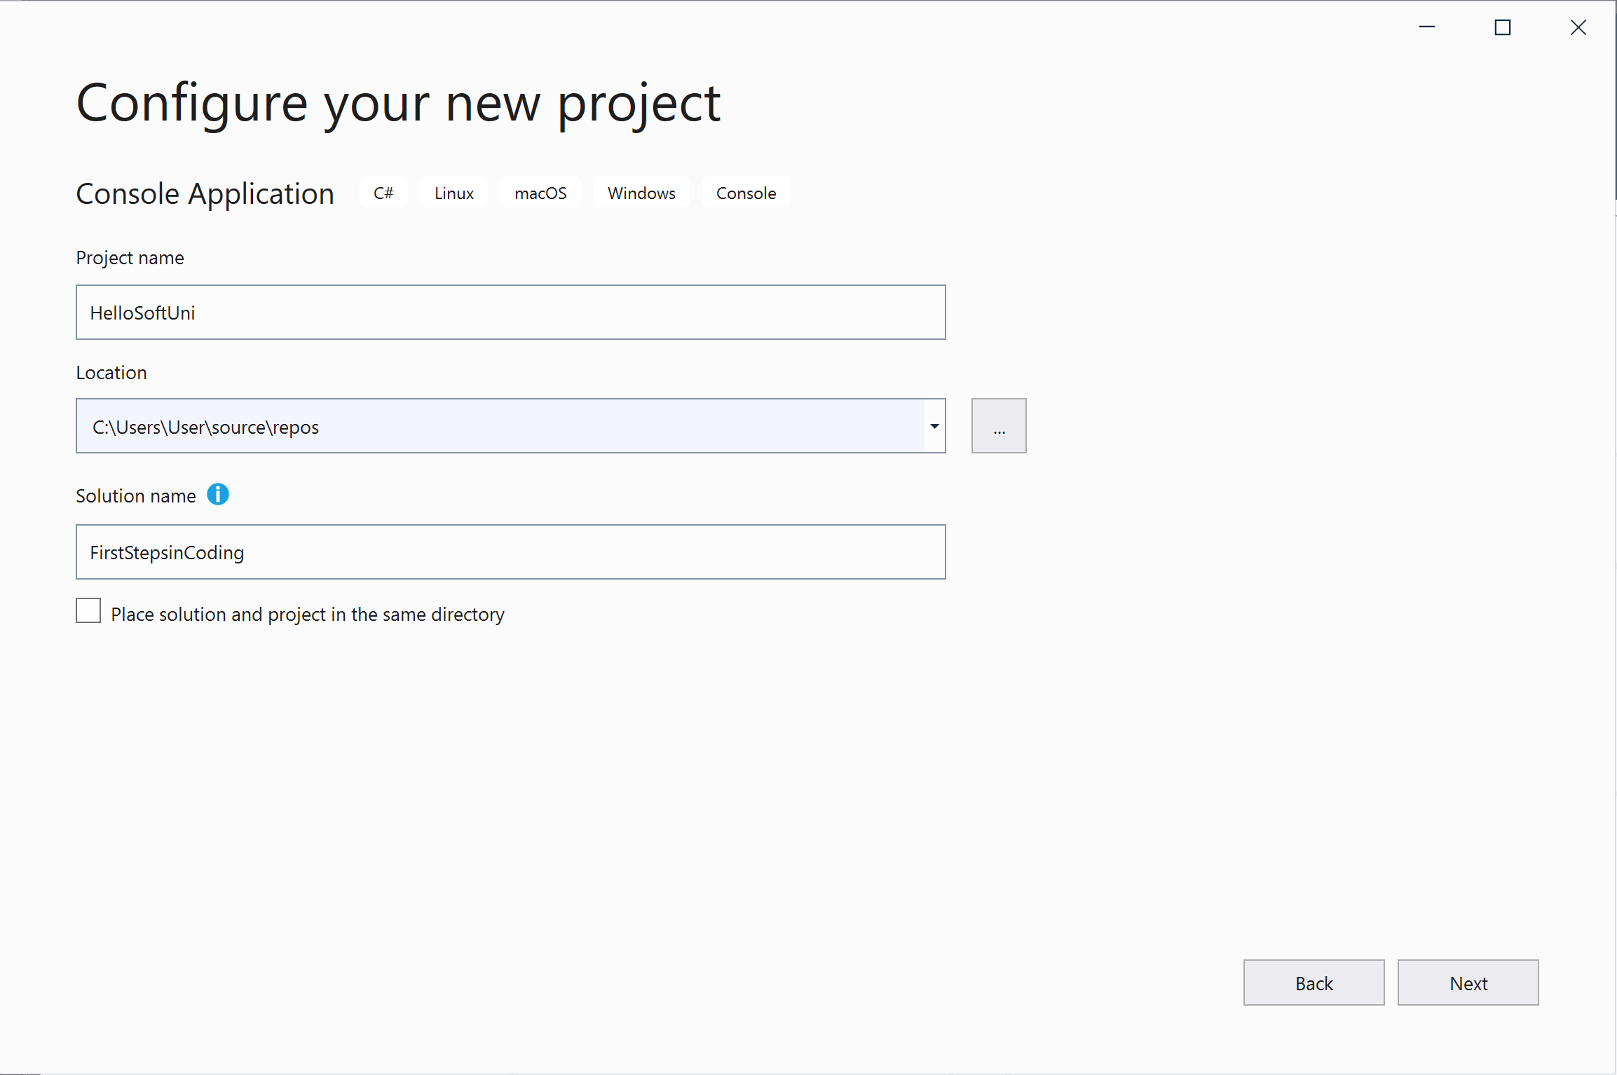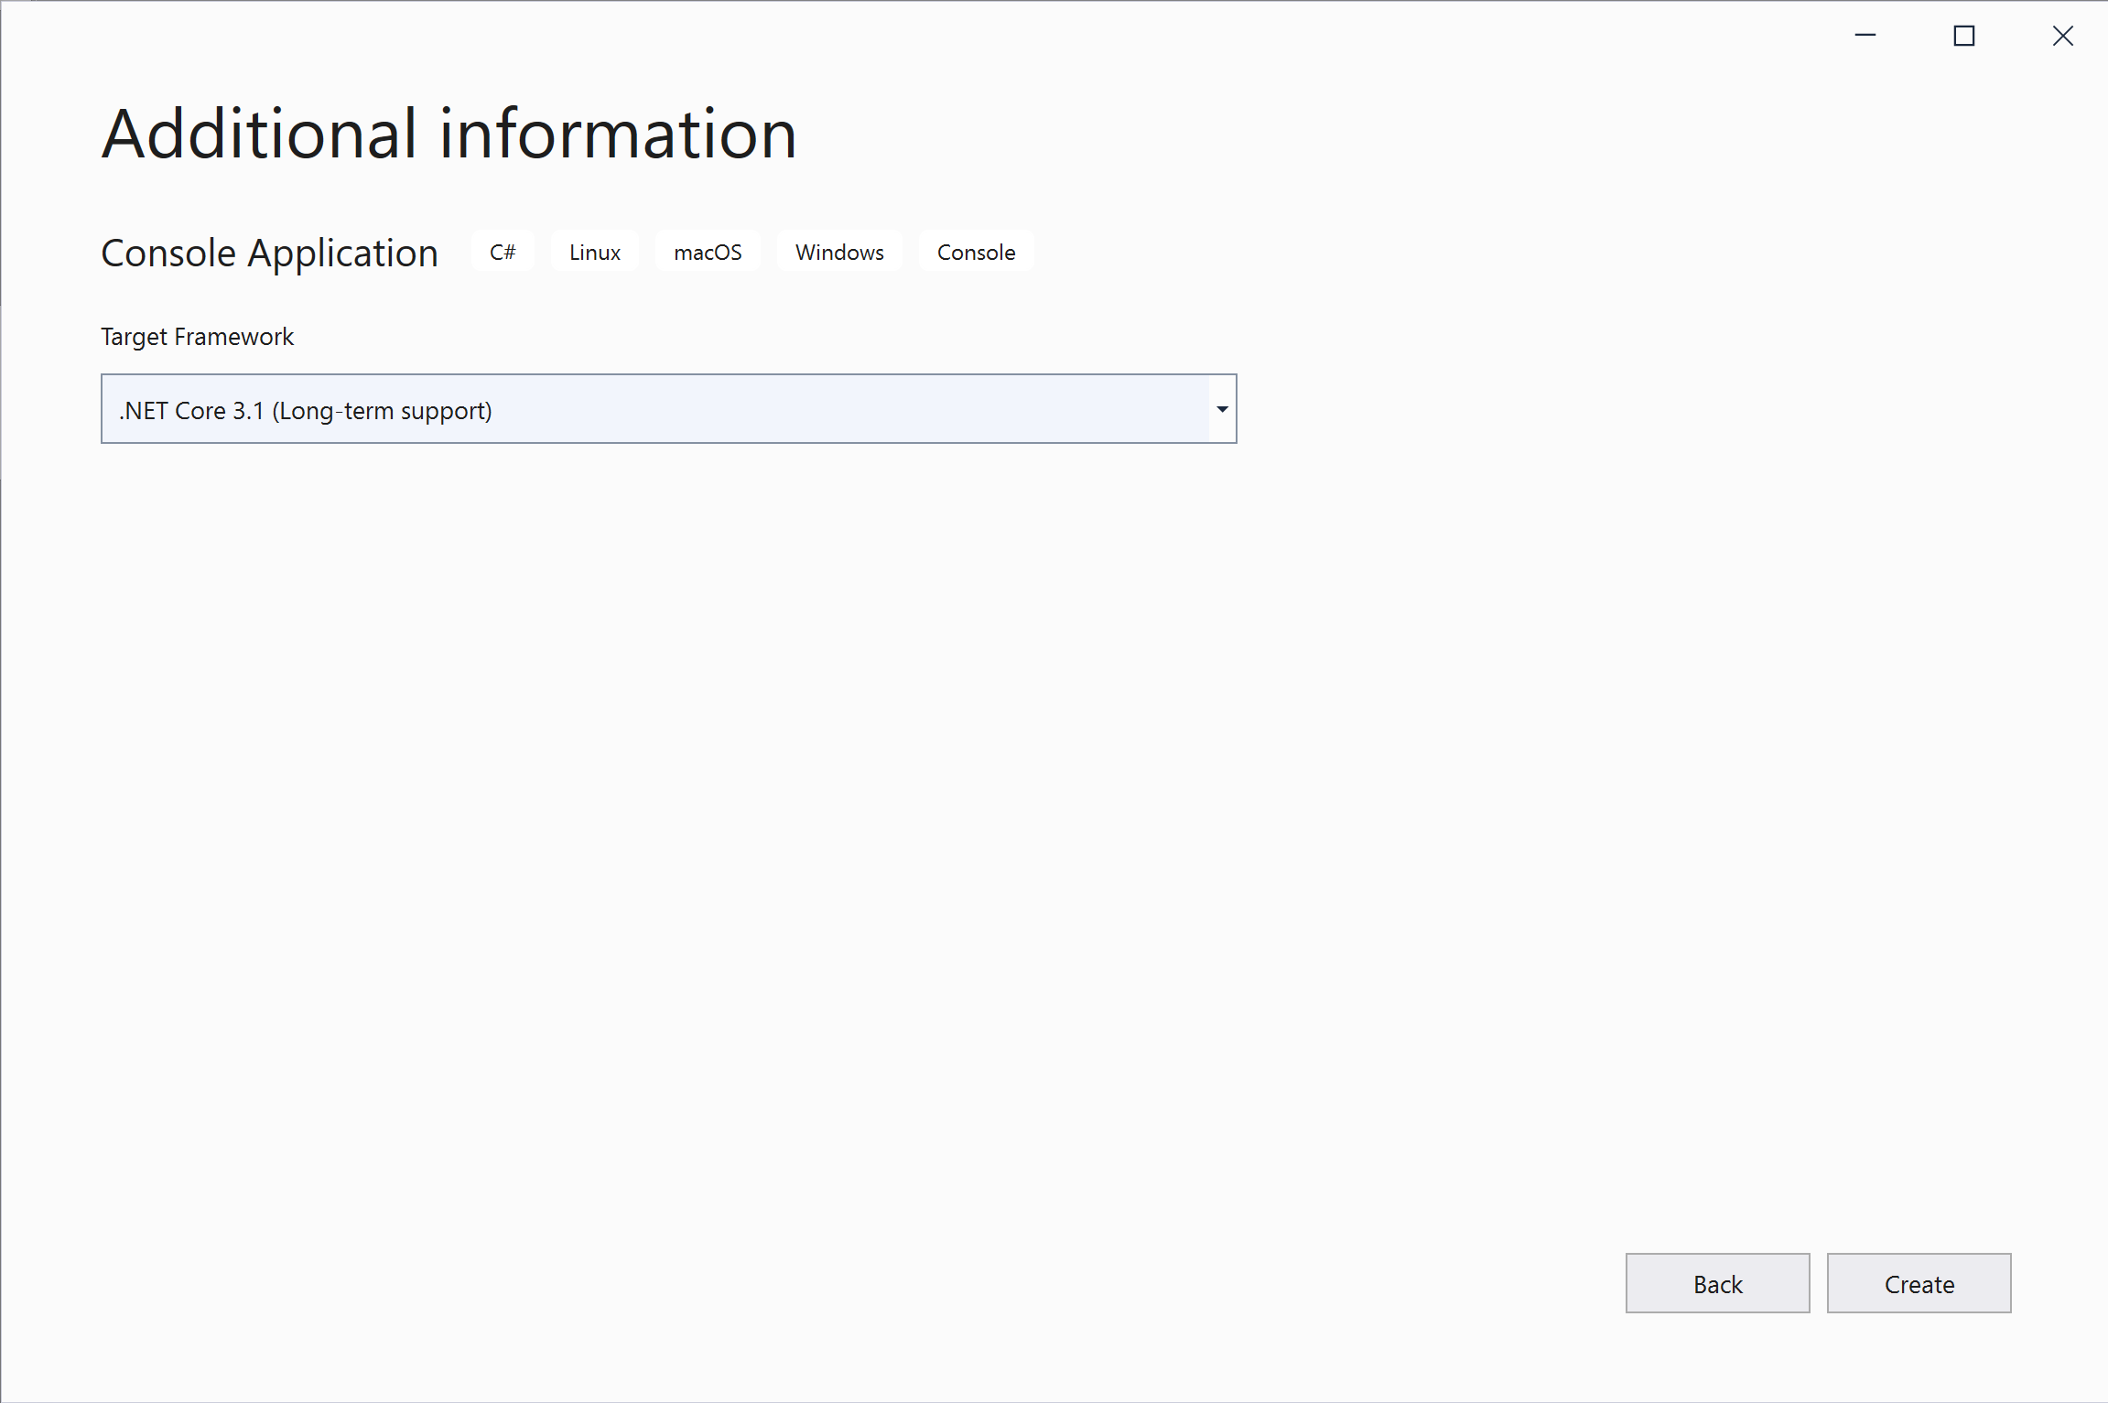
- Find the section Main(string[] args). The programming code is written in it for the C# language.
- Move the mouse cursor between the opening and closing brackets { }.
- Press Enter after the opening {.
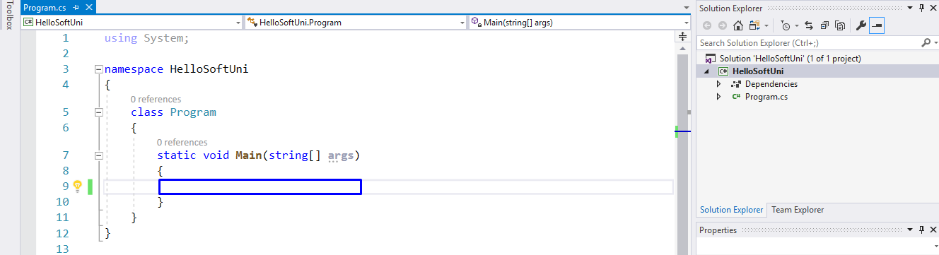
- Write the following program code (command for printing "Hello SoftUni"):
Console.WriteLine("Hello SoftUni");
The program code is written offset in one tab relative to the opening parenthesis {.
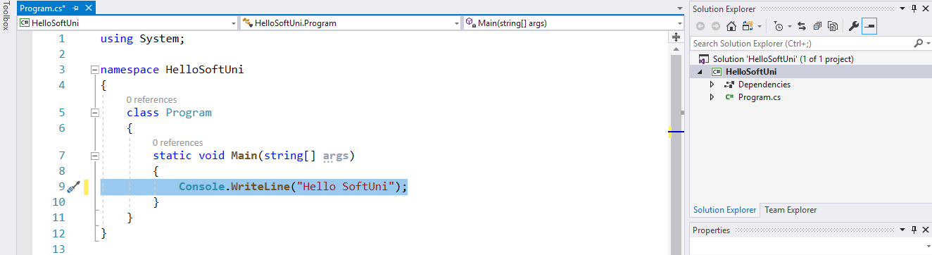
- Start the program using Ctrl+F5. The following result will appear:

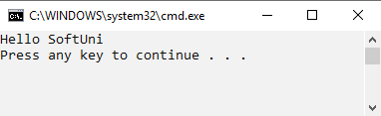
- Test the solution to this problem in the online Judge system of SoftUni. To do this, open: https://judge.softuni.org/Contests/Compete/Index/4564#0. Test the solution to this problem in the online judge system of SoftUni. To do this, open it first. Log in with your SoftUni username. A window for submitting solutions for the "Hello SoftUni" task will appear. Copy the entire source code from IntelliJ and paste it into the solution submission box:
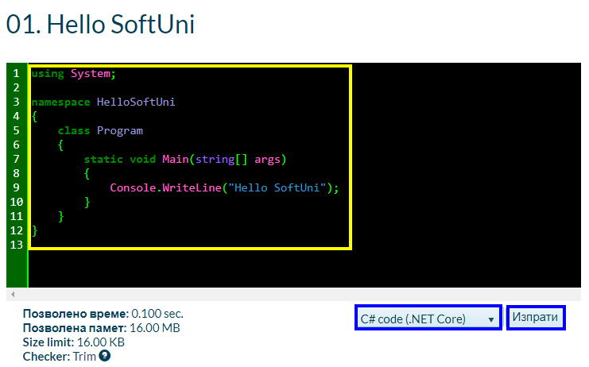
- Press the "Submit" button.
- The result will appear in the window below. To see it, press the "Refresh" button:
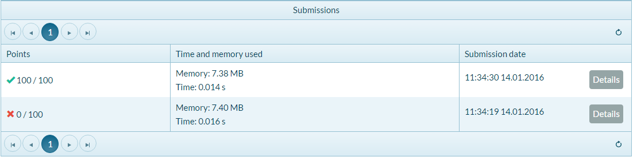

Nums 1...10
Write a C# console program, which prints the numbers from 1 to 10 on separate lines on the console.

Hints and Guidelines
- Create a C# console application with the name "Nums1To10".
- Write 10 commands Console.WriteLine(), one after another,to print 1 to 10.
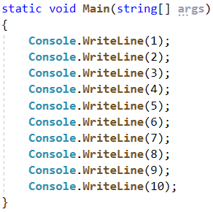
- Test your solution in the Judge system.

Rectangle Area
Write a console program that calculates and prints the area of a rectangle with predefined sides a and b.

Sample Input and Output
Input | Output
5  7 | 35
Input | Output
6  8 | 48

Hints and Guidelines
- Initialize two variables (a and b) and save the values entered by the console:
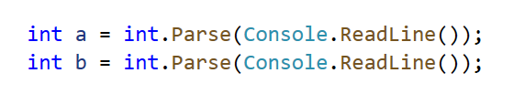
- Initialize a second variable area in which to write the value for the face of the rectangle obtained by the formula a * b. Print the result:
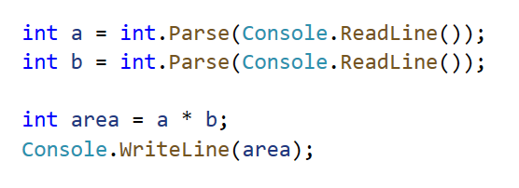
- Test your solution in the Judge system.

Inches to Centimeters
Write a program that reads a floating-point number from the console and converts it from inches to centimeters. To do this, multiply the inches by 2.54 (1 inch = 2.54 centimeters).

Sample Input and Output
Input | Output
5 | 12.7

Attention: depending on the regional settings of the operating system, it is possible to use a decimal point (GB settings) instead of a decimal point (US settings). If the program expects a decimal point and a number with a decimal point is entered, or vice versa (a decimal point is entered when a decimal point is expected), the following error will occur: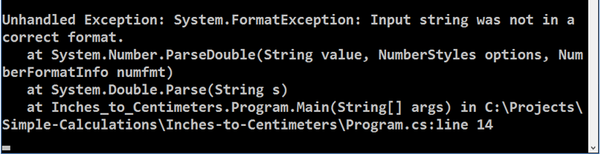
Warning: It is recommended that you change the settings on your computer to use a decimal point:
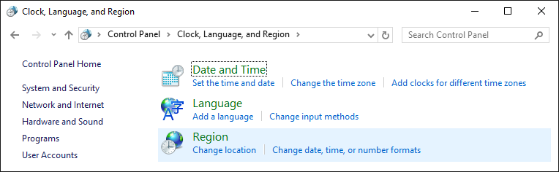
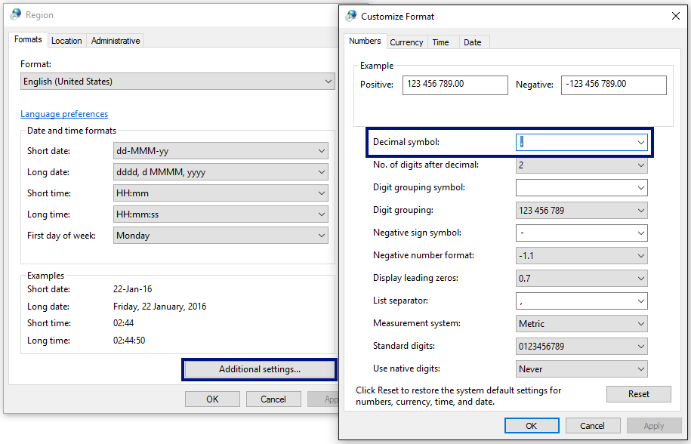
Test your solution in the Judge system.

Greeting by Name
Write a program that reads text (person's name) from the console and prints "Hello, <name>!", where <name> is the name entered from the console.

Hints and Guidelines
- Create a name variable of type string and save in it the name, which you will receive by the console.
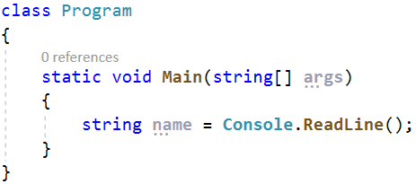

- Print the result to the console using concatenation:
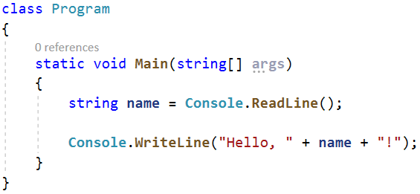
- Start your program with Ctrl + F5 and test with different input examples. 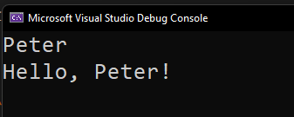
- Test your solution in the Judge system.

Concatenate Data
Write a program that reads the name, surname, age, and city from the console and prints the following message: "You are <firstName> <lastName>, a <age>-years old person from <town>."

Hints and Guidelines
- Add a new project to the current Visual Studio solution by right clicking on the project and then Add -> New Project...
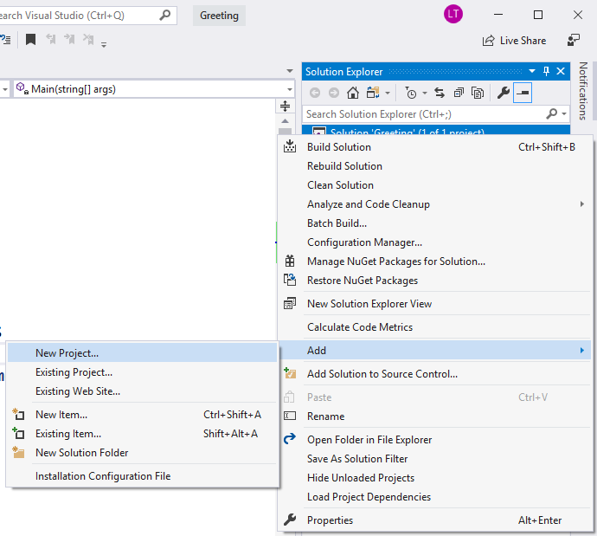

- Enter the input data and save it in variables with the appropriate data type:
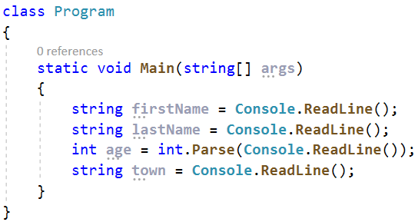

- Display the formatted output on the console:
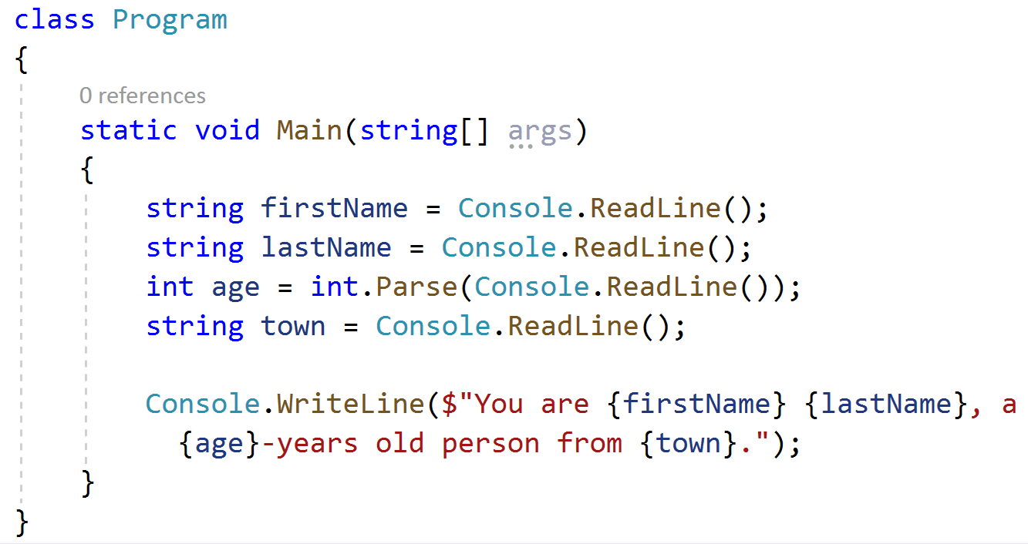

- Start the program and test with different input example.

If you're still getting the output from the last task, it's because you haven't changed the starter project. How to deal with the problem?
As you can see the Greeting project is in bold black letters - this means that this is your starter project. To change the startup project, right-click on the desired project and select Set as StartUp Project.
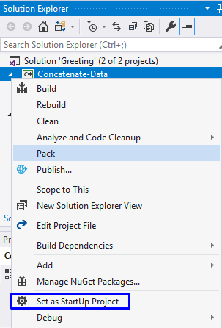
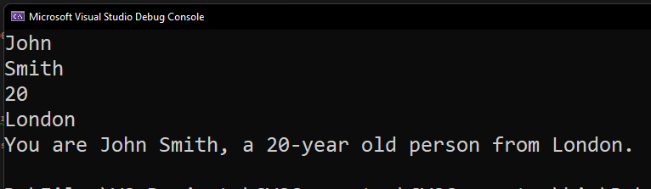
- Test your solution in the Judge system.

Projects Creation
Write a program that calculates how many hours it will take for an architect to design several construction projects. The preparation of a project takes three hours.

Input Data
2 lines are read from the console:
- Name of the architect – string
- Number of projects to be prepared – an integer in the interval [0 … 100]

Output Data
On the console print:
- "The architect {name of architect} will need {needed time} hours to complete {number of projects} project/s."

Sample Input and Output
Input | Output |  | Input | Output
George  4 | The architect George will need 12 hours to complete 4 project/s. |  | John  9 | The architect John will need 27 hours to complete 9 project/s.
Test your solution in the Judge system.

Pet Shop
Write a program that calculates the cost of buying dog and cat food. The food is bought from a pet store, as one package of dog food costs 2.50 USD, and a package of cat food costs 4 USD.

Input Data
2 lines are read from the console:
- Number of packages of dog food - an integer in the range [0… 100]
- Number of packages of cat food - an integer in the range [0… 100]

Output Data
On the console print:
"{Total sum} USD."

Sample Input and Output
Input | Output |  | Input | Output
5  4 | 28.5 USD. |  | 13  9 | - USD.
Test your solution in the Judge system.

Yard Greening
Sophia has several houses on the Black Sea coast and wants to green the yards of some of them, thus creating a cozy atmosphere and comfort for its guests. She has hired a company for this purpose.
Write a program that calculates the amount needed for Sophie to pay to the project contractor. The price per square meter is 7.61 USD including VAT. Because her yard is quite large, the contractor company offers an 18% discount on the final price.

Input Data
One line is read from the console:
- Square meters of the landscaped – a floating-point number in the range [0.00 … 10000.00]

Output Data
Two lines are printed on the console:
- "The final price is: {final price of the service} USD."
- "The discount is: {discount} USD."

Sample Input and Output
Input | Output | Comments
550 | The final price is: 3432.11 USD.  The discount is: 753.39 USD. | We calculate the price for landscaping the whole yard:  550 * 7.61 = 4185.50 USD.  We deduct the discount (18% = 0.18) of the total:  0.18 * 4185.5 = 753.39 USD.  We calculate the final price of the service:  4185.50 – 753.39 3432.11 USD.
Input | Output
150 | The final price is: 936.03 USD.  The discount is: 205.47 USD. | We calculate the price for landscaping the whole yard:  150 * 7.61 = 1141.50 USD.  We deduct the discount (18% = 0.18) of the total:  0.18 * 1141.50 = 205.47 USD.  We calculate the final price of the service:  1141.50 – 205.47 936.03 USD.

Test your solution in the Judge system.

