Lab: Conditional Statements
Problems for lab exercise for the "Programming Basics" course @ SoftUni Global
Submit your solutions to the SoftUni Judge system: https://judge.softuni.org/Contests/Compete/Index/4566

Excellent Result
Write a console program that reads a rating (integer) entered by the user and prints "Excellent!" if the score is 5 or higher.
Input | Output |  | Input | Output |  | Input | Output |  | Input | Output
6 | Excellent! |  | 4 | (no output) |  | 5 | Excellent! |  | 3 | (no output)

Hints and Guidelines:
- Create a new C# console project with the name"ExcellentResult" and add it to the current solution
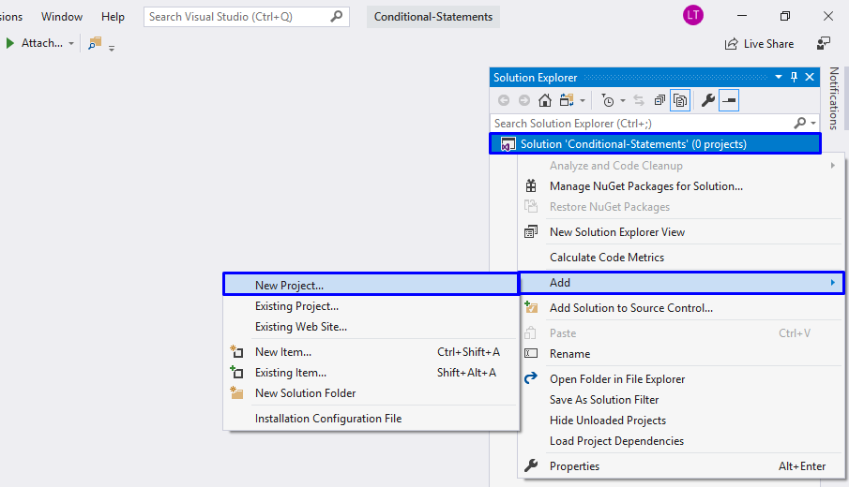
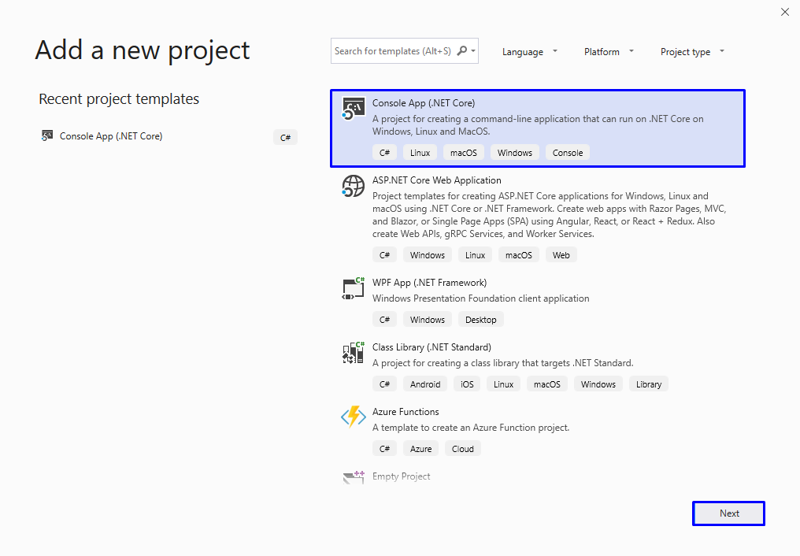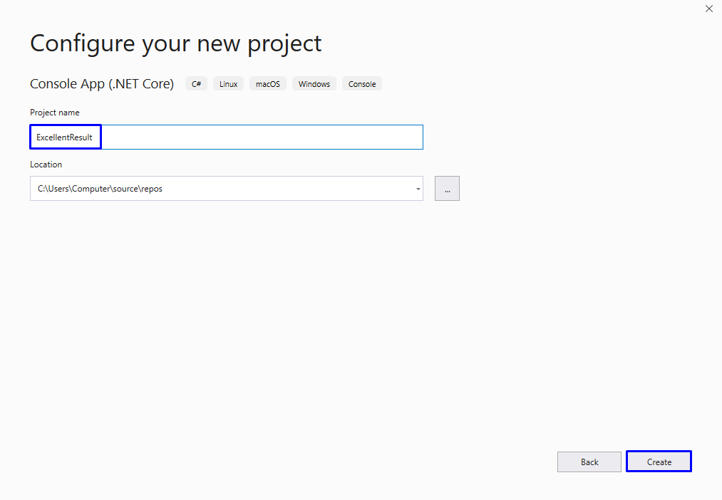
- You already have a Main method
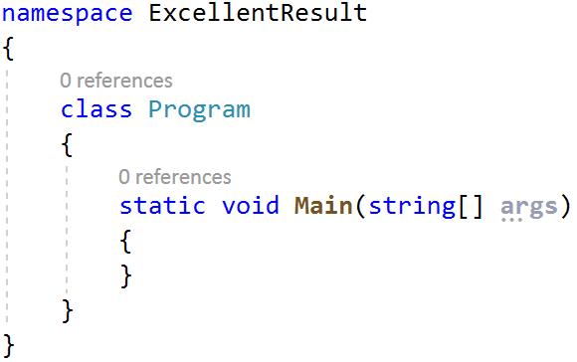
- Go in the body of the Main(string[] args) method. Create a new variable, in which to save the floating-point number – the grade, which will be read from the console:
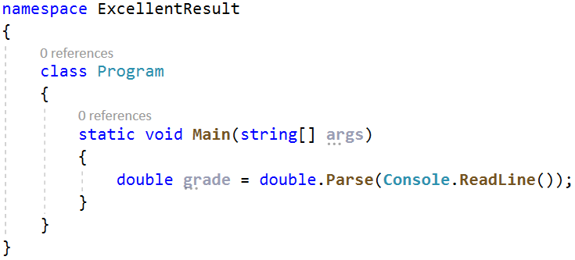
- Check the value of the assessment. If it is greater than or equal to 5.5, print the conditional output:
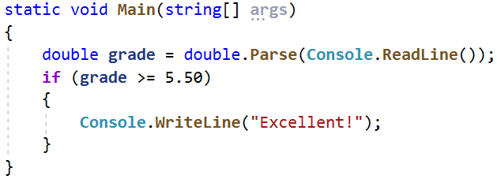
- Tart the program with Ctrl + F5 and test it with different input values:
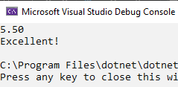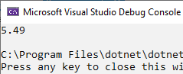
- Test your solution in the Judge system.

Greater Number
Write a program that reads two integers entered by the user and prints the larger of the two.

Sample Input and Output
Input | Output |  | Input | Output |  | Input | Output |  | Input | Output
5  3 | 5 |  | 3  5 | 5 |  | 10  10 | 10 |  | -5  5 | 5

Hints and Guidelines
- Read two integers from the console:
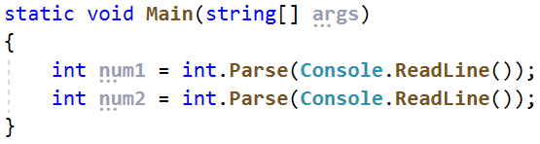
- Compare whether the first number num1 is greater than the second num2. Print the larger number.
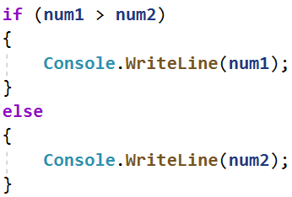
3. Test your solution in the Judge system.

Even or Odd
Write a program that reads an integer entered by the user and prints whether it is even or odd.

Sample Input and Output
Input | Output |  | Input | Output |  | Input | Output |  | Input | Output
2 | even |  | 3 | odd |  | 25 | odd |  | 1024 | even

Hints and Guidelines
- Add a new console project to your solution.
- Read an integer from the console:
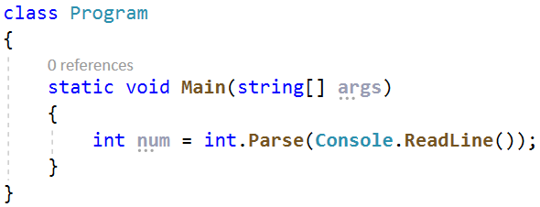
Check that the number is even by dividing it by 2, and check what the remainder of the division is. Print the output depending on the condition
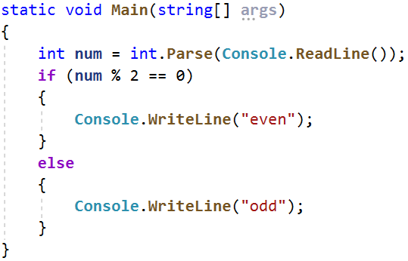
3. Test your solution in the Judge system.

Password Guess
Write a program that reads a password (string) entered by the user and checks if the entered password matches the phrase "s3cr3t!P@ssw0rd". In case of coincidence, display "Welcome". In case of discrepancy, display "Wrong password!".

Sample Input and Output
Input | Output |  | Input | Output |  | Input | Output
qwerty | Wrong password! |  | s3cr3t!P@ssw0rd | Welcome |  | s3cr3t!p@ss | Wrong password!
Test your solution in the Judge system.

Number 100...200
Write a program that reads an integer entered by the user and checks if it is below 100, between 100 and 200 or above 200. If the number is:
- below 100 print: "Less than 100"
- between 100 and 200 print: "Between 100 and 200"
- above 200 print: "Greater than 200"

Sample Input and Output
Input | Output |  | Input | Output |  | Input | Output
95 | Less than 100 |  | 120 | Between 100 and 200 |  | 210 | Greater than 200
Test your solution in the Judge system.

Speed Info
Write a program that reads the speed (floating-point number) entered by the user and prints speed information.
- At speed up to 10 (inclusive) print "slow"
- At speed between 10 and 50 (inclusive) print "average"
- At speed between 50 and 150 (inclusive) print "fast"
- At speed between 150 and 1000 (inclusive) print "ultra fast"
- At a higher speed print "extremely fast"

Sample Input and Output
Input | Output |  | Input | Output |  | Input | Output |  | Input | Output |  | Input | Output
8 | slow |  | 49.5 | average |  | 126 | fast |  | 160 | ultra fast |  | 3500 | extremely fast
Test your solution in the Judge system.

Area of Figures
Write a program in which the user enters the type and dimensions of a geometric figure and calculates its area. The figures are of four types: square, square, rectangle, circle, and triangle. The first line of the input reads the type of figure (string with the following options: square, rectangle, circle, or triangle).
- If the figure is a square: on the next line read a floating-point number - the length of its side
- If the figure is a rectangle: on the next two lines read two floating-point numbers - the lengths of its sides
- If the figure is a circle: on the next line read a floating-point number - the radius of the circle
- If the figure is a triangle: on the next two lines read two floating-point numbers - the length of its side and the length of the height to it
Round the result up to 3 digits after the decimal point.

Sample Input and Output
Input | Output |  | Input | Output |  | Input | Output |  | Input | Output
square  5 | 25.000 |  | rectangle  7  2.5 | 17.500 |  | circle  6 | 113.097 |  | triangle  4.5  20 | 45.000
Test your solution in the Judge system.

