Lab: Conditional Statements Advanced
Problems for lab exercise for the "Programming Basics" course @ SoftUni Global
Submit your solutions to the SoftUni Judge system: https://judge.softuni.org/Contests/Compete/Index/4568

Day of Week
Write a program that reads an integer entered by the user and prints a day of the week within [1 ... 7] or prints "Error" if the number entered is invalid.

Sample Input and Output
Input | Output
1 | Monday
2 | Tuesday
3 | Wednesday
4 | Thursday
5 | Friday
6 | Saturday
7 | Sunday
-1 | Error

Hints and Guidelines
- Create a new project in your current Visual Studio solution. In Solution Explorer right click on Solution and select [Add] [New Project…]:
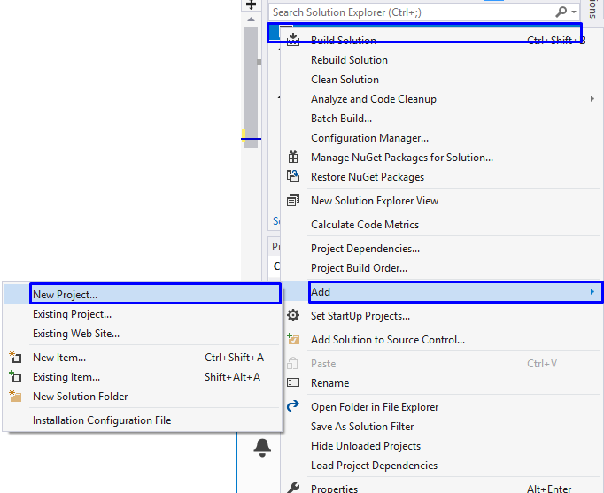
- In the new modal that opened, choose C# console application and choose an appropriate name, like "DayOfWeek":
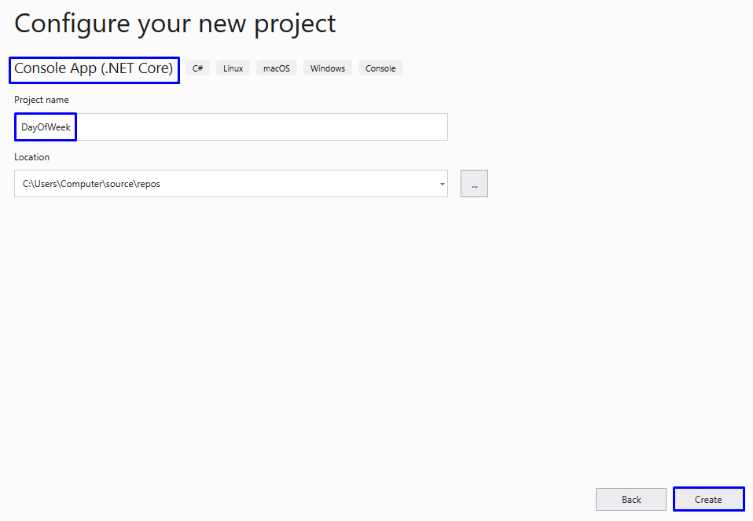
- Read an integer from the console:
  - Print the day of the week according to the number entered. If it is invalid, print "Error".
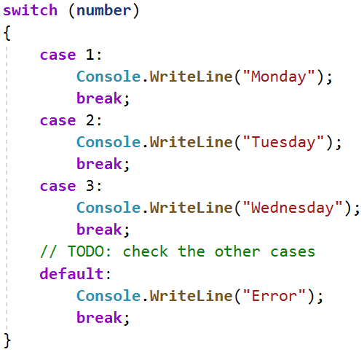
2. Test your solution in the Judge system.

Weekend or Working Day
Write a program that reads the day of the week (string) - entered by the user. If the day is a working day, it prints on the console - "Working day", if it is a day off - "Weekend". If any text other than the day of the week is entered, print "Error".

Sample Input and Output

Input | Output
Monday | Working day
Input | Output
Sunday | Weekend
Input | Output
April | Error

Hints and Guidelines
- Read the day of the week (string) from the console: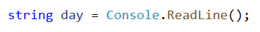
- Print a working day or day off, depending on the day you entered. If the day is invalid, print it "Error":
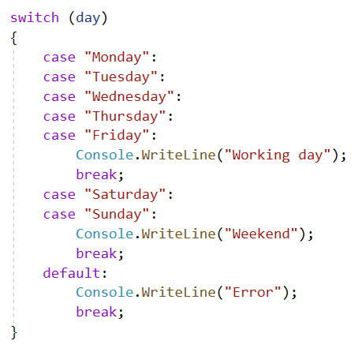
3. Test your solution in the Judge system.

Animal Type
Write a program that prints the species of the animal according to its name entered by the user.
- dog -> mammal
- crocodile, tortoise, snake -> reptile
- others -> unknown

Sample Input and Output
Input | Output
dog | mammal
snake | reptile
cat | unknown

Hints and Guidelines
- Read the input:
- Check the specie. If it is invalid, print "unknown".
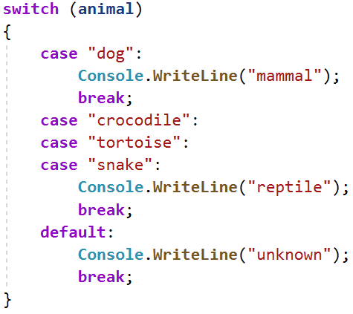
3. Test your solution in the Judge system.

Personal Titles
Write a console program that reads the age (a floating-point number) and gender ("m" or "f") entered by the user and prints an address from the following:
- "Mr." - a man (gender "m") of 16 years or more
- "Master" - a boy (gender "m") under 16 years old
- "Ms." – a woman (gender "f") of 16 years or more
- "Miss" – a girl (gender "f") under 16 years old

Sample Input and Output
Input | Output |  | Input | Output |  | Input | Output |  | Input | Output
12  f | Miss |  | 17  m | Mr. |  | 25  f | Ms. |  | 13.5  m | Master

Hints and Guidelines
- Read the input from the console. First read a floating-point number, "age", and the next line a string for "gender".
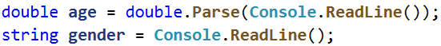
- Make a conditional statement for the gender and if the result is true, make a check for the ages. In the body of the age conditions print the appropriate result

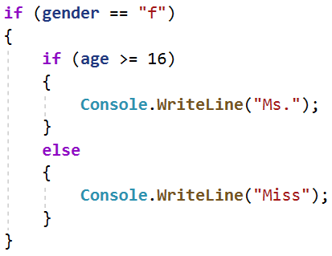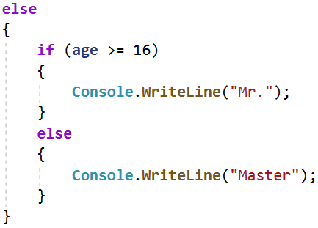
Start the program with [Ctrl + F5] and test it with different input values 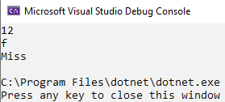 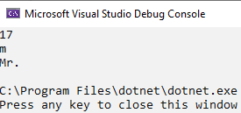
- You must receive 100 points (completely correct solution):
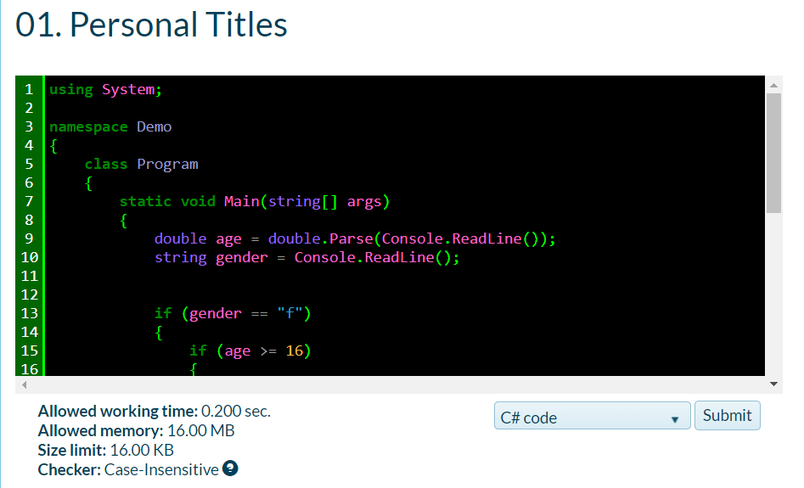
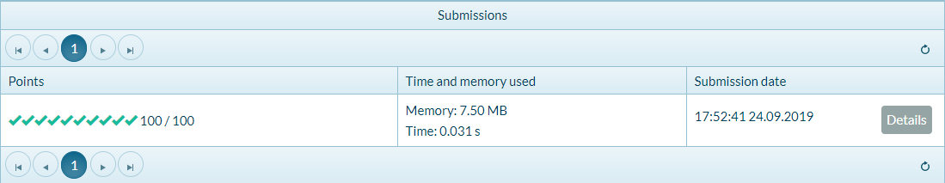
Test your solution in the Judge system.

Small Shop
An enterprising person opens neighborhood shops in several cities and sells at different prices:
city / product | coffee | water | beer | sweets | peanuts
London | 0.50 | 0.80 | 1.20 | 1.45 | 1.60
Rome | 0.40 | 0.70 | 1.15 | 1.30 | 1.50
Paris | 0.45 | 0.70 | 1.10 | 1.35 | 1.55
Write a program that reads product (string), city (string), and quantity (a floating-point number) entered by the user and calculates and prints how much the corresponding quantity of the selected product costs in the specified city.

Sample Input and Output
Input | Output |  | Input | Output |  | Input | Output |  | Input | Output |  | Input | Output
coffee  Paris  2 | 0.9 |  | peanuts  Rome  1 | 1.5 |  | beer  London  3 | 3.6 |  | water  Rome  2 | 1.4 |  | sweets  London  2.23 | 3.2335
Test your solution in the Judge system.

Number in Range
Write a program that checks if the number entered by the user is in the range [-100, 100] and is different from 0 and print "Yes" if it meets the conditions, or "No" if it is outside the range.

Sample Input and Output
Input | Output |  | Input | Output |  | Input | Output
-25 | Yes |  | 0 | No |  | 25 | Yes
Test your solution in the Judge system.

Working Hours
Write a program that reads an hour of the day (integer) and a day of the week (string) - entered by the user and checks whether the company's office is open, the office hours are from 10:00(10 am) to 18:00(6 pm), from Monday to Saturday including.

Sample Input and Output
Input | Output |  | Input | Output |  | Input | Output
11  Monday | open |  | 19  Friday | closed |  | 11  Sunday | closed
Test your solution in the Judge system.

Cinema Ticket
Write a program that reads the day of the week (string) - entered by the user and prints on the console the price of a movie ticket according to the day of the week:
Monday | Tuesday | Wednesday | Thursday | Friday | Saturday | Sunday
12 | 12 | 14 | 14 | 12 | 16 | 16

Sample Input and Output
Input | Output |  | Input | Output |  | Input | Output
Monday | 12 |  | Friday | 12 |  | Sunday | 16
Test your solution in the Judge system.

Fruit or Vegetable
Write a program that reads a product name entered by the user and checks if it is a fruit or vegetable.
- The fruits are banana, apple, kiwi, cherry, lemon, and grapes
- The vegetables "vegetable" are tomato, cucumber, pepper, and carrot
- Everything else is "unknown"
Print "fruit", "vegetable" or "unknown" depending to the introduced product.

Sample Input and Output
Input | Output |  | Input | Output |  | Input | Output |  | Input | Output
banana | fruit |  | apple | fruit |  | tomato | vegetable |  | water | unknown
Test your solution in the Judge system.

Invalid Number
A number is valid if it is in the range [100… 200] or is 0. Write a program that reads an integer entered by the user and print "invalid" if the number entered is not valid.

Sample Input and Output
Input | Output |  | Input | Output |  | Input | Output |  | Input | Output
75 | invalid |  | 150 | (no output) |  | 220 | invalid |  | 199 | (no output)

Input | Output |  | Input | Output |  | Input | Output |  | Input | Output
-1 | invalid |  | 100 | (no output) |  | 200 | (no output) |  | 0 | (no output)
Test your solution in the Judge system.

Fruit Shop
Fruit shop on weekdays works at the following prices:
fruit | banana | apple | orange | grapefruit | kiwi | pineapple | grapes
price | 2.50 | 1.20 | 0.85 | 1.45 | 2.70 | 5.50 | 3.85
On Saturdays and Sundays, the store is works at higher prices:
fruit | banana | apple | orange | grapefruit | kiwi | pineapple | grapes
price | 2.70 | 1.25 | 0.90 | 1.60 | 3.00 | 5.60 | 4.20
Write a program that reads from the console fruit (banana / apple / orange / grapefruit / kiwi / pineapple / grapes), day of the week (Monday / Tuesday / Wednesday / Thursday / Friday / Saturday / Sunday), and quantity (a floating-point number), entered from the customer, and calculates the sum according to the prices in the tables above. In case of an invalid day of the week or invalid fruit name, print "error".

Sample Input and Output
Input | Output |  | Input | Output |  | Input | Output |  | Input | Output |  | Input | Output
apple  Tuesday  2 | 2.40 |  | orange  Sunday  3 | 2.70 |  | kiwi  Monday  2.5 | 6.75 |  | grapes  Saturday  0.5 | 2.10 |  | tomato  Monday  0.5 | error
Test your solution in the Judge system.

Trade Commissions
The company gives the following commissions to its merchants according to the city in which they operate and the volume of sales:
City | 0 ≤ s ≤ 500 | 500 < s ≤ 1 000 | 1 000 < s ≤ 10 000 | s > 10 000
London | 5% | 7% | 8% | 12%
Paris | 4.5% | 7.5% | 10% | 13%
Rome | 5.5% | 8% | 12% | 14.5%
Write a console program that reads the city name (string) and sales volume (a floating-point number) entered by the user and calculates the percentage of the trade commission according to the table above. Display the result formatted to 2 digits after the decimal point. In case of invalid city or sales volume (negative number) print "error".

Sample Input and Output
Input | Output |  | Input | Output |  | Input | Output |  | Input | Output
London 1500 | 120.00 |  | Rome 499.99 | 27.50 |  | Paris 3874.50 | 387.45 |  | InvalidName  -50 | error
Test your solution in the Judge system.

