Lab: For-Loop
Problems for lab exercise for the course "Programming Basics" @ SoftUni Global
Submit your solutions to the SoftUni Judge system: https://judge.softuni.org/Contests/Compete/Index/4570

Numbers from 1 to 100
Write a program that prints the numbers from 1 to 100, each on a new line.

Sample Input and Output
Input | Output
(no input) | 1  2  3  …  98  99  100

Hints and Guidelines
- Create a new project named "Numbers1To100".
- Go into the body of the Main(String[] args) method and write the solution to the problem. You can help yourself with the code from the image below:
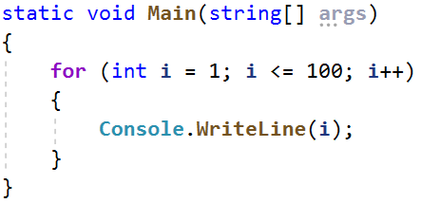
- Test your solution in the Judge system.

Numbers N…1
Write a program that reads a positive integer n entered by the user and prints the numbers from n to 1 in reverse order. The entered number n will always be greater than 1.

Sample Input and Output
Input | Output |  | Input | Output |  | Input | Output
2 | 2  1 |  | 3 | 3  2  1 |  | 5 | 5  4  3  2  1

Hints and Guidelines
1. Create a new project named "NumbersNTo1".
2. Go into the body of the Main(String[] args) method and write the solution to the problem. You can help yourself with the code from the image below and note that a loop with a negative step is used:
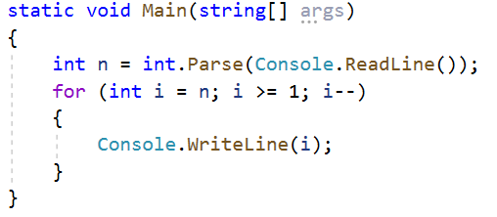
3. Test your solution in the Judge system.

Numbers 1...N with Step 3
Write a program that reads a number n entered by the user and prints the numbers from 1 to n with step 3.

Sample Input and Output
Input | Output |  | Input | Output |  | Input | Output
10 | 1  4  7  10 |  | 7 | 1  4  7 |  | 15 | 1  4  7  10  13

Hints and Guidelines
1. Create a new project named " Number1ToNWithStep3".
2. Go into the body of the Main(String[] args) method and write the solution to the problem. You can help yourself with the code from the image below and note that a loop is with step 3:
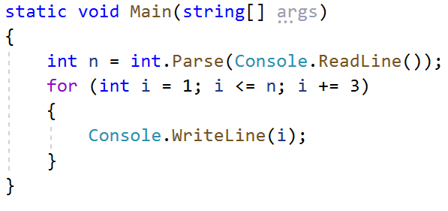
3. Test your solution in the Judge system.

Even Powers of 2
Write a program that receives a number n and prints the even powers of 2 ≤ 2^{n}: 2⁰, 2², 2⁴, 2⁶, …, 2^{n}.

Sample Input and Output
Input | Output |  | Input | Output |  | Input | Output |  | Input | Output |  | Input | Output
3 | 1  4 |  | 4 | 1  4  16 |  | 5 | 1  4  16 |  | 6 | 1  4  16  64 |  | 7 | 1  4  16  64
Test your solution in the Judge system.

Character Sequence
Write a program that receives text (string) and prints each character of the string on a separate line.

Sample Input and Output
Input | Output | Input | Output
softuni | s  o  f  t  u  n  i | ice cream | i  c  e  c  r  e  a  m

Hints and Guidelines
- Read the input text:
- Make a for loop with the initial value of the control variable from 0 to input.Length (the length of the text). At each iteration, take the letter at position in the input word equal to the value of the control variable i, using the charAt() method:
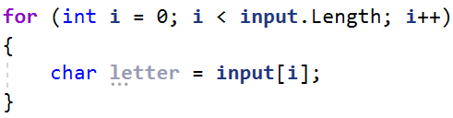
- At each iteration, print the value of the variable letter:
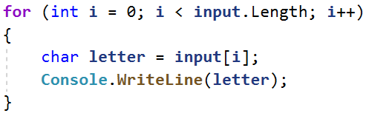
- Test your solution in the Judge system.

Vowels Sum
Write a program that reads text (string) entered by the user and calculates and prints the sum of the vowel values according to the table below:
Letter | a | e | i | o | u
Value | 1 | 2 | 3 | 4 | 5

Sample Input and Output
Input | Output | Comments
hello | 6 | e + o = 2 + 4 = 6
hi | 3 | i = 3
bamboo | 9 | a + o + o = 1 + 4 + 4 = 9
beer | 4 | e + e = 2 + 2 = 4
Test your solution in the Judge system.

Sum Numbers
Write a program that reads n number of integers entered by the user and sums them.
- From the first line of the input, the count of numbers n is entered.
- From the next n lines, one integer is entered at a time.
The program has to read the numbers, sums them and prints their sum.

Sample Input and Output
Input | Output |  | Input | Output |  | Input | Output |  | Input | Output |  | Input | Output
2  10  20 | 30 |  | 3  -10  -20  -30 | -60 |  | 4  45  -20  7  11 | 43 |  | 1  999 | 999 |  | 0 | 0
Test your solution in the Judge system.

Number sequence
Write a program that reads n number of integers. Print the largest and the smallest number among the entered ones.

Sample Input and Output
Input | Output |  | Input | Output
5  10  20  304  0  50 | Max number: 304  Min number: 0 |  | 6  250  5  2  0  100  1000 | Max number: 1000  Min number: 0
Test your solution in the Judge system.

Left and Right Sum
Write a program that reads 2 * n number of integers given by the user and checks if the sum of the first n numbers (left sum) is equal to the sum of the second n numbers (right sum). If equal, prints "Yes, sum = " + sum; otherwise prints "No, diff = " + diff. The difference is calculated as a positive number (in absolute value).

Sample Input and Output
Input | Output | Comments |  | Input | Output | Comments
2  10  90  60  40 | Yes, sum = 100 | 10+90 = 60+40 = 100 |  | 2  90  9  50  50 | No, diff = 1 | 90+9 ≠ 50+50  Difference = |99-100| = 1
Test your solution in the Judge system.

Odd Even Sum
Write a program that reads n number of integers given by the user and checks whether the sum of the numbers in even positions is equal to the sum of the numbers in odd positions.
- If the sums are equal print two lines: "Yes" and on a new line "Sum = " + sum;
- If the sums are not equal print two lines: "No" and on a new line "Diff = " + the difference;
The difference is calculated by absolute value.

Sample Input and Output
Input | Output | Comments |  | Input | Output | Comments |  | Input | Output | Comments
4  10  50  60  20 | Yes  Sum = 70 | 10+60 = 50+20 = 70 |  | 4  3  5  1  -2 | No  Diff = 1 | 3+1 ≠ 5-2  Diff =  |4-3| = 1 |  | 3  5  8  1 | No  Diff = 2 | 5+1 ≠ 8  Diff =  |6-8| = 2
Test your solution in the Judge system.

