Lab: While Loop
Problems for lab exercise for the course "Programming Basics" @ SoftUni Global
Submit your solutions in the SoftUni Judge system: https://judge.softuni.org/Contests/Compete/Index/4572

Read Text
Write a program that reads text from the console(string) and prints it until it receives the "Stop" command.

Sample Input and Output
Input | Output |  | Input | Output
Smith  SoftUni  Sofia  Bulgaria  SomeText  Stop  AfterStop  Europe  HelloWorld | Smith  SoftUni  Sofia  Bulgaria  SomeText |  | Sofia  Berlin  Moscow  Athens  Madrid  London  Paris  Stop  AfterStop | Sofia  Berlin  Moscow  Athens  Madrid  London  Paris
Test your solution in the Judge system.

Password
Write a program that initially reads the username and password of a user profile. Then reads the login password.
- On entering the wrong passwords: prompt the user to enter a new password.
- On entering the correct password: print "Welcome {username}!".

Sample Input and Output
Input | Output |  | Input | Output
Smith  1234  pass  1324  1234 | Welcome Smith! |  | George  secret  secret | Welcome George!

Hints and Guidelines
- Initialize two variables username and password, which will contain the username and password:
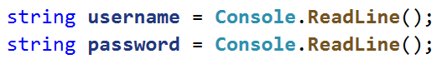
- Initialize the variable input, which will hold the user's login password:
- In a while loop, until a valid password is entered, read a new one:
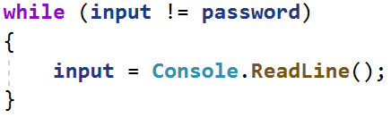

- When a valid password is entered, print the successful login message:
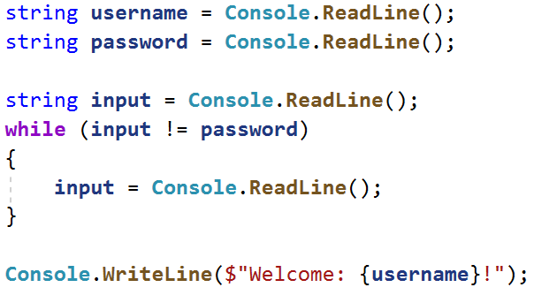
- Test your solution in the Judge system.

Sum Numbers
Write a program that reads an integer from the console and on each following line integers until their sum is greater than or equal to the original number. When the reading is finished, print the sum of the entered numbers.

Sample Input and Output
Input | Output | Input | Output
100  10  20  30  40 | 100 | 20  1  2  3  4  5  6 | 21
Test your solution in the Judge system.

Sequence 2k + 1
Write a program that accepts the number n entered by the user and prints all numbers ≤ n in the sequence: 1, 3, 7, 15, 31... Each following number is calculated by multiplying the previous number by 2 and adding 1.

Sample Input and Output
Input | Output |  | Input | Output |  | Input | Output |  | Input | Output
3 | 1  3 |  | 8 | 1  3  7 |  | 17 | 1  3  7  15 |  | 31 | 1  3  7  15  31

Hints and Guidelines
- Read an integer from the console.
- Create a variable of type integer, which will be a counter and has initial value 1.
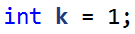
- Create a while loop that repeats until the counter is smaller than the number you read from the console.
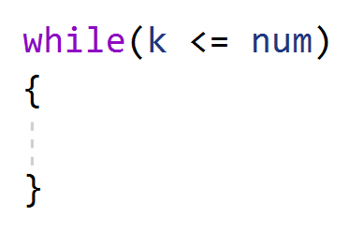
- At each loop iteration, print the counter value and add the given value to it.
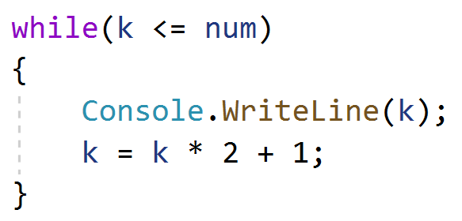
5. Test your solution in the Judge system.

Account Balance
Write a program that calculates how much total money is in a bank account after making a certain number of deposits. On each line, you will receive the amount you need to deposit into the account until you receive a "NoMoreMoney" command. For each amount received, the console should output "Increase: " + the amount and that amount should be added to the account. If a number less than 0 is received, the console should output "Invalid operation!" and the program should end. When the program ends, it should print "Total: " + the total amount in the account, formatted to two digits after the decimal point.

Sample Input and Output
Input | Output |  | Input | Output
5.51  69.42  100  NoMoreMoney | Increase: 5.51  Increase: 69.42  Increase: 100.00  Total: 174.93 |  | 120  45.55  -150 | Increase: 120.00  Increase: 45.55  Invalid operation!  Total: 165.55
Test your solution in the Judge system.

Max Number
Write a program that, until it receives the "Stop" command, reads integers entered by the user, finds the largest among them, and prints it. One number is entered per line.

Sample Input and Output
Input | Output |  | Input | Output |  | Input | Output |  | Input | Output |  | Input | Output
100  99  80  70  Stop | 100 |  | -10  20  -30  Stop | 20 |  | 45  -20  7  99  Stop | 99 |  | 999  Stop | 999 |  | -1  -2  Stop | -1
Test your solution in the Judge system.

Min Number
Write a program that, until it receives the "Stop" command, reads integers entered by the user, finds the least among them, and prints it. One number is entered per line.

Sample Input and Output
Input | Output |  | Input | Output |  | Input | Output |  | Input | Output |  | Input | Output
100  99  80  70  Stop | 70 |  | -10  20  -30  Stop | -30 |  | 45  -20  7  99  Stop | -20 |  | 999  Stop | 999 |  | -1  -2  Stop | -2
Test your solution in the Judge system.

8. Graduation
Write a program that calculates the student's average grade from all of his/her studies. On the first line you will receive the student's name, and on each following line his/her annual grades. The student passes to the next grade if his annual grade is greater than or equal to 4.00. If he/she failed more than once, he/she will be excluded and the program ends, printing the student's name and the class from which he/she was excluded.
At the successful completion of grade 12 to be printed:
"{student's name} graduated. Average grade: {average grade of all studies}"
In the student is excluded from school, to be printed:
"{student's name} has been excluded at {class he/she was excluded from} grade"
The average grade must be formatted to two digits after the decimal point.

Sample Input and Output
Input | Output |  | Input | Output
George  5  5.5  6  5.43  5.5  6  5.55  5  6  6  5.43  5 | George graduated. Average grade: 5.53 |  | Mary  5  6  5  6  5  6  6  2  3 | Mary has been excluded at 8 grade
Test your solution in the Judge system.

