Exercise: Nested Loops
Problems for exercise and homework for the course "Programming Basics " @ SoftUni Global
Submit your solutions to the SoftUni Judge system: https://judge.softuni.org/Contests/Compete/Index/4575

Number Pyramid
Write a program that receives an integer n, entered by the user, and prints a pyramid of numbers as in the examples.
Input | Output |  | Input | Output |  | Input | Output |  | Input | Output
7 | 1  2 3  4 5 6  7 |  | 10 | 1  2 3  4 5 6  7 8 9 10 |  | 12 | 1  2 3  4 5 6  7 8 9 10  11 12 |  | 15 | 1  2 3  4 5 6  7 8 9 10  11 12 13 14 15

Hints and Guidelines
- Read an integer from the console:
- Create two nested for loops, with which to print the pyramid of numbers, as the outer loop will determine how many rows to print, and the inner - how many numbers are printed on the corresponding row:
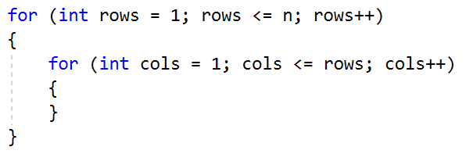
- In a separate counter keep how many numbers you have printed so far (and what is the current number). When you reach n, exit the two nested loops. To exit both loops, we need to use the break operator in both of them. For this purpose, we will make a boolean variable to check if we have exited from the inner loop. Go to the beginning of the program and initialize the following two variables:
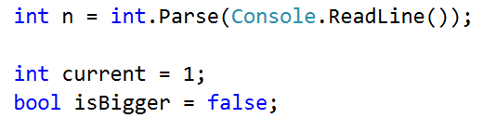
- In the inner for loop, check if the current variable has become greater than n. If so, change the value of the boolean variable and exit the inner loop:
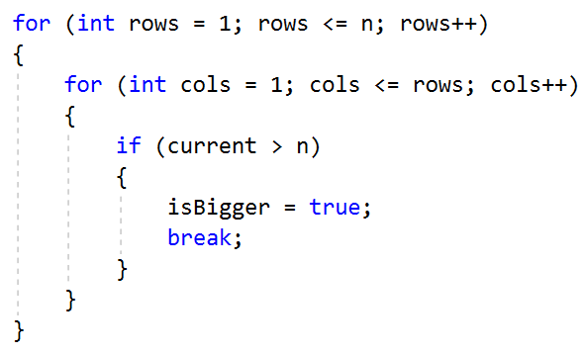
- After checking, print the current variable in the desired format and increment it by 1. If you are out of the loop, no print will be reached!
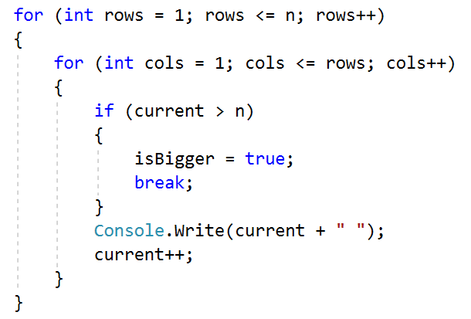
- In the body of the outer loop, check if we need to exit it as well. Then print a blank line so that the next numbers are on a new line. If we have exited the outer loop, we will not get to execute the Console.WriteLine() command! Your program should look like this:
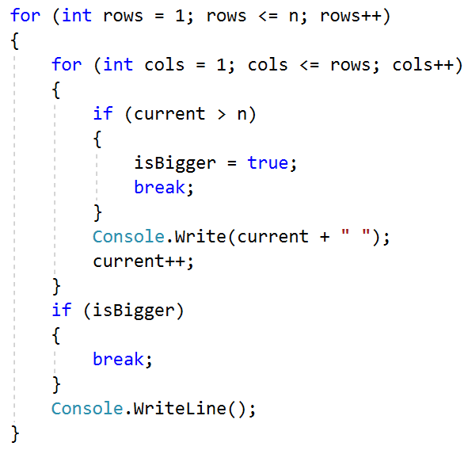
- Test your solution in the Judge system.
- Equal Sums Even Odd Position
Write a program that reads from the console two six-digit integers in the range 100000 to 300000. Always the first number entered will be less than the second. On the console, print on 1 line separated by space all the numbers that lie between the two numbers read from the console and satisfy the following condition:
- the sum of the digits of even and odd positions to be equal. If no numbers match the condition no result is displayed on the console.

Sample Input and Output
Input | Output | Comments
100000  100050 | 100001 100012 100023 100034 100045 | The first number we generate is the number 100000. The sum of the digits of even positions (yellow) is 0 + 0 + 0 = 0. The sum of the digits of odd positions (green) is 0 + 0 + 1 = 1. Since the two sums are different, the number is not printed on the console.  The next number is 100001. The sum of even positions is 1 + 0 + 0 = 1, and of odd positions 0 + 0 + 1 = 1. The two sums are equal and the number is printed.  The next number to check is 100002. It doesn’t meet the conditions and is not printed.  ……  With the number 100045, the sum of the even positions is 5 + 0 + 0 = 5, and of the odd 4 + 0 + 1 = 5. Both sums are equal and the number is printed. Etc.
Input | Output | Input | Output | Input | Output
123456  124000 | 123464 123475 123486 123497 123530 123541 123552 123563 123574 123585 123596 123640 123651 123662 123673 123684 123695 123750 123761 123772 123783 123794 123860 123871 123882 123893 123970 123981 123992 | 299900  300000 | 299970 299981 299992 | 100115  100120 | No output

Hints and Guidelines
- Read user input:
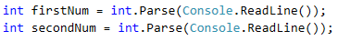

- To go through all the numbers in the interval, do a for loop. After you have read the input numbers, set the first number to the initial value of the control variable. Iterate until the second number is reached, increasing the value of the control variable by 1:
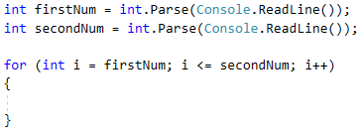

- Get the number of the current position as string using the method.ToString():
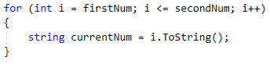

- To iterate over each digit of the number, do a for loop. Once it is taken as string, take its length with.Length. Iterate until the length of the number is reached, increasing the value of the control variable by 1:
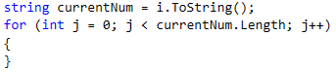

- Continue to complete the logic to find the sum of the even and odd positions for each number. Declare one variable each for the even and odd sum. To get the exact numerical value of the digits use the method int.Parse().
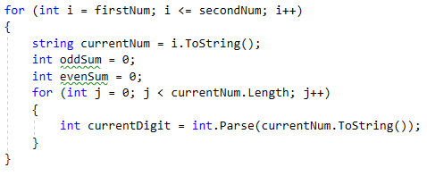

- To find the digits that are in the even position, use a conditional if statement, check if its index is an even number by dividing it modularly by 2(index % 2), if it is even, add it to the sum of the even ones, if it is not, add it to the sum of the odd ones.
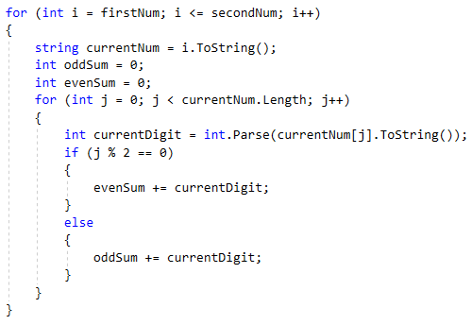

- Once you have found the sum of the numbers in the even and odd positions, check if they are equal, if they are, print the number. Your program should look like this: 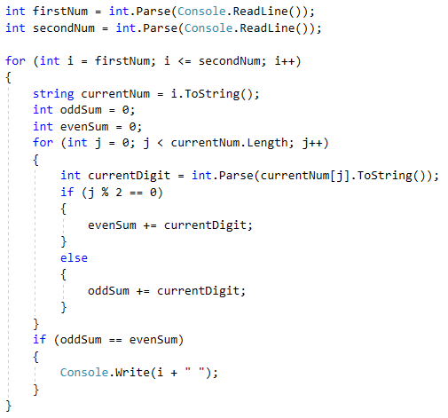
- Test your solution in the Judge system.

Sum Prime Non-Prime
Write a program that reads integers from the console until a "stop" command is received. Find the sum of all the entered prime numbers and the sum of all the entered non-prime numbers. Since by mathematical definition negative numbers cannot be prime, if the input is a negative number, display the following message "Number is negative." In this case, the entered number is ignored and is not added to either of the two sums, and the program continues its execution, waiting for another number to be entered.
The output should print on two lines the two found sums in the following format:
- "Sum of all prime numbers is: {prime numbers sum}"
- "Sum of all non prime numbers is: {nonprime numbers sum}"

Sample Input and Output
Input | Output | Comments
3  9  0  7  19  4  stop | Sum of all prime numbers is: 29  Sum of all non prime numbers is: 13 | The first entered number is 3. It is prime, so we add it to the sum of prime numbers.  The next number is 9. It is not prime, so we add it to the sum of non-prime numbers.  The number 0 is not prime, so we add it to the sum of non-prime numbers. The sum is 9+0=9.  The next two numbers are 7 and 19. Both are prime, so we add them to the sum of prime numbers. 3+7=10 and 10+19=29.  The next number is 4, which is not prime, so we add it to the corresponding sum 9+4=13.  The stop command is received. The program stops its execution and we print both sums.
Input | Output | Input | Output
30  83  33  -1  20  stop | Number is negative.  Sum of all prime numbers is: 83  Sum of all non prime numbers is: 83 | 0  -9  0  stop | Number is negative.  Sum of all prime numbers is: 0  Sum of all non prime numbers is: 0
Test your solution in the Judge system.

Train the Trainers
The "Train the trainers" course is coming to an end and the final evaluation is approaching. Your task is to help the jury that will evaluate the presentations by writing a program in which to calculate the average grade of each of the student’s presentations, and finally - the average grade of all of them.
From the console on the first line is read the number of people in the jury n – an integer.
Then on a separate line is read the name of the presentation - string.
For each presentation on a new line, n number of grades are read - a floating-point number.
After calculating the average grade for a specific presentation, print on the console:
"{presentation name} - {average grade}."
After receiving the command "Finish" print on the console:
"Student's final assessment is {average grade from all presentations}." and the program stops.
All grades must be formatted to two digits after the decimal point.

Sample Input and Output
Input | Output | Comments
2  While-Loop  6.00  5.50  For-Loop  5.84  5.66  Finish | While-Loop - 5.75.  For-Loop - 5.75.  Student's final assessment is 5.75. | 2 – the number of the people in the jury, therefore each presentation will receive 2 grades.  (6.00 + 5.50) / 2 = 5.75  (5.84 + 5.66) / 2 = 5.75  (6.00 + 5.50 + 5.84 + 5.66) / 4 = 5.75
Input | Output | Input | Output
3  Arrays  4.53  5.23  5.00  Lists  5.83  6.00  5.42  Finish | Arrays - 4.92.  Lists - 5.75.  Student's final assessment is 5.34. | 2  Objects and Classes  5.77  4.23  Dictionaries  4.62  5.02  RegEx  2.88  3.42  Finish | Objects and Classes - 5.00.  Dictionaries - 4.82.  RegEx - 3.15.  Student's final assessment is 4.32.
Test your solution in the Judge system.

Special Numbers
Write a program that reads a single integer N entered by the user and generates all possible "special" numbers from 1111 to 9999. For a number to be "special", it must meet the following condition:
- N to be divisible by each of its digits without remainder.
Example: with N = 16, 2418 is a special number:
- 16 / 2 = 8 no remainder
- 16 / 4 = 4 no remainder
- 16 / 1 = 16 no remainder
- 16 / 8 = 2 no remainder

Input Data
The input is read from the console and consists of an integer in the range [1...600000]

Output Data
Print all "special" numbers on the console, separated by a space.

Sample Input and Output
Input | Output |  | Comments
3 | 1111 1113 1131 1133 1311 1313 1331 1333 3111 3113 3131 3133 3311 3313 3331 3333 | 3 / 1 = 3 no remainder  3 / 3 = 1 no remainder  3 / 3 = 1 no remainder  3 / 3 = 1 no remainder
11 | 1111
16 | 1111 1112 1114 1118 1121 1122 1124 1128 1141 1142 1144 1148 1181 1182 1184 1188 1211 1212 1214 1218 1221 1222 1224 1228 1241 1242 1244 1248 1281 1282 1284 1288 1411 1412 1414 1418 1421 1422 1424 1428 1441 1442 1444 1448 1481 1482 1484 1488 1811 1812 1814 1818 1821 1822 1824 1828 1841 1842 1844 1848 1881 1882 1884 1888 2111 2112 2114 2118 2121 2122 2124 2128 2141 2142 2144 2148 2181 2182 2184 2188 2211 2212 2214 2218 2221 2222 2224 2228 2241 2242 2244 2248 2281 2282 2284 2288 2411 2412 2414 2418 2421 2422 2424 2428 2441 2442 2444 2448 2481 2482 2484 2488 2811 2812 2814 2818 2821 2822 2824 2828 2841 2842 2844 2848 2881 2882 2884 2888 4111 4112 4114 4118 4121 4122 4124 4128 4141 4142 4144 4148 4181 4182 4184 4188 4211 4212 4214 4218 4221 4222 4224 4228 4241 4242 4244 4248 4281 4282 4284 4288 4411 4412 4414 4418 4421 4422 4424 4428 4441 4442 4444 4448 4481 4482 4484 4488 4811 4812 4814 4818 4821 4822 4824 4828 4841 4842 4844 4848 4881 4882 4884 4888 8111 8112 8114 8118 8121 8122 8124 8128 8141 8142 8144 8148 8181 8182 8184 8188 8211 8212 8214 8218 8221 8222 8224 8228 8241 8242 8244 8248 8281 8282 8284 8288 8411 8412 8414 8418 8421 8422 8424 8428 8441 8442 8444 8448 8481 8482 8484 8488 8811 8812 8814 8818 8821 8822 8824 8828 8841 8842 8844 8848 8881 8882 8884 8888
Test your solution in the Judge system.

Cinema Tickets
Your task is to write a program that calculates the percentage of tickets for each type of the sold tickets: student, standard, and kid for all screenings. You also need to calculate what percentage of the hall is filled for each screening.

Input Data
The input is a series of integers and strings:
- On the first line, until receiving the "Finish" command – title of the movie – string
- On the second line – the free seats in the hall for each screening – an integer [1 … 100]
- For each movie, one line is read until there are no more free seats in the hall, or until the "End" command is received:
  - The type of the sold ticket – string ("student", "standard", "kid")

Output Data
Print the following lines to the console:
- After each movie, print what percentage of the cinema hall is full:
"{Movie title} - {percentage of taken seats}% full."
- On receiving the "Finish" command, print four lines:
  - "Total tickets: {the sum of all sold tickets for all movies}"
  - "{percentage of student tickets}% student tickets."
  - "{percentage of standard tickets}% standard tickets."
  - "{percentage of kids tickets}% kids tickets."

Sample Input and Output
Input | Output | Comments
Taxi  10  standard  kid  student  student  standard  standard  End  Scary Movie  6  student  student  student  student  student  student  Finish | Taxi - 60.00% full.  Scary Movie - 100.00% full.  Total tickets: 12  66.67% student tickets.  25.00% standard tickets.  8.33% kids tickets. | First movie – Taxi, the seats in the hall are 10  3 standard, 2 student, 1 kid tickets are bought until receiving the End command.  There are 6 tickets out of 10 seats -> 60% of the hall is occupied.  Second movie – Scary Movie, the seats in the hall are 6  6 student tickets are bought and there are no more free seats in the hall.  There are 6 tickets out of 6 seats -> 100% of the hall is occupied.  The command Finish is received.  The total number of purchased tickets for all movies is 12.  For all movies, there are:  8 student tickets. 8 tickets out of 12 are 66.67%  3 standard tickets. 3 tickets out of 12 are 25%  1 kid ticket. 1 ticket out of 12 is 8.33%
Input | Output | Comments
The Matrix  20  student  standard  kid  kid  student  student  standard  student  End  The Green Mile  17  student  standard  standard  student  standard  student  End  Amadeus  3  standard  standard  standard  Finish | The Matrix - 40.00% full.  The Green Mile - 35.29% full.  Amadeus - 100.00% full.  Total tickets: 17  41.18% student tickets.  47.06% standard tickets.  11.76% kids tickets. | First movie – The Matrix, the seats in the hall are 20  2 standard, 4 student, 2 kids tickets are bought until receiving the End command.  There are 8 tickets out of 20 seats -> 41.18% of the hall is occupied.  Second movie - The Green Mile, the seats in the hall are 17  3 standard, 3 student tickets are bought until receiving the End command.  There are 6 tickets out of 17 seats-> 47.06% of the hall is occupied.  Third movie – Amadeus, the seats in the hall are 3  3 standard tickets are bought and there are no more free seats in the hall.  There are 3 tickets out of 3 seats-> 100% of the hall is occupied.  The command Finish is received.  The total number of purchased tickets for all movies is 17.  For all movies, there are:  7 student tickets. 7 tickets out of 17 are 41.18%  8 standard tickets. 8 tickets out of 17 are 47.06%  2 kids tickets. 2 tickets out of 17 are 11.76%
Test your solution in the Judge system.

