Homework: Heaps and Priority Queues
This document defines the homework assignments for the "Data Structures" course @ Software University.

Implement Decrease Key
Extend your Binary Heap to support the DecreaseKey(T element) operation, that changes the priority of a given key. In a Min Binary Heap this should increase the priority of a given key, moving it higher in the tree structure, e.g. decreasing the price of a given product, increases its priority for the customers.

A* Algorithm
You are given a skeleton. Your task is to implement the A* algorithm in order to find the shortest path from a starting point "P" (Start) to a goal point "*" (Goal) on a given grid of squares. Player is only allowed to walk up, right, down or left. The AStar class should return the path as IEnumerable<Node>, each entry corresponding to the next cell in the shortest path.
You can read more about the A* here: http://web.mit.edu/eranki/www/tutorials/search/
Or here: http://www.redblobgames.com/pathfinding/a-star/introduction.html
Maze | Output Nodes | Path
-----  -*---  WWWW-  ---P- | { "3 3", "3 4", "2 4", "1 4", "1 3", "1 2", "1 1" } | -----  -@@@@  WWWW@  ---@@

If there is no path to the goal, return IEnumerable<Node> containing only the start node.
Maze | Output Nodes | Path
-----  -*---  WWWWW  ---P- | { "3 3" } | -----  -----  WWWWW  ---@-

Hints: H Cost
First of all, implement the method GetH(). H is the approximation of the distance from the current node to the goal. Use Manhattan distance (total number of squares moved horizontally and vertically to reach the target, ignoring diagonal movement, and ignoring any obstacles that may be in the way)
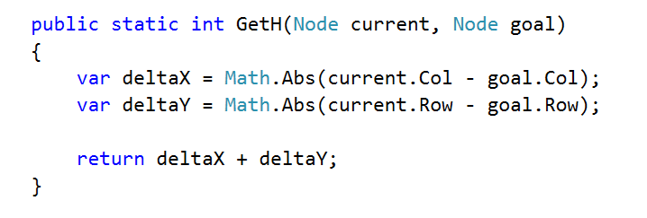

Hints: A* Pseudocode
We need some way to store to cost to a given node and the node that we are coming from.
- OPEN = priority queue containing START
- PARENT = dictionary storing the node from which we have reached a node (following a path)
- COST = dictionary storing cost from the start to a node (following a path)
- PARENT[START] = null
- COST[START] = 0

- while OPEN is not empty:
  - current = remove highest priority item from OPEN
  - if current is the goal break
  - for each neighbor of current (up, right, down, left):
    - new cost = COST[current] + 1
    - if neighbor is not in COST or new cost < COST[neighbor]
      - COST[neighbor] = new cost
      - neighbor.F = new cost + HCost(neighbor, goal)
      - OPEN neighbor
      - PARENT[neighbor] = current

You can reconstruct the path following PARENT[goal] to the starting node. If there is no path to the goal PARENT[goal] won't be in the dictionary.

