Exercises: Implement Binary Search Tree
This document defines the in-class exercises assignments for the "Data Structures" course @ Software University.
Your submissions can check in judge: https://judge.softuni.bg/Contests/624/B-Trees-and-Red-Black-Tree-CSharp-Lab
This lab aims to implement the insertion functionality of a red-black binary search tree. You are given the skeleton of a fully implemented BST.

Change the Node Data Structure
First, you will need to add a color bit to our node class:
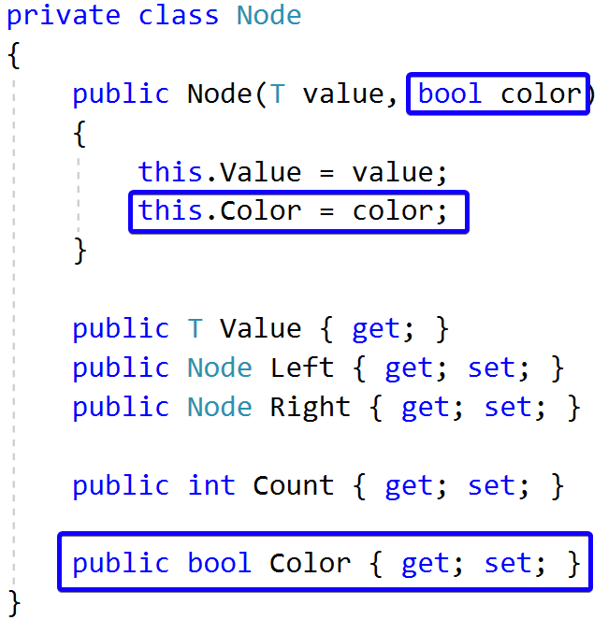

Check Red Node
Add the following constants to your RedBlackTree class:
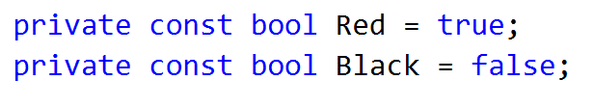
Now create a helper method that will check if a node is red:
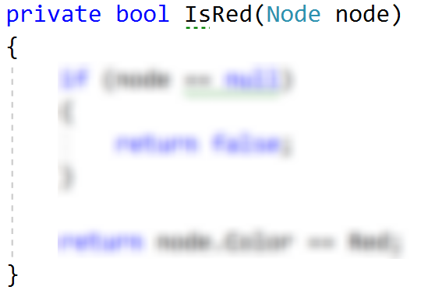

Left Rotation
Create a method that will accomplish the left rotation for a given node.
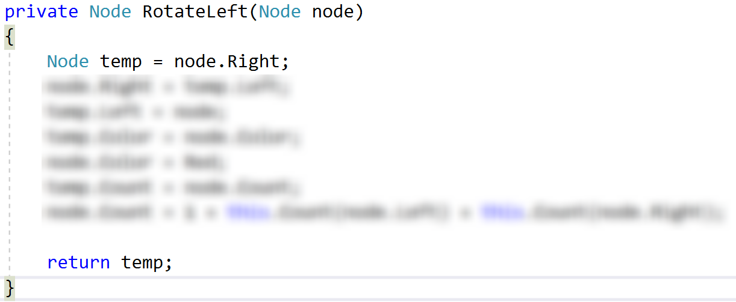

Right Rotation
Create a method that will perform right rotation on a given node. The code is similar to the left rotation.

Flip Colours
Implement a method that will make a node "black" and its children "red".

Insert
Modify the existing insert() method. It should create new red node for every insert, balance the tree and recolour the nodes if needed.

Run Unit Tests
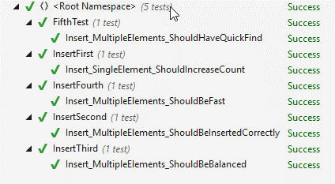
That's it, you're ready to start implementing delete. :)

