Homework: AVL Trees and AA Trees
This document defines the homework assignments for the "Data Structures" course @ Software University. You can submit your code in the SoftUni Judge System - https://judge.softuni.bg/Contests/630/AVL-Trees-and-AA-Trees-CSharp-Exercise.

First / Last List
You need to implement a “first / last list” data structure that performs fast enough the following operations:
- Add(element)
  - Adds an element to the structure (duplicate elements are accepted)
- Count
  - Returns the number of elements in the structure
- First(count)
  - Returns the earliest added count elements (in the order of addition from first to last)
  - Throws an exception in case the structure holds less than count elements
- Last(count)
  - Returns the latest added count elements (in the order of addition from last to first)
  - Throws an exception in case the structure holds less than count elements
- Min(count)
  - Returns the smallest count elements (ordered from the smallest to the largest as first criteria and by the order of adding as second criteria)
  - Throws an exception in case the structure holds less than count elements
  - Note: the elements should be comparable in order to find the minimal element
- Max(count)
  - Returns the biggest count elements (ordered from the biggest to the smallest as first criteria and by the order of adding as second criteria)
  - Throws an exception in case the structure holds less than count elements
  - Note: the elements should be comparable in order to find the maximal element
- Remove-All(element)
  - Removes all elements that are equal to the passed element
  - Returns the number of removed elements or 0 when no elements are matched
  - Note: the elements should be comparable in order to find which pairs of elements are equal
- Clear()
  - Removes all elements from the data structure

Input and Output
You are given a Visual Studio C# project skeleton (unfinished project) / Eclipse Java project / Visual Studio C++ project holding the interface IFirstLastList, the unfinished class FirstLastList and tests covering its functionality and its performance.
Your task is to finish this class to make the tests run correctly.
- You are not allowed to change the tests.
- You are not allowed to change the interface.

Interface IFirstLastList
The interface IFirstLastList in C# looks like the code below:
public interface IFirstLastList<T> where T : IComparable<T>
{
void Add(T element);
int Count { get; }
IEnumerable<T> First(int count);
IEnumerable<T> Last(int count);
IEnumerable<T> Min(int count);
IEnumerable<T> Max(int count);
void Clear();
int RemoveAll(T element);
}
The interface IFirstLastList in Java looks like the code below:
public interface IFirstLastList<T extends Comparable<T>> {
void add(T element);
int getCount();
Iterable<T> first(int count);
Iterable<T> last(int count);
Iterable<T> min(int count);
Iterable<T> max(int count);
void clear();
int removeAll(T element);
}

Unit Tests
The C# project holds many automated tests for the data structure functionality and its performance:
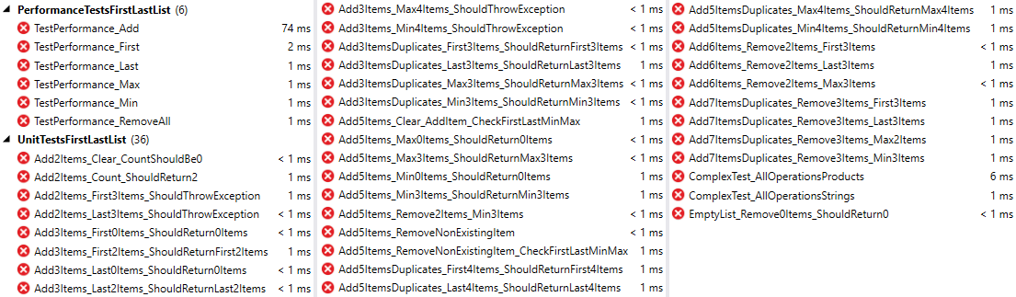

* Implement AVL Tree Deletion
Extend your AVL Tree to support:
- void DeleteMin() deletes the minimum element (balances the tree if necessary)
- void Delete(T item) deletes the given element (balances the tree if necessary)
You are given a skeleton with additional tests that cover delete operations.

