Lab: Interval Trees, K-d Trees
This document defines the in-class exercises assignments the "Data Structures" course @ Software University.
You are given a skeleton. Implement the following operations:
- Interval SearchAny(int, int) returns any interval that intersects with a given lower and upper bound
- IEnumerable<Interval> SearchAll(int, int) returns all intervals that intersect the given lower and upper bound
public class IntervalTree
{
private Node root;

public void Insert(double start, double end) { … }

public Interval SearchAny(double start, double end) { … }

public IEnumerable<Interval> SearchAll(double start, double end) { … }
}

Solution
You will need to update the max endpoint whenever you insert (or delete/balance) a node
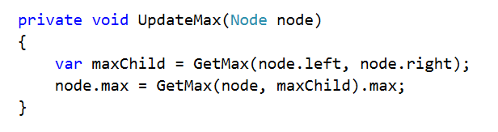
GetMax() returns the node that has greater max endpoint, while guarding against null values
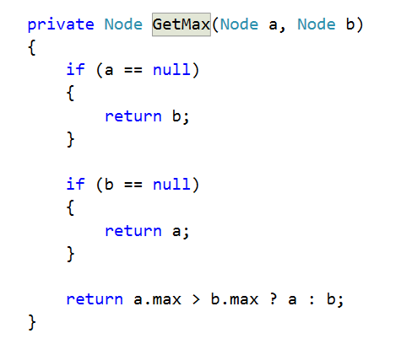
Search for any interval that intersects given bounds
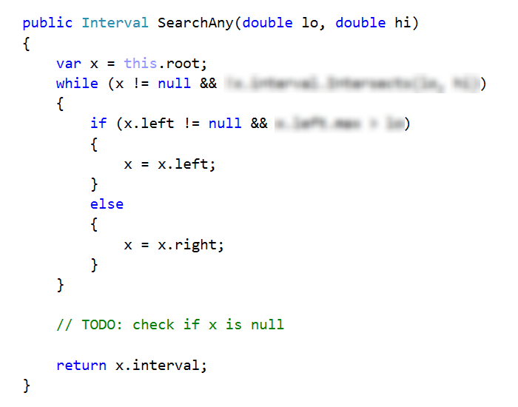
Searching for all intervals will do a recursive DFS, so you will need one method to call the recursion
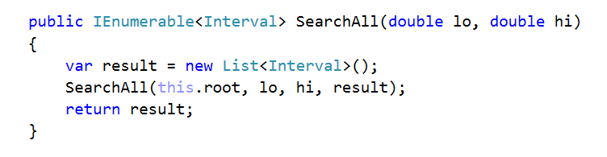
And the actual DFS
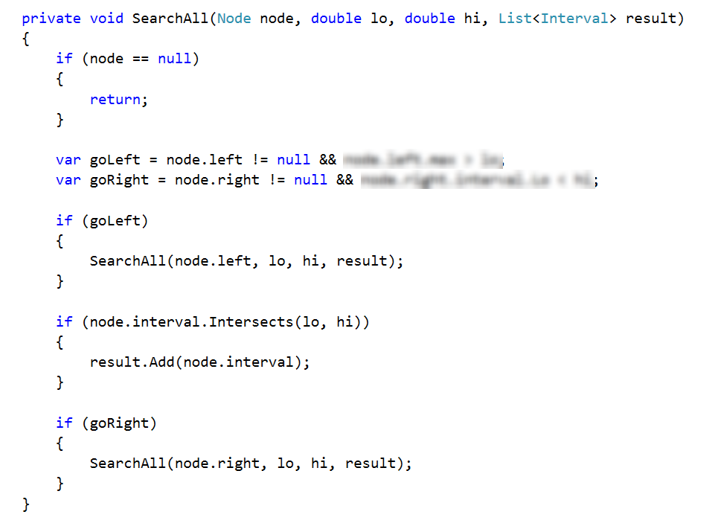

K-d Tree
You are given a skeleton. Implement the following operations:
- void Insert(Point2D) inserts a point into the tree
- bool Contains(Point2D) shows if the tree contains a given point
public class KdTree
{
private Node root;

public void Insert(Point2D point) { … }

public bool Contains(Point2D point) { … }

public void EachInOrder(Action<Point2D> action) { … }
}

Solution
The only thing different than a regular BST is the comparison. Create a method that will compare the point in a node and a second point, depending on the node depth
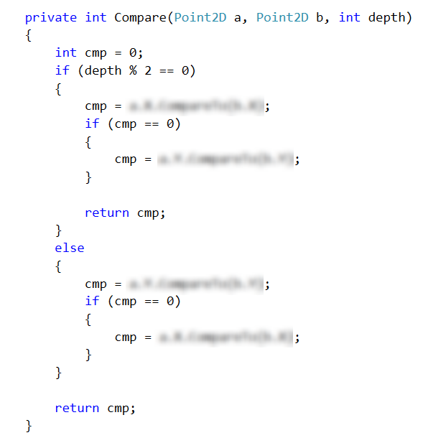
The other thing to consider is to pass the depth of a node when attemting to insert or search for a point

