Lab: Unit Testing
Problems for exercises and homework for the "C# OOP" course @ SoftUni".
You can check your solutions here: Unit-Testing-Lab

Part I: Unit Testing Basics

Test Axe
Load provided solution in Visual Studio. Add new project Tests
An AxeTests is given
Create the following tests:
- Test if weapon loses durability after each attack
- Test attacking with a broken weapon

Solution
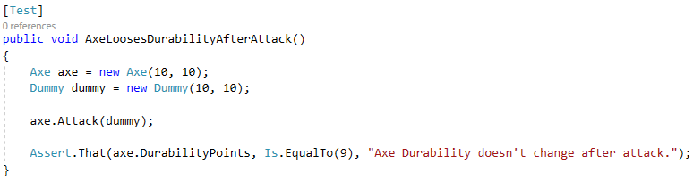

Test Dummy
A DummyTests is given
Create the following tests:
- Dummy loses health if attacked
- Dead Dummy throws an exception if attacked
- Dead Dummy can give XP
- Alive Dummy can't give XP

Hints
Follow the logic of the previous problem

Refactor Tests
Refactor the tests for Axe and Dummy classes
Make sure that:
- Names of test methods are descriptive
- You use appropriate assertions (assert equals vs assert true)
- You use assertion messages
- There are no magic numbers
- There is no code duplication (Don’t Repeat Yourself)

Hints
Extract constants and private fields for Axe class
Create a method that executes before each test
Make use of constants and private fields, as well as add assertion messages
Follow the same logic for other test methods and TestDummy class

