Box Model & Position
Problems for exercises and homework for the "HTML and CSS" course @ SoftUni. Submit your solutions in the SoftUni Judge system at https://judge.softuni.org/Contests/4381/03-Box-Model-and-Position.

Property: Padding
Use the skeleton is in resources to achieve the following view:
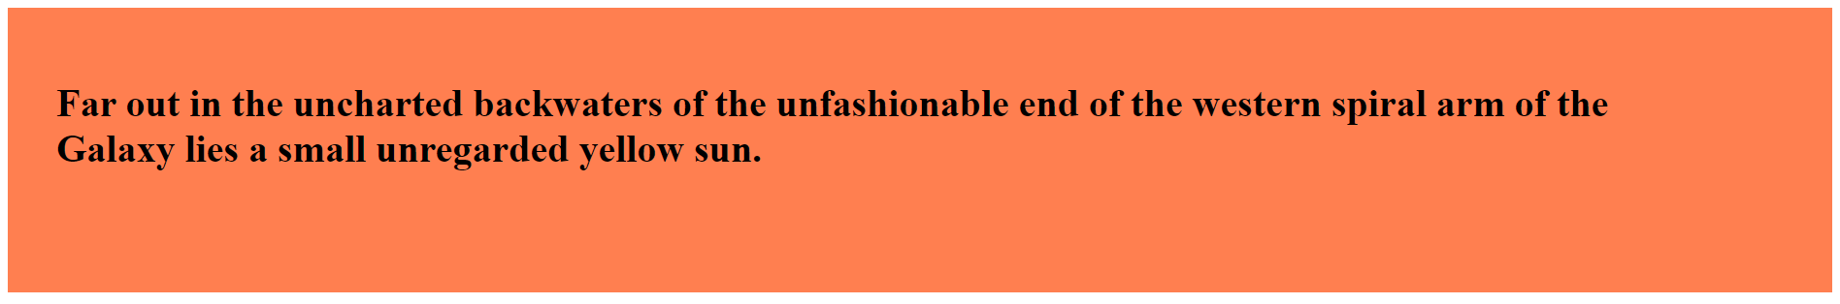
Use padding to solve the problem:
- Left – 20px
- Top – 30px
- Right – 40px
- Bottom – 50px

Property: Padding-Inline
Use the skeleton is in resources to achieve the following view:

Set padding-inline to 30% to solve the problem.

Property: Padding-Block
Use the skeleton is in resources to achieve the following view:
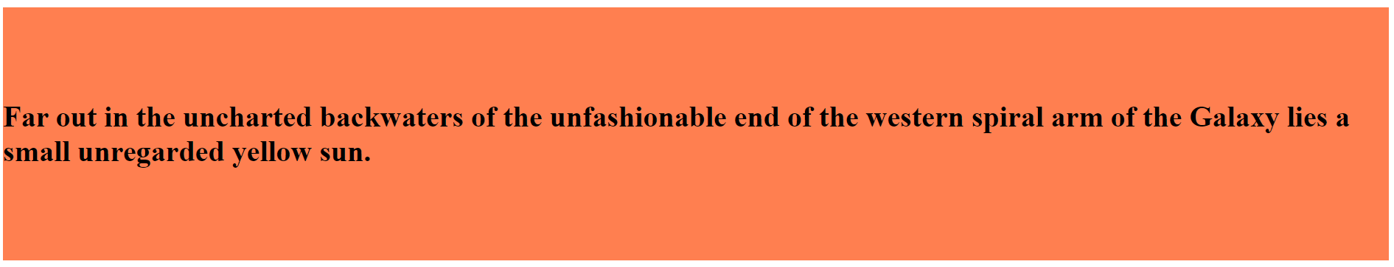
Set padding-block to 50px to solve the problem.

Property: Margin
Use the skeleton is in resources to achieve the following view:
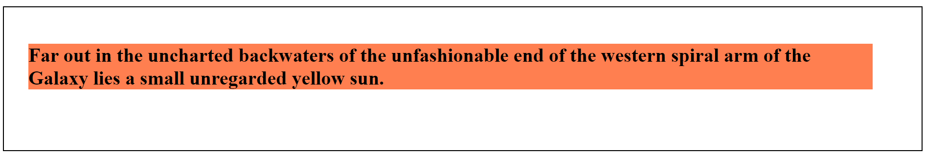
Use margin to solve the problem.
- Left – 20px
- Top – 30px
- Right – 40px
- Bottom – 50px

Property: Margin-Inline
Use the skeleton is in resources to achieve the following view:
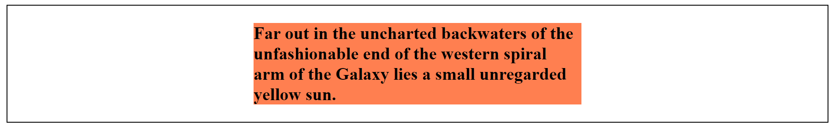
Set margin-inline to 30% to solve the problem.

Property: Margin-Block
Use the skeleton is in resources to achieve the following view:
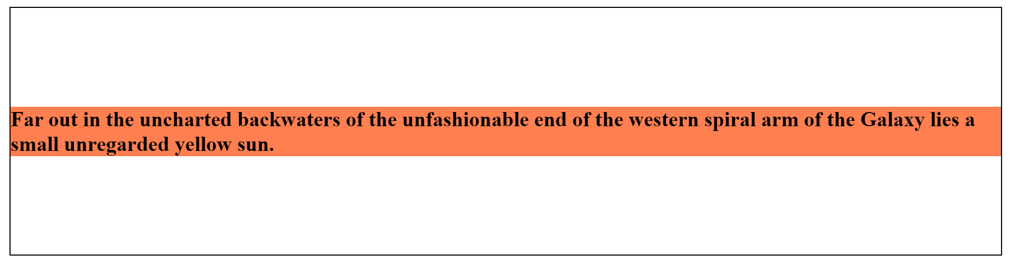
Set margin-block to 10% to solve the problem.

Property: Width
Use the skeleton is in resources to achieve the following view:
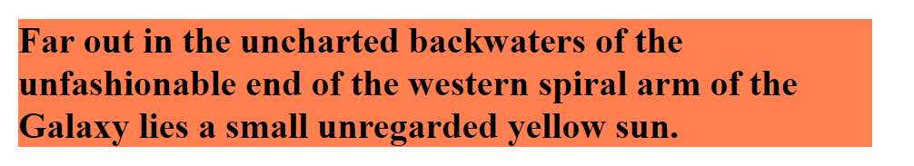
Set width to 50% to solve the problem.

Property: Height
Use the skeleton is in resources to achieve the following view:
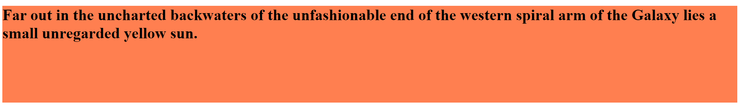
Set height to 100px to solve the problem.

Property: Border
Use the skeleton is in resources to achieve the following view:
Set border to 2px solid blue to solve the problem.

Property: Box-Sizing
Use the skeleton is in resources to achieve the following view:
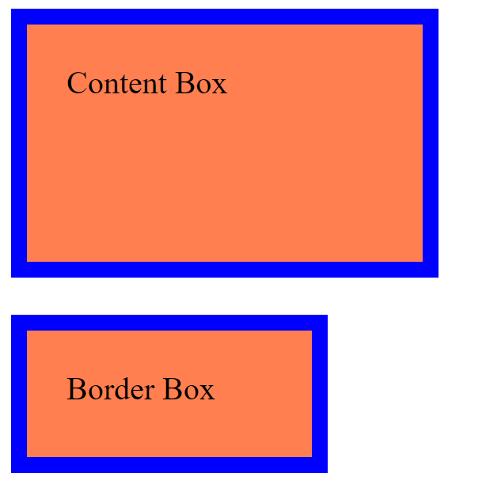
Use box-sizing to solve the problem.
- First Box – Use content-box on box-sizing
- Second Box – Use border-box on box-sizing

Property: Position - Absolute
Use the skeleton is in resources to achieve the following view:
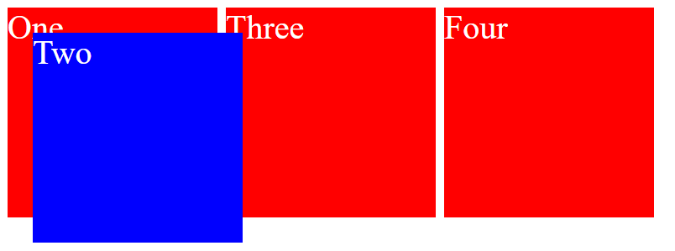
Set position to absolute to solve the problem.

Property: Position - Relative
Use the skeleton is in resources to achieve the following view:
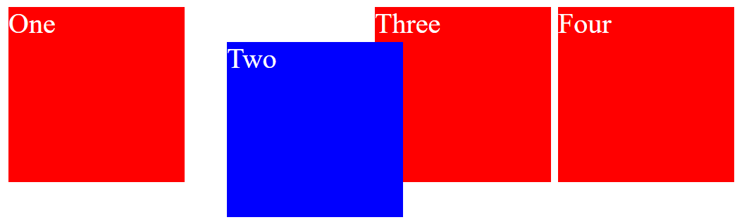
Set position to relative to solve the problem.

Property: Z-Index
Use skeleton, which is in resources to solve the next problem:
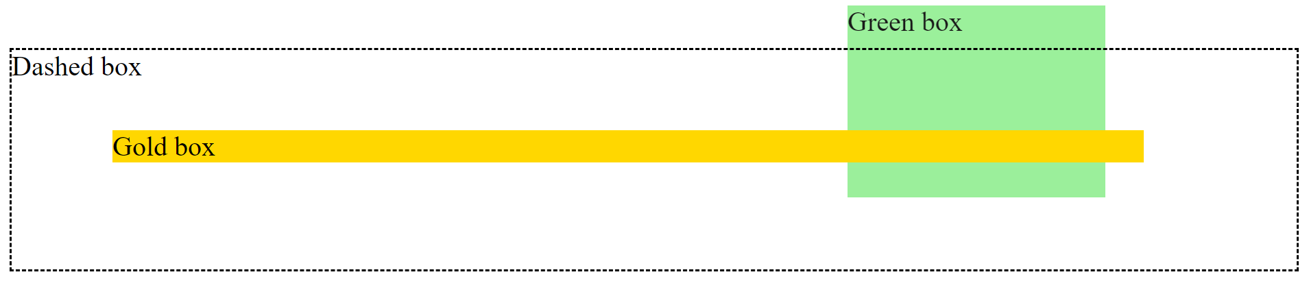
Use z-index to solve the problem:
- Put Dashed Box above the Green Box
- Put Gold Box above the Green Box
  - Green Box: z-index 1
  - Dashed Box: z-index 2
  - Gold Box: z-index 3

