CSS Layout - Flexbox
Problems for exercises and homework for the "HTML and CSS" course @ SoftUni. Submit your solutions in the SoftUni Judge system at https://judge.softuni.org/Contests/4382/04-CSS-Layout-Flexbox.

Property: Display Flex
Use the skeleton is in resources to achieve the following view:
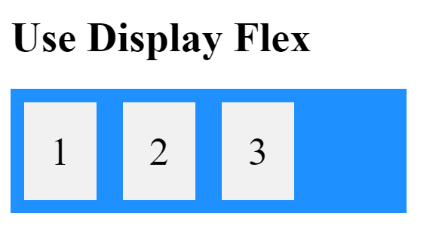
Use display to solve the problem.

Property: Flex Direction
Use the skeleton is in resources to achieve the following view:
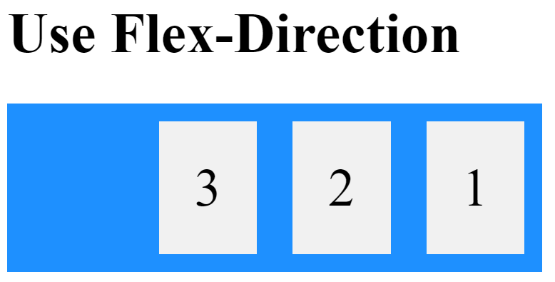
Set flex-direction to row-reverse to solve the problem.

Property: Flex Wrap
Use the skeleton is in resources to achieve the following view: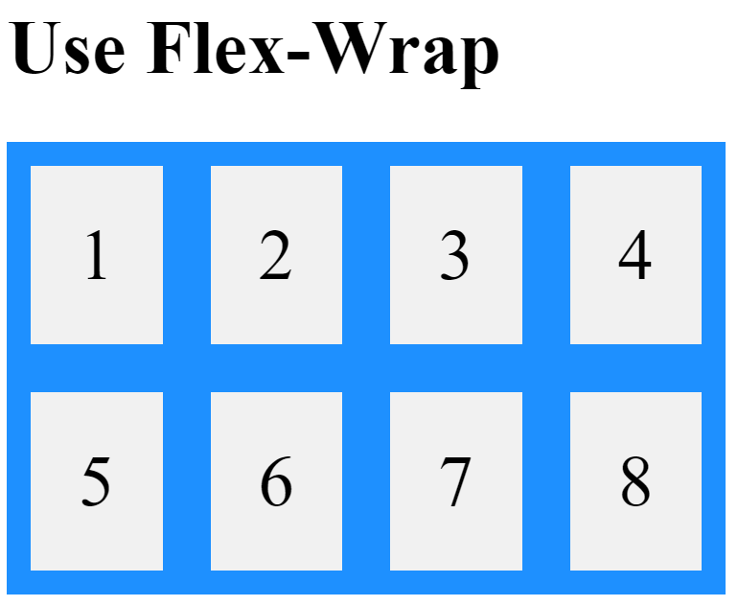
Set flex-wrap to wrap to solve the problem.

Property: Justify Content
Use the skeleton is in resources to achieve the following view: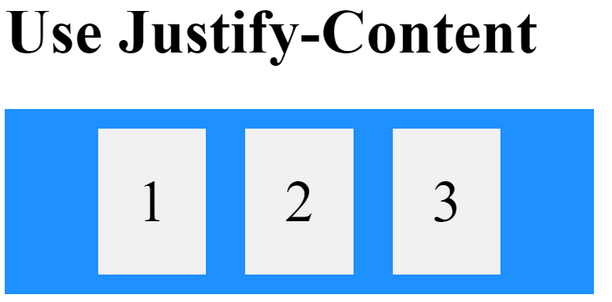
Set justify-content to center to solve the problem.

Property: Align Items
Use the skeleton is in resources to achieve the following view: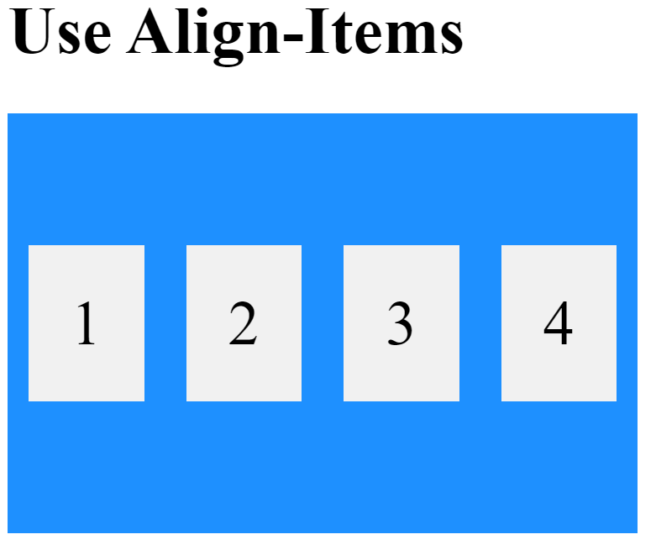
Set align-item to center to solve the problem.

Property: Align Content
Use the skeleton is in resources to achieve the following view: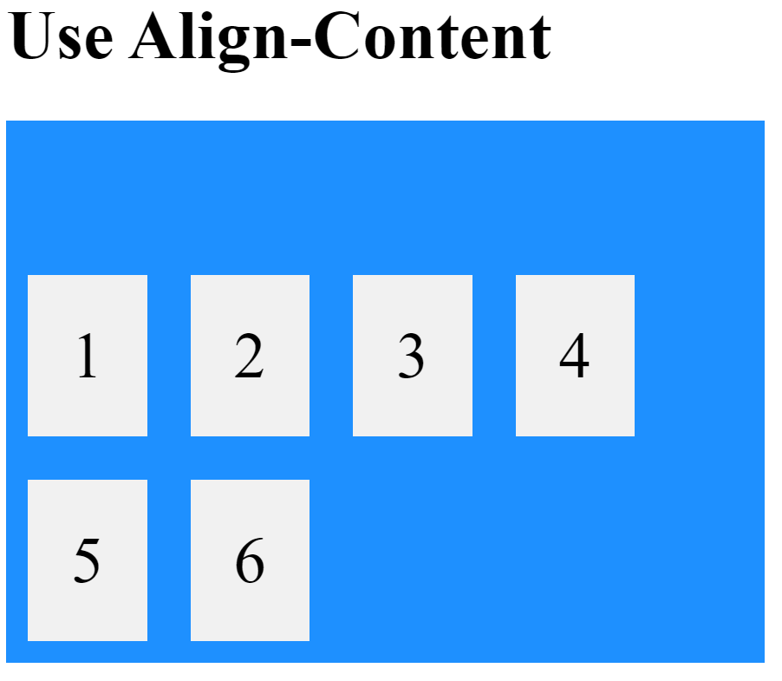
Set align-content to flex-end to solve the problem.

Property: Gap
Use the skeleton is in resources to achieve the following view: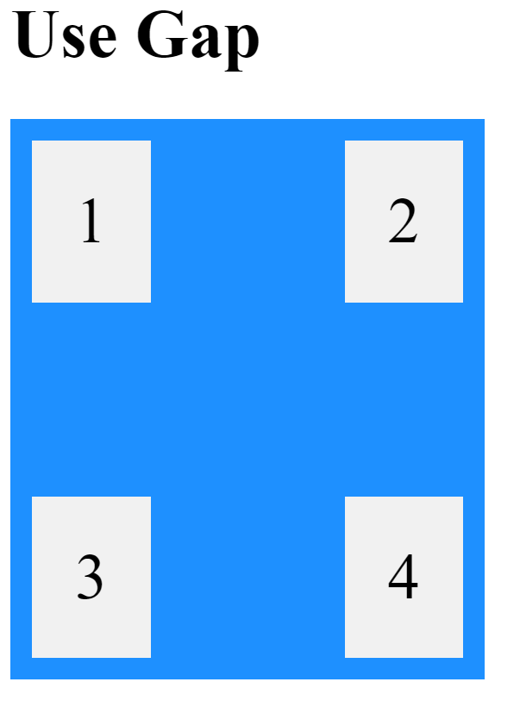
Set gap to 70px to solve the problem.

Property: Flex Grow
Use the skeleton is in resources to achieve the following view: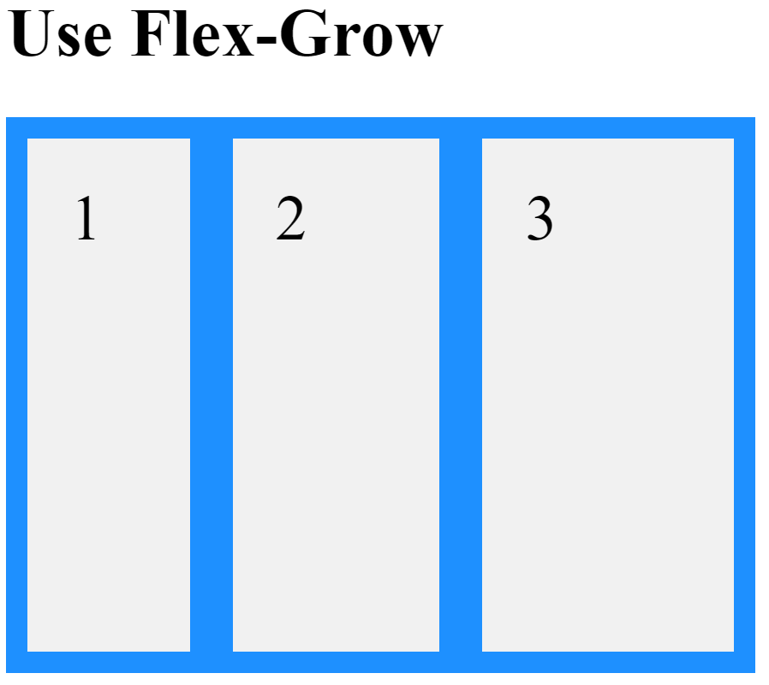
Use flex-grow to solve the problem:
- Box One – 1
- Box Two – 2
- Box Three – 3

Property: Flex Shrink
Use the skeleton is in resources to achieve the following view:
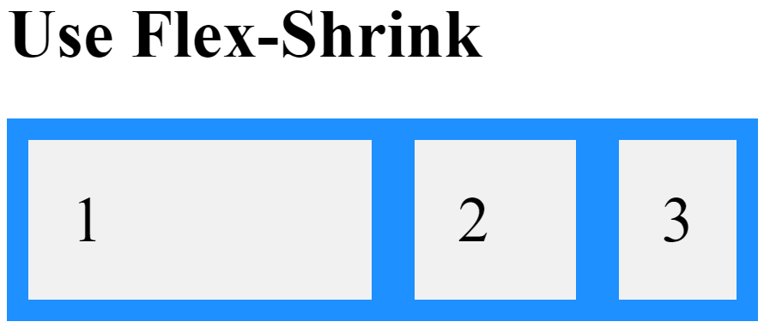
Use flex-shrink to solve the problem:
- Box One – 0
- Box Two – 1
- Box Three – 2

Property: Flex Basis
Use the skeleton is in resources to achieve the following view: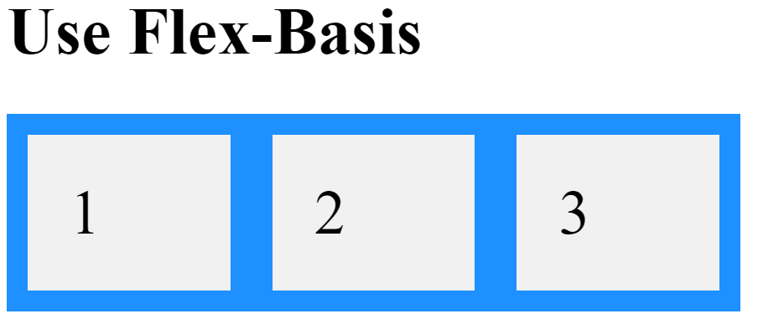
Set flex-basis to 120px to solve the problem.

Property: Align Self
Use the skeleton is in resources to achieve the following view: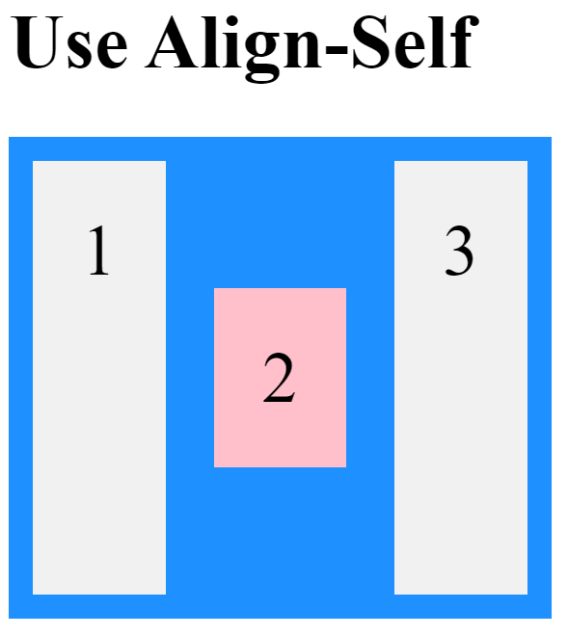
Set align-self to center to solve the problem.

Property: Order
Use the skeleton is in resources to achieve the following view: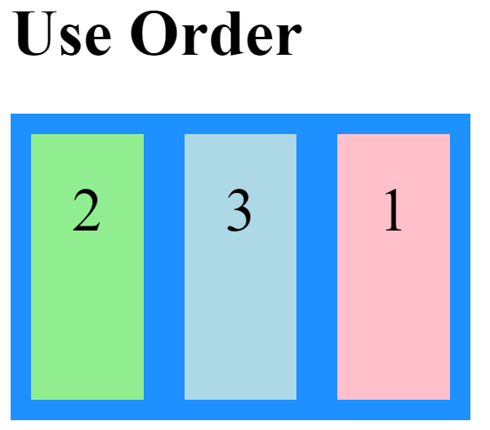
Use order to solve the problem:
- Box One – 2
- Box Two – 0
- Box Three – 1

