Working with Forms
Problems for exercises and homework for the "HTML and CSS" course @ SoftUni. Submit your solutions in the SoftUni Judge system at https://judge.softuni.org/Contests/4384/05-Working-with-Forms.

Tag Cardio: Form
Create a Web Page, using form tag.
Create a file named form.html. Set the html title to be the same as the task name.

Tag Cardio: Input
Create a Web Page like the following:
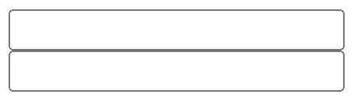
Create a file named input.html. Set the html title to be the same as the task name.
Use input with type="text" to solve the problem.
Outside on input tag need to be put form tag.
Hint: Use <br> tag for new line!

Tag Cardio: Textarea
Create a Web Page like the following:
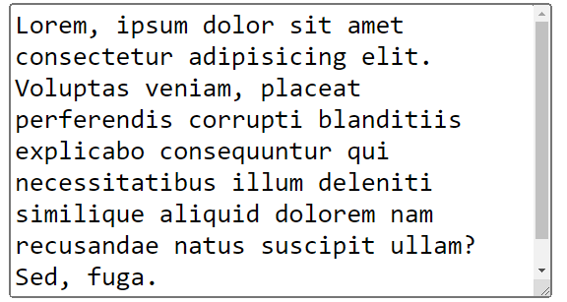
Create a file named textarea.html. Use the texts from the file site-texts.txt. Set the html title to be the same as the task name.
Use textarea to solve the problem.
Outside on textarea tag need to be put form tag.

Tag Cardio: Label
Create a Web Page like the following:
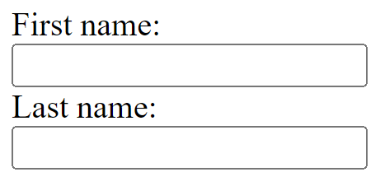
Create a file named label.html. Use the texts from the file site-texts.txt. Set the html title to be the same as the task name.
Use label to solve the problem.
Outside on label tag need to be put form tag.

Tag Cardio: Button
Create a Web Page like the following:
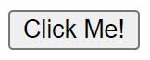
Create a file named button.html. Use the texts from the file site-texts.txt. Set the html title to be the same as the task name.
Use button to solve the problem.

Tag Cardio: Fieldset Legend
Create a Web Page like the following:
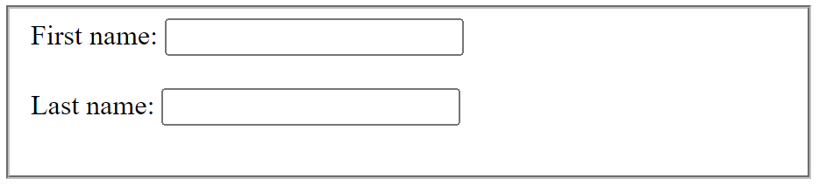
Create a file named fieldset-legend.html. Use the texts from the file site-texts.txt. Set the html title to be the same as the task name.
Use fieldset to solve the problem.
Outside on fieldset tag need to be put form tag.

Tag Cardio: Select Option
Create a Web Page like the following:

↓
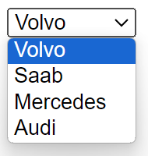
Create a file named select-option.html. Use the texts from the file site-texts.txt. Set the html title to be the same as the task name.
Use select and option to solve the problem.

Tag Cardio: Datalist
Use skeleton, which is in resources to solve the next problem:

↓
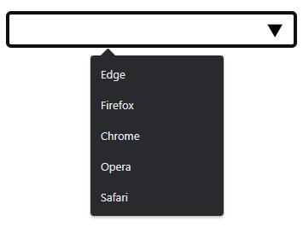
Create a file named datalist.html. Use the texts from the file site-texts.txt. Set the html title to be the same as the task name.
Use datalist to solve the problem.
Outside on datalist tag need to be put form tag.

