Spring Data

Car Repair Service
Link for Car Repair Service in Judge

Car Repair Service offers a seamless car service experience at the convenience of a tap. With our highly skilled technicians, manufacturer recommended procedures and the promise of genuine spare parts we are your best bet. To tasks a better experience to its customers, a mechanic will look at your car's condition and check parts for wear and tear, like brakes, oil, filters and engine belt. The Car Repair Service owner has turned to SoftUni for help. Now a small team led by you must take on this task.

Functionality Overview
The application should be able to easily import hard-formatted data and support functionalities for also exporting the imported data. The application is called – Car Repair Service.
Look at the pictures below to see what must happen:

- The home page before importing anything:
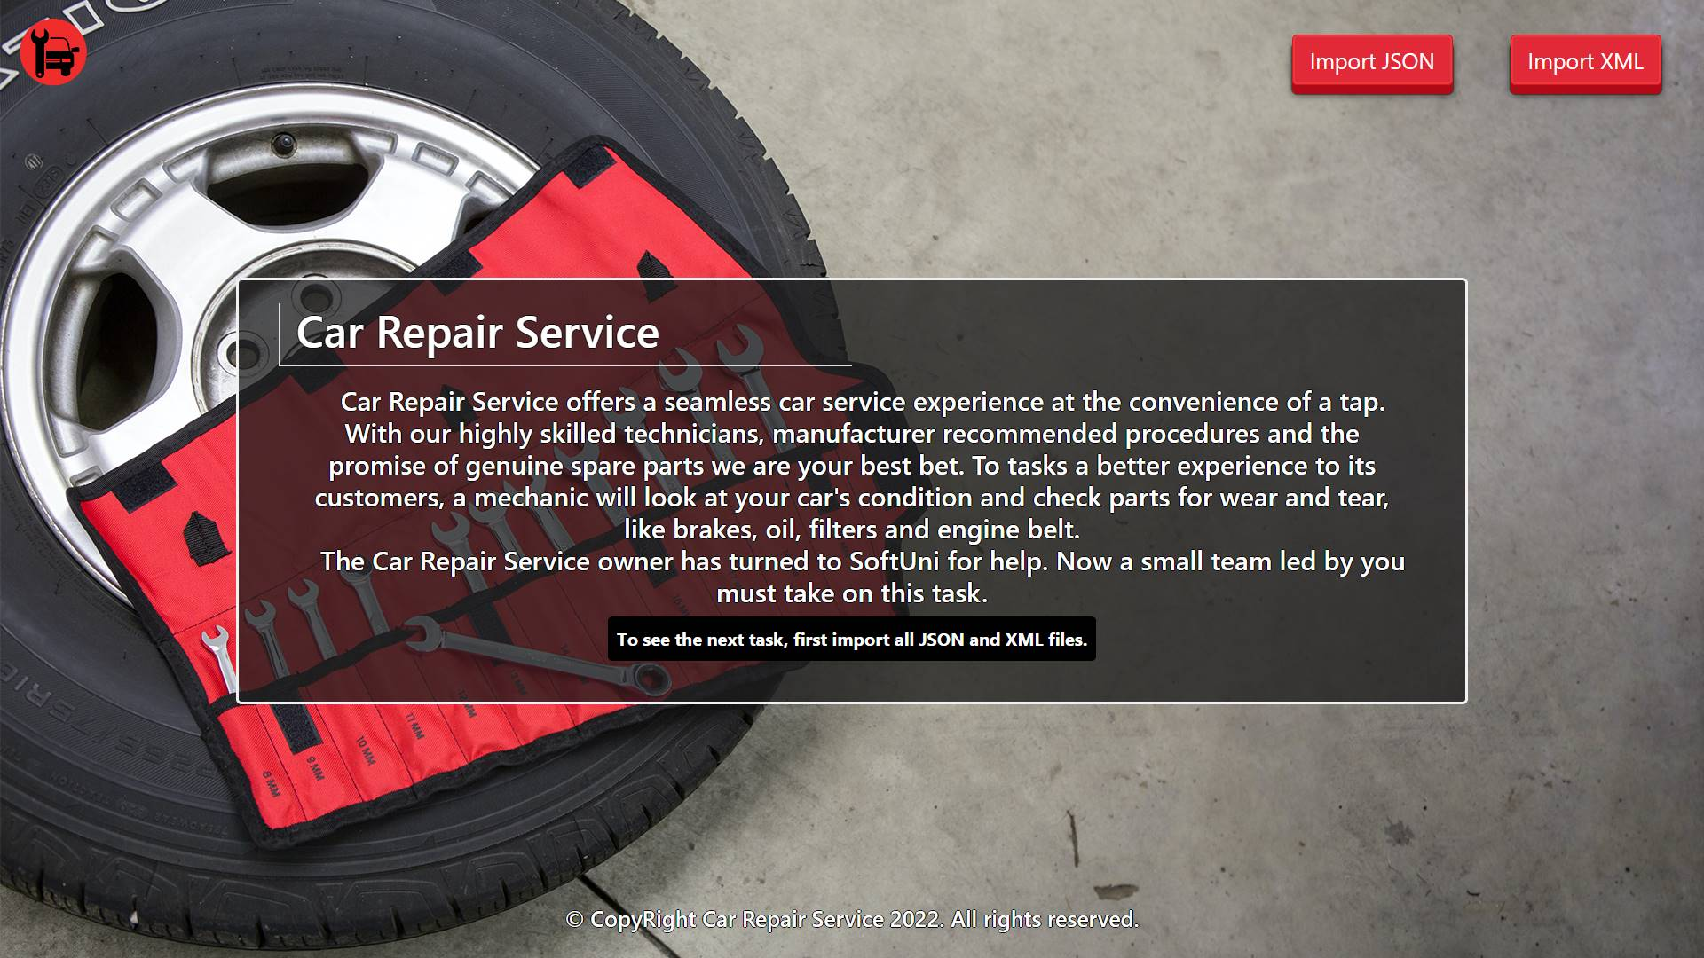

- The import JSON page before importing anything:
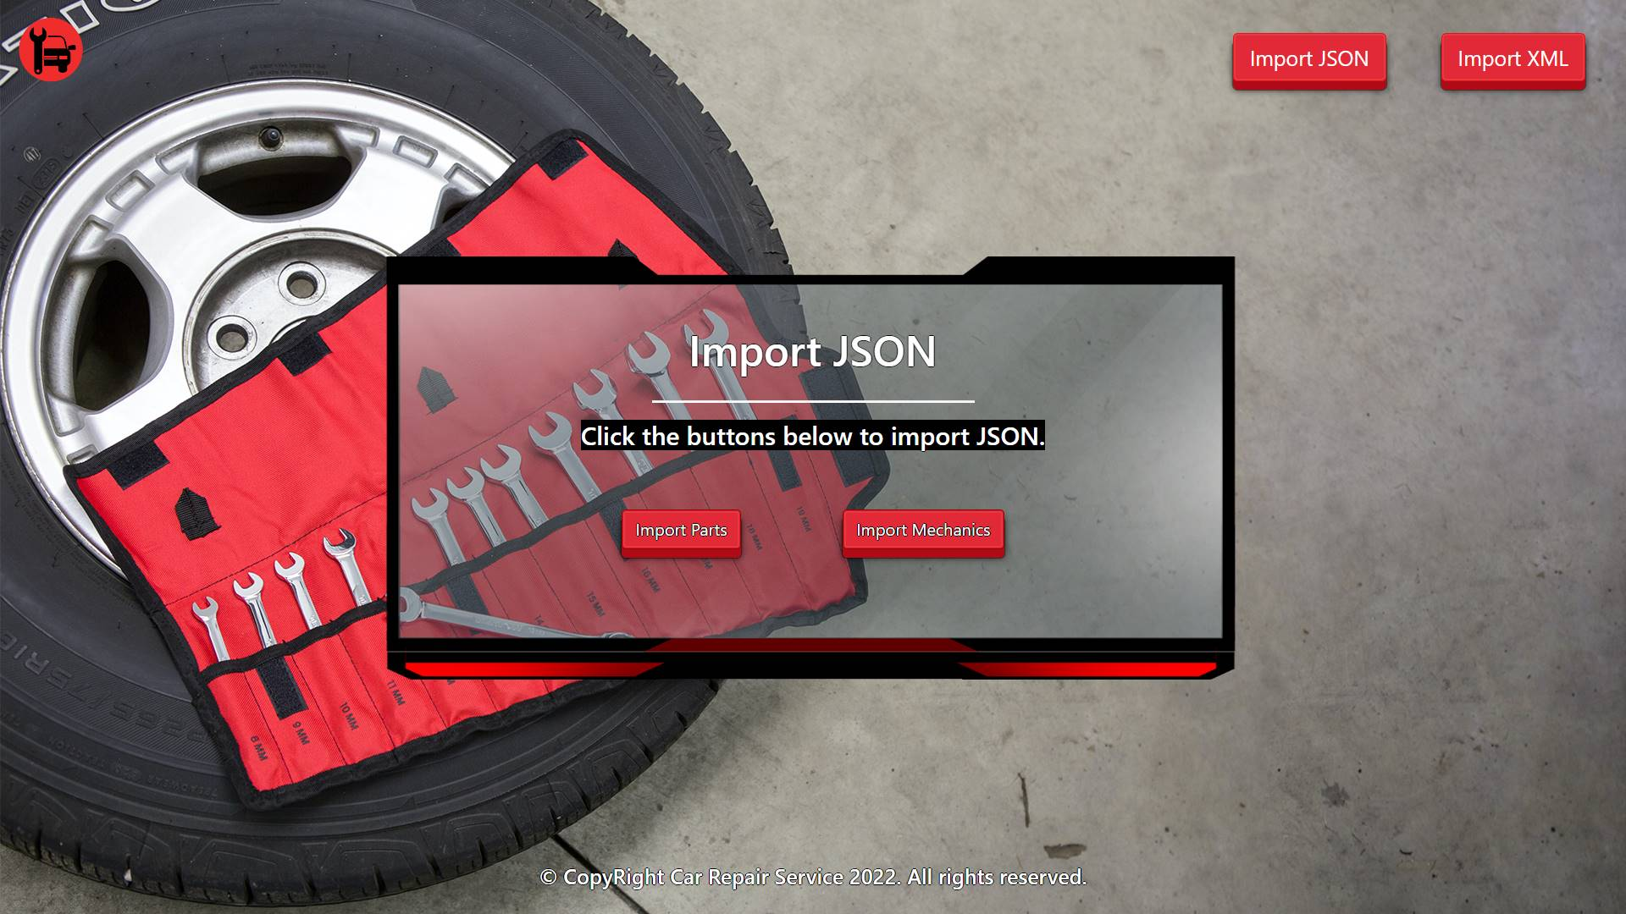

- Import the parts first:
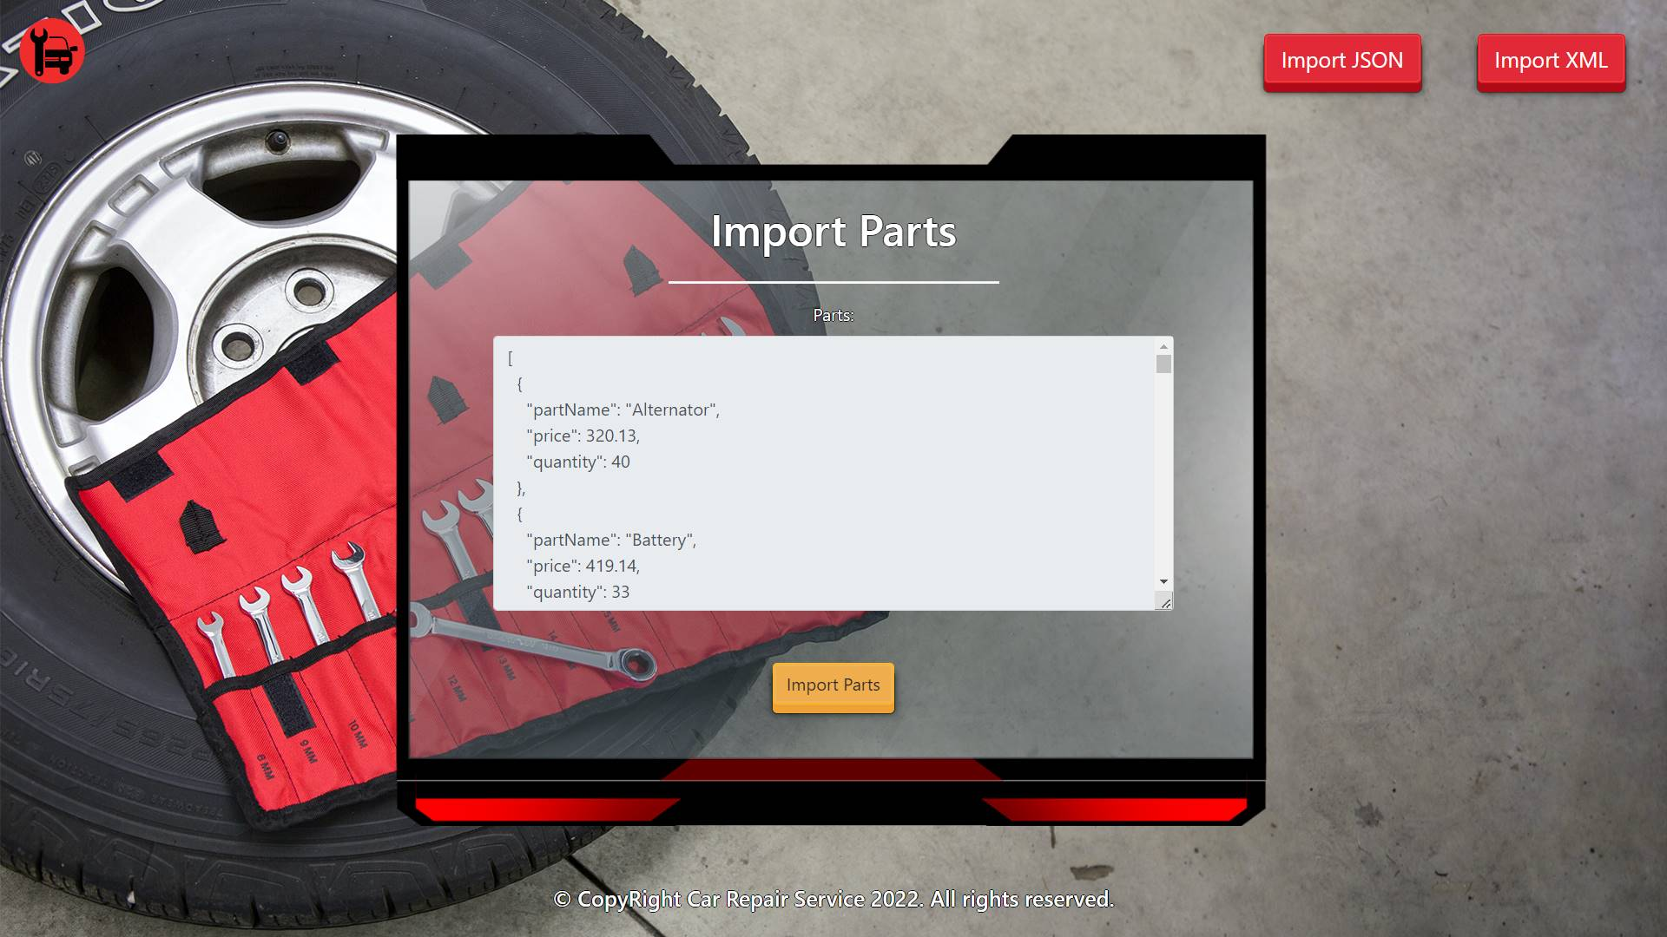

- Import the mechanics second:
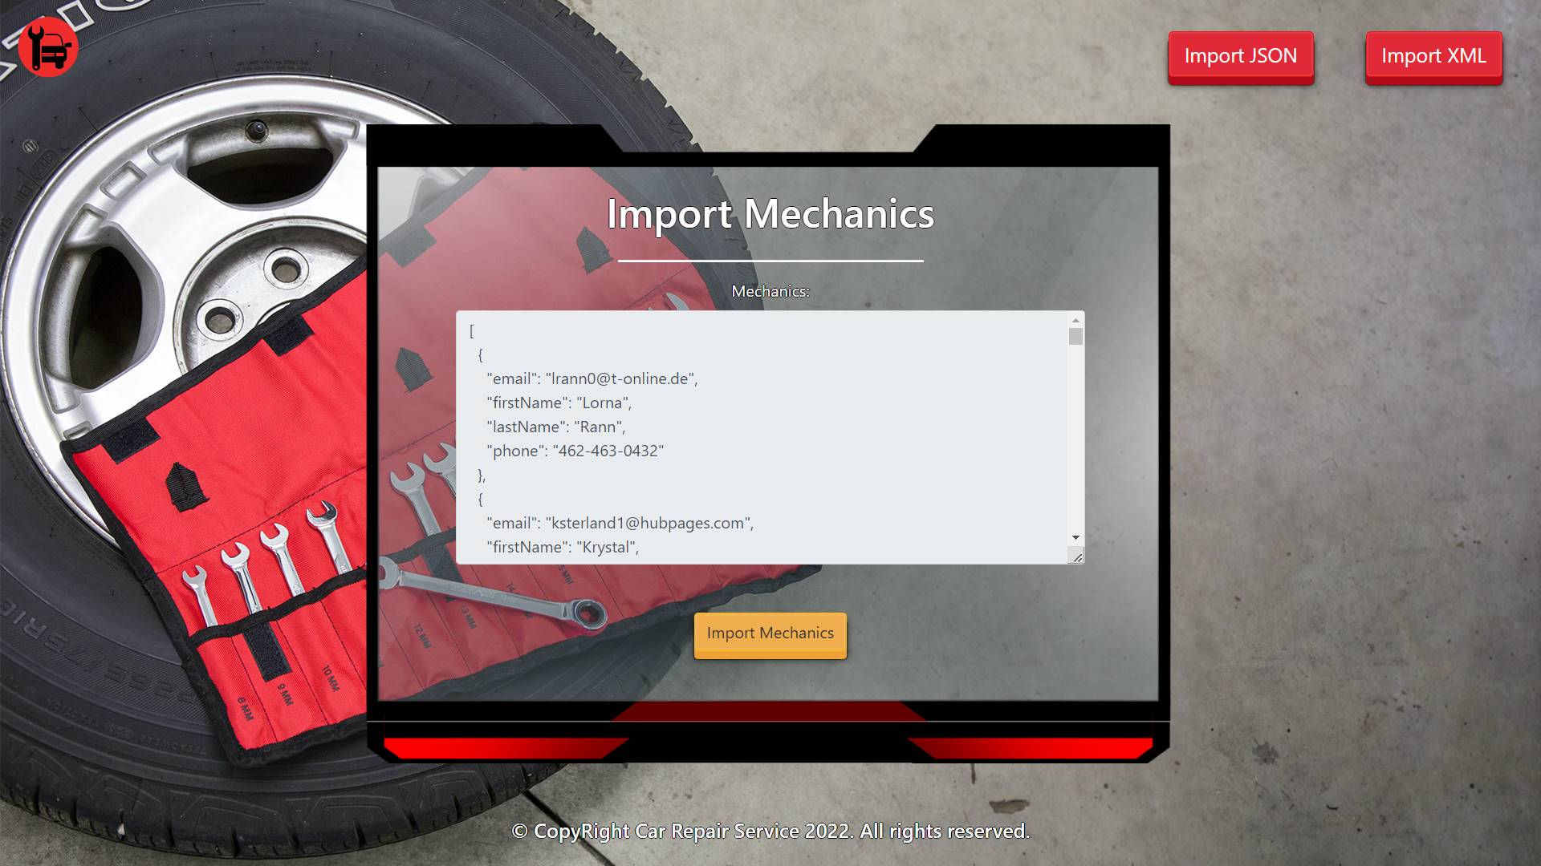

- The import JSON page after importing both files:
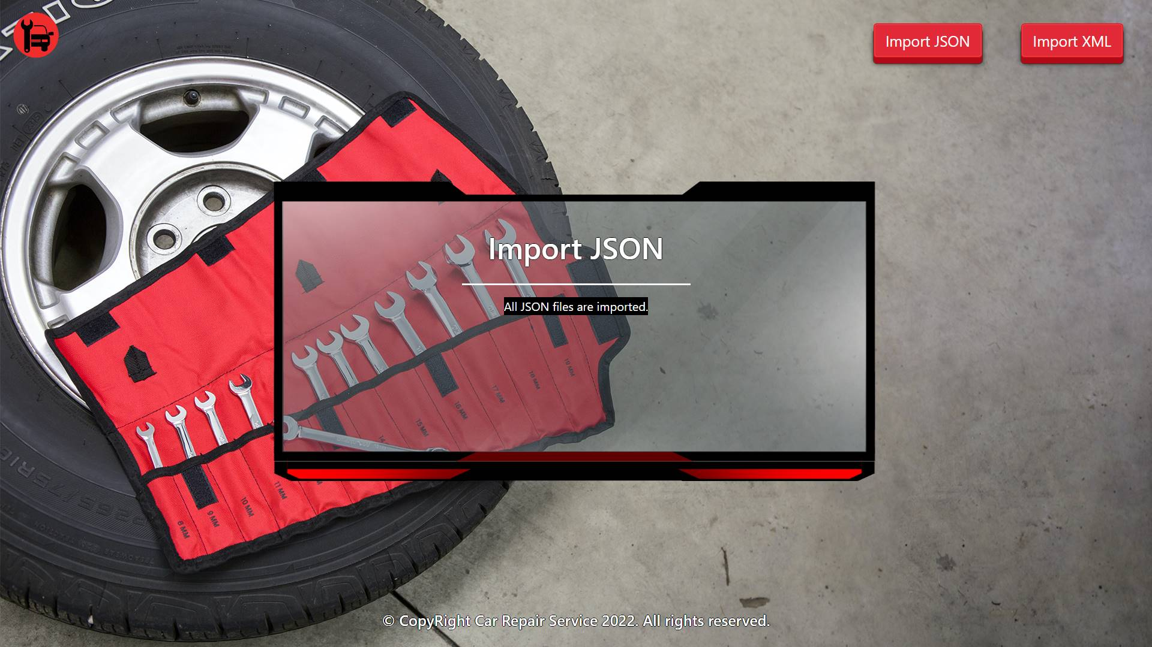

- The import XML page before importing the given data:
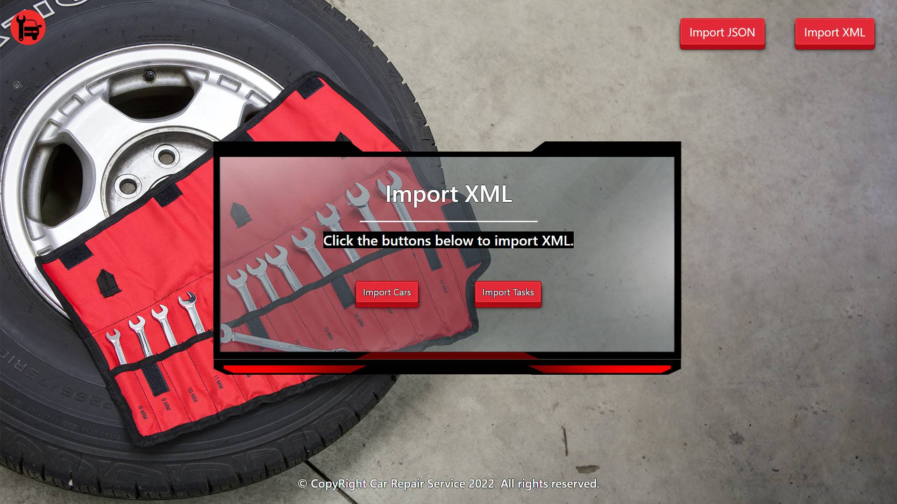

- Import the cars data:
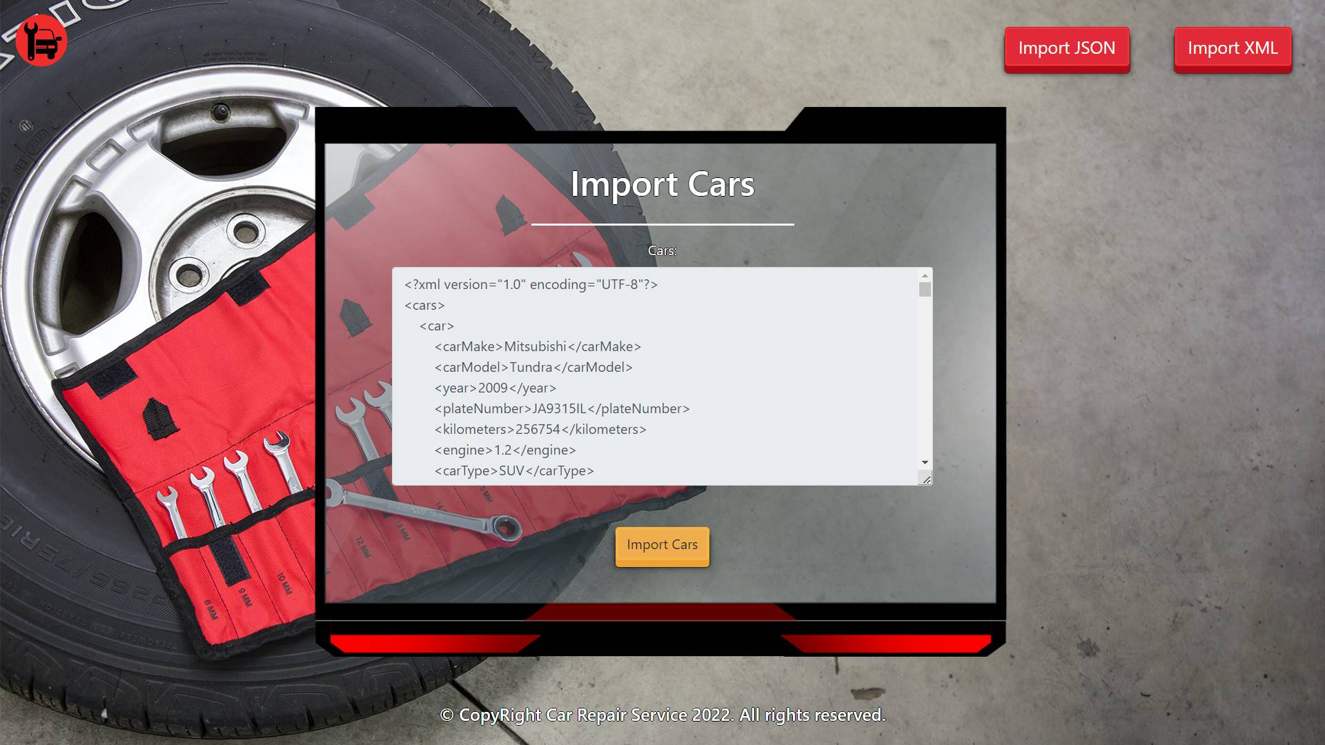

- Import the tasks data:
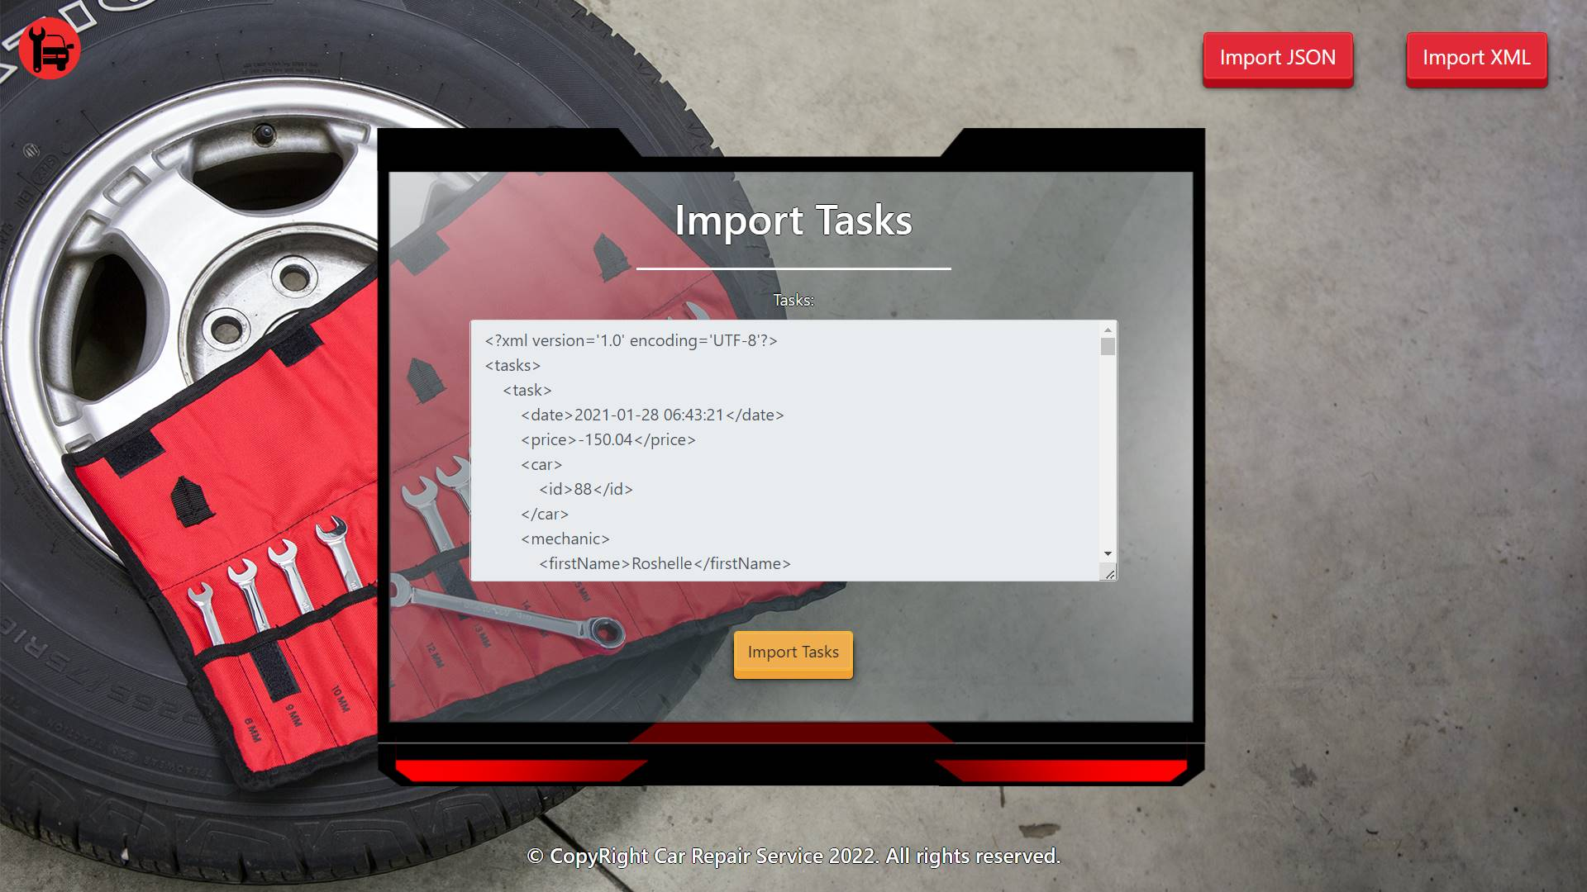

- The import XML page after importing the data:
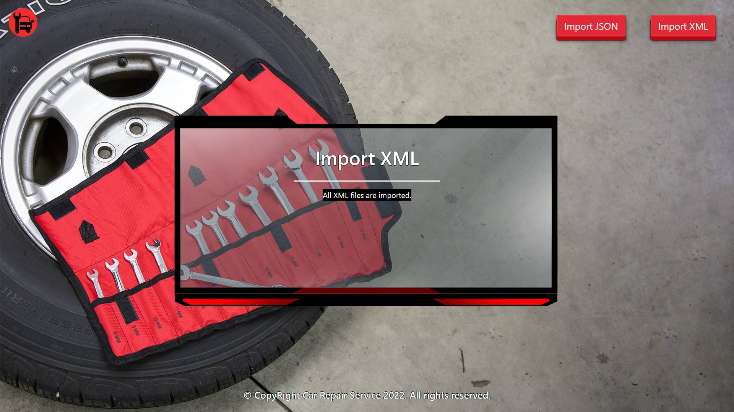

- The home page after the data is imported:
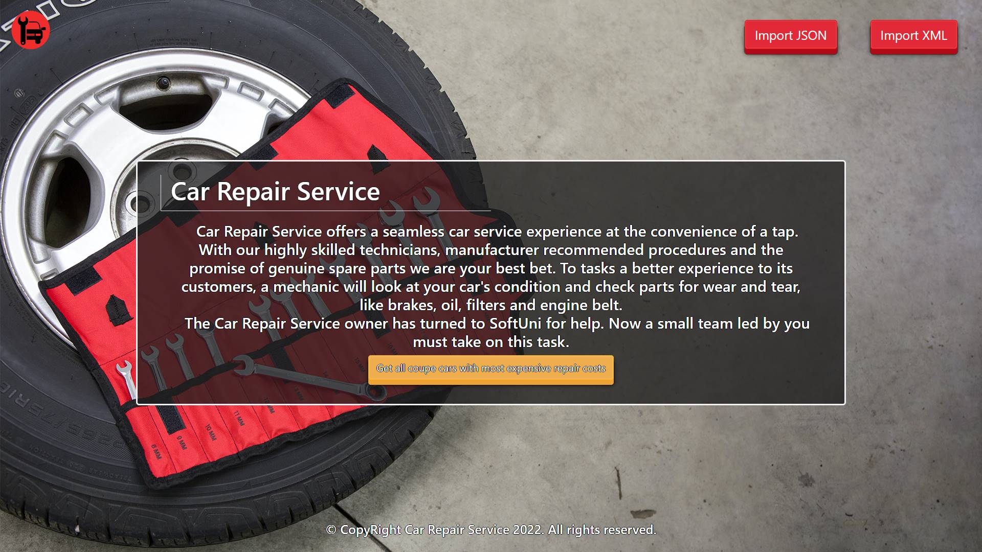

- Export tasks for coupe cars:
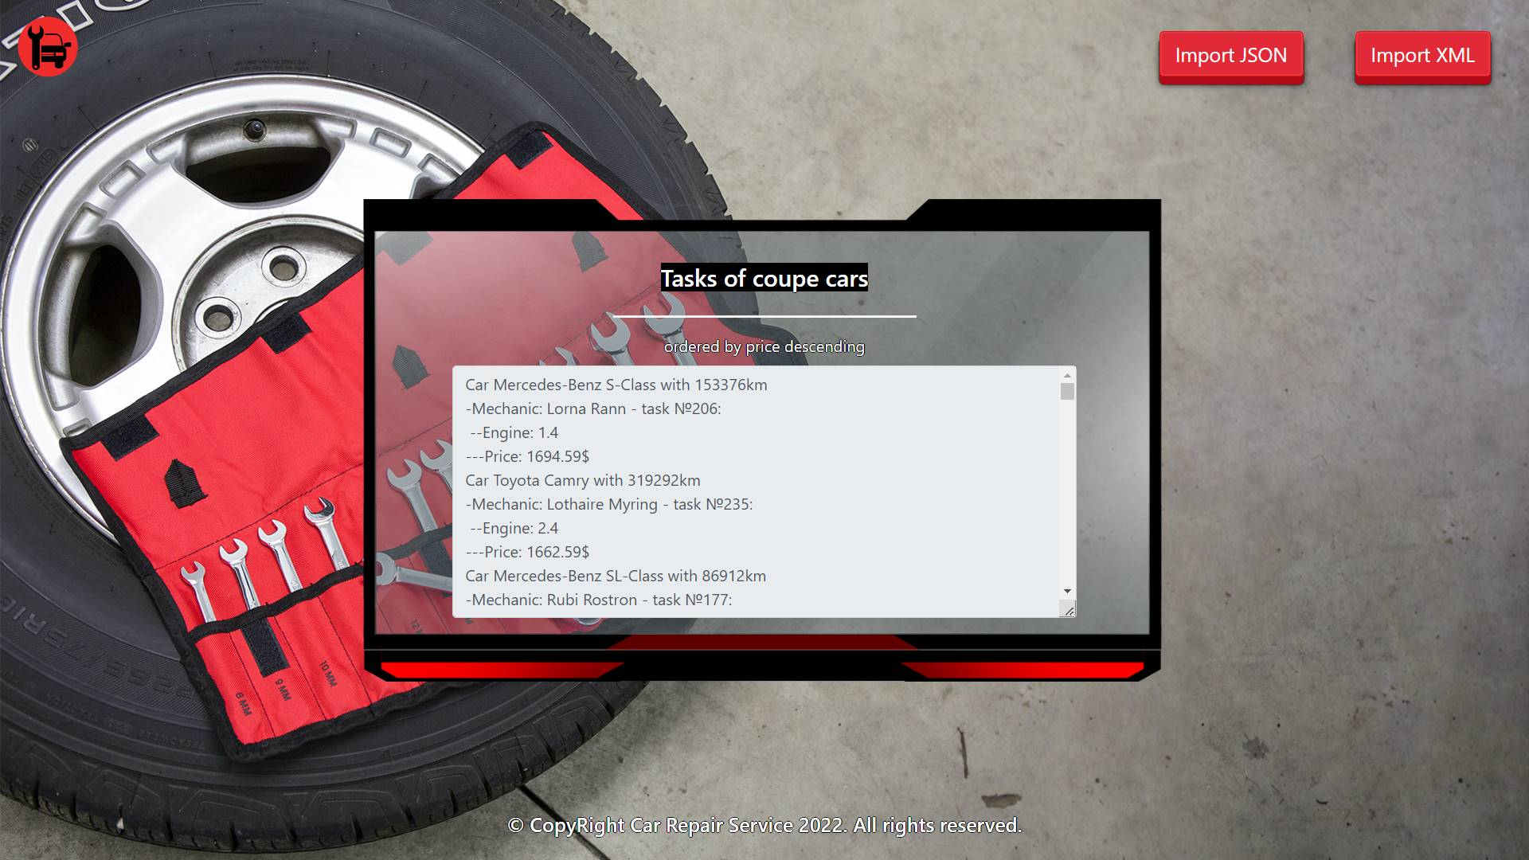

Project Skeleton Overview
You will be given a skeleton, containing a certain architecture (MVC) with several classes, some of which are completely empty. The Skeleton will include the files with which you will seed the database.
When submitting your project in Judge please make a .zip file only with src folder and pom.xml file.
There are four problems in Judge:
1. Database will test the structure of your database.
2. Service will test the two methods areImported() and readClassFromFile() in every service class.
3. Imports will test the whole logic of your importClass() method in every service class.
4. Export will test the logic of the final export button which is in the ExportController.

Please note that the automated system Judge may take up to 5 minutes to show results for each problem. We kindly ask you to be patient.

Model Definition
There are 4 main models that the Car Repair Service database application should contain in its functionality.
Design them in the most appropriate way, considering the following data constraints:

Part
- id – accepts integer values, a primary identification field, an auto incremented field.
- part name – accepts char sequence (between 2 to 19 inclusive). The values are unique in the database.
- price – a floating point number. Must be between 10 and 2000 (both numbers are INCLUSIVE).
- quantity – accepts a positive number.

Mechanic
- id – accepts integer values, a primary identification field, an auto incremented field.
- first name – accepts char sequences as values where their character length value higher than or equal to 2. The values are unique in the database.
- last name – accepts char sequences as values where their character length value higher than or equal to 2.
- email – an email – (must contains ‘@’ and ‘.’ – dot). The email of a seller is unique.
- phone – accepts char sequences as values where their character length value higher than or equal to 2. Can be nullable. The values are unique in the database.

Car
- id – accepts integer values, a primary identification field, an auto incremented field.
- car type – the enumeration, one of the following – SUV, coupe, sport
- car make – accepts char sequence (between 2 to 30 inclusive).
- car model – accepts char sequence (between 2 to 30 inclusive).
- year – accepts a positive number.
- plate number – accepts char sequence (between 2 to 30 inclusive). The values are unique in the database.
- kilometers – accepts a positive number.
- engine – accepts number values that are more than or equal to 1.00.

Task
- id – accepts integer values, a primary identification field, an auto incremented field.
- price – accepts a very big positive number.
- date – a date and time of registering the task in the "yyyy-MM-dd HH:mm:ss" format.
- Constraint: The task table has a relation with the parts table.
- Constraint: The task table has a relation with the mechanics table.
- Constraint: The task table has a relation with the cars table.

Relationships
Your partners gave you a little hint about the more complex relationships in the database, so that you can implement it correctly.
One Task may have only one Mechanic, but one Mechanic may have many Tasks.
One Task may need only one Part, but one Part may be used in many Tasks.
One Task may have only one Car, but one Car can be in many Tasks.

Constraint:
- Name the entities and their class members exactly in the format stated above.
- All fields are NOT NULL unless explicitly stated to be nullable.

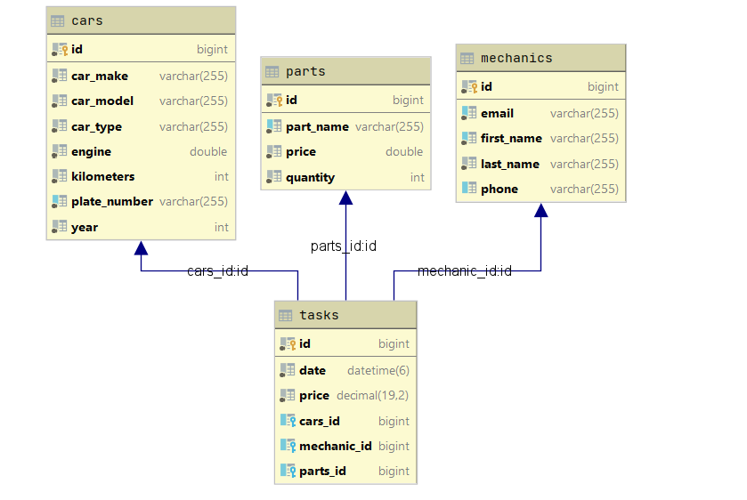

Data Import
Use the provided files to populate the database with data. Import all the information from those files into the database.
You are not allowed to modify the provided files.
ANY INCORRECT data should be ignored and a message:
"Invalid {part / mechanic / car / task}" should be printed.
When the import is finished:
"Successfully imported {part / mechanic / car / task} {name – price(to second digit after decimal point) / first name last name / carMake – carModel / price}"

JSON Import
Your new colleagues have prepared some JSON data for you to import.
Parts (parts.json)
[
{
"partName": "Alternator",
"price": 320.13,
"quantity": 40
},
{
"partName": "Battery",
"price": 419.14,
"quantity": 33
},
{
"partName": "Performance Battery",
"price": 455.38,
"quantity": 15
},
{
"partName": "Alternator",
"price": 240.13,
"quantity": 18
},
{
"partName": "Battery Box",
"price": 590.43,
"quantity": 21
},
...
Successfully imported part Alternator - 320.13
Successfully imported part Battery - 419.14
Successfully imported part Performance Battery - 455.38
Invalid part
Successfully imported part Battery Box - 590.43
Invalid part
Invalid part
Invalid part
Successfully imported part Battery Cable - 269.73
…

Constraint:
- If the mechanic with the same email already exists in the DB return "Invalid mechanic".

Mechanics (mechanics.json)
[
{
"email": "lrann0@t-online.de",
"firstName": "Lorna",
"lastName": "Rann",
"phone": "462-463-0432"
},
{
"email": "ksterland1@hubpages.com",
"firstName": "Krystal",
"lastName": "Sterland",
"phone": "201-115-5358"
},
{
"email": "qle@es.com",
"firstName": "Q",
"lastName": "Beck",
"phone": "101-135-6558"
},
{
"email": "wrongNumber@no.com",
"firstName": "Qentin",
"lastName": "Jock",
"phone": "1"
},
{
"email": "gledeker2@amazon.com",
"firstName": "Gerladina",
"lastName": "Ledeker",
"phone": "534-162-5734"
},
{
"email": "ksterland1@hubpages.com",
"firstName": "Deidre",
"lastName": "Goodinge",
"phone": "148-743-0753"
},
{
"email": "dhebard4@histats.com",
"firstName": "Dulcy",
"lastName": "Hebard",
"phone": "654-577-5713"
},

. . .
Successfully imported mechanic Lorna Rann
Successfully imported mechanic Krystal Sterland
Invalid mechanic
Invalid mechanic
Successfully imported mechanic Gerladina Ledeker
Invalid mechanic
Successfully imported mechanic Dulcy Hebard
…

XML Import
Your new colleagues have prepared some XML data for you to import.
Constraint:
- If the car with the same plate number already exists in the DB return "Invalid car".
Cars (cars.xml)
Cars (cars.xml)
<?xml version="1.0" encoding="UTF-8"?>
<cars>
<car>
<carMake>Mitsubishi</carMake>
<carModel>Tundra</carModel>
<year>2009</year>
<plateNumber>JA9315IL</plateNumber>
<kilometers>256754</kilometers>
<engine>1.2</engine>
<carType>SUV</carType>
</car>
<car>
<carMake>MitsubishiAventadorBmwLamborghiniOpelBentley</carMake>
<carModel>Tundra</carModel>
<year>2009</year>
<plateNumber>QA7315IL</plateNumber>
<kilometers>251754</kilometers>
<engine>1.3</engine>
<carType>SUV</carType>
</car>
<car>
<carMake>Hyundai</carMake>
<carModel>Tiburon</carModel>
<year>2006</year>
<plateNumber>JA9315IL</plateNumber>
<kilometers>18862</kilometers>
<engine>2.2</engine>
<carType>SUV</carType>
</car>
...
Successfully imported car Mitsubishi - Tundra
Invalid car
Invalid car
Successfully imported car Land Rover - Range Rover
Successfully imported car Dodge - Intrepid
Invalid car
Successfully imported car Honda - S2000
...

Tasks (tasks.xml)
Constraint:
- If the given mechanic name doesn’t already exist in the DB return "Invalid task".
- The provided part ids will always be valid.
- Format the price to the second digit after the decimal point.
Tasks (tasks.xml)
<?xml version='1.0' encoding='UTF-8'?>
<tasks>
<task>
<date>2021-01-28 06:43:21</date>
<price>-150.04</price>
<car>
<id>88</id>
</car>
<mechanic>
<firstName>Roshelle</firstName>
</mechanic>
<part>
<id>7</id>
</part>
</task>
<task>
<date>2021-01-28 06:43:21</date>
<price>240.04</price>
<car>
<id>88</id>
</car>
<mechanic>
<firstName>Roshelle</firstName>
</mechanic>
<part>
<id>7</id>
</part>
</task>
<task>
<date>2021-09-10 06:53:58</date>
<price>1325.82</price>
<car>
<id>35</id>
</car>
<mechanic>
<firstName>Ozzie</firstName>
</mechanic>
<part>
<id>32</id>
</part>
</task>
<task>
<date>2021-03-24 02:11:32</date>
<price>1033.98</price>
<car>
<id>16</id>
</car>
<mechanic>
<firstName>Lothaire</firstName>
</mechanic>
<part>
<id>39</id>
</part>
</task>
...
Invalid task
Successfully imported task 240.04
Successfully imported task 1325.82
Successfully imported task 1033.98
Successfully imported task 1230.28
Invalid task
Successfully imported task 705.94
…

Data Export
Get ready to export the data you have imported in the previous task. Here you will have some complex database querying. Export the data in the formats specified below.

Export The Highest priced Tasks from the Data Base
- Extract from the database, the car's make, car's model, mechanic's first name, mechanic's last name, task id, engine, task price (to second digit after decimal point) of the task.
- Filter only coupe cars and order them by the price in descending order.
- Return the information in this format:
- "Car {carMake} {carModel} with {kilometers}km
-Mechanic: {firstName} {lastName} - task №{taskId}:
--Engine: {engine}
---Price: {taskPrice}$
. . ."

