Lab: Conditional Statements
Problems for in-class and homework exercises for the course "Programming Basics" @ SoftUni
Test your solutions on the Judge System

Excellent Result
The first task in this chapter is to write a function isExcellent(grade) that reads a grade received as an argument and prints "Excellent!" if the grade is 5.50 or higher. If not – Print “No”

Sample Input and Output
Input | Output |  | Input | Output |  | Input | Output |  | Input | Output
isExcellent(6) | Excellent! |  | isExcellent(5) | No |  | isExcellent(5.50) | Excellent! |  | isExcellent(5.49) | No

Hints and Guidelines
- Create a new JavaScript file in the existing folder and name it appropriately. It is recommended to name each script file as the name of the task whose solution it contains.
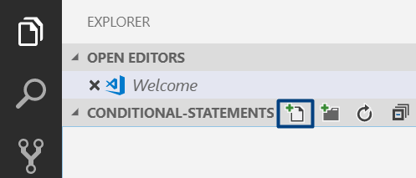
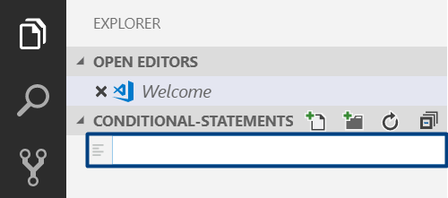

- The content of the new file will open in the window on the right.
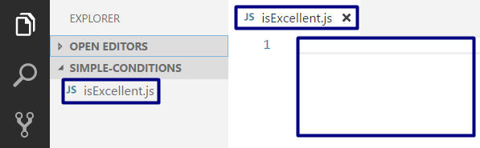
- Go to the file isExcellent.js and create the function isExcellent(input):
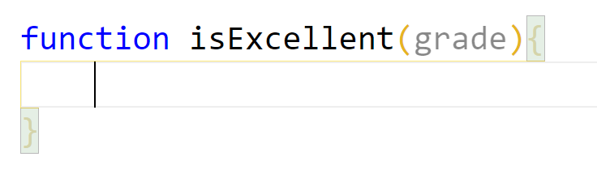
- Check the value of the grade. If it is greater than or equal to 5.50, print the output according to the condition:

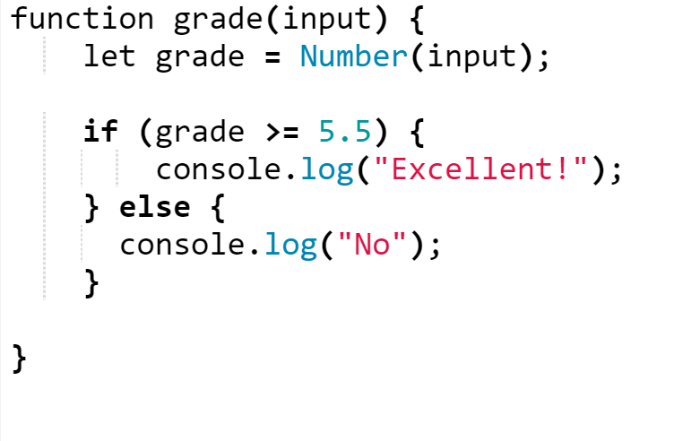
- Call the function with different input values and start it with Ctrl + F5:
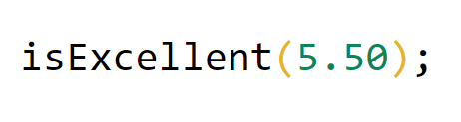

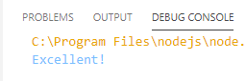

Testing in the Judge System
Test the solution to this problem here: https://judge.softuni.org/Contests/Compete/Index/4702#0

Greater Number
Write a function greaterNumber(firstNum,secondNum) that receives two integers and prints the greater of the two.

Sample Input and Output
Input | Output |  | Input | Output |  | Input | Output |  | Input | Output
greaterNumber(5,3) | 5 |  | greaterNumber(3,5) | 5 |  | greaterNumber(10,10) | 10 |  | greaterNumber(-5,5) | 5

Hints and Guidelines
- Compare whether the first number is greater than the second number. Print the greater number.
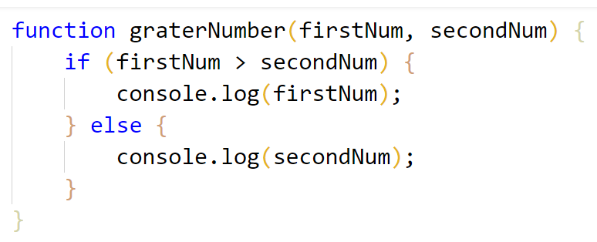

Testing in the Judge System
Test the solution to this problem here: https://judge.softuni.org/Contests/Compete/Index/4702#1

Even or Odd
Write a function oddOrEven(num) that receives an integer as an argument and prints to the console, whether it is even or odd. If it is even, print "even". If it is odd, print "odd".

Sample Input and Output
Input | Output |  | Input | Output |  | Input | Output |  |  | Input | Output
oddOrEven(2) | even |  | oddOrEven(3) | odd |  | oddOrEven(25) |  | odd |  | oddOrEven(1024) | even

Hints and Guidelines
- First, add a new JavaScript file to the existing project.
- Check if the number is even by dividing it by 2 and checking if there is a remainder from the division. Print the output according to the condition - the text "even" or "odd".
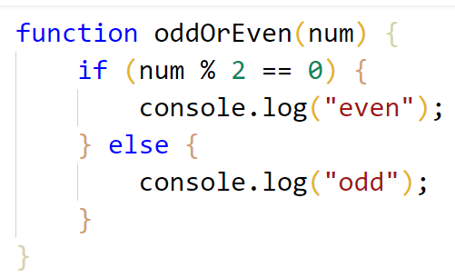

Testing in the Judge System
Test the solution to this problem here: https://judge.softuni.org/Contests/Compete/Index/4702#2

Password Guess
Write a function login(pass) that receives a password (text) and checks if the given password matches the phrase "s3cr3t!P@ssw0rd". If matches, output "Welcome". If it does not match, output "Wrong password!".

Sample Input and Output
Input | Output |  | Input | Output |  | Input | Output
login("qwerty") | Wrong password! |  | login("s3cr3t!P@ssw0rd") | Welcome |  | login("s3cr3t!p@ss") | Wrong password!

Testing in the Judge System
Test the solution to this problem here: https://judge.softuni.org/Contests/Compete/Index/4702#3

Number 100...200
Write a function solve(num) that receives an integer and checks whether it is less than 100, between 100 and 200, or greater than 200. If the number is:
- less than 100 print: "Less than 100"
- between 100 and 200 print: "Between 100 and 200"
- greater than 200 print: "Greater than 200"

Sample Input and Output
Input | Output |  | Input | Output |  | Input | Output
solve(95) | Less than 100 |  | solve(120) | Between 100 and 200 |  | solve(210) | Greater than 200

Testing in the Judge System
Test the solution to this problem here: https://judge.softuni.org/Contests/Compete/Index/4702#4

Speed Info
Write a function solve(speed) that receives speed (a floating-point number) and prints info about the speed.
- At speed up to 10 (inclusive) print "slow"
- At speed greater than 10 and up to 50 (inclusive) print "average"
- At speed greater than 50 and up to 150 (inclusive) print "fast"
- At speed greater than 150 and up to 1000 (inclusive) print "ultra fast"
- At higher speed print "extremely fast"

Sample Input and Output
Input | Output |  | Input | Output |  | Input | Output
solve(8) | slow |  | solve(49.5) | average |  | solve(126) | fast

Input | Output |  | Input | Output
solve(160) | ultra fast |  | solve(3500) | extremely fast

Testing in the Judge System
Test the solution to this problem here: https://judge.softuni.org/Contests/Compete/Index/4702#5

Area of Figures
Write a function calculate(shape, …) that receives the type and the dimensions of a geometric figure and calculates its area. The figures are four types: square, rectangle, circle, and triangle. The first parameter of the input represents the type of the figure (a string with the following options: square, rectangle, circle, and triangle) and the next parameters are dependent on the type of figure.
- If the figure is a square: the second parameter is a fractional number – the length of the square side
- If the figure is a rectangle: the next two parameters are both fractional numbers – the lengths of its sides
- If the figure is a circle: the next parameter is a fractional number – the radius of the circle
- If the figure is a triangle: the next two parameters are both fractional numbers – the length of its side and the length of the height to it
Round the result to 3 digits after the decimal point.

Sample Input and Output
Input | Output |  | Input | Output |  | Input | Output |  | Input | Output
calculate(square, 5) | 25.000 |  | calculate(rectangle, 7, 2.5) | 17.500 |  | calculate(circle, 6) | 113.097 |  | calculate(triangle, 4.5, 20) | 45.000

Testing in the Judge System
Test the solution to this problem here: https://judge.softuni.org/Contests/Compete/Index/4702#6

