Lab: Conditional Statements Advanced
Problems for in-class and homework exercises for the course "Programming Basics" @ SoftUni
Test your solutions on the Judge System

Day of Week
Write a function that receives an integer number and prints the corresponding day of the week (in English), in the range [1...7] or prints "Error" in case of invalid input.

Sample Input and Output
Input | Output
printDayOfWeek(1) | Monday
printDayOfWeek(2) | Tuesday
printDayOfWeek(3) | Wednesday
printDayOfWeek(4) | Thursday
printDayOfWeek(5) | Friday
printDayOfWeek(6) | Saturday
printDayOfWeek(7) | Sunday
printDayOfWeek(-1) | Error

Hints and Guidelines
- Create a new JavaScript file in the existing folder and name it appropriately. It is recommended to name each script file as the name of the task whose solution it contains.


- The content of the new file will open in the window on the right.
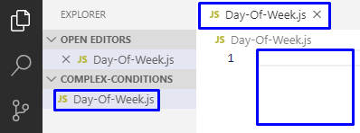

- Convert the input from string to a number.
- Print the day of the week, according to the input. If the number is invalid, print "Error".
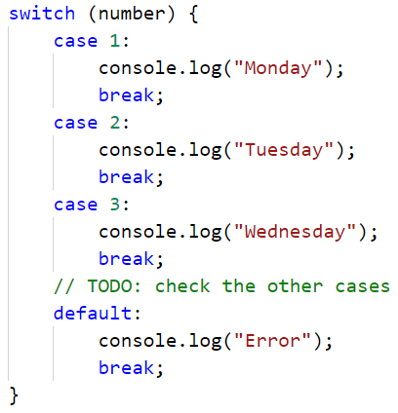

Testing in the Judge System
Test the solution to this problem here: https://judge.softuni.org/Contests/Compete/Index/4704#0

Weekend or Working Day
Write a function that receives a day of the week (string) in English - entered by the user. If the day is a working day prints on the console - "Working day” if it is a holiday - "Weekend". If the input text is different from the day of the week it prints - "Error".

Sample Input and Output
Input | Output
isWorkingDay('Monday') | Working day

Input | Output
isWorkingDay('Sunday') | Weekend

Input | Output
isWorkingDay('April') | Error

Hints and Guidelines
- Print Working day or Weekend according to the entered day, if the day is invalid print "Error":
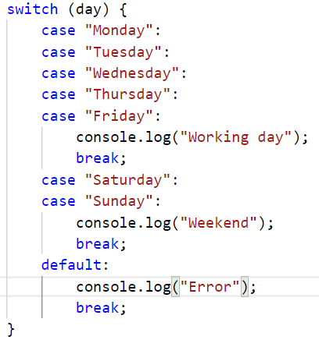

Testing in the Judge System
Test the solution to this problem here: https://judge.softuni.org/Contests/Compete/Index/4704#1

Animal Type
Write a function that prints the type of an animal, according to the name entered by the user.
- dog -> mammal
- crocodile, tortoise, snake -> reptile
- others -> unknown

Sample Input and Output
Input | Output
typeOfAnimal('dog') | mammal
typeOfAnimal('snake') | reptile
typeOfAnimal('test') | unknown

Hints and Guidelines
- Check the animal type. If it’s invalid, print "unknown".
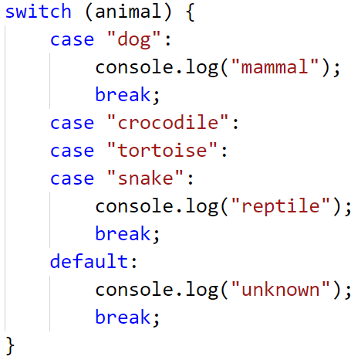

Testing in the Judge System
Test the solution to this problem here: https://judge.softuni.org/Contests/Compete/Index/4704#2

Personal Titles
Write a function that receives an age (a floating-point number) and a gender ('m' or 'f'), entered by the user, and prints a personal title among the following
- "Mr." – man (gender 'm') 16 years old or older
- "Master" – boy (gender 'm') under the age of 16
- "Ms." – woman (gender 'f') 16 years old or older
- "Miss" – girl (gender 'f') under the age of 16

Sample Input and Output
Input | Output |  | Input | Output |  | Input | Output |  | Input | Output
personalTitle(12,'f') | Miss |  | personalTitle(17,'m') | Mr. |  | personalTitle(25,'f') | Ms. |  | personalTitle(13.5,'m') | Master

Hints and Guidelines
- Convert the age from a string to a numeric type.
- Do a check for the gender, and if it returns true, do a check for the years. In the body of the age conditional statements, print the desired personal title.

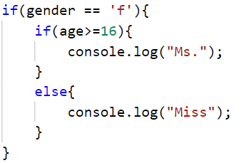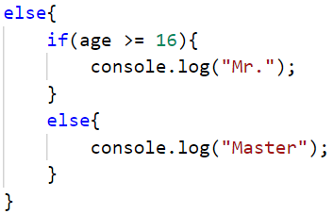
- Run the program with [Ctrl+F5] and test it by calling the function at the bottom and giving it different input values.

Testing in the Judge System
Test the solution to this problem here: https://judge.softuni.org/Contests/Compete/Index/4704#3
You must receive 100 points (completely correct solution):
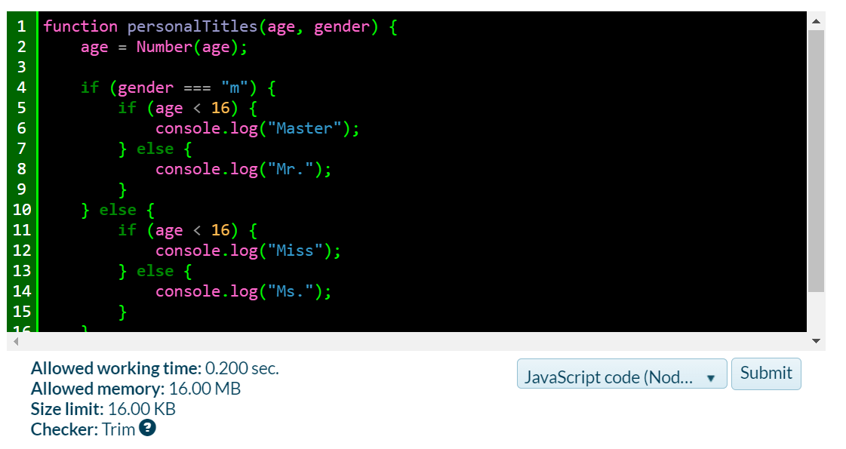
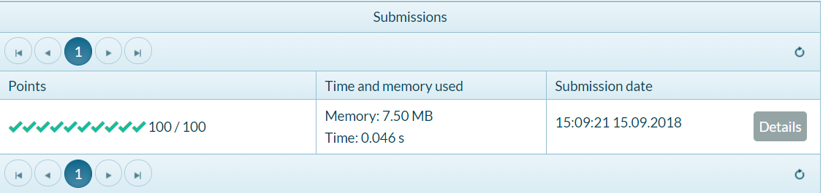

Small Shop
Businessman opens small shops in several cities and sells at different prices according to the city:
city / product | coffee | water | beer | sweets | peanuts
London | 0.50 | 0.80 | 1.20 | 1.45 | 1.60
Rome | 0.40 | 0.70 | 1.15 | 1.30 | 1.50
Paris | 0.45 | 0.70 | 1.10 | 1.35 | 1.55
Write a function that receives 3 arguments: product (string), city (string), and quantity (number), and calculates and prints how much the corresponding quantity of the selected product costs in the specified city.

Sample Input and Output
Input | Output |  | Input | Output |  | Input | Output |  | Input | Output |  | Input | Output
solve('sweets', 'London', 2.23) | 3.2 |  | solve('peanuts', 'Rome', 1) | 1.5 |  | solve('beer', 'London', 2) | 2.4 |  | solve('water', 'Paris', 2) | 1.4 |  | solve('beer', 'London', 3) | 3.6

Testing in the Judge System
Test the solution to this problem here: https://judge.softuni.org/Contests/Compete/Index/4704#4

Number in Range
Write a function that checks if the number entered by the user is in the range [-100, 100] and if it’s different from 0 and outputs "Yes" if it meets the conditions, or "No" if it does not.

Sample Input and Output
Input | Output |  | Input | Output |  | Input | Output
solve(-25) | Yes |  | solve(0) | No |  | solve(25) | Yes

Testing in the Judge System
Test the solution to this problem here: https://judge.softuni.org/Contests/Compete/Index/4704#5

Working Hours
Write a function that receives a time of the day (an integer number) and a day of the week (text) and checks if a company's office is open, with office hours from 10 am to 6 pm, Monday to Saturday inclusive.

Sample Input and Output
Input | Output |  | Input | Output |  | Input | Output
workingHours(11, "Monday") | open |  | workingHours(19, "Friday") | closed |  | workingHours(11, "Sunday") | closed

Testing in the Judge System
Test the solution to this problem here: https://judge.softuni.org/Contests/Compete/Index/4704#6

Cinema Ticket
Write a function that receives a day of the week (text) and prints on the console the price of a movie ticket according to the day of the week:
Monday | Tuesday | Wednesday | Thursday | Friday | Saturday | Sunday
12 | 12 | 14 | 14 | 12 | 16 | 16

Sample Input and Output
Input | Output |  | Input | Output |  | Input | Output
solve('Monday') | 12 |  | solve('Friday') | 12 |  | solve('Sunday') | 16

Testing in the Judge System
Test the solution to this problem here: https://judge.softuni.org/Contests/Compete/Index/4704#7

Fruit or Vegetable
Write a function that receives a product name as an argument and checks whether it is a fruit or a vegetable.
- Fruits "fruit" has the following possible values: banana, apple, kiwi, cherry, lemon, and grapes
- Vegetables "vegetable" has the following possible values: tomato, cucumber, pepper, and carrot
- Everything else is "unknown"
Output "fruit", "vegetable" or "unknown" according to the entered product.

Sample Input and Output
Input | Output |  | Input | Output |  | Input | Output |  | Input | Output
solve('banana') | fruit |  | solve('apple') | fruit |  | solve('tomato') | vegetable |  | solve('water') | unknown

Testing in the Judge System
Test the solution to this problem here: https://judge.softuni.org/Contests/Compete/Index/4704#8

10. Invalid Number
Write a function that receives an integer argument, and prints "invalid" if the entered number is not valid. A given number is valid if it is in the range [100...200] or is 0. If the number is valid print “valid”

Sample Input and Output
Input | Output |  | Input | Output |  | Input | Output |  | Input | Output
solve(75) | invalid |  | solve(150) | valid |  | solve(220) | invalid |  | solve(199) | valid

Input | Output |  | Input | Output |  | Input | Output |  | Input | Output
solve(-1) | invalid |  | solve(100) | valid |  | solve(200) | valid |  | solve(0) | valid

Testing in the Judge System
Test the solution to this problem here: https://judge.softuni.org/Contests/Compete/Index/4704#9

11. Fruit Shop
A fruit shop works on weekdays at the following prices:
fruit | banana | apple | orange | grapefruit | kiwi | pineapple | grapes
price | 2.50 | 1.20 | 0.85 | 1.45 | 2.70 | 5.50 | 3.85
On Saturdays and Sundays, the shop sells at higher prices:
fruit | banana | apple | orange | grapefruit | kiwi | pineapple | grapes
price | 2.70 | 1.25 | 0.90 | 1.60 | 3.00 | 5.60 | 4.20
Write a function that receives the following arguments: fruit ( banana / apple / orange / grapefruit / kiwi / pineapple / grapes), day of the week ( Monday / Tuesday / Wednesday / Thursday / Friday / Saturday / Sunday) and quantity (number) and calculates the price, according to the prices in the tables above. The result must be printed rounded to 2 digits after the decimal point. In case of invalid day of the week or fruit name, print "error".

Sample Input and Output
Input | Output |  | Input | Output |  | Input | Output
calculatePrice('apple', 'Tuesday', 2) | 2.40 |  | calculatePrice('orange', 'Sunday', 3) | 2.70 |  | calculatePrice('kiwi', 'Monday', 2.5) | 6.75

Input | Output |  | Input | Output
calculatePrice('grapes', 'Saturday', 0.5) | 2.10 |  | calculatePrice('tomato', 'Monday', 0.5) | error

Testing in the Judge System
Test the solution to this problem here: https://judge.softuni.org/Contests/Compete/Index/4704#10

12. Trade Commissions
A company gives the following trade commissions to its sellers according to the city in which they work and the volume of sales:
City | 0 ≤ s ≤ 500 | 500 < s ≤ 1 000 | 1 000 < s ≤ 10 000 | s > 10 000
London | 5% | 7% | 8% | 12%
Rome | 4.5% | 7.5% | 10% | 13%
Paris | 5.5% | 8% | 12% | 14.5%

Write a function that receives a city name (string) and a sales volume (number) and calculates and outputs the trade commission according to the above table. Output the result formatted to 2 digits after the decimal point. In case of invalid city or sales volume (a negative number) print "error".

Sample Input and Output
Input | Output |  | Input | Output |  | Input | Output |  | Input | Output
solve('London', 1500) | 120.00 |  | solve('Paris', 499.99) | 27.50 |  | solve('Rome', 3874.50) | 387.45 |  | solve('Atlanta', -50) | error

Testing in the Judge System
Test the solution to this problem here: https://judge.softuni.org/Contests/Compete/Index/4704#11

