Lab: For-Loop
Problems for in-class and homework exercises for the course "Programming Basics" @ SoftUni
Test your solutions on the Judge System

Numbers from 1 to 100

Write a function that prints the numbers from 1 to 100, each on a new line.

Sample Input and Output
Input | Output
(no input) | 1  2  3  …  98  99  100

Hints and Guidelines
- Create a new file named "numbers1To100".
- Go to the function body and write the solution to the problem. You can help yourself with the code from the image below:
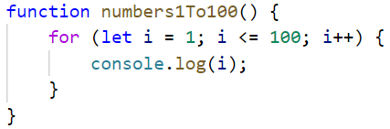

Testing in the Judge System
Test the solution to this problem here: https://judge.softuni.org/Contests/Compete/Index/4706#0

Numbers N...1
Write a function solve(num) that receives a positive number n entered by the user and prints the numbers from n to 1 in reverse order. The entered number n will always be greater than 1.

Sample Input and Output
Input | Output |  | Input | Output |  | Input | Output
solve(2) | 2  1 |  | solve(3) | 3  2  1 |  | solve(5) | 5  4  3  2  1

Hints and Guidelines
- Convert the given number from a string to a numeric type.

- Make a for-loop from n to 0, but instead of increasing the variable i by 1, decrease it by 1 at each iteration of the loop:
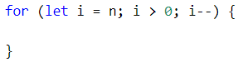
- In the loop body, print the variable i:
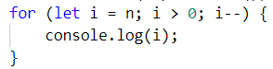

Testing in the Judge System
Test the solution to this problem here: https://judge.softuni.org/Contests/Compete/Index/4706#1

Numbers 1...N with Step 3
Write a function solve(num) that receives a number n and prints the numbers from 1 to n with step 3.

Sample Input and Output
Input | Output |  | Input | Output |  | Input | Output
solve(10) | 1  4  7  10 |  | solve(7) | 1  4  7 |  | solve(15) | 1  4  7  10  13

Hints and Guidelines
- Make a for-loop from 1 to n (inclusive) and set the step to 3. This means that at each iteration of the loop, the variable i will increase its value by 3 instead of 1:
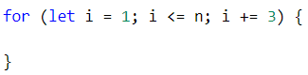
In the loop body, print the variable i:
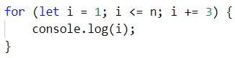

Testing in the Judge System
Test the solution to this problem here: https://judge.softuni.org/Contests/Compete/Index/4706#2

Even Powers of 2
Write a function solve(num) that receives a number n and prints the even powers of 2 ≤ 2^{n}: 2⁰, 2², 2⁴, 2⁶, …, 2^{n}.

Sample Input and Output
Input | Output |  | Input | Output |  | Input | Output |  | Input | Output |  | Input | Output
solve(3) | 1  4 |  | solve(4) | 1  4  16 |  | solve(5) | 1  4  16 |  | solve(6) | 1  4  16  64 |  | solve(7) | 1  4  16  64

Testing in the Judge System
Test the solution to this problem here: https://judge.softuni.org/Contests/Compete/Index/4706#3

Character Sequence
Write a function solve(text) that receives text (string) and prints each character of the string on a separate line.

Sample Input and Output
Input | Output | Input | Output
solve("softuni") | s  o  f  t  u  n  i | solve("ice cream") | i  c  e  c  r  e  a  m

Hints and Guidelines
- Make a for-loop with the initial value of the control variable from 0 to input.length (the length of the string). At each iteration, take the letter at the position in the input word equal to the value of the control variable i, by []
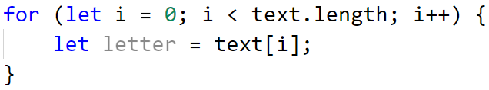
- At each iteration, print the value of the variable letter:
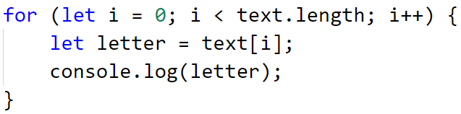

Testing in the Judge System
Test the solution to this problem here: https://judge.softuni.org/Contests/Compete/Index/4706#4

Vowels Sum
Write a function solve(text) that receives, calculates, and prints the sum of the vowel values according to the table below:
Letter | a | e | i | o | u
Value | 1 | 2 | 3 | 4 | 5

Sample Input and Output
Input | Output | Comments
solve("hello") | 6 | e + o = 2 + 4 = 6
solve("hi") | 3 | i = 3
solve("bamboo") | 9 | a + o + o = 1 + 4 + 4 = 9
solve("beer") | 4 | e + e = 2 + 2 = 4

Testing in the Judge System
Test the solution to this problem here: https://judge.softuni.org/Contests/Compete/Index/4706#5

Sum of Numbers
Write a function solve(n) that receives an integer n, sums all its digits, and prints the sum.

Input Data
The function receives a number n.

Output Data
Print on the console on a single line:
"The sum of the digits is:{sum}" – where sum is the sum of the individual digits.

Sample Input and Output
Input | Output |  | Input | Output
solve(1234) | The sum of the digits is:10 |  | solve(564891) | The sum of the digits is:33

Testing in the Judge System
Test the solution to this problem here: https://judge.softuni.org/Contests/Compete/Index/4706#6

Numbers, Divisible by 9
Write a function solve(num1, num2) that receives two numbers and prints to the console all the numbers in the range that are divisible by 9 without remainder, and their sum. On the first line, print the sum of the numbers, and on the following lines, print the numbers that meet the condition.

Sample Input and Output
Input | Output
solve(100,200) | The sum: 1683  108  117  126  135  144  153  162  171  180  189  198

Testing in the Judge System
Test the solution to this problem here: https://judge.softuni.org/Contests/Compete/Index/4706#7

