Lab: While Loop
Problems for in-class and homework exercises for the course "Programming Basics" @ SoftUni
Test your solutions on the Judge System

Read Text
Write a function that reads the elements of an array until it receives the command "Stop".

Sample Input and Output
Input | Output |  | Input | Output
solve(["Smith",  "SoftUni",  "London",  "Bulgaria",  "SomeText",  "Stop",  "AfterStop",  "Europe",  "HelloWorld"]) | Smith  SoftUni  London  Bulgaria  SomeText |  | solve(["London",  "Berlin",  "Moscow",  "Athens",  "Madrid",  "London",  "Paris",  "Stop",  "AfterStop"]) | London  Berlin  Moscow  Athens  Madrid  London  Paris

Testing in the Judge System
Test the solution to this problem here: https://judge.softuni.org/Contests/Compete/Index/4708#0

Password
Write a function that initially reads the username and password of a user profile. Then reads the login password.
- On entering the wrong passwords: prompt the user to enter a new password.
- On entering the correct password: print "Welcome {username}!".

Sample Input and Output
Input | Output |  | Input | Output
solve(["Smith",  "1234",  "Pass",  "1324",  "1234"]) | Welcome Smith! |  | solve(["George",  "secret",  "secret"]) | Welcome George!

Hints and Guidelines
- Initialize two variables username and password, which will contain the username and password:
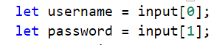
- Initialize the variable data, which will hold the user's login password:
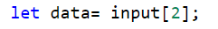
- Initialize the variable index, which will hold the index of the current element in the array. Since we have already assigned the first three elements, we will set index to equal 3.
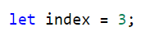
- In a while loop, until a valid password is entered, read a new one and increment index by 1:
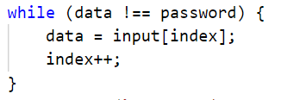
- When a valid password is entered, print the successful login message:
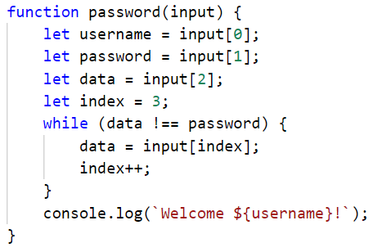

Testing in the Judge System
Test the solution to this problem here: https://judge.softuni.org/Contests/Compete/Index/4708#1

Sum Numbers
Write a function that reads an integer from an array and then integers until their sum becomes greater than or equal to the initial number. When finished, print the sum of the entered numbers.

Sample Input and Output
Input | Output |  | Input | Output
solve([100,  10,  20,  30,  40]) | 100 |  | solve([20,  1,  2,  3,  4,  5,  6]) | 21

Testing in the Judge System
Test the solution to this problem here: https://judge.softuni.org/Contests/Compete/Index/4708#2

Sequence 2k + 1
Write a function solve(n) that accepts the number n entered by the user and prints all numbers ≤ n in the sequence: 1, 3, 7, 15, 31... Each following number is calculated by multiplying the previous number by 2 and adding 1.

Sample Input and Output
Input | Output |  | Input | Output |  | Input | Output |  | Input | Output
solve(3) | 1  3 |  | solve(8) | 1  3  7 |  | solve(17) | 1  3  7  15 |  | solve(31) | 1  3  7  15  31

Hints and Guidelines
- Create a variable that will be a counter and have an initial value of 1.
- Create a while loop that repeats until the counter is smaller than the number you read from the console.
- At each loop iteration, print the counter value and add the given value to it.

Testing in the Judge System
Test the solution to this problem here: https://judge.softuni.org/Contests/Compete/Index/4708#3

Account Balance
Write a function that calculates how much total money is in a bank account after making a certain number of deposits. In each argument, you will get the amount you need to deposit into the account until you receive a "NoMoreMoney" command. For each amount received, the console should output "Increase: " + the amount and that amount should be added to the account. If a number less than 0 is received, the console should output "Invalid operation!" and the program should end. When the program ends, it should print "Total: " + the total amount in the account.
All amounts must be formatted to two digits after the decimal point.

Sample Input and Output
Input | Output |  | Input | Output
solve([5.51,  69.42,  100,  "NoMoreMoney"]) | Increase: 5.51  Increase: 69.42  Increase: 100.00  Total: 174.93 |  | solve([120,  45.55,  -150]) | Increase: 120.00  Increase: 45.55  Invalid operation!  Total: 165.55

Testing in the Judge System
Test the solution to this problem here: https://judge.softuni.org/Contests/Compete/Index/4708#4

Max Number
Write a function that accepts integers until it receives the "Stop" command and finds the largest among them.

Sample Input and Output
Input | Output |  | Input | Output |  | Input | Output |  | Input | Output |  | Input | Output
solve([100,  99,  80,  70,  "Stop"]) | 100 |  | solve([-10,  20,  -30,  "Stop"]) | 20 |  | solve([45,  -20,  7,  99,  "Stop"]) | 99 |  | solve([999,  "Stop"]) | 999 |  | solve([-1,  -2,  "Stop"]) | -1

Testing in the Judge System
Test the solution to this problem here: https://judge.softuni.org/Contests/Compete/Index/4708#5

Min Number
Write a function that accepts integers until it receives the "Stop" command and finds the smallest among them.

Sample Input and Output
Input | Output |  | Input | Output |  | Input | Output |  | Input | Output |  | Input | Output
solve([100,  99,  80,  70,  "Stop"]) | 70 |  | solve([-10,  20,  -30,  "Stop"]) | -30 |  | solve([45,  -20,  7,  99,  "Stop"]) | -20 |  | solve([999,  "Stop"]) | 999 |  | solve([-1,-2,  "Stop"]) | -2

Testing in the Judge System
Test the solution to this problem here: https://judge.softuni.org/Contests/Compete/Index/4708#6

Graduation
Write a function that calculates the student's average grade from all of his/her studies. You will receive the student's name as the first argument and his annual grades as the following arguments. The student passes to the next grade if his annual grade is greater than or equal to 4.00. If he/she failed more than once, he/she will be excluded and the program ends, printing the student's name and the class he/she was excluded from.
At the successful completion of grade 12 to be printed:
"{student's name} graduated. Average grade: {average grade of all studies}"
In the student is excluded from school, to be printed:
"{student's name} has been excluded at {class he/she was excluded from} grade"
The average grade must be formatted to two digits after the decimal point.

Sample Input and Output
Input | Output |  | Input | Output
solve(["George",  5,  5.5,  6,  5.43,  5.5,  6,  5.55,  5,  6,  6,  5.43,  5]) | George graduated. Average grade: 5.53 |  | solve(["Mary",  5,  6,  5,  6,  5,  6,  6,  2,  3]) | Mary has been excluded at 8 grade

Testing in the Judge System
Test the solution to this problem here: https://judge.softuni.org/Contests/Compete/Index/4708#7

