Lab: Strings and Text Processing
Problems for in-class lab for the "C# Fundamentals" course @ SoftUni Global
You can check your solutions in Judge

Reverse Strings
You will be given a series of strings, until you receive an "end" command. Write a program that reverses strings and prints each pair on a separate line in the format "{word} = {reversed word}".

Examples
Input | Output
helLo  Softuni  bottle  end | helLo = oLleh  Softuni = inutfoS  bottle = elttob
Dog  caT  chAir  end | Dog = goD  caT = Tac  chAir = riAhc

Solution
Use while loop and read strings, until you receive "end".
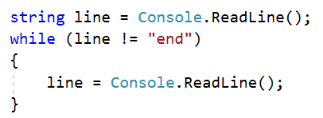
Reverse the string with a for loop. Start from the last index and append each symbol to the new string.
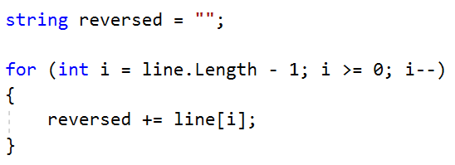
Print the reversed string in the specified format.

Repeat Strings

Create a program that reads an array of strings. Each string is repeated N times, where N is the length of the string. Print the concatenated string.

Examples
Input | Output
hi abc add | hihiabcabcabcaddaddadd
work | workworkworkwork
ball | ballballballball

Solution
- Read a string array.
- Initialize StringBuilder.
- Iterate through the elements of the array.
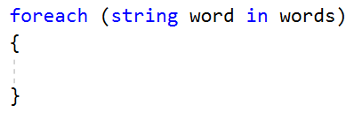
- Find the length of the current word and append it.
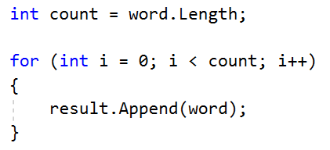
- Print the StringBuilder.

Substring
On the first line, you will receive a string. On the second line, you will receive a second string. Create a program that removes all of the occurrences of the first string in the second, until there is no match. At the end print the remaining string.

Examples
Input | Output | Comment
ice  kicegiciceeb | kgb | We remove "ice" once and we get "kgiciceeb"  We match "ice" one more time and we get "kgiceb"  There is one more match. The finam result is "kgb"
hep  ShepoftunihepIsGrhepeat | SoftuniIsGreat

Hints
- Read the input.
- Find the first index where the key appears
  - Use the built-in method IndexOf().
- Remove the match
  - Use the built-in method Remove(index, length)
- Repeat it, until the text doesn't contain the key anymore.

Text Filter
Create a program that takes a text and a string of banned words. All words included in the ban list should be replaced with a string of asterisks '*', whose length must be equal to the word's length. The entries in the ban list will be separated by a comma and space ", ". The ban list should be entered on the first input line and the text on the second input line.

Examples
Input | Output
Linux, Windows  It is not Linux, it is GNU/Linux. Linux is merely the kernel, while GNU adds the functionality. Therefore we owe it to them by calling the OS GNU/Linux! Sincerely, a Windows client | It is not *****, it is GNU/*****. ***** is merely the kernel, while GNU adds the functionality. Therefore we owe it to them by calling the OS GNU/*****! Sincerely, a ******* client
von Richthofen, German, 80 air  Manfred Albrecht Freiherr von Richthofen, known in English as Baron von Richthofen was a fighter pilot with the German Air Force during World War I. He is considered the ace-of-aces of the war, being officially credited with 80 air combat victories. | Manfred Albrecht Freiherr **************, known in English as Baron ************** was a fighter pilot with the ****** Air Force during World War I. He is considered the ace-of-aces of the war, being officially credited with ****** combat victories.

Hints
- Read the input.
- Replace all ban words in the text with an asterisk ('*').
  - Use the built-in method Replace(banWord, replacement).
  - Use a new string(char ch, int repeatCount) to create the replacement

Digits, Letters and Others
Create a program that receives a single string and prints all the digits on the first line, on the second – all the letters, and on the third – all the other characters. There will always be at least one digit, one letter and one other character.

Examples
Input | Output
Agd#53Dfg^&4F53 | 53453  AgdDfgF  #^&
So%f94t34U*n&i></37 | 943437  SoftUni  %*&></

Hints
- Read the input.
- Use a loop to iterate through all characters in the text. If the char is digit, print it, otherwise ignore it.
  - Use char.IsDigit(char symbol)
- Do the same for the letters and other chars.
  - Find something like the IsDigit method for the letters.

