Lab: Basic Syntax, Conditional Statements and Loops
Problems with exercises and homework for the "Java Fundamentals" course @ SoftUni Global.
You can check your solutions in Judge.

Student Information
Write a program that:
- Reads 3 lines of input – student name, age and average grade
- Print all the info about the student in the following format:
"Name: {student name}, Age: {student age}, Grade: {student grade}".

Examples
Input | Output
John  15  5.40 | Name: John, Age: 15, Grade: 5.40
Steve  16  2.50 | Name: Steve, Age: 16, Grade: 2.50
Marry  12  6.00 | Name: Marry, Age: 12, Grade: 6.00

Solution
First, we need a scanner, which we can use to read data from the console.
Read all the information – student name, age, and grade
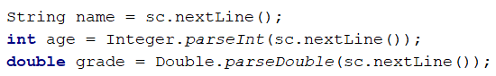
Finally, we need to print the information in the specified format

Passed
Write a program that:
- Read a floating-point number, which represents a grade
- If the grade is equal or more than 3.00, print "Passed!"

Examples
Input | Output |  | Input | Output
5.32 | Passed! |  | 2.34 | (no output)

Passed or Failed
Write a program that:
- Read a floating-point number, which represents a grade
- If the grade is equal or more than 3.00, print "Passed!"
- If the grade is smaller than 3.00, print "Failed!"

Examples
Input | Output |  | Input | Output
5.32 | Passed! |  | 2.36 | Failed!

Hint
We need to take a floating-point number from the console. After that, print in the else statement the appropriate message.
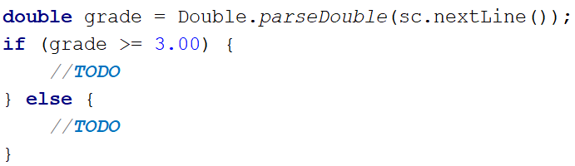

Time After 30 Minutes
Write a program that:
- Reads two integer numbers: current hours and current minutes
- Calculate time after 30 minutes
- Print on the console calculated time in the format "hh:mm"
Note: The hours have one or two digits, and the minutes always have two digits (with leading zero).

Constraints
- The current hours will be between 0 and 23.
- The current minutes will be between 0 and 59.

Examples
Input | Output |  | Input | Output |  | Input | Output |  | Input | Output |  | Input | Output
1  46 | 2:16 |  | 0  01 | 0:31 |  | 23  59 | 0:29 |  | 11  08 | 11:38 |  | 11  32 | 12:02

Month Printer
Write a program that:
- Reads an integer from the console
- Print the corresponding month:
  - 1 -> "January"
  - 2 -> "February"
  - 3 -> "March"
  - 4 -> "April"
  - 5 -> "May"
  - 6 -> "June"
  - 7 -> "July"
  - 8 -> "August"
  - 9 -> "September"
  - 10 -> "October"
  - 11 -> "November"
  - 12 -> "December"
- Print "Error!", if the number is more than 12 or less than 1

Examples
Input | Output |  | Input | Output
2 | February |  | 13 | Error!

Hints
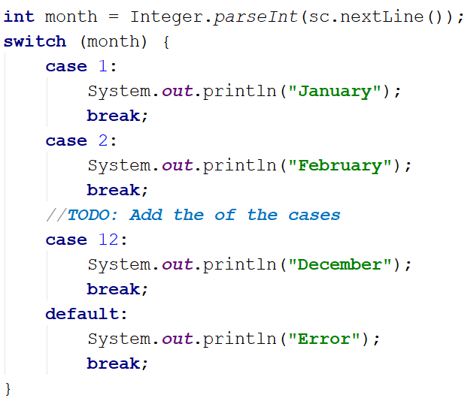

Foreign Languages
Write a program that:
- Reads a string from the console, representing country
- Print:
  - "English" -> if the entered country is "USA" or "England"
  - "Spanish" -> if the entered country is "Spain" or "Argentina" or "Mexico"
  - "unknown" -> if the entered country is any other different from countries listed above

Examples
Input | Output |  | Input | Output
USA | English |  | Germany | unknown

Theatre Promotions
A theatre is having a ticket sale, but they need a program to calculate the price of a single ticket. If the given age does not fit one of the categories, you should print "Error!". You can see the prices in the table below:
Day / Age | 0 <= age <= 18 | 18 < age <= 64 | 64 < age <= 122
Weekday | 12$ | 18$ | 12$
Weekend | 15$ | 20$ | 15$
Holiday | 5$ | 12$ | 10$

Input
The input comes in two lines. On the first line, you will receive the type of day. On the second – is the age of the person.

Output
Print the ticket price according to the table, or "Error!" if the age is not in the table.

Constraints
- The age will be in the interval [-1000…1000].
- The type of day will always be valid.

Examples
Input | Output |  | Input | Output |  | Input | Output |  | Input | Output
Weekday  42 | 18$ |  | Holiday  -12 | Error! |  | Holiday  15 | 5$ |  | Weekend  122 | 15$

Hints
We need to read two lines. The first one will be the type of day. We will convert it to lower case letters with the method "toLowerCase()". After that, we will read the person's age and declare a variable – price, which we will use to set the ticket price.
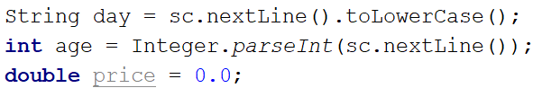
For every type of day, we will need to add different cases to check the person's age and set the price. Some age groups have equal prices for the same type of day. This means we can use logical operators to merge some of the conditions.
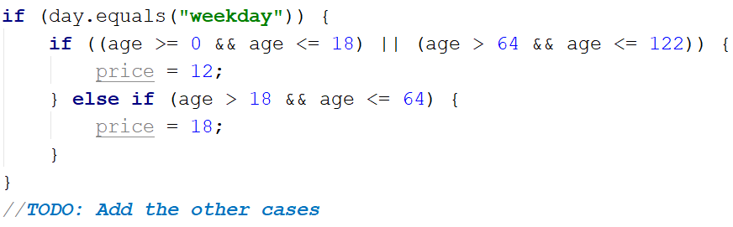
Think where and how you can use logical operators for the other cases.
We can check if the price has a value is different from the initial one. If it does, that means we got a valid combination of day and age, and the ticket price is saved in the price variable. If the price has a value of 0, then none of the cases got hit, therefore, we have to print the error message.
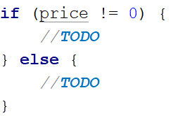

Divisible by 3
Write a program that prints all the numbers from 1 to 100, which are divisible by 3. You have to use a single for loop. The program should not receive input.

Solution
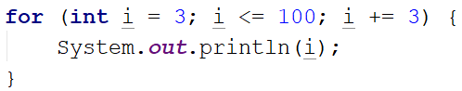

Sum of Odd Numbers
Write a program that prints the next n odd numbers (starting from 1) and on the last row prints the sum of them.

Input
On the first line, you will receive a number – n. This number shows how many odd numbers you should print.

Output
Print the next n odd numbers, starting from 1, separated by new lines. On the last line, print the sum of these numbers.

Constraints
- n will be in the interval [1…100]

Examples
Input | Output |  | Input | Output
5 | 1  3  5  7  9  Sum: 25 |  | 3 | 1  3  5  Sum: 9

Hints
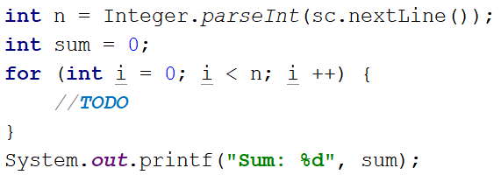

Multiplication Table
You will receive an integer as input from the console. Print the 10 times table for this integer. See the examples below for more information.

Output
Print every row of the table in the following format:
{theInteger} X {times} = {product}

Constraints
- The integer will be in the interval [1…100]

Examples
Input | Output |  | Input | Output
5 | 5 X 1 = 5  5 X 2 = 10  5 X 3 = 15  5 X 4 = 20  5 X 5 = 25  5 X 6 = 30  5 X 7 = 35  5 X 8 = 40  5 X 9 = 45  5 X 10 = 50 |  | 2 | 2 X 1 = 2  2 X 2 = 4  2 X 3 = 6  2 X 4 = 8  2 X 5 = 10  2 X 6 = 12  2 X 7 = 14  2 X 8 = 16  2 X 9 = 18  2 X 10 = 20

Even Number
Take as an input an even number and print its absolute value with a message: "The number is: {absoluteValue}". If the number is odd, print "Please write an even number." and continue reading numbers.

Examples
Input | Output |  | Input | Output
1  3  6 | Please write an even number.  Please write an even number.  The number is: 6 |  | -6 | The number is: 6

Refactor Sum of Odd Numbers
You are assigned to find and fix the bugs in an existing piece of code, using the debugger. You should trace the program execution to find the lines of code that produce incorrect or unexpected results.
You are given a program (existing source code) that prints the next n odd numbers (starting from 1) and on the last row, prints the sum of them.

Examples
Input | Output |  | Input | Output
5 | 1  3  5  7  9  Sum: 25 |  | 3 | 1  3  5  Sum: 9

SumOddNumbers.java
Scanner sc = new Scanner(System.in);
int n = Integer.parseInt(sc.nextLine());
int sum = 1;
for (int i = 0; i <= n; i++) {
System.out.print(2 * i + 1);
sum += 2 * i;
}
System.out.printf("Sum: %d%n", sum);

