Exercise: Arrays
Problems with exercises and homework for the "Java Fundamentals" course @ SoftUni Global.
You can check your solutions in Judge.

Train
You will be given a count of wagons in a train n. On the next n lines, you will receive how many people will get on that wagon. In the end, print the whole train and the sum of the people on the train.

Examples
Input | Output
3  13  24  8 | 13 24 8  45
6  3  52  71  13  65  4 | 3 52 71 13 65 4  208
1  100 | 100  100

Common Elements
Write a program that prints common elements in two arrays. You have to compare the elements of the second array to the elements of the first.

Examples
Input | Output
Hey hello 2 4  10 hey 4 hello | 4 hello
S of t un i  of i 10 un | of i un
i love to code  code i love to | code i love to

Zig-Zag Arrays
Write a program that creates 2 arrays. You will be given an integer n. On the next n lines, you get 2 integers. Form 2 arrays as shown below.

Examples
Input | Output
4  1 5  9 10  31 81  41 20 | 1 10 31 20  5 9 81 41
2  80 23  31 19 | 80 19  23 31

Array Rotation
Write a program that receives an array and the number of rotations you have to perform (the first element goes at the end). Print the resulting array.

Examples
Input | Output
51 47 32 61 21  2 | 32 61 21 51 47
32 21 61 1  4 | 32 21 61 1
2 4 15 31  5 | 4 15 31 2

Top Integers
Write a program to find all the top integers in an array. A top integer is an integer that is bigger than all the elements to its right.

Examples
Input | Output
1 4 3 2 | 4 3 2
14 4 3 19 15 17 | 19 17
27 9 42 2 13 45 48 | 48

Equal Sums
Write a program that determines if an element exists in the array such that the sum of the elements on its left is equal to the sum of the elements on its right. If there are no elements to the left/right, their sum is considered to be 0. Print the index that satisfies the required condition or "no" if there is no such index.

Examples
Input | Output | Comments
1 2 3 3 | 2 | At a[2] -> left sum = 3, right sum = 3  a[0] + a[1] = a[3]
1 2 | no | At a[0] -> left sum = 0, right sum = 2  At a[1] -> left sum = 1, right sum = 0  No such index exists
1 | 0 | At a[0] -> left sum = 0, right sum = 0
1 2 3 | no | No such index exists
10 5 5 99 3 4 2 5 1 1 4 | 3 | At a[3] -> left sum = 20, right sum = 20  a[0] + a[1] + a[2] = a[4] + a[5] + a[6] + a[7] + a[8] + a[9] + a[10]

Condense Array to Number
Write a program to read an array of integers and condense them by summing adjacent couples of elements until a single integer is obtained. For example, if we have 3 elements {2, 10, 3}, we sum the first two and the second two elements and obtain {2+10, 10+3} = {12, 13}, then we sum again all adjacent elements and obtain {12+13} = {25}.

Examples
Input | Output | Comments
2 10 3 | 25 | 2 10 3 2+10 10+3 12 13 12 + 13 25
5 0 4 1 2 | 35 | 5 0 4 1 2 5+0 0+4 4+1 1+2 5 4 5 3 5+4 4+5 5+3 9 9 8 9+9 9+8 18 17 18+17 35
1 | 1 | 1 is already condensed to number

Hints
While we have more than one element in the array nums[], repeat the following:
- Allocate a new array condensed[] of size nums.Length-1.
- Sum the numbers from nums[] to condensed[]:
  - condensed[i] = nums[i] + nums[i+1]
- nums[] = condensed[]
The process is illustrated below:
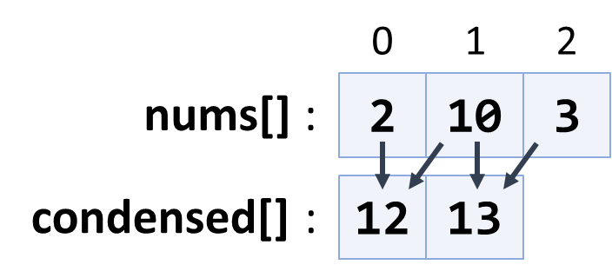
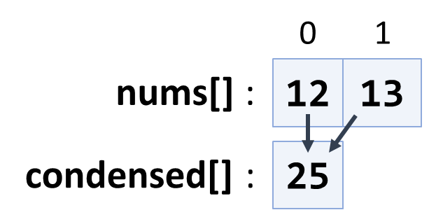

Magic Sum
Write a program that prints all unique pairs in an array of integers whose sum is equal to a given number.

Examples
Input | Output
1 7 6 2 19 23  8 | 1 7  6 2
14 20 60 13 7 19 8  27 | 14 13  20 7  19 8

Array Modifier
You are given an array with integers. Write a program to modify the elements after receiving the following commands:
- "swap {index1} {index2}" takes two elements and swap their places.
- "multiply {index1} {index2}" takes the element at the 1st index and multiplies it with the element at 2nd index. Save the product at the 1st index.
- "decrease" decreases all elements in the array with 1.

Input
On the first input line, you will be given the initial array values separated by a single space.
On the next lines, you will receive commands until you receive the command "end". The commands are as follows:
- "swap {index1} {index2}"
- "multiply {index1} {index2}"
- "decrease"

Output
The output should be printed on the console and consist of elements of the modified array – separated by a comma and a single space ", ".

Constraints
- Elements of the array will be integer numbers in the range [-2³¹...2³¹].
- The count of the array elements will be in the range [2...100].
- Indexes will always be in the range of the array.

Examples
Input | Output | Comments
23 -2 321 87 42 90 -123  swap 1 3  swap 3 6  swap 1 0  multiply 1 2  multiply 2 1  decrease  end | 86, 7382, 2369942, -124, 41, 89, -3 | 23 -2 321 87 42 90 -123 – initial values  swap 1(-2) and 3(87) ▼  23 87 321 -2 42 90 -123  swap 3(-2) and 6(-123) ▼  23 87 321 -123 42 90 -2  swap 1(87) and 0(23) ▼  87 23 321 -123 42 90 -2  multiply 1(23) 2(321) = 7383 ▼  87 7383 321 -123 42 290 -2  multiply 2(321) 1(7383) = 2369943 ▼  87 7383 2369943 -123 42 90 -2  decrease – all - 1 ▼  86 7383 2369942 -124 41 89 -3
1 2 3 4  swap 0 1  swap 1 2  swap 2 3  multiply 1 2  decrease  end | 1, 11, 3, 0

The Lift
Write a program that finds a place for the tourist on a lift.
Every wagon should have a maximum of 4 people on it. If a wagon is full, you should direct the people to the next one with space available.

Input
- On the first line, you will receive how many people are waiting to get on the lift.
- On the second line, you will receive the current state of the lift separated by a single space: " ".

Output
When there is no more available space left on the lift, or there are no more people in the queue, you should print on the console the final state of the lift's wagons separated by a single space " " and one of the following messages:
- If there are no more people and the lift has empty spots, you should print:
"The lift has empty spots!
{wagons separated by ' '}"
- If there are still people in the queue and no more available space, you should print:
"There isn't enough space! {people} people in a queue!
{wagons separated by ' '}"
- If the lift is full and there are no more people in the queue, you should print only the wagons separated by a single space " ".

Examples
Input | Output
15  0 0 0 0 | The lift has empty spots!  4 4 4 3
Comment
First state - 4 0 0 0 -> 11 people left
Second state – 4 4 0 0 -> 7 people left
Third state – 4 4 4 0 -> 3 people left
Input | Output
20  0 2 0 | There isn't enough space! 10 people in a queue!  4 4 4
Comment
First state - 4 2 0 -> 16 people left
Second state – 4 4 0 -> 14 people left
Third state – 4 4 4 -> 10 people left, but they're no more wagons.

