C# Advanced Lab - Algorithms
This document defines algorithmic problems from the "Advanced C#" Course @ Software University. You are presented with some problems and certain steps you need to take in order to accomplish the tasks.

Insertion Sort
Insertion Sort Algorithm
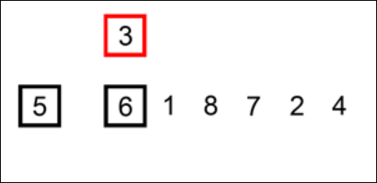
You can see an animated version of the algorithm in detail here: http://upload.wikimedia.org/wikipedia/commons/0/0f/Insertion-sort-example-300px.gif

Your task is to implement the Insertion Sort algorithm using C#. The solution of the algorithm is as follows:
- Start from i = 1 and iterate to the last element
  - If A[i-1] is larger than A[i]:
    - Start shifting all previous elements (i-1, i-2, i-3, etc.) larger than the A[i] to the right
    - Do the above until A[i-n] is smaller or equal to A[i]

Constraints
- The input list will hold integers in the range [−2147483648 … 2147483647].
- You are NOT allowed to use Array.Sort(), .OrderBy() or similar methods. Write your own Insertion Sort algorithm.

Example
Input | Output
5 1 19 12 3 6 10 2 | 1 2 3 5 6 10 12 19
0 1 2 3 4 5 6 6 7 8 | 0 1 2 3 4 5 6 6 7 8
0 -1 0 -1 -1 0 -2 3 -1 -3 5 -1 | -3 -2 -1 -1 -1 -1 -1 0 0 0 3 5

