C# Advanced Lab - Algorithms
This document defines algorithmic problems from the "Advanced C#" Course @ Software University. You are presented with some problems and certain steps you need to take in order to accomplish the tasks.

Linear and Binary Search
There are two standard array searching algorithms - Linear and Binary Search.
- Linear search traverses the entire collection until the searched element is found.
- Binary search works only on sorted collections. It picks the mid element of the collection and checks if it's equal to the searched element.
  - If it's equal, returns the mid index.
  - If it's smaller, cuts the right half of the collection and repeats the same step.
  - If it's larger, cuts the left half of the collection and repeats the same step.
If no such element is found, both algorithms should return -1 as result.
Linear Search vs Binary Search Comparison
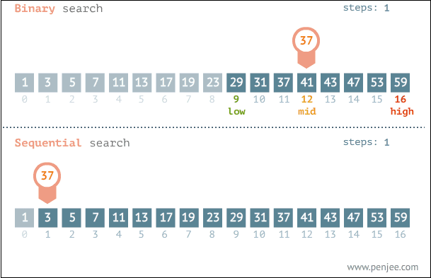
Animated gif:
https://blog.penjee.com/wp-content/uploads/2015/04/binary-and-linear-search-animations.gif

Your task is to implement both Linear Search and Binary Search algorithms using C#. Create respective methods for them - LinearSearch(array, element) and BinarySearch(array, element).
The solution for Linear search is as follows:
- Iterate through each element of the collection
  - Check if its equal to the searched element. Return index if it is.
  - Continue iterating if not.
  - Return -1 if no such element is found.

One solution for Binary search is as follows:
- Define min=0 and max=A.length-1
- Until there is at least 1 element in range:
  - Get mid index in range [min…max] and check if A[mid] is equal to search element
    - If it's equal, return mid index
    - If it's larger, repeat iteration by ignoring all elements to the left of mid
    - If it's smaller, repeat iteration by ignoring all elements to the right of mid
In case of duplicate elements, both algorithms should return the leftmost index (see example 3 below).

Constraints
- The input list will hold integers in the range [−2147483648 … 2147483647].
- You are NOT allowed to use .IndexOf(), Array.BinarySearch() or similar methods. Write your own Linear and Binary search algorithms.

Example
Input | Output
-2 0 3 5 213 8582 239191 985128  239191 | 6
0 1 2 3 4 5 6 6 7 8  -2 | -1
3 9 10 12 13 13 13 13  13 | 4

