Problem 21 – IT Village
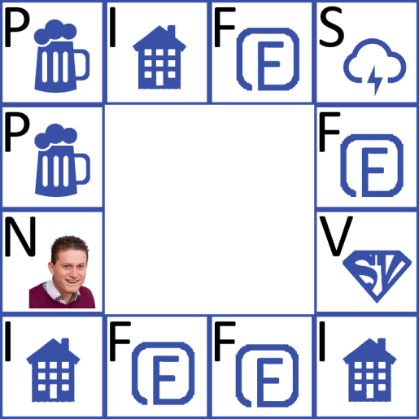
Every Friday night a group of super cool programmers get together and play their favorite board game – "IT Village". But they are so tired of coding through the week they forget the rules of the game all the time. Also, they find it very difficult to work with paper and roll the dice so they made a very important decision – their game needed to evolve from a board game into a computer game. It is a well-known fact that programmers are lazy. They started programming the game, but they stopped. Your task is to finish the game for them.
You are given a game board which is 4 fields high and 4 fields wide. You can play only on the game fields (the first and the last row, as well as the first and the last column). All other fields are always empty and you cannot play on them. You start the game on an entering position (on one of the game fields) and you roll the dice. You move on the game fields clockwise. You have the following types of fields:
Field Name | Letter in the Input | Description | Money Gain(+) / Loose(-) | Occurrences in the Game
Wi-Fi pub | P | You have to buy one Cloud Cocktail | -5 coins | Many
Wi-Fi Inn | I | - If you have enough money you have to buy the Inn  - If you don't – you pay for your stay  - Assume you won’t land on an inn you already own | - -100 coins  - -10 coins | Many
Freelance Project | F | You get paid | 20 coins | Many
Storm | S | The Wi-Fi in the village dies and you get so depressed that you miss 2 moves | - | Many
Super Vlado | V | Your coins are multiplied by 10 | *10 | Only 1 field
Nakov | N | When you step on this field you immediately win the game | - | 1 or no such field
Empty Field | 0 | Empty field | - | Always 4
You start the game with 50 coins. For every inn you own, you gain 20 coins per inn per move. When you skip moves because of a storm you do not get paid for inns. The coins for inns are added to your money in the beginning of every move (from the next one you bought the inn).
The game ends in the following cases:
Game End Case | Output
If you run out of money (< 0 coins) | <p>You lost! You ran out of money!<p>
If you buy all the inns | <p>You won! You own the village now! You have {0} coins!<p>
If you run out of moves | <p>You lost! No more moves! You have {0} coins!<p>
If you step on the "Nakov" field | <p>You won! Nakov's force was with you!<p>
Note: {0} is how much coins you have when the game ends.

Input
The input will be read from the console. The game board will be received as a string on the first line. The entering position will be received on the second line. The numbers on the dice for each move will be received on the third line.

Output
The output consists of a paragraph, containing one of the messages in the 'Output' column in the table above.

Constraints
- The game board will always be 4 fields wide and 4 fields high. The string for the game board contains the letter combinations: P, I, F, S, V, N, or 0. The letter N is optional. All the other letters will always be on the game board. The letter combinations are separated by a space. The rows are separated by a ' | '.
- The entering position will consist of two numbers, separated by a space. The first number is the row number, the second – the column number. For example '3 4' means that the entering position is row 3, column 4 (indexing starts from 1).
- The dice numbers are received as a string of numbers from 2 to 12, separated by a space.

Examples
Input | Output
P I F S | P 0 0 F | N 0 0 V | I F F I  2 1  5 11 9 8 6 8 4 | <p>You lost! No more moves! You have 500 coins!<p>
Comment
You start on row 2, column 1 – "P". First move is 5 – you go to "F" – you are paid 20 coins, you have 70 coins now. Second move is 11 – you go to "S" – you miss the next two moves – 9 and 8. Fifth move is 6 – you go to "I" – you have less than 100 coins so you pay 10 coins to sleep, you have 60 coins now. Sixth move is 8 – you go to "V" – Super Vlado multiplies your coins by 10 – you have 600 coins now. Seventh move is 4 – you go to "I" – you have enough coins so you buy it – you have 500 coins now. You have no more moves and you didn't buy all the inns, so the output is as shown above on the right.

