Problem 3 - Bakery Shop
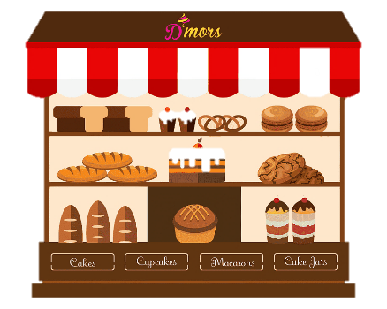
Maria is opening a bakery shop, and she needs your help to keep track of the stock availability.
Create a program that keeps the information about the stock at the shop.
You will be receiving lines with commands until you receive the "Complete" command. The possible commands are:
- "Receive {quantity} {food}":
  - Add the quantity to the given food.
  - If the food does not exist, add it to your record.
  - If the quantity is invalid (<= 0), ignore the command.
- "Sell {quantity} {food}":
  - If the food is not in your record, print: "You do not have any {food}.".
  - If there is not enough quantity of the wanted food, you should sell (decrease) what you have in stock and then remove the food from your record. Print: "There aren't enough {food}. You sold the last {sold quantity} of them."
  - Otherwise, decrease the quantity of the given food and print: "You sold {quantity} {food}.". If, after reducing the quantity, there is 0 amount of this food, you should remove it from your record.
You must keep track of all sold food quantities!
In the end, you should print the stock availability in the format:
"{food1}: {quantity}
{food2}: {quantity}
…
{foodN}: {quantity}
All sold: {count of all sold food quantity} goods"

Input
- You will be receiving lines until you receive the "Complete" command.
- The input will always be valid.

Output
- Print the stock availability in the format described above.
- Print the amount of all sold food in the format described above.

Examples
Input | Output
Receive 105 cookies  Receive 10 donuts  Sell 10 donuts  Sell 1 bread  Complete | You sold 10 donuts.  You do not have any bread.  cookies: 105  All sold: 10 goods
Receive 10 muffins  Receive 23 bagels  Sell 5 muffins  Sell 10 bagels  Complete | You sold 5 muffins.  You sold 10 bagels.  muffins: 5  bagels: 13  All sold: 15 goods

JS Examples
Input | Output
([Receive 105 cookies,  Receive 10 donuts,  Sell 10 donuts,  Sell 1 bread,  Complete]) | You sold 10 donuts.  You do not have any bread.  cookies: 105  All sold: 10 goods
([Receive 10 muffins,  Receive 23 bagels,  Sell 5 muffins,  Sell 10 bagels,  Complete]) | You sold 5 muffins.  You sold 10 bagels.  muffins: 5  bagels: 13  All sold: 15 goods

