Lab: Multidimensional Arrays
Problems for the "C# Advanced" course @SoftUni Global
You can check your solutions in Judge

Sum Matrix Elements
Write a program that reads a matrix from the console and prints:
- Count of rows
- Count of columns
- Sum of all matrix elements
On the first line, you will get matrix sizes in format [rows, columns]

Examples
Input | Output
3, 6  7, 1, 3, 3, 2, 1  1, 3, 9, 8, 5, 6  4, 6, 7, 9, 1, 0 | 3  6  76

Hints
- On the next [rows] lines, you will get elements for each column separated with coma and whitespace.
- Try to use only foreach for printing.

Sum Matrix Columns
Create a program that reads a matrix from the console and prints the sum for each column. On the first line, you will get matrix rows. On the next rows lines, you will get elements for each column separated with a space.

Examples
Input | Output
3, 6  7 1 3 3 2 1  1 3 9 8 5 6  4 6 7 9 1 0 | 12  10  19  20  8  7
3, 3  1 2 3  4 5 6  7 8 9 | 12  15  18

Hints
- Read matrix sizes.
- On the next lines, read the columns.
- Traverse the matrix and sum all elements in each column.
- Print the sum and continue with the other columns.

Primary Diagonal
Create a program that finds the sum of elements from the matrix’s primary diagonal.
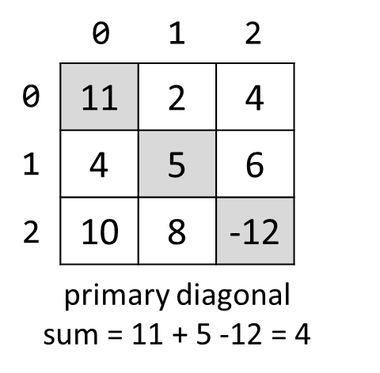

Input
- On the first line, you are given the integer N – the size of the square matrix.
- The next N lines, hold the values for every row – N numbers separated by a space.

Examples
Input | Output
3  11 2 4  4 5 6  10 8 -12 | 4
3  1 2 3  4 5 6  7 8 9 | 15

Symbol in Matrix
Create a program that reads N, a number representing rows and cols of a matrix. On the next N lines, you will receive rows of the matrix. Each row consists of ASCII characters. After that, you will receive a symbol. Find the first occurrence of that symbol in the matrix and print its position in the format: "({row}, {col})". If there is no such symbol, print an error message "{symbol} does not occur in the matrix".

Examples
Input | Output
3  ABC  DEF  X!@  ! | (2, 1)
4  asdd  xczc  qwee  qefw  4 | 4 does not occur in the matrix

Square with Maximum Sum
Create a program that reads a matrix from the console. Then find the biggest sum of the 2x2 submatrix and print it to the console.
On the first line, you will get matrix sizes in format rows, columns.
On the next rows lines, you will get elements for each column, separated with a comma and a space.
Print the biggest top-left square, which you find, and the sum of its elements.

Examples
Input | Output
3, 6  7, 1, 3, 3, 2, 1  1, 3, 9, 8, 5, 6  4, 6, 7, 9, 1, 0 | 9 8  7 9  33
2, 4  10, 11, 12, 13  14, 15, 16, 17 | 12 13  16 17  58

Hints
- Think about IndexOutOfRangeException().
- If you find more than one max square, print the top-left one (min row, then min column).

Jagged-Array Modification
Create a program that reads a matrix from the console. On the first line, you will get matrix rows. On the next rows lines, you will get elements for each column separated with space. You will be receiving commands in the following format:
- Add {row} {col} {value} – Increase the number at the given coordinates with the value.
- Subtract {row} {col} {value} – Decrease the number at the given coordinates by the value.
Coordinates might be invalid. In this case, you should print "Invalid coordinates". When you receive "END" you should print the matrix and stop the program.

Examples
Input | Output
3  1 2 3  4 5 6 7  8 9 10  Add 0 0 5  Subtract 1 2 2  Subtract 1 4 7  END | Invalid coordinates  6 2 3  4 5 4 7  8 9 10
4  1 2 3 4  5  8 7 6 5  4 3 2 1  Add 4 4 100  Add 3 3 100  Subtract -1 -1 42  Subtract 0 0 42  END | Invalid coordinates  Invalid coordinates  -41 2 3 4  5  8 7 6 5  4 3 2 101

Pascal Triangle
The Pascal’s triangle may be constructed in the following manner: in row 0 (the topmost row), there is a unique nonzero entry 1. Each entry of each subsequent row is constructed by adding the number above and to the left with the number above and to the right, treating blank entries as 0:
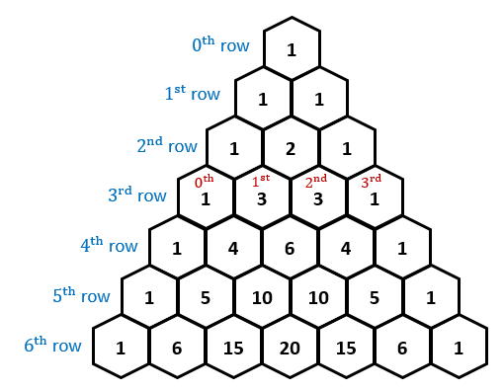
If you want more info about Pascal's triangle here.
Write a program to print the Pascal’s triangle of given size n.

Examples
Input | Output
4 | 1  1 1  1 2 1  1 3 3 1
13 | 1  1 1  1 2 1  1 3 3 1  1 4 6 4 1  1 5 10 10 5 1  1 6 15 20 15 6 1  1 7 21 35 35 21 7 1  1 8 28 56 70 56 28 8 1  1 9 36 84 126 126 84 36 9 1  1 10 45 120 210 252 210 120 45 10 1  1 11 55 165 330 462 462 330 165 55 11 1  1 12 66 220 495 792 924 792 495 220 66 12 1

Hints
- The input number n will be 1 <= n <= 60.
- Think about the proper type for elements in the array.
- Don't be scared to use more and more arrays.
- Use a jagged array, with triangular form.
- Each row is created by summing two elements from the previous rows.
- You may use

