Lab: Tuples and Sets
This document defines the exercises for the "Python Advanced" course at @SoftUni Global.
Please, submit your source code solutions for the described problems to the Judge System.

Count Same Values
You will be given numbers separated by a space. Write a program that prints the number of occurrences of each number in the format "{number} - {count} times". The number must be formatted to the first decimal point.

Examples
Input | Output
-2.5 4 3 -2.5 -5.5 4 3 3 -2.5 3 | -2.5 - 3 times  4.0 - 2 times  3.0 - 4 times  -5.5 - 1 times
2 4 4 5 5 2 3 3 4 4 3 3 4 3 5 3 2 5 4 3 | 2.0 - 3 times  4.0 - 6 times  5.0 - 4 times  3.0 - 7 times

Students' Grades
Write a program that reads students' names and their grades and adds them to the student record.
On the first line, you will receive the number of students – N. On the following N lines, you will be receiving a student's name and grade.
For each student print all his/her grades and finally his/her average grade, formatted to the second decimal point in the format: "{student's name} -> {grade1} {grade2} ... {gradeN} (avg: {average_grade})".
The order in which we print the result does not matter.

Examples
Input | Output
7  Peter 5.20  Mark 5.50  Peter 3.20  Mark 2.50  Alex 2.00  Mark 3.46  Alex 3.00 | Mark -> 5.50 2.50 3.46 (avg: 3.82)  Peter -> 5.20 3.20 (avg: 4.20)  Alex -> 2.00 3.00 (avg: 2.50)
4  Scott 4.50  Ted 3.00  Scott 5.00  Ted 3.66 | Ted -> 3.00 3.66 (avg: 3.33)  Scott -> 4.50 5.00 (avg: 4.75)
5  Lee 6.00  Lee 5.50  Lee 6.00  Peter 4.40  Kenny 3.30 | Peter -> 4.40 (avg: 4.40)  Lee -> 6.00 5.50 6.00 (avg: 5.83)  Kenny -> 3.30 (avg: 3.30)

Record Unique Names
Write a program, which will take a list of names and print only the unique names in the list.
The order in which we print the result does not matter.

Examples
Input | Output |  | Input | Output |  | Input | Output
8  Lee  Joey  Lee  Joe  Alan  Alan  Peter  Joey | Alan  Joey  Lee  Joe  Peter |  | 7  Lyle  Bruce  Alice  Easton  Shawn  Alice  Shawn | Easton  Lyle  Alice  Bruce  Shawn |  | 6  Adam  Adam  Adam  Adam  Adam  Adam | Adam

Parking Lot
Write a program that:
- Records a car number for every car that enters the parking lot
- Removes a car number when the car leaves the parking lot
On the first line, you will receive the number of commands - N. On the following N lines, you will receive the direction and car's number in the format: "{direction}, {car_number}". The direction could only be "IN" or "OUT". Print the car numbers which are still in the parking lot. Keep in mind that all car numbers must be unique. If the parking lot is empty, print "Parking Lot is Empty".
Note: The order in which we print the result does not matter.

Examples
Input | Output
10  IN, CA2844AA  IN, CA1234TA  OUT, CA2844AA  IN, CA9999TT  IN, CA2866HI  OUT, CA1234TA  IN, CA2844AA  OUT, CA2866HI  IN, CA9876HH  IN, CA2822UU | CA2844AA  CA9999TT  CA2822UU  CA9876HH
4  IN, CA2844AA  IN, CA1234TA  OUT, CA2844AA  OUT, CA1234TA | Parking Lot is Empty

SoftUni Party
There is a party at SoftUni. Many guests are invited, and there are two types of them: Regular and VIP. When a guest comes, check if they exist on any of the two reservation lists.
On the first line, you will receive the number of guests – N. On the following N lines, you will be receiving their reservation codes. All reservation codes are 8 characters long, and all VIP numbers will start with a digit. Keep in mind that all reservation numbers must be unique.
After that, you will be receiving guests who came to the party until you read the "END" command.
In the end, print the number of guests who did not come to the party and their reservation numbers:
- The VIP guests must be first.
- Both the VIP and the Regular guests must be sorted in ascending order.

Examples
Input | Output | Input | Output
5  7IK9Yo0h  9NoBUajQ  Ce8vwPmE  SVQXQCbc  tSzE5t0p  9NoBUajQ  Ce8vwPmE  SVQXQCbc  END | 2  7IK9Yo0h  tSzE5t0p | 6  m8rfQBvl  fc1oZCE0  UgffRkOn  7ugX7bm0  9CQBGUeJ  2FQZT3uC  2FQZT3uC  9CQBGUeJ  fc1oZCE0  END | 3  7ugX7bm0  UgffRkOn  m8rfQBvl

Summation Pairs
The task is not included in the Judge system.
You will receive a sequence of numbers (unique integers) separated by space on the first line. On the second line, you'll receive a target number. Your task is to find the pairs of numbers whose sum equals the target number. For each found pair print "{number} + {number} = {target_number}". You should NOT use the same element twice to fulfill the condition above.
Can you come up with an algorithm that has less time complexity?

Examples
Input | Output
1 5 4 2 3 0  4 | 1 + 3 = 4  4 + 0 = 4
11 8 5 6 9 2 7 3 4  11 | 5 + 6 = 11  9 + 2 = 11  8 + 3 = 11  7 + 4 = 11

Hints
First, we read the sequence of numbers and the target number from the console:
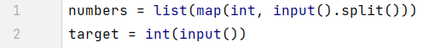
Then, we write nested for-loops to loop through the list of numbers and check the sum of each two numbers with the target:
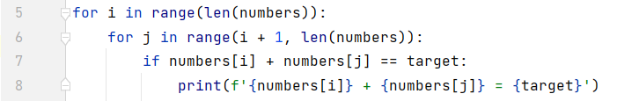
That is not enough. When we find a matching pair of numbers, we should find a way to eliminate them from the following summation. One way to do that is by changing the value of the element and continuing the loop when we hit that value:
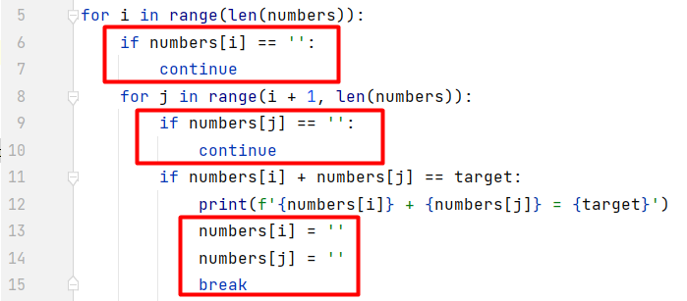
This is an example solution to our problem.
However, is it possible to improve the solution, so the result is found faster? We can use just one loop to iterate over the sequence and an additional set, where we will keep the difference between the target and each of the numbers in the list. Then we will continue to look for exactly that number from the following numbers in the given sequence.
First, let us create the set to keep the numbers as described above. Then, create an empty dictionary that will keep the same number (as added in the set) as a key, and the list's number (that we subtracted from the target) as a value:
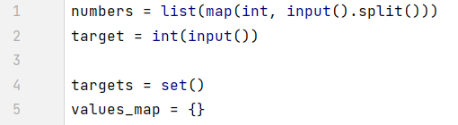
Next, iterate over the sequence of numbers and start subtracting each of them from the target number. The resulting number should be added to the set, and the value should be added in the dictionary mapped to the resulting number (as key):
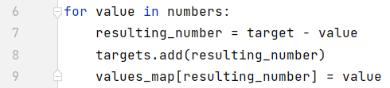
To create a match where the sum of two numbers should be equal to the target number, we should check if any of the next numbers are in the target set. If the condition is met, print the value and its pair (the value from the dictionary mapping the same key). Do not forget to remove the found pair from the set and the dictionary:
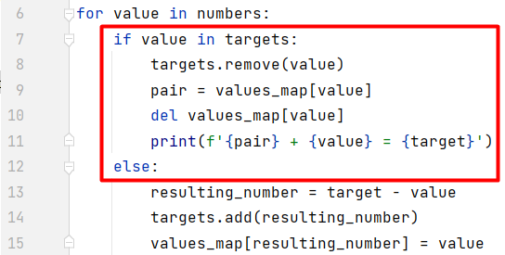
This is a faster way to solve the problem.
You can check this by wrapping the solution in a time range using the time.time() method: 

