Lab: Stacks and Queues
This document defines the exercises for the "Java Advanced" course @ SoftUni Global
Please submit your solutions (source code) to all below-described problems in Judge.

Working with Stacks

Browser History
Write a program that takes two types of browser instructions:
- Normal navigation: a URL is set, given by a string;
- The string "back" sets the current URL to the last set URL
After each instruction, the program should print the current URL. If the back instruction can't be executed, print
"no previous URLs". The input ends with the "Home" command, and then you simply have to stop the program.

Examples
Input | Output
https//softuni.bg/  back  https//softuni.bg/trainings/courses  back  https//softuni.bg/trainings/2056  back  https//softuni.bg/trainings/live  https//softuni.bg/trainings/live/details  Home | https//softuni.bg/  no previous URLs  https//softuni.bg/trainings/courses  https//softuni.bg/  https//softuni.bg/trainings/2056  https//softuni.bg/  https//softuni.bg/trainings/live  https//softuni.bg/trainings/live/details
https//google.bg/  https//google.bg/softuni  back  back  https//google.bg/java/advanced  back  https//google.bg/java/oop  Home | https//google.bg/  https//google.bg/softuni  https//google.bg/  no previous URLs  https//google.bg/java/advanced  https//google.bg/  https//google.bg/java/oop

Hints
- Use ArrayDeque<>.
- Use String to keep the current page.
- Use push(), when moving to the next page.
- Use pop(), when going back.

Simple Calculator
Create a simple calculator that can evaluate simple expressions that will not hold any operator different from addition and subtraction. There will not be parentheses or operator precedence.
Solve the problem using a Stack.

Examples
Input | Output
2 + 5 + 10 - 2 - 1 | 14
2 - 2 + 5 | 5

Hints
- Use an ArrayDeque<>.
- Consider using the add() method.
- You can either
  - add the elements and then pop them out
  - or push them and reverse the stack

Decimal to Binary Converter
Create a simple program that can convert a decimal number to its binary representation. Implement an elegant solution using a Stack.
Print the binary representation back at the terminal.

Examples
Input | Output
10 | 1010
1024 | 10000000000

Hints
- If the given number is 0, just print 0.
- Else, while the number is greater than zero, divide it by 2 and push the reminder into the stack.
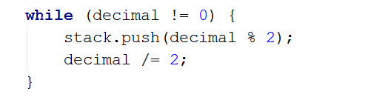
- When you are done dividing, pop all reminders from the stack, which is the binary representation.
- Matching Brackets
We are given an arithmetical expression with brackets. Scan through the string and extract each sub-expression.
Print the result back at the terminal.

Examples
Input | Output
1 + (2 - (2 + 3) * 4 / (3 + 1)) * 5 | (2 + 3)  (3 + 1)  (2 - (2 + 3) * 4 / (3 + 1))
(2 + 3) - (2 + 3) | (2 + 3)  (2 + 3)

Hints
- Use a stack, namely an ArrayDeque().
- Scan through the expression searching for brackets:
  - If you find an opening bracket, push the index into the stack.
  - If you find a closing bracket, pop the topmost element from the stack. This is the index of the opening bracket.
  - Use the current and the popped index to extract the sub-expression.
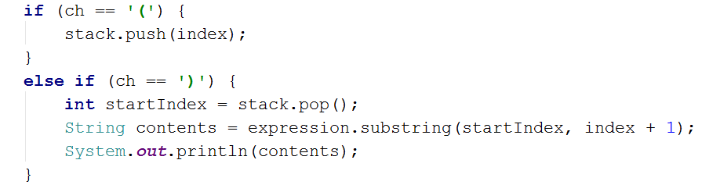

Working with Queues
- Printer Queue
The printer queue is a simple way to control the order of files sent to a printer device. We know that a single printer can be shared between multiple devices. So to preserve the order of the files sent, we can use a queue.
Write a program which takes filenames until the "print" command is received. Then as output, print the filenames in the order of printing. Some of the tasks may be canceled. If you receive "cancel" you have to remove the first file to be printed. If there is no current file to be printed, print "Printer is on standby".

Examples
Input | Output
Lab.docx  cancel  cancel  Presentation.pptx  NoteNothing.txt  SomeCode.java  cancel  print | Canceled Lab.docx  Printer is on standby  Canceled Presentation.pptx  NoteNothing.txt  SomeCode.java
Presentation.pptx  cancel  Text.txt  cancel  cancel  cancel  print | Canceled Presentation.pptx  Canceled Text.txt  Printer is on standby  Printer is on standby

Hints
- Use an ArrayDeque<>.
- Use offer(), when adding the file.
- Use pollFirst(), when printing the file.

Hot Potato
Hot potato is a game in which children form a circle and start passing a hot potato. The counting starts with the first kid. Every n^{th} toss, the child left with the potato leaves the game. When a kid leaves the game, it passes the potato forward. This continues repeating until there is only one kid left.
Create a program that simulates the game of Hot Potato. Print every kid that is removed from the circle. In the end, print the kid that is left last.

Examples
Input | Output
Sam John Sara  2 | Removed John  Removed Sam  Last is Sara
George Peter Sam John Zak  10 | Removed Zak  Removed Peter  Removed Sam  Removed George  Last is John
George Peter Misha Sara Kendal  1 | Removed George  Removed Peter  Removed Misha  Removed Sara  Last is Kendal
- Math Potato
Rework the previous problem by using a PriorityQueue so that a child is removed only on a composite (not prime) cycle (cycles start from 1).
If a cycle is prime, print the child's name.
As before, print the name of the child that is left last.

Examples
Input | Output
Maria Peter George  2 | Removed George  Prime Maria  Prime Maria  Removed Maria  Last is Peter
George Peter Misha Sara Kendal  10 | Removed George  Prime Kendal  Prime Kendal  Removed Kendal  Prime Misha  Removed Misha  Prime Peter  Removed Peter  Last is Sara

Browser History Upgrade
Extend "Browser History" with a "forward" instruction, which visits URLs that were navigated away from by "back".
Each forward instruction visits the next most recent such URL. If normal navigation happens, all potential forward URLs are removed until a new back instruction is given if the forward instruction can't be executed, print
"no next URLs".

Examples
Input | Output
forward  https//softuni.bg/  https//softuni.bg/trainings/courses  back  forward  https//softuni.bg/trainings/2056  back  forward  forward  https//softuni.bg/trainings/courses  Home | no next URLs  https//softuni.bg/  https//softuni.bg/trainings/courses  https//softuni.bg/  https//softuni.bg/trainings/courses  https//softuni.bg/trainings/2056  https//softuni.bg/trainings/courses  https//softuni.bg/trainings/2056  no next URLs  https//softuni.bg/trainings/courses
back  https//google.bg/  https//google.bg/softuni  back  forward  https//google.bg/java/advanced  back  forward  https//google.bg/java/oop  back  https//google.bg/java/oop  Home | no previous URLs  https//google.bg/  https//google.bg/softuni  https//google.bg/  https//google.bg/softuni  https//google.bg/java/advanced  https//google.bg/softuni  https//google.bg/java/advanced  https//google.bg/java/oop  https//google.bg/java/advanced  https//google.bg/java/oop

Hints
- Use the solution from Browser History.
- Use ArrayDeque<> as the queue to keep the forward pages.
- Use the clear() method to reset the forward pages.
- Use addFirst() when adding a page to the forward pages.

