Exercises: Streams, Files and Directories
This document defines the exercises for the "Java Advanced" course @ SoftUni Global.
Please submit your solutions (source code) to all below-described problems in Judge.
For these exercises, you are given a zipped folder with resources that you will need to use. For each exercise, submit the output of the program, not the code.

Sum Lines
Write a program that reads a text file ("input.txt" from the Resources - Exercises) and prints on the console the sum of the ASCII symbols of each of its lines. Use BufferedReader in combination with FileReader.

Examples
Input | Output
On January 1 , 1533 ,  Michael Angelo,  then fifty-seven years old,  writes  from Florence to  Tommaso de' Cavalieri,  a youth of noble Roman family, | 1452  1397  2606  670  1573  2028  2762

Hints
- Use try-with-resources to handle the file.
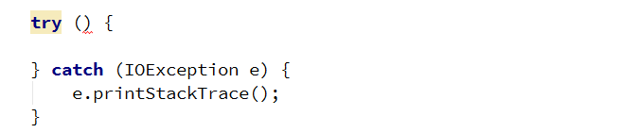
- Create a BufferedReader to read each line of the file.
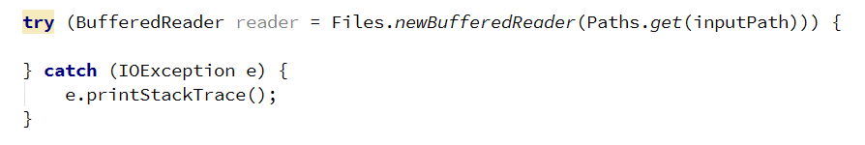
- Get the ASCII code of each character in the line and add it to the sum for the current line and print the sum on the console.
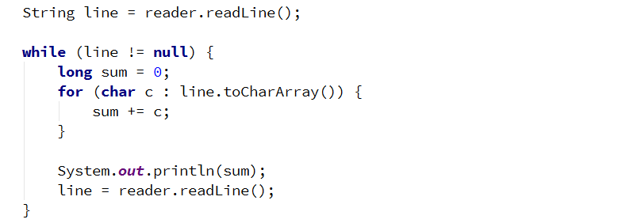

Sum Bytes
Write a program that reads a text file ("input.txt" from the Resources - Exercises) and prints on the console the sum of the ASCII symbols of all characters inside the file. Use BufferedReader in combination with FileReader.
Input | Output
On January 1 , 1533 ,  Michael Angelo,  then fifty-seven years old,  writes  from Florence to  Tommaso de' Cavalieri,  a youth of noble Roman family, | 12488

Hints
- You can modify your solution to the previous problem.
- Use a type that will not overflow like long or BigInteger.

ALL CAPITALS!
Write a program that reads a text file ("input.txt" from the Resources - Exercises) and changes the casing of all letters to the upper. Write the output to another file ("output.txt").

Examples
Input | Output
On January 1 , 1533 ,  Michael Angelo,  then fifty-seven years old,  writes  from Florence to  Tommaso de' Cavalieri,  a youth of noble Roman family, | ON JANUARY 1 , 1533 ,  MICHAEL ANGELO,  THEN FIFTY-SEVEN YEARS OLD,  WRITES  FROM FLORENCE TO  TOMMASO DE' CAVALIERI,  A YOUTH OF NOBLE ROMAN FAMILY,

Hints
- Use BufferedReader and PrintWriter.

Count Character Types
Write a program that reads a list of words from the file ("input.txt" from the Resources - Exercises) and finds the count of vowels, other symbols, and punctuation marks. Assume that:
- a, e, i, o, u are vowels, only lower case.
- All others are other symbols.
- Punctuation marks are (! , . ?).
- Do not count whitespace.
Write the results to another file – "output.txt".

Examples
Input | Output
On January 1 , 1533 , Michael Angelo, then fifty-seven years old, writes  from Florence to Tommaso de' Cavalieri, a youth of noble Roman family, | Vowels: 41  Other symbols: 72  Punctuation: 6

Hints
- Use BufferedReader and PrintWriter.

Line Numbers
Write a program that reads a text file ("inputLineNumbers.txt" from the Resources - Exercises) and inserts line numbers in front of each of its lines. The result should be written to another text file – "output.txt".

Examples
Input | Output
Two households, both alike in dignity,  In fair Verona, where we lay our scene,  From ancient grudge break to new,  Where civil blood makes civil hands.  From forth the fatal loins of these two  A pair of star-cross'd lovers take their life;  Whose misadventured piteous overthrows  Do with their death bury their parents' strife. | 1. Two households, both alike in dignity,  2. In fair Verona, where we lay our scene,  3. From ancient grudge break to new,  4. Where civil blood makes civil hands.  5. From forth the fatal loins of these two  6. A pair of star-cross'd lovers take their life;  7. Whose misadventured piteous overthrows  8. Do with their death bury their parents' strife.

Word Count
Write a program that reads a list of words from the file "words.txt" (from the Resources - Exercises) and finds how many times each of the words is contained in another file "text.txt" (from the Resources - Exercises). Matching should be case-insensitive.
Write the results in the file "results.txt". Sort the words by frequency in descending order.

Examples
Input | Output
of which The | of - 6  which - 2  The - 1

Merge Two Files
Write a program that reads the contents of two text files ("inputOne.txt", "inputTwo.txt" from Resources - Exercises) and merges them into a third one.

Examples
File 1 | File 2 | Output
1  2  3 | 4  5  6 | 1  2  3  4  5  6

Get Folder Size
Write a program that traverses a folder and calculates its size in bytes. Use Folder Exercises Resources in Resources.

Examples
Input | Output
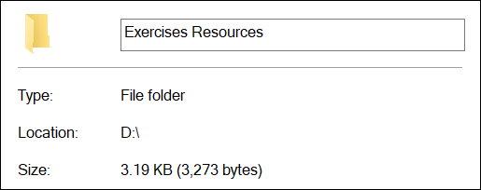 | Folder size: 2878

Copy a Picture
Write a program that makes a copy of a .jpg file using FileInputStream, FileOutputStream, and byte[] buffer. Set the name of the new file as "picture-copy.jpg".

Serialize Array List
Write a program that saves and loads an ArrayList of doubles to a file using ObjectInputStream and ObjectOutputStream. Set the name of the file as "list.ser".

*Serialize Custom Object
Write a program that saves and loads the information about a custom object using ObjectInputStream and ObjectOutputStream.
Create a simple class called "Course" that has a String field containing its name and an integer field containing the number of students attending the course. Set the name of the save file as "course.ser".

*Create Zip Archive
Write a program that reads three .txt files and creates a zip archive named "files.zip". Use FileOutputStream, ZipOutputStream, and FileInputStream.

