Lab: Defining Classes
This document defines the lab for the "Java Advanced" course @ SoftUni Global.
Please submit your solutions (source code) to all below-described problems in Judge.

I: Defining Classes

Car Info
Create a class named Car.
The class should have public fields for:
- Brand: String
- Model: String
- Horsepower: int
Create a new class and ensure proper naming:
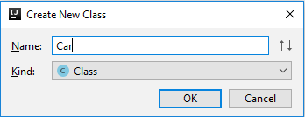
Define the fields:
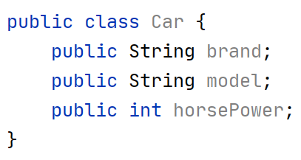
Create a Test client in the same package:
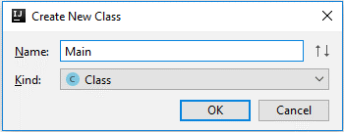
You should now be able to use your class:
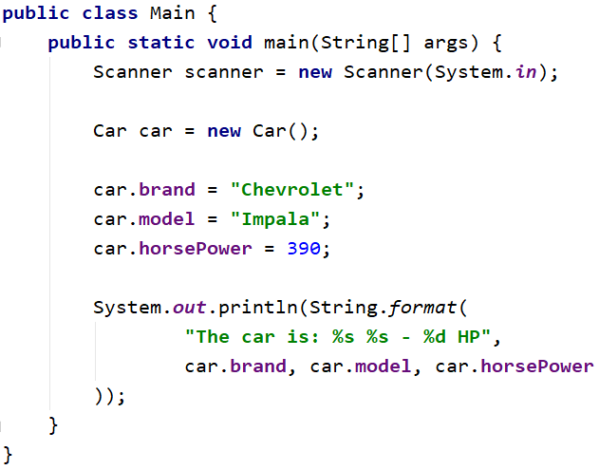

Private Fields
Change the access modifiers of all class fields to private.
When done, go back to the main method you should have compilation errors like this:
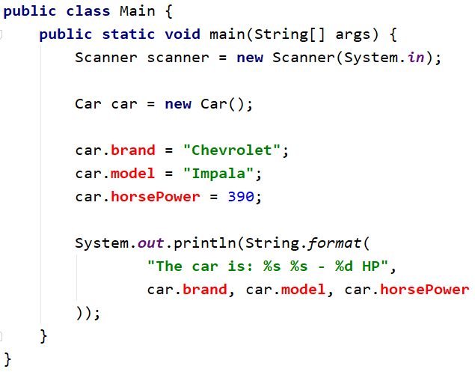

Getters and Setters
Create getters and setters for each class field.
Getter for the car brand:
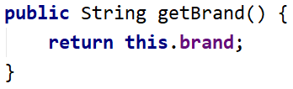
Setter for the car brand:
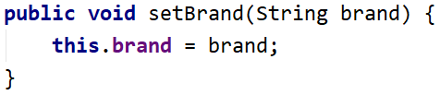
Do the same for all the fields.
Fix Main Method
You should set and get the values by using the correct methods
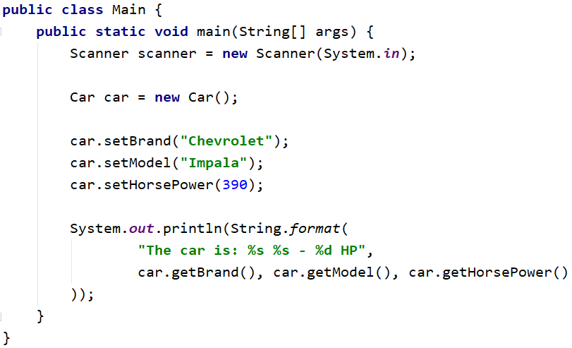

Create Car Info Method
This method should return the info about any car object in the following format:
"The car is: {brand} {model} – {horsePower} HP."
You have to figure out how to create a method and use it in the outside code, as shown below:
Test the Program
Read cars objects, add them to the collection of your choice, and print each one on the console using the carInfo() method. The input consists of a single integer N, the number of lines representing car objects. On each line you will read car info in the following format "{brand} {model} {horsePower}" separated by single space.

Examples
Input | Output
3  Chevrolet Impala 390  Mercedes Benz 500  Volga 24 49 | The car is: Chevrolet Impala - 390 HP.  The car is: Mercedes Benz - 500 HP.  The car is: Volga 24 - 49 HP.
5  This Car 1  Was Made 2  Only For 3  Test Purposes 4  No Way 5 | The car is: This Car - 1 HP.  The car is: Was Made - 2 HP.  The car is: Only For - 3 HP.  The car is: Test Purposes - 4 HP.  The car is: No Way - 5 HP.

II: Constructors

Car Constructors
Make proper constructors for the Car class so you can create car objects with a different type of input information.
If you miss information about the field of type String set the value to "unknown", and for an integer, fieldset -1.
First, declare a constructor which takes only the car brand as a parameter:
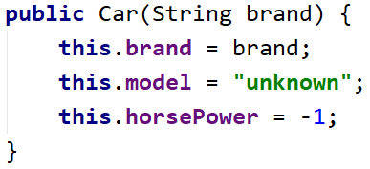
Also, create a constructor which sets all the fields:
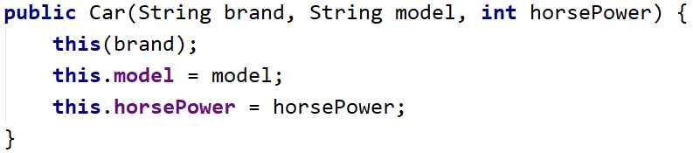
Read information about cars the same way as the previous task, however, this time uses constructors to create the objects, not creating an object with the default constructor. You should be able to handle different types of input, the format will be the same as the previous task, but this time some of the data may be missing. For example, you can get only the car brand – which means you have to set the car model to "unknown" and the Horsepower value to -1. There will be lines with complete car data, declare constructor which sets all the fields.
You have to add the car objects to a collection of your choice and print the data as in the previous task. The input will always have one or three elements on each line.

Examples
Input | Output
2  Chevrolet  Golf Polo 49 | The car is: Chevrolet unknown - -1 HP.  The car is: Golf Polo - 49 HP.
4  Was  Only For 3  Test Purposes 4  No Way 5 | The car is: Was unknown - -1 HP.  The car is: Only For - 3 HP.  The car is: Test Purposes - 4 HP.  The car is: No Way - 5 HP.

Bank Account
Create class BankAccount.
The class should have private fields for:
- Id: int (Starts from 1 and increments for every new account)
- Balance: double
- Interest rate: double (Shared for all accounts. Default value: 0.02)
The class should also have public methods for:
- setInterestRate(double interest): void (static)
- getInterest(int Years): double
- deposit(double amount): void
Create a test client supporting the following commands:
- Create
- Deposit {Id} {Amount}
- SetInterest {Interest}
- GetInterest {ID} {Years}
- End

Examples
Input | Output | Comments
Create  Deposit 1 20  GetInterest 1 10  End | Account ID1 created  Deposited 20 to ID1  4.00
Create  Create  Deposit 1 20  Deposit 3 20  Deposit 2 10  SetInterest 1.5  GetInterest 1 1  GetInterest 2 1  GetInterest 3 1  End | Account ID1 created  Account ID2 created  Deposited 20 to ID1  Account does not exist  Deposited 10 to ID2  30.00  15.00  Account does not exist | Sets the global interest rate to 1.  Prints interest for a bank account with id 1 for 1 year period.

Solution
Create the class as usual and create a constant for the default interest rate:
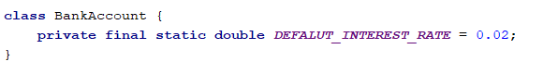
Create the static and non-static fields, all private:
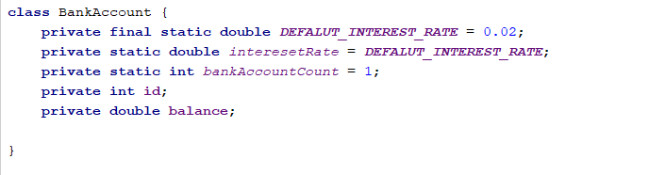
Set the id of an account upon creation while incrementing the global account count:

Create a setter for the global interest rate. Making the method static will let you access it through the class name:
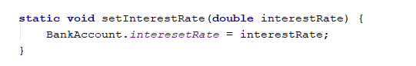
Implement deposit() and getInterest():


