Lab: Generics
This document defines the lab for the "Java Advanced" course @ SoftUni Global.
Please submit your solutions (source code) to all below-described problems in Judge.

Jar of T
Create a class Jar<> that can store anything.
It should have two public methods:
- void add(element)
- element remove()
Adding should add on top of its contents. Remove should get the topmost element.

Examples
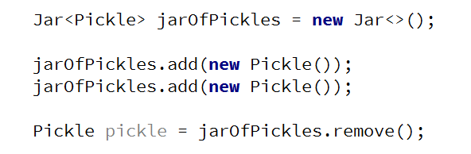

Hints
Use the syntax Jar<T> to create a generic class.

Submit in Judge
Submit your solution in Judge zip your whole package with the Jar and Main classes:
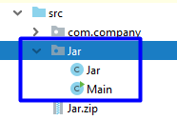
If you didn't create a package choose your classes and zip them.

Generic Array Creator
Create a class ArrayCreator with a method and a single overload to it:
- static T[] create(int length, T item)
- static T[] create(Class<T> class, int length, T item)
The method should return an array with the given length, and every element should be set to the given default item.

Examples
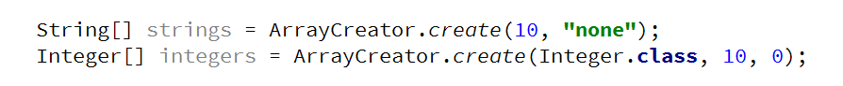

Generic Scale
Create a class Scale<T> that holds two elements - left and right. The scale should receive the elements through its single constructor:
- Scale(T left, T right)
The scale should have a single method:
- T getHeavier()
The greater of the two elements is heavier. The method should return null if elements are equal.

Examples
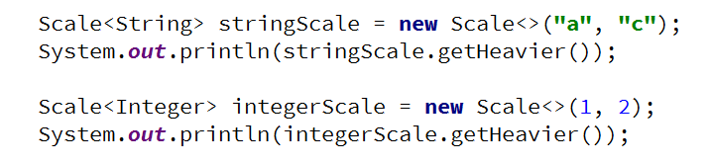

List Utilities
Create a class ListUtils that you will use through several other exercises:
The class should have two static methods:
- T getMin(List<T> list)
- T getMax(List<T> list)
The methods should throw IllegalArgumentException if an empty list is passed.

Examples


