Lab: Iterators and Comparators
This document defines the lab for the "Java Advanced" course @ SoftUni Global.
Please submit your solutions (source code) of all below-described problems in Judge.

Book
Create a class Book from the UML diagram below:
Book
- | title: String
- | year: int
- | authors: List<String>
- | setTitle(String)
- | setYear(String)
- | setAuthors(String…)
+ | getTitle(): String
+ | getYear(): int
+ | getAuthors(): List<String>
You can use only one constructor. There can be no authors, one author, or many authors.

Examples
Main.java
public static void main(String[] args) {
Book bookOne = new Book("Animal Farm", 2003, "George Orwell");
Book bookThree = new Book("The Documents in the Case", 2002);
Book bookTwo = new Book("The Documents in the Case", 1930, "Dorothy Sayers", "Robert Eustace");
List<Book> books = new ArrayList<>();
books.add(bookOne);
books.add(bookTwo);
books.add(bookThree);
}

Solution
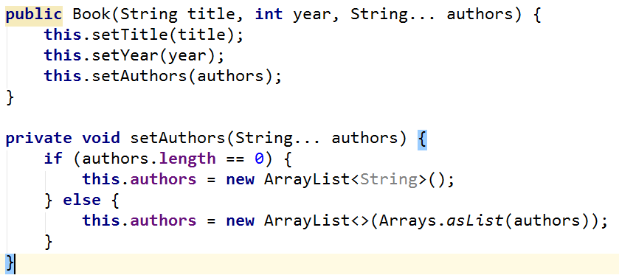

Library
Create a class Library from the UML diagram below:
<<Iterable<Book>>>
Library
- | books: Book[]
+ | iterator(): Iterator<Book>
Create a nested class LibIterator from the UML diagram below:
<<Iterator<Book>>>
LibIterator
- | counter: int
+ | hasNext(): boolean
+ | next(): Book

Examples
Main.java
public static void main(String[] args) {
Book bookOne = new Book("Animal Farm", 2003, "George Orwell");
Book bookThree = new Book("The Documents in the Case", 2002);
Book bookTwo = new Book("The Documents in the Case", 1930, "Dorothy Sayers", "Robert Eustace");
Library library = new Library<>(bookOne, bookTwo, boоkThree);
for (Book book: library) {
System.out.println(book.getTitle());
}
}

Solution
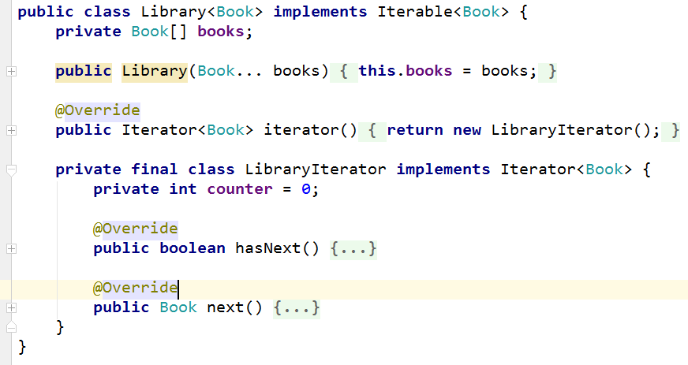

Comparable Book
Expand Book by implementing Comparable<Book>.
The book has to be compared by title. When the title is equal, compare them by year.
Expand Book from UML diagram below:
<<Comparable<Book>>>
Book
- | title: String
- | year: int
- | authors: List<String>
- | setTitle(String)
- | setYear(String)
- | setAuthors(String…)
+ | getTitle(): String
+ | getYear(): int
+ | getAuthors(): List<String>
+ | compareTo(Book): int
You can use only one constructor. There can be no authors, one author, or many authors.

Examples
Main.java
public static void main(String[] args) {
Book bookOne = new Book("Animal Farm", 2003, "George Orwell");
Book bookThree = new Book("The Documents in the Case", 2002);
Book bookTwo = new Book("The Documents in the Case", 1930, "Dorothy Sayers", "Robert Eustace");
if (bookOne.compareTo(bookTwo) > 0) {
System.out.println(String.format("%s is before %s", bookOne, bookTwo));
} else if (bookOne.compareTo(bookTwo) < 0) {
System.out.println(String.format("%s is before %s", bookTwo, bookOne));
} else {
System.out.println("Book are equal");
}
}

Book Comparator
Create a class BookComparator from the UML diagram below:
<<Comparator<Book>>>
BookComparator
+ | compare(Book, Book): int
BookComparator has to compare two books by:
- Book title.
- Year of publishing a book.

Examples
Main.java
public static void main(String[] args) {
Book bookOne = new Book("Animal Farm", 2003, "George Orwell");
Book bookThree = new Book("The Documents in the Case", 2002);
Book bookTwo = new Book("The Documents in the Case", 1930, "Dorothy Sayers", "Robert Eustace");
List<Book> books = new ArrayList<>();
books.add(bookOne);
books.add(bookTwo);
books.add(bookThree);
books.sort(new BookComparator());
for (Book : books) {
System.out.println(book.getTitle() + book.getYear());
}
}

