JS Advanced: Exam Preparation 1

Problem 1. Gem Collection
Environment Specifics
Please be aware that every JS environment may behave differently when executing code. Certain things that work in the browser are not supported in Node.js, which is the environment used by Judge.
The following actions are NOT supported:
- .forEach() with NodeList (returned by querySelector() and querySelectorAll())
- .forEach() with HTMLCollection (returned by getElementsByClassName() and element.children)
- Using the spread-operator (...) to convert a NodeList into an array
- append() in Judge (use only appendChild())
- prepend()
- replaceWith()
- replaceAll()
- closest()
- replaceChildren()
- Always turn the collection into a JS array (forEach, forOf, et.)
If you want to perform these operations, you may use Array.from() to first convert the collection into an array.

Your Task
Use the provided skeleton to solve this problem.
Write the missing functionality of this user interface. The functionality is divided in the following steps: 
Write the missing JavaScript code to make the Gem Collection work as expected:
All fields (Gemstone Name, Color, Carats, Price, and Type) are filled with the correct input
- Gemstone Name, Color, Age, Carats, Price and Type are non-empty strings. If any of them is empty, the program should not do anything.

- Getting the information from the form
- On clicking the [“Add Gem”] button the information from the input fields is listed in the "preview" section. To the unordered list with id "preview-list", should be added a list item, containing the input information.
- The text format and order for each list item should be the same as in the picture below.
- When the button is clicked, the input fields must be cleared and the ["Add Gem"] button must be disabled. At the same time the "Save to Collection", "Edit Information" and the "Cancel" buttons must be added.
The HTML structure looks like this:
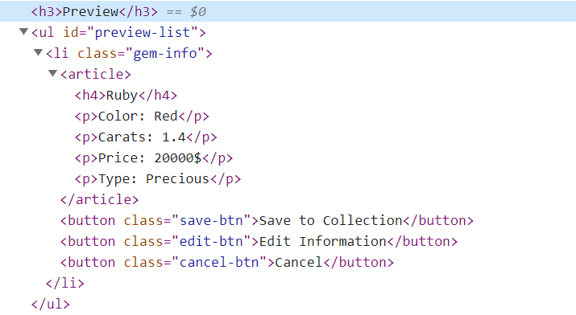

- Editing the information from the Preview
The functionality here is the following:
- When the "Edit Information" button is clicked, all of the information is loaded in the input fields from step 1 and all buttons in preview section are removed while the ["Add Gem"] button is enabled again.

- The list items must be removed from the "preview-list" and all of the information must go back to the input fields again.
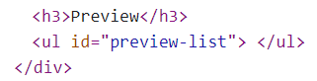

- Saving the information from the Preview

- When the "Save to Collection" button is clicked, the gem information must be transferred from "preview" to "collection", for you that means a new list item should be added to the unordered list with id: "collection", having the information about gems.
The HTML structure looks like this: 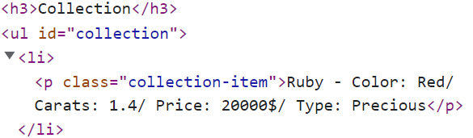

- The list item from preview section must be removed while the ["Add Gem"] button is enabled again.

- Cancel the information from the Preview
- When the "Cancel" button is clicked, the list item must be removed from the "preview-list" and the ["Add Gem"] button is enabled again.

Submission
Submit only yours solution() function.

Problem 2. Refurbished Smartphones
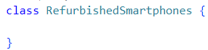
Write a class RefurbishedSmartphones, which implements the following functionality:

Functionality
Constructor
Should have these 4 properties:
- retailer – String
- availableSmartphones – Array
- soldSmartphones – Array
- revenue – default: 0
At the initialization of the RefurbishedSmartphones class, the constructor accepts the retailer. The revenue has a default value of 0! The rest of the properties must be empty!
Hint: You can add more properties to help you finish the task.

addSmartphone (model, storage, price, condition) - This method should add a new smartphone to the retailer. The method accepts 4 arguments:
- If any of the following requirements is NOT fulfilled, an error with the following message should be thrown: "Invalid smartphone!"
  - Model – non-empty string;
  - Storage – positive integer number;
  - Price – positive number;
  - Condition – non-empty string;
Hint: Zero is also a positive number.
- Otherwise, you should add the smartphone, with properties: {model, storage, price, condition} to the availableSmartphones array and return:
"New smartphone added: {model} / {storage} GB / {condition} condition - {price}$"
- When returning the result, the Price must be rounded to the second decimal point!
sellSmartphone (model, desiredStorage) – This method should search for a smartphone with the given model in the availableSmartphones array, and then sell it. Accepts 2 arguments.
- If a smartphone with the given model cannot be found, an error with the following message should be thrown:
"{model} was not found!"
- If you find the smartphone with the given model, you should look up its storage. The person who wants to buy it has a simple request. He is looking for a smartphone with a storage that is more or equal to his desired storage. To ensure the sale of the smartphone you must make a bargain:
  - If the found smartphone’s storage is more than or equal to the desiredStorage – the price stays the same!
  - If the difference between the smartphone’s storage and the desiredStorage is less or equal to 128 GB – the price gets deducted by 10%!
  - If the difference between the smartphone’s storage and the desiredStorage is more than 128 GB – the price gets deducted by 20%!
- You should remove the smartphone from the availableSmartphones array and add it to the soldSmartphones array in the following format: {model, storage, soldPrice}
- Finally, you must add the soldPrice to the revenue and return:
"{model} was sold for {soldPrice}$"
Note: soldPrice must be rounded to the second decimal point!
upgradePhones () - This method should find the storage for every available smartphone and double it, then return them separated by a new line in format:
" Upgraded Smartphones:
{model} / {storage} GB / {condition} condition / {price}$
{model} / {storage} GB / {condition} condition / {price}$"
Note: price must be rounded to the second decimal point!
Note: storage must be updated to availableSmartphones array!
- If there are no available smartphones, throw:
"There are no available smartphones!"
salesJournal (criteria) – This method accepts 1 argument. It should sort the sold smartphones, based on a given criteria. The two possible criteria are – "storage" or "model"
- If the given criteria do not match either of the possible criteria, an error with the following message should be thrown:
"Invalid criteria!"
- If the given criteria is "storage" – the sold smartphones must be sorted by their storage in descending order;
- If the given criteria is "model" – the sold smartphones must be sorted alphabetically by their model;
- Finally, return all sorted sold smartphones separated by a new line in format:
"{ RetailerName} has a total income of { revenue }$
{soldSmartphonesCount} smartphones sold:
{model} / {storage} GB / {price}$
{model} / {storage} GB / {price}$"
…
Note: revenue and price must be rounded to the second decimal point!

Example
Input 1
let retailer = new RefurbishedSmartphones('SecondLife Devices');
console.log(retailer.addSmartphone('Samsung S20 Ultra', 256, 1000, 'good'));
console.log(retailer.addSmartphone('Iphone 12 mini', 128, 800, 'perfect'));
console.log(retailer.addSmartphone('', 512, 1900, 'good'));

Output 1
New smartphone added: Samsung S20 Ultra / 256 GB / good condition - 1000.00$
New smartphone added: Iphone 12 mini / 128 GB / perfect condition - 800.00$
Uncaught Error Error: Invalid smartphone!

Input 2
let retailer = new RefurbishedSmartphones('SecondLife Devices');
retailer.addSmartphone('Samsung S20 Ultra', 256, 1000, 'good');
retailer.addSmartphone('Iphone 12 mini', 128, 800, 'perfect');
retailer.addSmartphone('Xiaomi Redmi Note 10 Pro', 128, 330, 'perfect');
console.log(retailer.sellSmartphone('Samsung S20 Ultra', 256));
console.log(retailer.sellSmartphone('Xiaomi Redmi Note 10 Pro', 256));
console.log(retailer.sellSmartphone('Samsung Galaxy A13', 64));

Output 2
Samsung S20 Ultra was sold for 1000.00$
Xiaomi Redmi Note 10 Pro was sold for 297.00$
Uncaught Error Error: Samsung Galaxy A13 was not found!

Input 3
let retailer = new RefurbishedSmartphones('SecondLife Devices');
retailer.addSmartphone('Samsung S20 Ultra', 256, 1000, 'good');
retailer.addSmartphone('Iphone 12 mini', 128, 800, 'perfect');
retailer.addSmartphone('Xiaomi Redmi Note 10 Pro', 128, 330, 'perfect');
console.log(retailer.upgradePhones());

Output 3
Upgraded Smartphones:
Samsung S20 Ultra / 512 GB / good condition / 1000.00$
Iphone 12 mini / 256 GB / perfect condition / 800.00$
Xiaomi Redmi Note 10 Pro / 256 GB / perfect condition / 330.00$

Input 4
let retailer = new RefurbishedSmartphones('SecondLife Devices');
retailer.addSmartphone('Samsung S20 Ultra', 256, 1000, 'good');
retailer.addSmartphone('Iphone 12 mini', 128, 800, 'perfect');
retailer.addSmartphone('Xiaomi Redmi Note 10 Pro', 128, 330, 'perfect');
retailer.sellSmartphone('Samsung S20 Ultra', 256);
retailer.sellSmartphone('Xiaomi Redmi Note 10 Pro', 256);
console.log(retailer.salesJournal('model'));

Output 4
SecondLife Devices has a total income of 1297.00$
2 smartphones sold:
Samsung S20 Ultra / 256 GB / 1000.00$
Xiaomi Redmi Note 10 Pro / 128 GB / 297.00$

Problem 3. Unit Testing

Your Task
Using Mocha and Chai write JS Unit Tests to test a variable named weddingDay, which represents an object. You may use the following code as a template:
describe("Tests …", function() {
describe("TODO …", function() {
it("TODO …", function() {
// TODO: …
});
});
// TODO: …
});

The object should have the following functionality:
- PickVenue (capacity, pricePerGuest, location) - A function that accepts three parameters: number, number, and string.
- There is a need for validation for the input, in case of submitted invalid parameters or empty string, throw an error "Invalid Information!
  - If the value of the string location is different from "Varna", throw an error:
"The location of this venue is not in the correct area!"
- To be picked, the venue must meet the following requirement:
  - If the capacity of the venue is greater or equal to 150, and pricePerGuest is less or equal to 120 return the string:
"This venue meets the requirements, with capacity of ${capacity} guests and ${pricePerGuest}$ cover."
- Otherwise, if the above conditions are not met, return the following message:
"This venue does not meet your requirements!"
- otherSpendings (weddingDecoration, photography, discount) - A function that accepts three parameters: array, array, and boolean.
- Calculate the total price you are going to pay depending on the purchased weddingDecoration and photography:
- The theater offers two options for weddingDecoration and photography:
    - The two options for weddingDecoration are:
      - flowers, which costs $500
      - Fabric drapes and curtains, which costs $400
    - The two options for photography are:
      - pictures, which costs $700
      - video, which costs $1300
- If the discount is true, a 15% discount should be applied. Then return the following message:
"You spend {totalPrice}$ for wedding decoration and photography with 15% discount!"
- Else, return the following message:
"You spend {totalPrice}$ for wedding decoration and photography!"
- You need to validate the input, if the weddingDecoration, photography and discount are not an array, array and Boolean, throw an error: "Invalid Information!"

- tableDistribution (guests, tables) - A function that accepts two parameters: number, number.
- You need to calculate how many guests on table you will have.
- If the peopleOnTable are less than 6. return the following message:
"There is only {peopleOnTable} people on every table, you can join some tables."
- Else, return the following message:
"You have {tables} tables with {peopleOnTable} guests on table."
- You need to validate the input, if the guests and tables are not a numbers, or are a negative numbers, throw an error: "Invalid Information!".

JS Code
To ease you in the process, you are provided with an implementation that meets all of the specification requirements for the weddingDay object:
weddingDay.js
const weddingDay = {
pickVenue(capacity, pricePerGuest, location) {
if (typeof capacity !== 'number' || typeof pricePerGuest !== 'number' || typeof location !== 'string' || location === '') {
throw new Error("Invalid Information!")
};
if (location == "Varna") {

if (capacity >= 150 && pricePerGuest <= 120) {
return `This venue meets the requirements, with capacity of ${capacity} guests and ${pricePerGuest}$ cover.`;
} else {
return `This venue does not meet your requirements!`;
}
}else {
throw new Error(`The location of this venue is not in the correct area!`);
};
},

otherSpendings(weddingDecoration, photography, discount) {
if (!Array.isArray(weddingDecoration) || !Array.isArray(photography) || typeof discount !== "boolean") {
throw new Error("Invalid Information!");
}
let totalPrice = 0;

weddingDecoration.forEach((decoration) => {
if (decoration === "flowers") {
totalPrice += 500
} else if (decoration === "Fabric drapes and curtains") {
totalPrice += 400
}
});

photography.forEach((service) => {
if (service === "pictures") {
totalPrice += 700
} else if (service === "video") {
totalPrice += 1300
}
});
if (discount) {
totalPrice = totalPrice * 0.85;
return `You spend ${totalPrice}$ for wedding decoration and photography with 15% discount!`
} else {
return `You spend ${totalPrice}$ for wedding decoration and photography!`
}

}
,
tableDistribution(guests, tables) {
if (typeof guests !== "number" || guests <= 0 ||
typeof tables !== "number" || tables <= 0) {
throw new Error("Invalid Information!");
}
let peopleOnTable = Math.round(guests / tables);

if(peopleOnTable < 6) {
return `There is only ${peopleOnTable} people on every table, you can join some tables.`
}else{
return `You have ${tables} tables with ${peopleOnTable} guests on table.`
}
}
}

Submission
Submit your tests inside a describe() statement, as shown above.

