Python Advanced: Exam Preparation

Pie Pursuit

Get ready for the "Pie Pursuit" – a delightful journey where contestants indulge in a pie-eating frenzy. It will be a fun competition. Join us in this exciting adventure as contestants showcase their love for delicious treats and strive to emerge as the ultimate pie-eating champions!
You will receive two sequences on two separate lines. Each sequence will consist of integer values,
separated by a single whitespace.
The first sequence represents contestants, each value indicating the total count of pieces of pie a contestant can consume, while the second sequence represents the pies, signifying the number of pieces each pie contains.

Contest Rules
- The competition continues until no more pies are left or no more contestants remain in the battle
- The contest kicks off with the first contestant facing the last pie in the sequence
- If the contestant's pie-eating capacity is greater than or equal to the pie's size, they manage to eat the entire pie, subtracting the pie's value (count of pie pieces) from the contestant's value
(pie-eating capacity). The pie is removed from the collection.
  - If the contestant's pie-eating capacity reaches 0, bid them farewell from the contest (remove the contestant from the competition).
  - Otherwise, move the satisfied contestant to the back of the lineup, with the remaining
pie-eating capacity.
- If the pie's size exceeds the contestant's pie-eating capacity, the contestant consumes as many pieces as possible, subtracting the eaten pieces (contestant's capacity), from the pie's size.
  - The pie remains in the sequence with the value of pieces left.
  - If the pie's size reaches 1 piece, remove the pie, adding the remaining piece to the next pie in the sequence.
  - If this is the last pie, be careful, you won’t be able to add a piece to the next pie. Just leave that last piece back in the sequence.
  - Say goodbye to the contented contestant from the contest (remove the contestant from the competition).
- In the end:
  - If the pies are over, and there are contestants left, print on the console:
"We will have to wait for more pies to be baked!" and the final state of the contestants' sequence on a separate line.
  - If both the pies and contestants are over, it means that we have a champion. Print on the console: "We have a champion!"
  - If the contestants are over, but there are pies left, print on the console:
"Our contestants need to rest!" and the final state of the pie sequence on a separate line.
Let the Pie Pursuit unfold and discover who will be the ultimate champion!

Input / Constraints
- On the first line, you will receive the integers, representing the contestant's pie-eating capacity, separated by a single space.
- On the second line, you will receive the integers, representing the number of pieces each pie contains, separated by a single space.

Output
The following result should be printed on the Console, on separate lines:
- If the pies are over, and there are contestants left:
  - "We will have to wait for more pies to be baked!"
  - The final state of the contestants' sequence:
"Contestants left: {contestant₁}, {contestant₂}, … {contestant_{n}}"
- If both the pies and contestants are over:
  - "We have a champion!"
- If the contestants are over, but there are pies left:
  - "Our contestants need to rest!"
  - The final state of the pie sequence
  - "Pies left: {pie₁}, {pie₂}, … {pie_{n}}"

Examples
Input | Output | Comment
5 8 4 6  3 7 2 9 | We will have to wait for more pies to be baked!  Contestants left: 2 | We take the first contestant (5) and the last pie (9). The contestant can eat only 5 pieces of pie, and there will be 4 pieces left. We remove the contestant and keep the 4 pieces in the sequence.  Now we have the following sequences:  8 4 6  3 7 2 4  The next contestant can eat all four pieces, and go at the back of the sequence, with the value of 4. We remove the pie, and we have the following sequences:  4 6 4  3 7 2  4 eats 2, and goes at the back with a value of 2:  6 4 2  3 7  The next contestant eats 6 pieces, and one is left to be added to the next pie:  4 2  4  The next contestant eats all 4 pieces and is unable to eat more. As reaching the value of zero, he quits the competition. The only contestant left is 2.
4 6 8 10 12 16  16 12 10 8 6 4 | We have a champion!
3 3 3 3 3  4 4 4 4 | Our contestants need to rest!  Pies left: 1

Escape the Maze
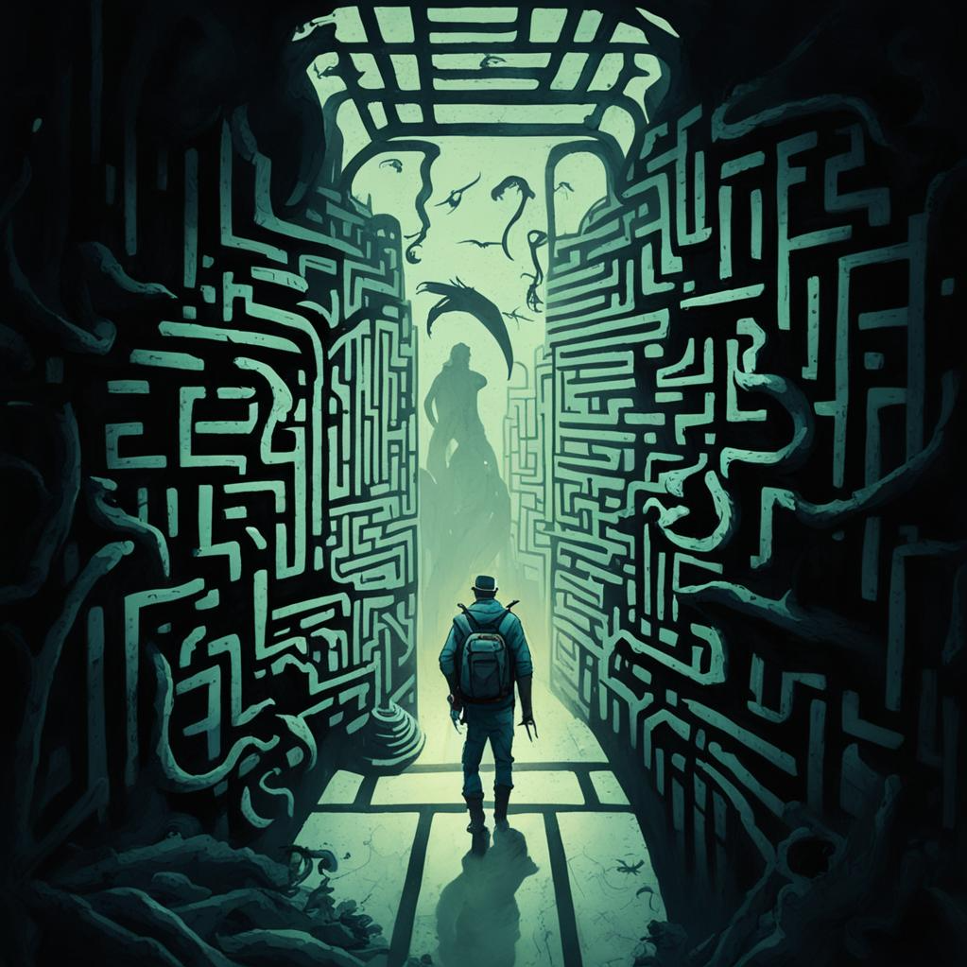
Embark on an epic adventure as a brave traveller lost in a dangerous maze! Your mission is to navigate through the maze's intricate corridors, avoiding traps and monsters while seeking the path to freedom. Will you find your way out or succumb to the dangers lurking within? Good luck on your journey!
You are a brave traveler that got lost in a maze and you need to find your way out. The maze is represented by a matrix - field. Each cell in the field represents a part of the maze, and it can contain one of the following elements:
- 'P' - Represents the starting position of the traveller.
- 'X' - Represents the location of the exit that leads outside of the maze.
- 'M' - Represents a monster which wants to harm the traveller.
- 'H' - Represents a health potion which will restore the health of the traveller.
- '-' – Represents the maze's corridors, which the traveller can walk through.
Initially, you will be given N – an integer, indicating the size of a square matrix. The traveller starts with 100 units of health.
The traveller must carefully navigate through the maze, following the commands that will be received on each of the following lines- "up", "down", "right", and "left", moving one position towards the direction given. If the command leads the traveller outside the bounds of the field, skip the command and proceed with the next one.
However, in the maze, encountering a cell marked with 'M' signifies the presence of a monster. When the traveller encounters a monster, he takes substantial damage, his health is reduced by 40 units. It's important to note that the monster disappears from the maze only if the traveller survives the encounter. In the case where the traveller's health drops to 0 or below due to the encounter with a monster, the traveller is considered defeated, health is set to zero and the maze traversal concludes. If the traveller survives, the monster disappears from the maze, and its position is marked with '-'. This indicates that the monster has been successfully dealt with and is no longer a threat in the subsequent maze traversal.
In addition, within the maze, encountering a cell marked with 'H' signifies the presence of a health potion. When the traveller encounters a health potion, he moves in that direction and experiences a boost in his health by 15 units. It's crucial to note that the traveller's health may happen to exceed the maximum limit of 100 units during the adventure. If the traveller's health surpasses 100 units due to the health potion, it is adjusted to the maximum limit of 100 units. This ensures that the traveller's health does not exceed the predefined maximum value. The position is marked with '-'.
Once the traveller successfully reaches a position marked as 'X', he finally reaches the exit and escapes the maze. The adventure is over.
Remember, the traveller must follow the commands, he will always either reach the exit or die in the maze.
In the end, print the final state of the matrix (maze area) with the traveller in his ending position. Each row is on a new line.

Input
- On the first line, you will get N - the size of the matrix (square).
- On the next N lines, you will receive strings, representing each row of the matrix.
- On each of the following lines, you will receive the possible directions for the traveller to move - "up", "down", "right", and "left".

Output
- On the first line:
  - If the traveller has less than or equal to 0 health:
"Player is dead. Maze over!"
  - If the traveller survived with more than 0 health and managed to escape the maze:
"Player escaped the maze. Danger passed!"
- On the second line, print the final value of the traveller's health following the format:
"Player's health: {health value} units"
- On the next lines, print the final state of the matrix with the traveller in its ending position. Each row - on a new line.

Constraints
- The commands are guaranteed to lead him either to escape out of the maze or to die by monsters, ensuring that the commands are sufficient in all cases.
- Some commands may lead our hero outside of the boundaries of the matrix. Do not allow that.
- The size of the matrix will always be a valid positive integer in the range [4,10].
- The last known position of the traveller should always be marked with 'P' in the final state of the matrix.

Examples
Input | Output | Comments
5  -----  -PM--  -M---  ---H-  -X---  down  right  down  down  left | Player escaped the maze. Danger passed!  Player's health: 60 units  -----  --M--  -----  ---H-  -P--- | The player starts from the position [1,1]. The direction is down, towards the monster. The player's health becomes 60 units, the monster position is marked with '-'. Next direction is right, the position is empty(corridor) so we continue to the next command. Down – empty position, down – empty position. Last direction is left. The player reaches the 'X' mark and manages to escape the maze.
8  --H-----  ---P---X  --------  --M--M--  --H--M--  H-----M-  --------  ------H-  down  right  right  down  down  right  down  left  up  up | Player is dead. Maze over!  Player's health: 0 units  --H-----  -------X  --------  --M-----  --H-----  H-----P-  --------  ------H-
4  ----  P-H-  ----  X---  right  right  right  right  down  down  down  left  left  left | Player escaped the maze. Danger passed!  Player's health: 100 units  ----  ----  ----  P---

Wild Card Game

A fun and wild card game!
Draw cards and split them by type.
Write a function named draw_cards that takes a variable number of arguments (tuples) and keyword arguments (key-value pairs).
The function receives information about monster cards and spell cards and returns a formatted string.
The arguments will be passed as follows:
- The first group of arguments will be an unknown number of tuples
- the first element in the tuple is the name of the card (string) (every card will have a unique name)
- the second element is the card type (string) (every card can either have a "monster" type or "spell" type)
- The second group will be an unknown number of keyword arguments (key-value pairs)
- the key is the name of the card (string) (every card will have a unique name)
- the value is the card type (string) (every card can either have a "monster" or "spell" type)
After receiving the information and calling the function:
- You should keep track of the different card types in separate collections
- Sort the monster cards in descending order by their name.
- Sort the spell cards in ascending order by their name.
- Format the result as follows (each card info on a different line):
- Separate monster and spell cards under appropriate headings:
- First are the monster cards (only if there are cards from this specific type), each on a different line under the heading
"Monster cards:"
- Then the spell cards (only if there are cards from this specific type), each on a different line under the heading
"Spell cards:"
In the end, return the output as described below.
Note: Submit only the function in the judge system

Input
- There will be no input from the console, just parameters passed to your function.

Output
- The output should look like this (each string should be on a new line):
- Prefix monster names with " ***" - (exactly two spaces and three asterisks "*").
- Prefix spell names with " $$$" - (exactly two spaces and three dollar signs "$").
"Monster cards:"
" ***{monster_name1}"
" ***{monster_name2}"
...
" ***{monster_nameN}"
"Spell cards:"
" $$${spell_name1}"
" $$${spell_name2}"
...
" $$${spell_nameN}"

- Important notes:
  - You may exclusively draw either "monster" or "spell" cards. If so, return only the type you have. Do not include the heading for the missing card type in your formatted string.
- There are exactly two intervals before the monster's and the spell's names.

Constraints
- The arguments will be always before the keyword arguments.
- Each tuple will always contain the monster's or spell's name with its type.
- There always will be at least one tuple and at least one keyword argument with a valid name and a valid type. (Valid card types are "monster" and "spell")

Examples
Input | Output
print(draw_cards(("cyber dragon", "monster"), freeze="spell",)) | Monster cards:  ***cyber dragon  Spell cards:  $$$freeze
print(draw_cards(("celtic guardian", "monster"), ("earthquake", "spell"), ("fireball", "spell"), raigeki="spell", destroy="spell",)) | Monster cards:  ***celtic guardian  Spell cards:  $$$destroy  $$$earthquake  $$$fireball  $$$raigeki
print(draw_cards(("brave attack", "spell"), ("freeze", "spell"), lightning_bolt="spell", fireball="spell",)) | Spell cards:  $$$brave attack  $$$fireball  $$$freeze  $$$lightning_bolt

